SURYA DAS
IT Support Engineer
+91-7003029446 suryadas131@gmail.com
Surya Das | LinkedIn Say Hi on WhatsApp
B. N. Das Road, Lalbagan,

Chandannagar, Hooghly, PIN- 712136 West Bengal.
D.O.B- 05th July, 1990

SUMMARY
Senior IT Executive with over 6 + years of experience in the Metal Industry, Retail Sector and E-commerce sector in both field and inhouse support with a good record of issue handling and project rollout skills.

A hardworking individual with high moral values, eager to learn at every step.

EXPERIENCE

Technical Executive
Ingress Energy
05/2025 – Till Now Salt Lake
- Project: Vishal Metal & Mining Limited

Desk-side Engineer
Progressive Infotech Private Limited
01/2017 – 01/2018 Dhulagarh
- Project: Bigbasket

IT Support Engineer
Ikya Global Human Resource Solution Limited 03/2015 – 01/2017 Kolkata
- Project: Aditya Birla Retail Limited

IT Support Engineer
Microdata Computer Services Private Limited 06/2013 – 03/2015 Kolkata
Project: Hindalco Industries Limited (ABG)

EDUCATION
B. A. Honours (Bachelor of Arts)
The University or Burdwan 2008 – 2011 Hooghly
Percentage %
41.75/
100
LANGUAGES

English
Proficient

Bengali
Native

Hindi
Native

TECHNICAL SKILL

Certification
03 Years Diploma in :
  - Hardware Engineering
  - Network Engineering
  - Windows Administration

KEY SKILL
- Hardware, Network & Remote Support,
- Desktop & Technical Support,
- Retail IT Support, Troubleshooting,
- Assets Verification & Management,
- Vendor Management,
- IT Helpdesk Support,
- Firewall, DNS, CCTV Monitoring.

ADDITIONAL SKILL
  - Basic Linux Administration
  - Basic knowledge on GCP, AWS.

HOBBIES/PASSIONS
Watching Movies, Technical Tricks and practical, Listening Music, Internet Surfing, etc.

Secondary Education West Bengal Board of Secondary Education
Higher Secondary Education
West Bengal Council of Higher Secondary Education
Percentage %
65 / 100
2006 – 2008 Hooghly
2004 – 2006 Hooghly

Percentage %
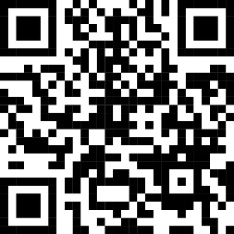
72.5/ 100




