Craigslist Used Car Prediction
Venkata Satya Surya Deepthi Sista
Student ID: 001164783
Data Science I

Acknowledgement
I would like to express my sincere gratitude to Dr. Scott Cook for his invaluable guidance, support and mentorship throughout the Data Science I course this semester. Your engaging lectures, critical feedback and encouragement have been instrumental in deepening my understanding of data science concepts. This project would not have been possible without the foundational knowledge and practical skills gained in Dr. Cook’s class, which equipped me with the tools to tackle real-world data challenges confidently. I am grateful for his dedication and willingness to go the extra mile to ensure the course material is well grasped.
Thank you, Dr. Cook for inspiring a deep passion for data-driven problem-solving throughout the course.
Additionally, I would like to acknowledge the use of Google Colab’s AI assistant for providing useful code suggestions and completions during the development of this project.

- Introduction
The used car market in the United States is one of the largest and most dynamic sectors, involving millions of transactions every year between individual sellers, buyers and dealerships. While there are several companies that sell used cars in the US, Craigslist is one of the most popular classified ad websites that offers a wide range of vehicle listings across different regions, price points and conditions. However, Craigslist users often face challenges in pricing vehicles accurately, especially in situations where the data is inconsistent and sometimes incomplete.
The purpose of this project is to develop a predictive machine learning model that estimates the price of cars listed on Craigslist using data science and machine learning techniques. By analyzing historical data, this project aims to uncover patterns and relationships between key vehicle attributes, such as manufacturing year, odometer reading, vehicle condition and final listing price. The desired outcome is a deployable machine learning model that can serve as a practical tool for buyers, sellers and industry actors.
This project holds significant importance because it addresses both consumer and industry pain points. For individual buyers, a reliable price prediction system can reduce the risk of overpaying. On the other hand, for sellers, it offers guidance to set competitive prices that reflect true market value. Overall, in an industry known for information asymmetry and inefficiencies in pricing models, this project aims to improve price transparency in the used car market.
- Data Sources
Original Source: https://www.kaggle.com/datasets/austinreese/craigslist-carstrucks-data
Date and Time Retrieved: April 16, 2025
Collection Method:
When: The dataset was scraped periodically over a time frame in recent years (specific dates not provided by uploader).
Where: Listings were collected from various Craigslist regional websites across the United States.
Who: The dataset was curated and uploaded to Kaggle by a user named Austin Reese.
How: Data was gathered using web scraping techniques from Craigslist's publicly available car and truck listings.

Description of Contents:
This dataset includes hundreds of thousands of vehicle listings from Craigslist, with features describing car attributes, listing details, and geographic location. Each record corresponds to a single car listing.
High-Level Description:
The dataset is a tabular CSV file containing 25 columns and 426880 rows where each row represents a vehicle listing. It is relatively large and includes a diverse range of manufacturers, models, conditions, and price ranges. This dataset provides sufficient volume and variety for comprehensive analysis, with both numeric and categorical features that support advanced preprocessing and modeling techniques.
Column Name | Description
price | Target variable. The listed selling price of the car in USD.
year | Year the car was manufactured. Often correlates with vehicle depreciation and value.
odometer | Mileage of the car in miles. Typically, higher mileage lowers resale value.
condition | Condition of the vehicle (e.g., new, like new, excellent, good, fair, salvage). Impacts buyer perception and pricing.
manufacturer | Car's brand or manufacturer (e.g., Ford, Toyota, BMW). Used to assess brand value and popularity.
type | General category of the vehicle (e.g., SUV, sedan, pickup, convertible). Used for segmentation of pricing strategies.
The dataset aligns with all project guidelines and provides a real-world context for building predictive models. It contains past vehicle listings with clearly defined selling prices, making it well-suited for a supervised learning approach. Since the goal is to predict a continuous numerical value, the listed price of the vehicle, it is a regression problem.

- Problem Statement
The used car market presents a complex landscape in terms of pricing variability, inconsistent listing details and varying buyer-seller expectations (Wang et al., 2021). Unlike certified dealerships, platforms like Craigslist operates as an open classified system where listings often lack standardized pricing guidelines or quality verification. As a result, both buyers and sellers struggle to assess the fair market value of a vehicle. This in turn leads to challenges, such as overpricing, undervaluing or the vehicle sitting in the market for a long time.
The core problem this project aims to address is the need for a data-driven approach when it comes to estimating car prices based on historical data. While some buyers may rely on rough comparisons or personal judgment, in reality, car prices are influenced by a combination of quantitative and qualitative aspects (Rane et al., 2021). Without a systematic process, it becomes difficult to balance these factors and arrive at an accurate price estimate. Some of the notable challenges include wide price ranges listed hundreds or even thousands of dollars apart for similar cars, time-consuming and error-prone manual efforts by buyers to compare car listings without any statistical precision, and most importantly, sellers pricing their vehicles either too high or too low, often leading to unsold inventory and financial loss (Sherki et al., 2024). Addressing these challenges through predictive modeling offers a clear opportunity to improve price accuracy, enhance decision-making and increase overall efficiency of the used cars market.
- Proposed Solution
This project proposes a machine learning model to address the pricing variability and lack of transparency in Craigslist’s used car listings. Through the use of historical data scraped from Craigslist, this project builds a regression model capable of estimating a car’s selling price with improved accuracy when compared to manual judgments.
The key data science methods used in this project include exploratory data analysis (EDA), feature engineering, outlier handling and supervised machine learning. The project explores multiple algorithms, such as random forest regressor and FLAML (Fast Lightweight AutoML) to identify the most effective modeling approach for this dataset. These models are trained on historical data, validated through cross-validation and evaluated using metrics like mean absolute error (MAE) and R² score.
- Exploratory Data Analysis (EDA)
For the exploratory data analysis, I aimed to uncover key relationships, trends and potential data quality issues within the Craigslist dataset. I examined distributions of numerical variables like price, odometer readings and vehicle manufacturing year to identify skewness and outliers that require additional filtering or transformation. I also explored categorical variables, such as condition, manufacturer and vehicle type to assess how they influenced the price of used cars. For example, the boxplot of price versus condition (see figure) shows how vehicles listed as ‘new’ or ‘like new’ typically command higher prices, while ‘salvage’ or ‘fair’ condition cars were priced in the lower range.
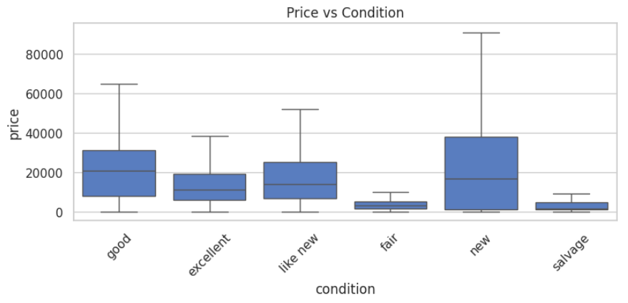
This analysis validates the importance of including condition as an ordinal predictor in the model. Throughout the EDA process, I generated scatterplots, boxplots, and correlation heatmaps to determine appropriate feature engineering strategy and ensure that the model would be built on clean, meaningful input variables.
- Data Cleaning
The raw data included numerous missing or incomplete entries, which were efficiently handled by either imputing reasonable values or removing records with excess missing values. Specific outlier filtering steps included dropping car listings with implausibly higher odometer readings over 500,000 miles or extreme prices over $400,000, which could distort the model. Rare categories in manufacturer and type were grouped into ‘other’ category to prevent sparsity issues and improve model generalization. Additionally, categorical fields, such as ‘cylinders’ were cleaned by extracting numeric values from inconsistent text entries, such as ‘6 cylinders’ to 6 and using replacements.
- Feature Engineering
Several feature engineering transformations have been applied to the model to improve its accuracy. For instance, the ‘condition’ field was converted into an ordinal scale to represent increasing quality levels and numerical features, such as odometer readings were log-transformed to reduce skewness and make relationships more linear. Sample code is pasted below.
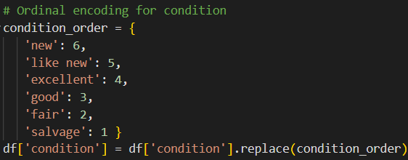
- Data Wrangling
A machine learning pipeline was built using a ColumnTransformer() to handle different feature types. Scaling and dimensionality reduction was applied to continuous variables, while ordinal encoding was used to rank categories like condition. Additionally, one-hot encoding was applied to nominal categories, such as manufacturer and type to ensure all inputs were properly preprocessed before model training.
- Model Development
A variety of regression models were developed and compared in this project, such as Random Forest Regressor, LGBM and AutoML using the FLAML library. Hyperparameter tuning was performed through gridsearchCV for manual models and automatic selection in FLAML. The goal is to balance accuracy through mean absolute error and R² scores.
- Evaluation & Interpretation
Model performance was evaluated on the holdout set using metrics, such as mean absolute error (MAE) and R² score. Additionally, permutation feature importance was calculated to determine the variables that had the strongest impact on the price predictions. This step provided insights in showing which model worked the best and why it made the predictions.
- Results & Findings
The machine learning models developed in this project produced clear, actionable insights into the factors driving car prices on Craigslist.
What Worked Well:
- RandomForestRegressor emerged as the top-performing machine learning algorithm in this project, achieving a strong R² score of 0.8176 on the holdout dataset, which indicates it could explain over 81% of the variance in car prices. The model also achieved a mean absolute error (MAE) of approximately $2,685, indicating reasonably precise price predictions compared to the actual price listings on Craigslist.
The table shown below summarizes the top-performing evaluation metrics for RandomForestRegressor model. A residual plot has also been added for reference to visualize the spread of prediction errors and confirm whether the model demonstrates reliable performance across majority of the price ranges.
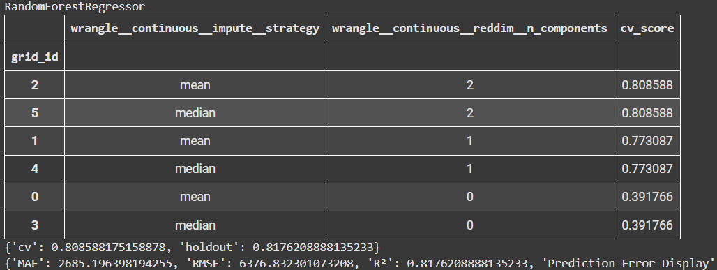

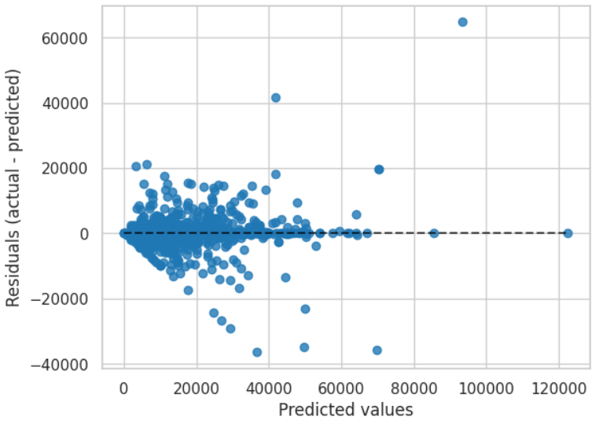
- Model stability was improved by using log transformation on skewed features like odometer.
- Derived features like vehicle age (current year minus manufacturing year) added valuable predictive power than using year as a direct feature.
- Ordinal encoding of condition variable into a ranked scale provided meaningful predictive power.
- Focusing on the top influential features provided better interpretable results than overfitting the model to all available variables.
- Applying FLAML and gridsearchCV to tune hyperparameters improved the final model accuracy.
What Didn’t Work Well:
- LGBM (Light Gradient Boosting Machine) showed significantly lower R² value of 0.23 and very high MAE of $9514 which implies underperformance when compared to RandomForestRegressor.
- Simple linear models and untuned regressors did not capture the nonlinear relationships between features like age, condition, and price.
- Basic categorical-to-numeric conversions, such as one-hot encoding for condition variable didn’t work well for the model because the categories like ‘salvage’ and ‘excellent’ were treated as equally distinct, missing their natural order.
- Including too many rare or sparsely populated categorical variables like fuel, paint color sometimes added noise.
- Using too many PCA components reduced performance and even crashed the notebook rather than benefitting the model.
What Else Was Tried:
- The HistGradientBoostingRegressor was tested as part of the modeling experiments but ultimately did not achieve competitive performance compared to the RandomForestRegressor.
- AutoML with FLAML was tested but it did not outperform the RandomForestRegressor in this dataset.
- Different imputation strategies, such as mean vs. median were explored for handling missing values with minor performance differences.
- Feature combinations and engineered features, such as age and manufacturer averages were tested to see if they improved the prediction.
The following key insights have been discovered in the project:
- Vehicle Age: Newer vehicles commanded significantly higher prices and the depreciation is steep for cars over 10-15 years old.
- Odometer Readings: Mileage was a dominant price predictor as cars with higher mileage showed sharply lower prices, though the lowering effect leveled off beyond 200,000 miles.
- Condition: Car listings marked as ‘excellent’ or ‘like new’ were valued much higher than those marked as ‘fair’ or ‘salvage’, which highlights the importance of vehicle condition despite accounting for price differences with respect to vehicle age.
- Manufacturer and Type: Brand reputation played a key role with premium brands retaining stronger resale values compared to economy brands. In a similar fashion, pickup trucks and SUVs had higher predicted prices compared to sedans or coupes.
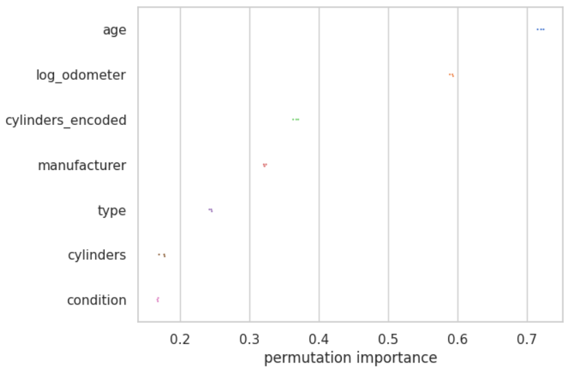
Lastly, analyzing the permutation feature importance confirmed that age, log-transformed odometer and vehicle condition were the most influential features in determining the price, followed by manufacturer and vehicle type. This quantitative understanding offers a solid foundation for deriving pricing strategies on Craigslist.
- Conclusion
This project developed a robust machine learning model to predict the prices of used cars on Craigslist in an attempt to reduce inconsistencies in the pricing strategy and improve decision-making for buyers and sellers. The RandomForestRegressor emerged as the best-performing model, achieving an R² score of 0.8176 and a mean absolute error of approximately $2,685, which indicates the effectiveness of the model in capturing key price patterns in the data. The analysis revealed that vehicle age, odometer readings, condition, manufacturer, and type of the vehicle are the strongest predictors of price, thereby offering valuable insights into market dynamics. These results can play an important role in influencing buyers to avoid overpaying and assisting the sellers in setting competitive prices.

References
Google Colaboratory AI. Code assistance and auto-suggestions. Google, 2025. Available at: https://colab.research.google.com
Rane, M., Patil, M., Rane, N., & Amune, A. (2023, January). Random Forest Regressor Approach for Predicting Resale Value of used Vehicles (RFRVP). In 2023 Third International Conference on Advances in Electrical, Computing, Communication and Sustainable Technologies (ICAECT) (pp. 1-6). IEEE.
Sherki, A., Bandhate, P., Thete, T., Habib, F., Zambre, P., & Bhoyar, K. (2024, November). Machine Learning Models for Predicting Resale Value of Car. In 2024 2nd International Conference on Emerging Trends in Engineering and Medical Sciences (ICETEMS) (pp. 367-374). IEEE.
Wang, F., Zhang, X., & Wang, Q. (2021, December). Prediction of used car price based on supervised learning algorithm. In 2021 International Conference on Networking, Communications and Information Technology (NetCIT) (pp. 143-147). IEEE.

