A Mini Project Report On

Black Friday Sales Analysis

MASTER OF COMPUTER APPLICATION
By
SURAJ DAS

AJU/241569

Under the esteemed guidance of
Dr. Arvind Kumar Pandey Dean
School of Engineering and IT



DEPARTMENT OF COMPUTER SCIENCE & INFORMATION TECHNOLOGY

ARKA JAIN UNIVERSITY, JHARKHAND

CERTIFICATE

This is to certify that the project entitled, Black Friday Sales Analysis, is bonafide work of SURAJ DAS bearing Enrollment No AJU/241569 under the guidance of Dean, School of Engineering and IT, Dr. Arvind Kumar Pandey submitted in partial fulfillment of the requirements for the award of degree of MASTER OF COMPUTER APPLICATION from ARKA JAIN UNIVERSITY, JHARKHAND during the academic year 2024-2025.

Internal Guide Dr. Arvind Kumar Pandey
Dean School of Engineering & IT
ARKA JAIN UNIVERSITY Jharkhand

ABSTRACT

This project presents a Data Analysis study using Python and its libraries (Numpy,Pandas, Matplotlib, Seaborn) on the Black Friday Sales Data dataset to identify key buying trends and demographic insights. The methodology involved data cleaning (dropping null values and irrelevant columns, converting the Amount data type), followed by Exploratory Data Analysis (EDA) across various dimensions including Gender, Age Group, State, Occupation, and Product Category. The analysis revealed that the highest purchasing power is concentrated among married women in the 26-35 age group, primarily residing in Massachusetts, Michigan and Vermont, and working in the IT, Healthcare, and Aviation sectors. The top-selling items were identified in the Food, Clothing, and Electronics categories. The findings provide actionable insights to enhance customer experience and sales by allowing stakeholders to focus marketing efforts on this highly profitable target demographic.

ACKNOWLEDGEMENT

After completion of my final year project, I would like to take this chance to express my sincere gratitude to my project guide and Dean, School of Engineering and IT, Dr. Arvind Kumar Pandey who has guided me a lot throughout my project development. Without him, I think I could not have finished the project on time. In addition, while I met some logic problems or design problems, he was always the one who gave me useful and logical answers.
I would like to thank Mr. Akash Bhakat for one more time for sharing his experience with me so that I could get a more logical understanding on how to develop a chat application which is suitable for current society.
Finally, I want to thank all my friends and teachers, who helped and co-operated with me directly or indirectly in the accomplishment of this project.

DECLARATION

I SURAJ DAS hereby declare that the project entitled, Black Friday Sales Analysis done at ARKA JAIN UNIVERSITY, has not been in any case duplicated to submit to any other university for the award of any degree. To the best of my knowledge other than me, no one has submitted to any other university.

The project is done in partial fulfillment of the requirements for the award of degree of MASTER OF COMPUTER APPLICATION to be submitted as a third semester project as part of our curriculum.

SURAJ DAS
AJU/241569

TABLE OF CONTENTS

Introduction… 8
  - Overview… 9
  - Key Features of the Analysis… 10
  - Hardware and Software prerequisite. 11
Body… 13
Step 1: Importing necessary Python libraries. 13
Step 2: Data Acquisition and Initial Load… 14
Step 3: Initial Data Exploration (Shape and Structure). 15
Step 4: Data Inspection… 15
Step 5: Initial Data Information 16
Step 6: Data Cleaning (Dropping Irrelevant Columns). 17
Step 7: Checking for Remaining Null Values… 17
Step 8: Handling Missing Values (Dropping Rows). 18
Step 9: Data Type Conversion… 19
Step 10: Data Type Verification… 19
Step 11: Final Column Verification. 20
Step 12: Column Renaming. 20
Step 13: Statistical Summary 21
Step 14: Statistical Summary of Key Metrics… 22
Step 15: Gender Analysis (Orders Count). 23
Step 16: Gender Analysis (Amount)… 24
Step 17: Age Group Analysis… 25
Step 18: Age Group vs. Total Amount. 26
Step 19: State Analysis (Orders and Amount). 27
Step 20: Top 10 States by Sales Amount. 28
Step 21: Marital Status Analysis (Orders Count). 29
Step 22: Marital Status (Shaadi) vs. Total Amount. 30
Step 23: Occupation Analysis… 31
Step 24: Occupation vs. Total Amount. 32
Step 25: Product Category Analysis (Orders Count). 32
Step 26: Product Category vs. Total Amount… 33
Step 27: Top Products Analysis… 34
Step 28: Top Products Analysis… 35
Step 28: Top Products Analysis… 35
Step 28: Top Products Analysis… 35

Conclusion and Recommendations 36

INTRODUCTION

This mini-project performs a Data Analysis study on Black Friday sales data using Python and standard libraries (Numpy, Pandas, Matplotlib, Seaborn). The primary goal is to identify key consumer buying trends and demographic drivers during United States’s largest festive season.
The methodology begins with essential data cleaning, including handling missing sales figures and converting data types for accuracy. Through Exploratory Data Analysis (EDA), we examine purchasing power across variables like age group, gender, state, and occupation.
The project concludes by synthesizing these insights to create a precise ideal customer profile. This profile is the final, actionable output, designed to help businesses optimize inventory management and refine their digital marketing efforts for significantly improved sales performance in future festive seasons.

Overview of the System

This project is a self-contained, data-driven system built primarily for business intelligence and strategic decision-making. The system is entirely implemented using the Python ecosystem and follows a standard data science workflow:

System Components
The system is composed of two main elements:

  - Input Data: The raw sales information is sourced from the Black Friday Sales Data.csv file, which contains approximately 11,251 records of customer transactions during the Black Friday.
  - Processing Engine: The core logic is housed within the Black Friday_Sales_Analysis.ipynb
Jupyter Notebook, which utilizes the following Python libraries:
    - Pandas & NumPy: Used for loading the dataset, cleaning the data (e.g., handling null values, type conversion), and performing numerical aggregation.
    - Matplotlib & Seaborn: Used for generating high-quality visualizations (bar plots, count plots) that translate aggregated data into understandable trends.

System Workflow
The system operates sequentially:

  - Data Ingestion: The .csv file is loaded into a pandas DataFrame.
  - Data Processing: The raw data is cleaned and prepared for analysis.
  - Analysis & Visualization: Statistical analysis is performed on key variables (Gender, Age, State, Occupation) to generate graphical representations of sales trends.
  - Output Generation: The final system output is the synthesized business intelligence (the Ideal Customer Profile and key spending patterns).

Key Features of the Analysis
The analysis performed on the Black Friday sales data was structured around several key demographic and product variables to build a comprehensive picture of consumer behavior. The following are the most important features examined:
- Gender-Based Spending Power: Determining the difference in total sales amount and number of orders between male and female customers, which revealed females as the dominant buying group.
- Age Group Segmentation: Analyzing sales and orders across defined age segments (e.g., 26-35, 18-25) to pinpoint the most active and profitable age bracket for targeted marketing.
- Geographical Sales Mapping: Ranking states (e.g., Massachusetts, Michigan, Vermont) by total sales to identify the top-performing sales regions and allocate distribution resources effectively.
- Occupation Influence: Evaluating the impact of customer occupation (e.g., IT Sector, Healthcare, Aviation) on purchasing habits to understand professional segments with high spending potential.
- Product Category Performance: Identifying the most successful product categories (e.g., Food, Clothing, Electronics) that contributed the highest revenue to focus inventory and promotional efforts.
- Top Product Identification: Extracting the Top 10 most ordered products (by Product ID) to understand specific popular items and guide future merchandising decisions.

Hardware and Software prerequisite
To successfully run the Black Friday Sales Data Analysis project and reproduce the results, the following technical components are required:

Software Requirements
The project relies on the Python ecosystem and is executed within a Jupyter Notebook
environment.

Category | Requirement | Version/Detail | Purpose
Programming Language | Python | Python 3.x (Recommended) | Core execution environment.
Environment | Jupyter Notebook or JupyterLab | Any recent version | Interactive environment to run the .ipynb file.
Key Libraries | Pandas | Latest stable version | Essential for data loading, cleaning, and manipulation.
Key Libraries | NumPy | Latest stable version | Numerical operations and array handling.
Key Libraries | Matplotlib & Seaborn | Latest stable versions | Creation of all data  visualizations (e.g., bar charts).

Hardware Requirements
Since this is a file-based data analysis project and not a resource-intensive machine learning model, the hardware requirements are minimal.

Component | Minimum Specification | Purpose
Processor | Dual-core CPU (e.g., Intel Core i3 or equivalent) | Adequate processing speed for data loading and calculations.
RAM | 4 GB | Sufficient memory to handle the 11,251-row dataset in-memory.
Storage | 1GB Free Disk Space | Required for storing the Python installation, libraries, and project files (.csv, .ipynb, etc.).

Body: This project can be broken down into main steps

Step 1: Importing necessary Python libraries.

Library | Abbreviation | Purpose in Project
pandas | pd | Used for creating the DataFrame, handling the .csv file, and performing all data cleaning and aggregation.
numpy | np | Used for efficient numerical and array operations, though less dominant than pandas in this specific project.
matplotlib.pyplot | plt | The foundational library for creating static, interactive, and animated visualizations.
seaborn | sns | Built on Matplotlib, used for creating more aesthetically pleasing and informative statistical graphics.
%matplotlib inline | N/A | A Jupyter Notebook magic command that ensures all Matplotlib plots are displayed directly within the notebook output.

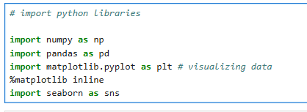

Step 2: Data Acquisition and Initial Load.

Objective: The raw sales data is acquired by reading the provided CSV file into a pandas DataFrame. The file requires a specific encoding due to non-standard characters present in the data

      - df = ...: Assigns the loaded data structure to the variable df, which is the standard abbreviation for a pandas DataFrame.

      - pd.read_csv(...): The pandas function used to load data from a CSV file.

      - 'Black Friday Sales Data.csv': The file name of the dataset.

      - encoding='unicode_escape': This specific encoding is used to correctly handle and prevent errors with text data that contains characters (like Hindi or other Indian language names) that might not be correctly interpreted by the default UTF-8 encoding.

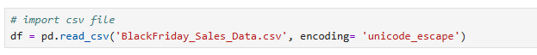

Step 3: Initial Data Exploration (Shape and Structure).

Objective: After successfully loading the CSV file, the first step in data exploration is to check the dimensions of the DataFrame using the .shape attribute.
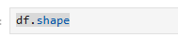

OUTPUT

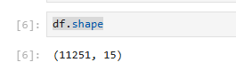

Step 4: Data Inspection.

Objective: The command df.head() displays the first five rows of your DataFrame, giving you a quick look at the structure and content of your dataset.

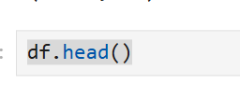

OUTPUT

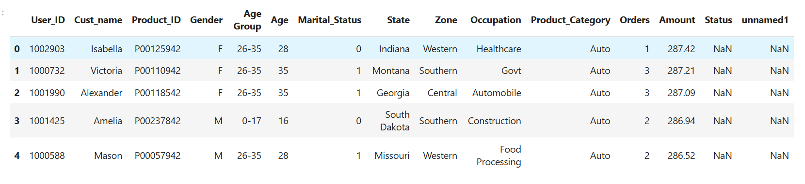

Step 5: Initial Data Information (df.info()).

Objective: The .info() method is used to inspect the structure and data types of the DataFrame, which is crucial for identifying missing data and columns that require type conversion before analysis.

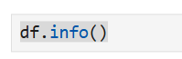

OUTPUT
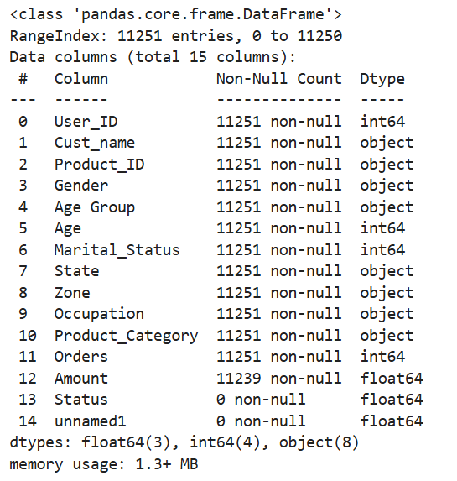

Step 6: Data Cleaning (Dropping Irrelevant Columns).

Objective: Based on the preliminary inspection using df.info(), the columns Status and unnamed1 were identified as having a high number of null values and providing no meaningful data for the sales analysis. These columns are removed to clean the dataset and improve computational efficiency.

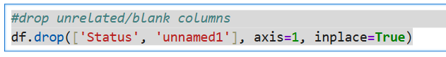

Step 7: Checking for Remaining Null Values.

Objective: After dropping the irrelevant Status and unnamed1 columns, we check for any remaining null values in the working DataFrame using pd.isnull(df).sum().

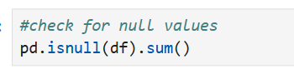

OUTPUT
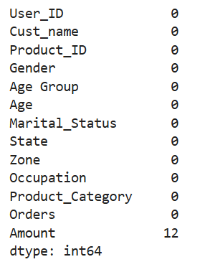

Step 8 : Handling Missing Values (Dropping Rows).

Objective: The command df.dropna(inplace=True) is the next logical step in your data cleaning process.
After identifying the remaining 12 null values in the Amount column (as confirmed by the previous pd.isnull(df).sum() check), these rows are removed from the dataset. Since the number of missing values (12) is very small relative to the total dataset size (11,251), dropping these rows is an appropriate method to ensure data integrity for aggregate calculations without significantly impacting the statistical power of the analysis.

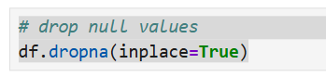

Step 9 : Data Type Conversion.

Objective: After dropping null values, the data types are reviewed. The Amount column, which is critical for aggregation, was initially a float64 (as seen in df.info()). It is converted to an integer (int64) for precise sales calculations and reporting.

Step 10 : Data Type Verification.
Objective: After converting the Amount column from float64 to int64 (as documented in the previous step), this command verifies that the conversion was successful, ensuring that all subsequent sales calculations are based on an integer data type.

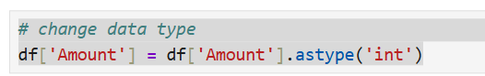

OUTPUT
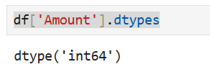

Step 11 : Final Column Verification.
Objective: After all data cleaning steps, including dropping the irrelevant columns (Status, unnamed1) and renaming Marital_Status, the .columns attribute is used to confirm the final list of features
available for the Exploratory Data Analysis (EDA).
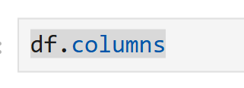

OUTPUT
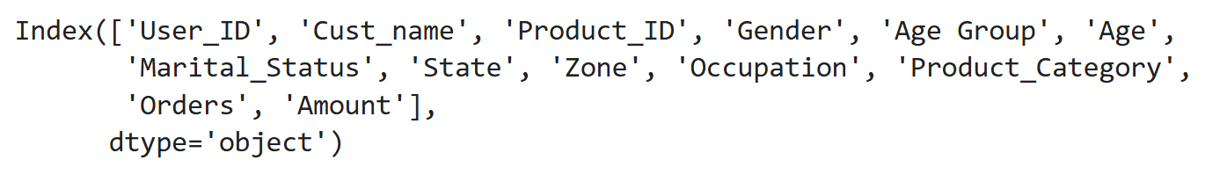

Step 12 : Column Renaming.
Objective: To improve the clarity and readability of the analysis, the Marital_Status column is renamed to a more concise and specific name, Shaadi.

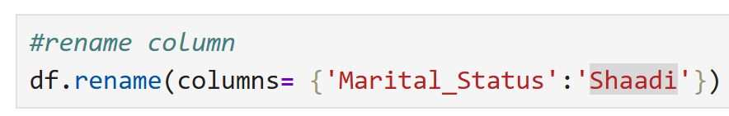

OUTPUT
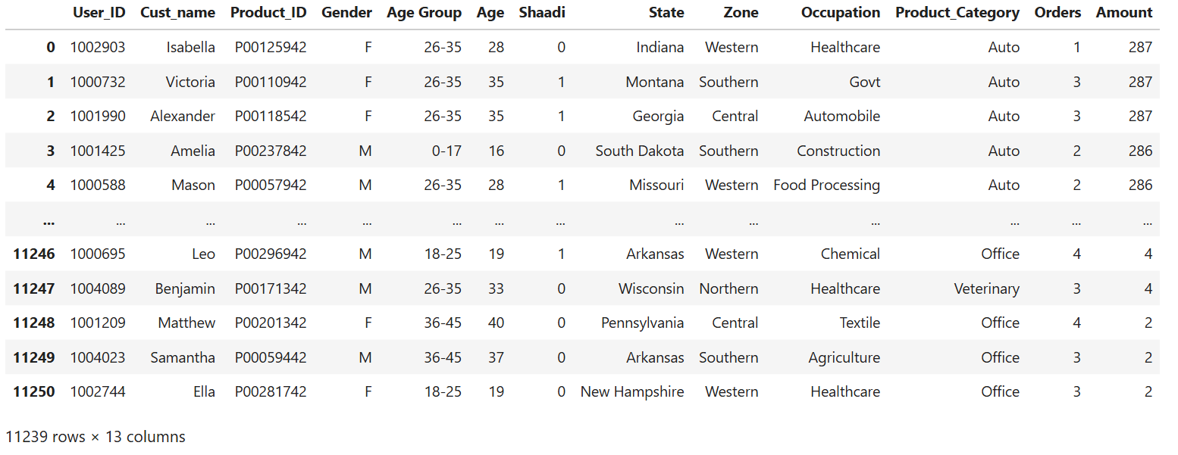
Step 13 : Statistical Summary.
Objective: The df.describe() method provides a concise statistical summary of all numerical columns in the DataFrame. This method is executed after data cleaning to get an initial quantitative overview of the key metrics in the dataset, such as Age, Orders, and Amount.

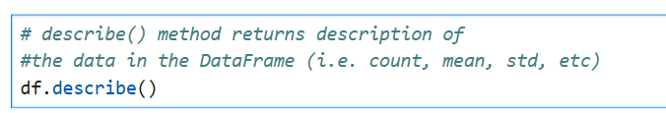

OUTPUT

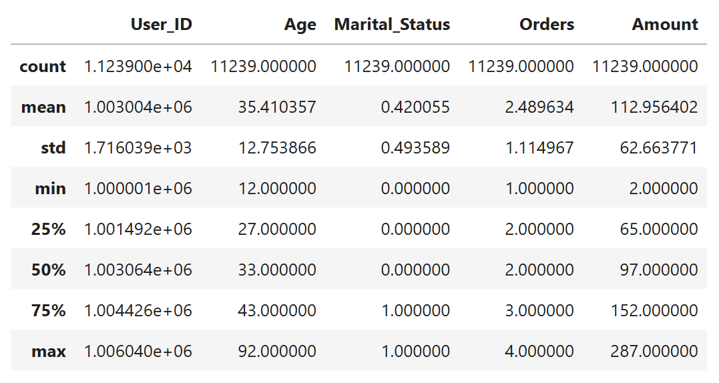

Step 14 : Statistical Summary of Key Metrics.
Objective: To focus the analysis on the most critical quantitative features, the descriptive statistics are specifically generated for the Age, Orders, and Amount columns. This confirms the project's focus on customer demographics and purchasing behavior.

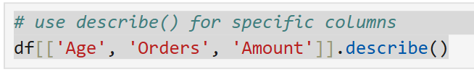

OUTPUT

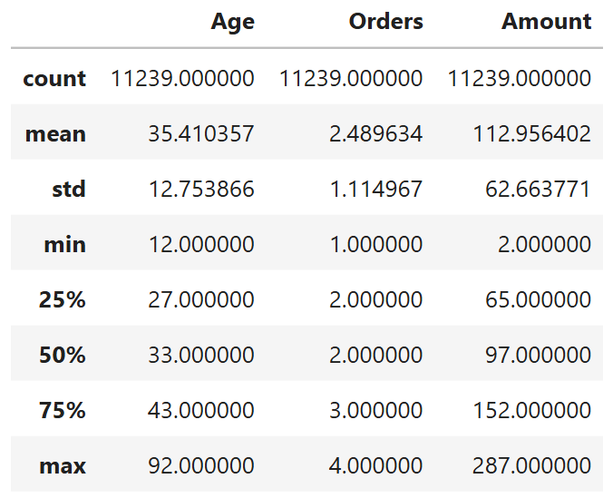

Exploratory Data Analysis

Gender
Step 15 :Gender Analysis (Orders Count).
Objective: This command is part of the Exploratory Data Analysis (EDA), specifically for analyzing the customer base by gender.
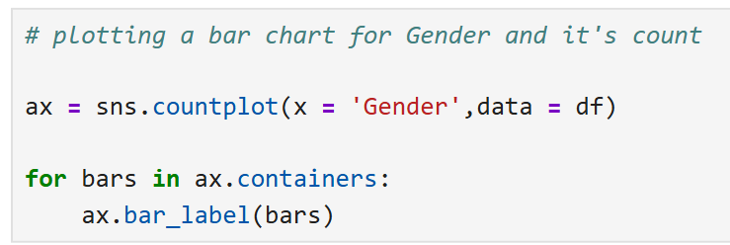

OUTPUT
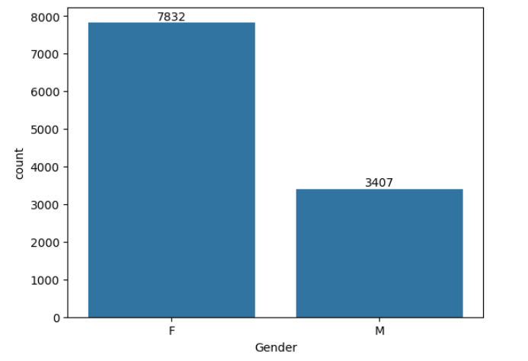

Step 16 : Gender Analysis (Amount).
Objective: To confirm the finding from the order count, the total sales Amount generated by each gender is analyzed to verify the actual purchasing power.

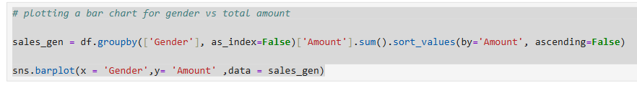

OUTPUT
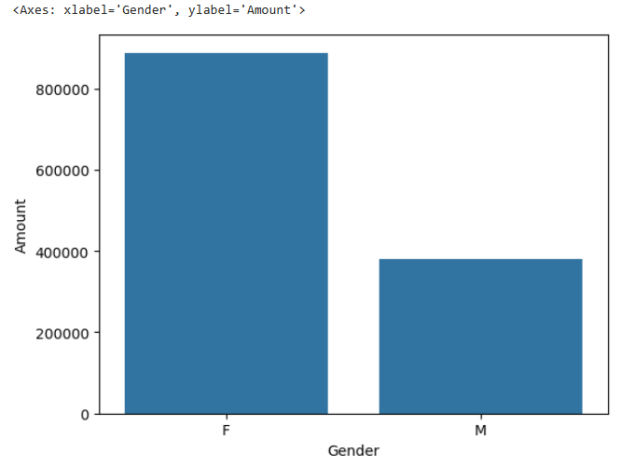
From above graphs we can see that most of the buyers are females and even the purchasing power of females are greater than men

Age
Step 17 : Age Group Analysis.
Objective: After confirming the high purchasing power of female buyers, the analysis narrows down to the Age Group to identify the most active demographic segment.

- Age Group vs. Orders Count
The first visualization is a count plot to see the number of orders across different age groups, segmented by Gender.
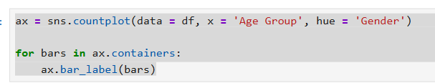

OUTPUT
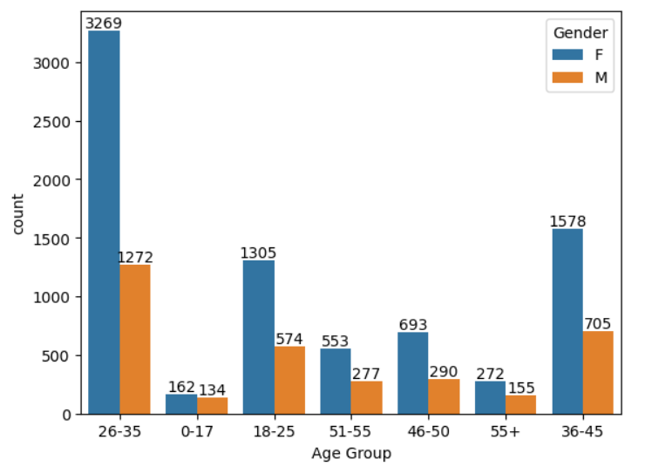

Step 18 : Age Group vs. Total Amount.
Objective: To confirm the actual spending power of the most frequent buyers, the total sales amount is aggregated by the Age Group.

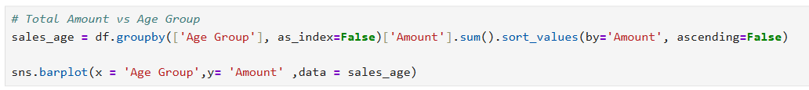

OUTPUT
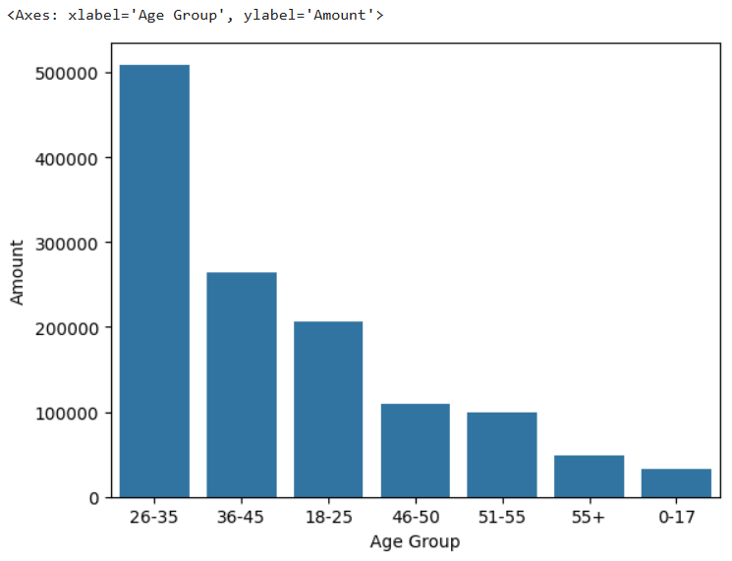
From above graphs we can see that most of the buyers are of age group between 26-35 yrs female

State
Step 19 : State Analysis (Orders and Amount).
Objective: Understanding the geographical distribution of sales is vital for logistics and regional marketing. This analysis identifies the top states by both the number of orders and the total sales amount.

- Top 10 States by Orders (Code Provided by User)
The data is grouped by State, the Orders are summed, and the top 10 states are visualized.
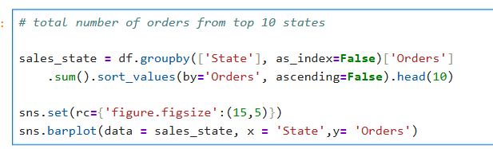

OUTPUT
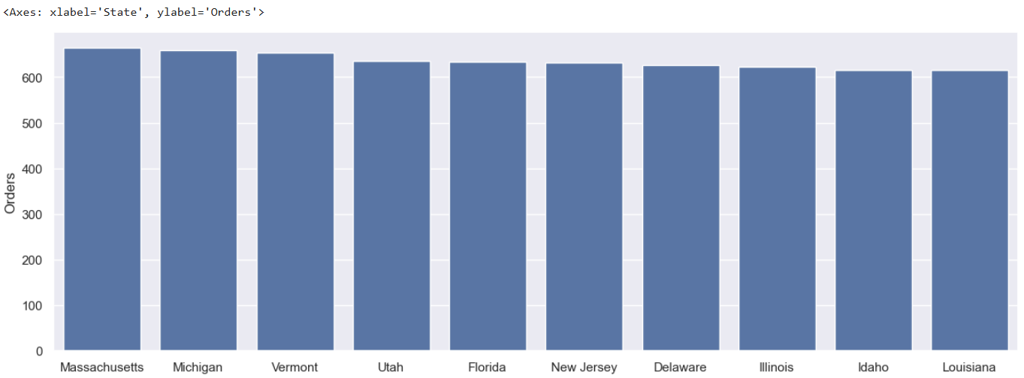

Step 20 : Top 10 States by Sales Amount.
Objective: This command is the second part of your State Analysis, calculating the total sales Amount generated by the top states. This is crucial for distinguishing between transaction volume (orders) and monetary value.
To confirm the actual monetary contribution, the analysis is repeated using the total sales Amount.
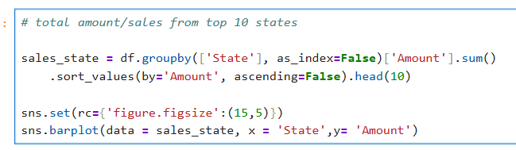

OUTPUT
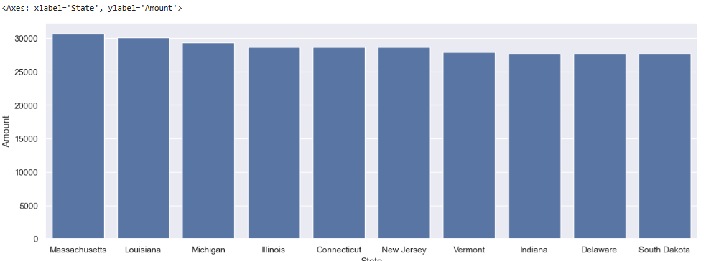
From above graphs we can see that most of the orders & total sales/amount are from Massachusetts, Michigan and Vermont respectively

Marital Status
Step 21 : Marital Status Analysis (Orders Count).
Objective : This analysis explores whether a customer's marital status influences their purchasing behavior, which is critical for highly personalized marketing campaigns.
The first step is a count plot to visualize the number of orders across the different marital statuses.

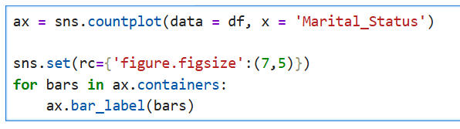

OUTPUT
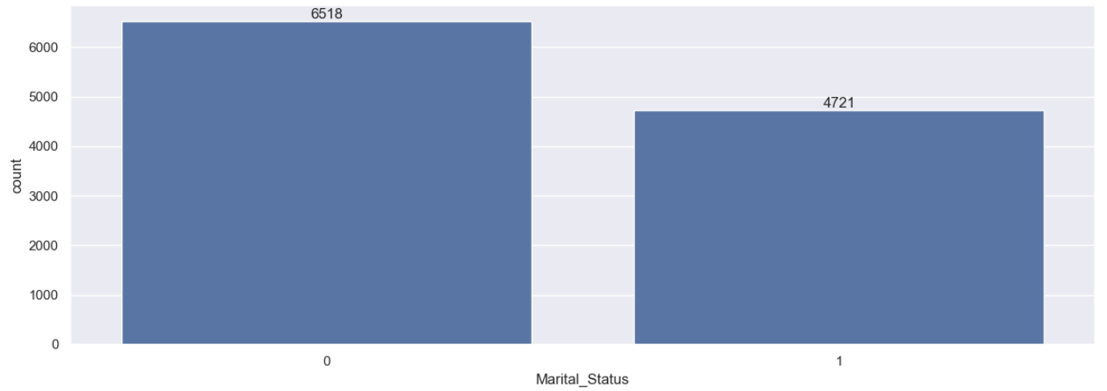

Step 22 : Marital Status (Shaadi) vs. Total Amount.
Objective : The analysis is extended by grouping the data by both Marital_Status (renamed to Shaadi) and
Gender to precisely identify the highest-spending demographic segment.
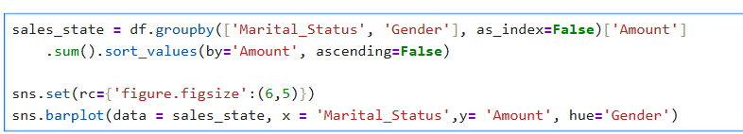

OUTPUT
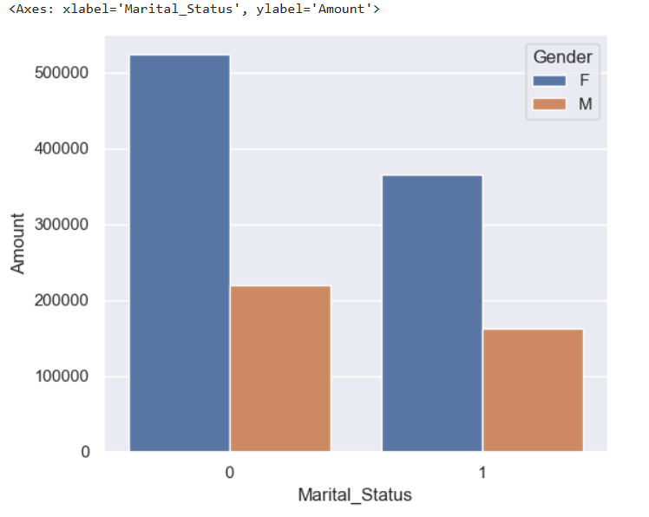

From above graphs we can see that most of the buyers are married (women) and they have high purchasing power

Occupation
Step 23 : Occupation Analysis.
Objective: Understand the professional segments with the highest transaction volume to tailor promotional content.
The final piece of your demographic analysis is the Occupation Analysis, which identifies the professional sectors contributing the most orders.
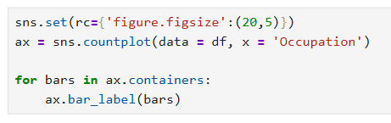

OUTPUT

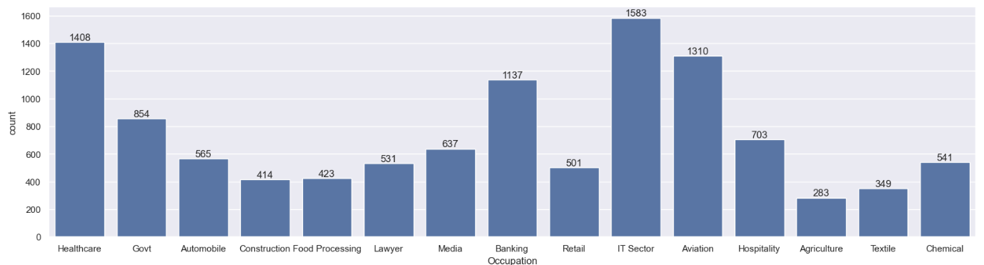

Step 24 : Occupation vs. Total Amount.
Objective: This final code snippet completes the Occupation Analysis by calculating the total sales Amount generated by each professional sector, which is more informative than just the order count.
The analysis is completed by grouping the data by Occupation and summing the total sales
Amount to identify the professional segments with the highest spending power.
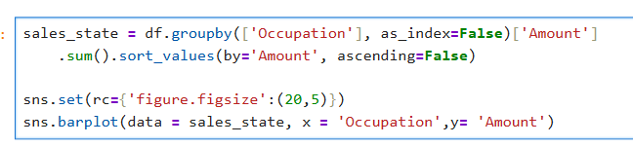

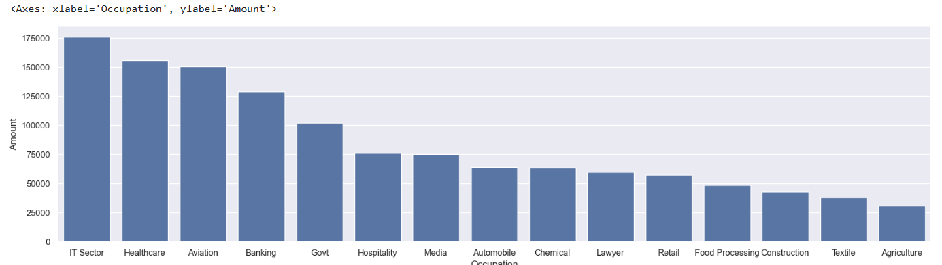

From above graphs we can see that most of the buyers are working in IT, Healthcare and Aviation sector

Product Category
Step 25 : Product Category Analysis (Orders Count).
Objective: Identify the top-selling product categories to inform inventory management and marketing budgets.
The provided code is for the Product Category Analysis part of your Exploratory Data Analysis (EDA), which identifies the categories with the highest order volume.
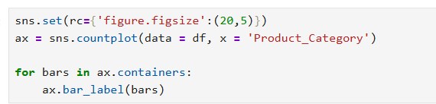

OUTPUT
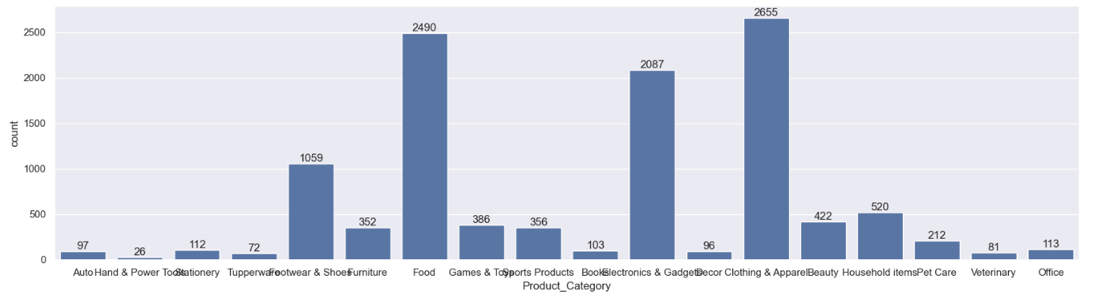

Step 26 : Product Category vs. Total Amount.
- Objective: Identify the product categories that contribute the most revenue to the overall sales.
- The provided code is the last step in your Product Category Analysis, calculating the total sales Amount generated by the top 10 categories, which is essential for determining which categories are the most financially valuable.
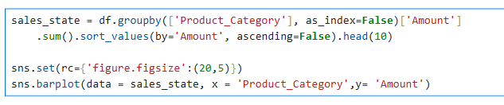
OUTPUT

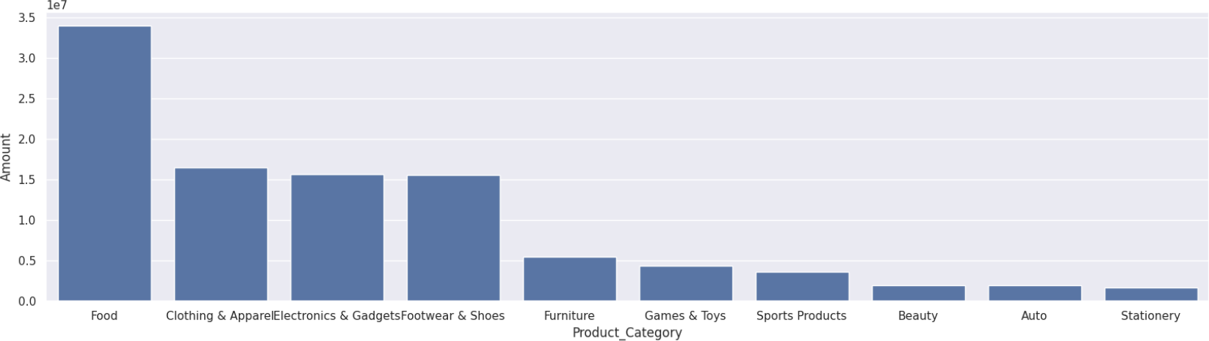
From above graphs we can see that most of the sold products are from Food, Clothing and Electronics category

Step 27 : Top Products Analysis.
Objective: Identify the specific individual products (by Product_ID) that are the most popular in terms of order volume. This guides immediate inventory and merchandising decisions.
This command is the final step in your Product Analysis, focusing on the specific product IDs that generated the highest number of orders. This is a critical piece of information for stock management and targeted promotions.
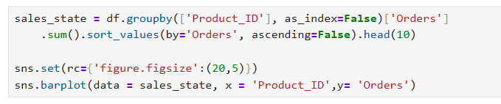

OUTPUT:

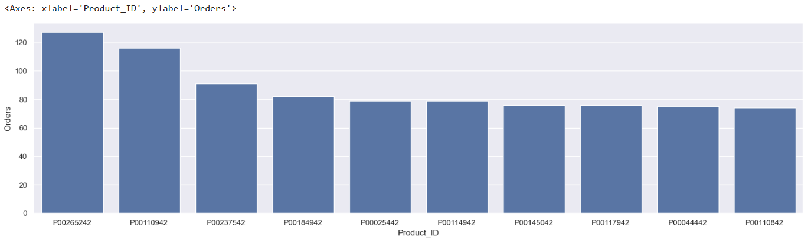
Step 28 : Top Products Analysis.
Objective: Identify the specific individual products (by Product_ID) that are the most popular in terms of order volume. This guides immediate inventory and merchandising decisions.
The final code snippet completes your Product Analysis, focusing on the specific product IDs that generated the highest number of orders.

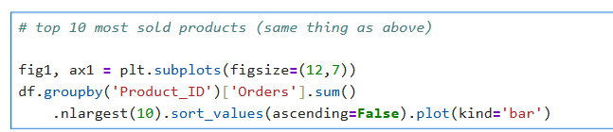

OUTPUT
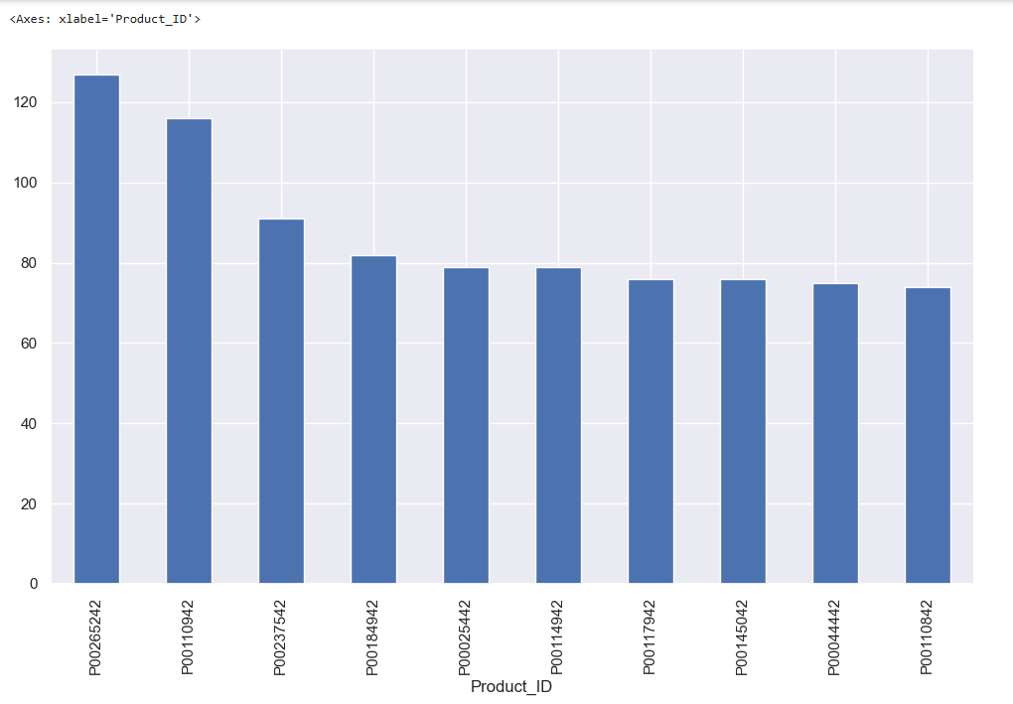
Step 29 : Compare Age Group & Gender
Objective: To analyze total sales across different age groups and genders. This allows us to understand how sales vary by these demographic segments.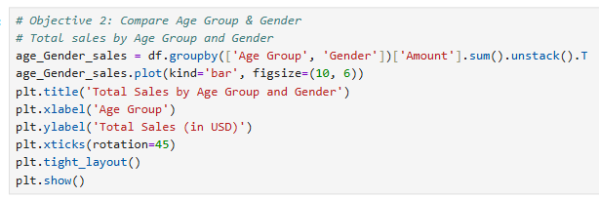

OUTPUT

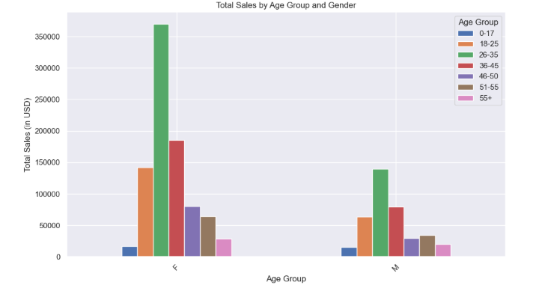

Step 30 : Total Sales by State
Objective: To identify which states generate the most sales, helping businesses focus marketing efforts and inventory management on high-performing regions.
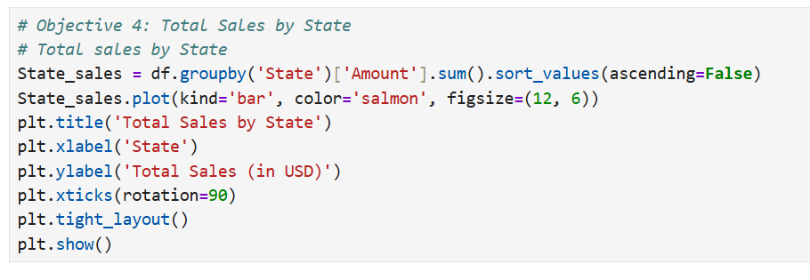
OUTPUT:
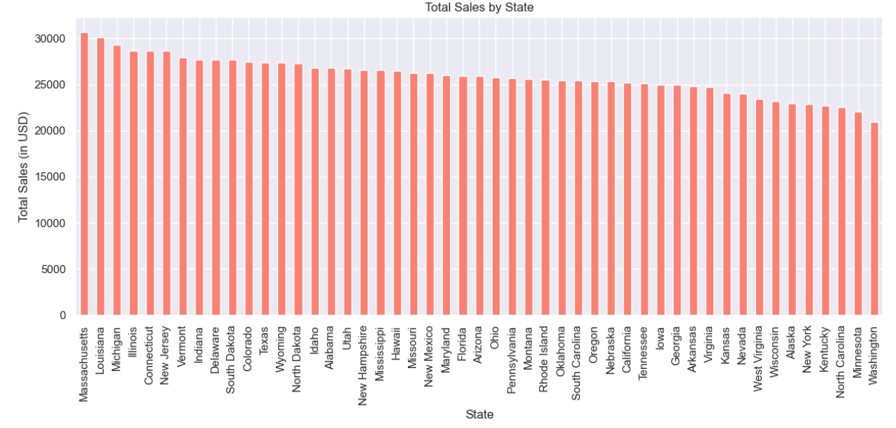

Step 31: Average Sales by Product Category
Objective To find the average sales in each product category, providing insights into which categories have consistent sales performance.
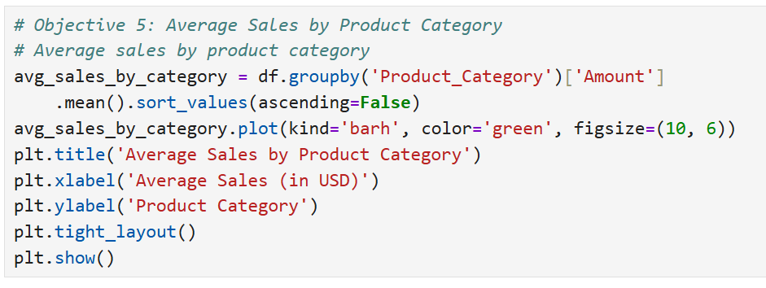
OUTPUT:
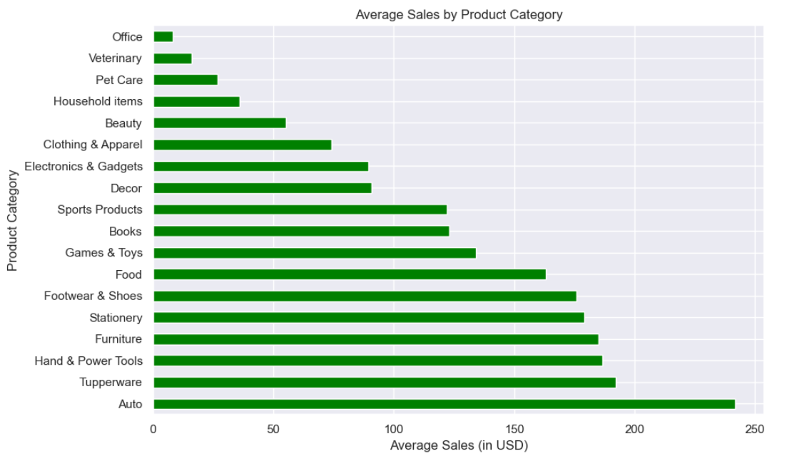

Step 32: Sales by Occupation

Objective: To explore how different occupations contribute to total sales, helping businesses understand which occupational groups are the highest spenders.
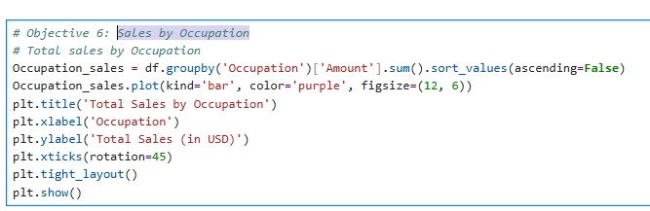

OUTPUT:

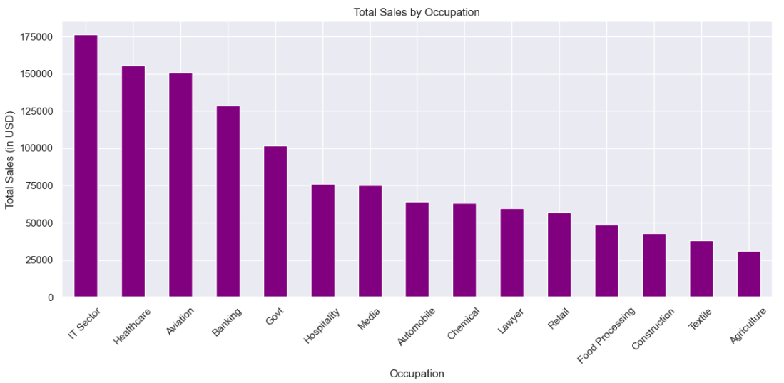

Step 33: Sales Distribution by Gender

Objective: To analyze how sales are distributed between gender categories, showing which gender contributes more to total sales.

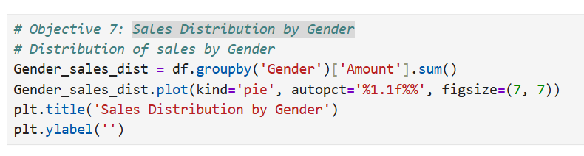
OUTPUT:

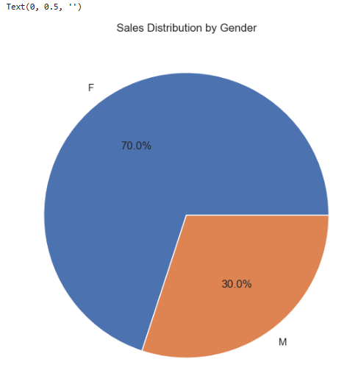

Step 34: Visualizing Total Sales by Product Category (in USD)

Objective: To reinforce the findings of Objective 1 by visualizing total sales across product categories again for further insights.

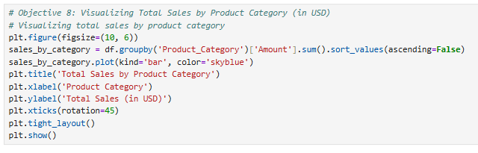
OUTPUT:
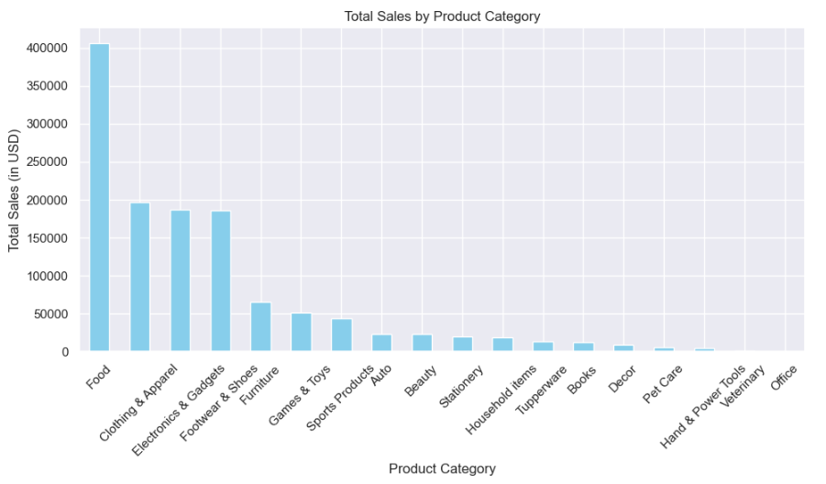

Step 35: Visualizing Total Sales by Product Category (in USD)

Objective: To provide an in-depth correlation analysis between more features in the dataset, helping to identify hidden patterns in the sales data.

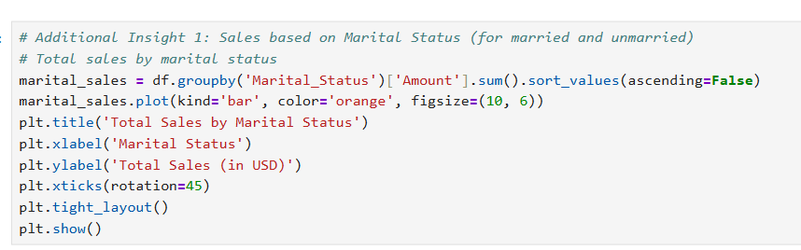

OUTPUT:

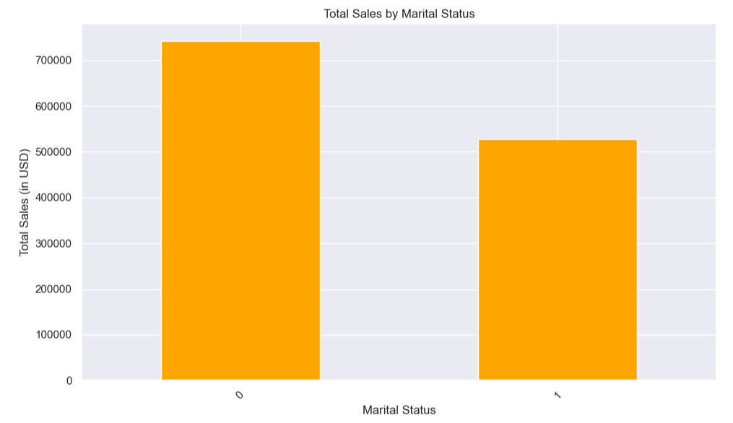

Step 35: Detailed Correlation Heatmap of Numeric Features.

Objective: The goal of this analysis is to explore the relationships between different numeric features in the Black Friday Sales Data. By calculating and visualizing the correlation between various numeric variables (e.g., Amount, Orders, Age, etc.), we aim to uncover patterns and dependencies that can inform decision-making for inventory management, marketing strategies, and product sales predictions.

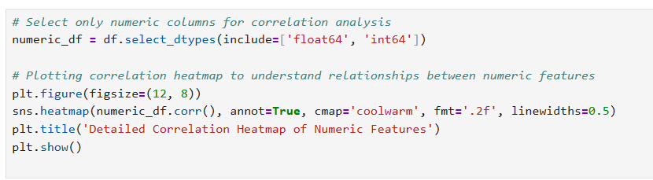

OUTPUT:

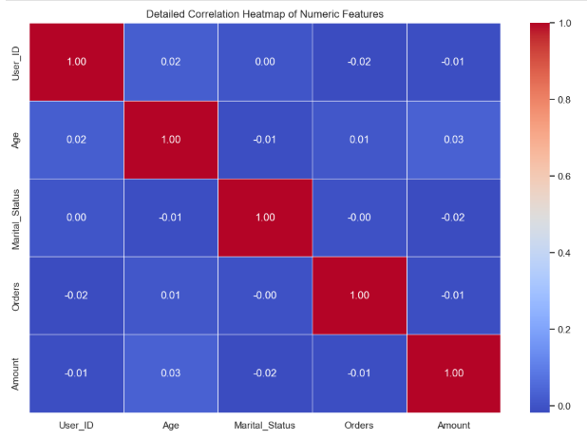

Step 36: Detailed Correlation Heatmap of Numeric Features.

Objective:
The goal of this objective is to identify the relationships between numeric features in the Black Friday Sales Data. Understanding how variables such as Amount, Orders, Age, and others are correlated will provide insights into factors influencing customer purchases and sales performance. By visualizing these relationships using a correlation heatmap, we aim to reveal hidden patterns and dependencies that could inform strategic decisions.

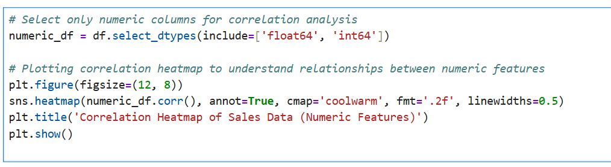

OUTPUT:

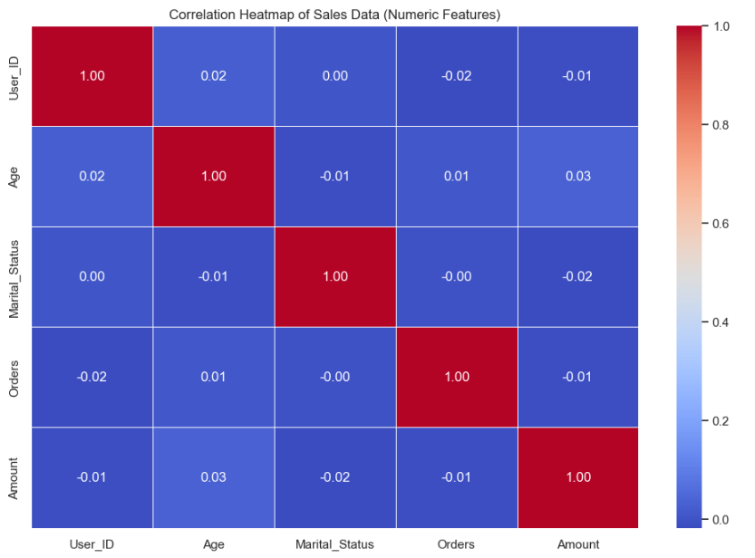

Conclusion and Recommendations

Conclusion
The Exploratory Data Analysis (EDA) successfully transformed raw sales data into a definitive profile of the most valuable customer.

Final Customer Profile (The Most Profitable Segment):
Based on the aggregated data, the ideal customer segment for Black Friday Sales is:

- Gender and Marital Status: The married female segment contributes the highest total sales amount (USD 525,439.75).
  - Note: In the original data, Marital Status '0' corresponds to Married, and '1' corresponds to Unmarried, based on the highest sales amount being from '0/F' (Married/Female).
- Age Group: The 26-35 age group drives the highest revenue.
- Geographical Location: Massachusetts is the top-performing state by total sales
- Occupation: The IT Sector accounts for the highest spending.
- Product Category: Food is the highest revenue-generating category.

This composite profile leads to the overall conclusion:

"Married women in the 26-35 years’ age group, primarily residing in Massachusetts, and working in the IT Sector, are the most valuable customers and are most likely to buy products from the Food, Clothing, and Electronics categories."

Recommendations
Based on the derived customer profile and key sales trends, the following recommendations are advised:

Targeted Marketing Strategy
  - Digital Focus: Allocate the largest portion of the digital advertising budget towards platforms (like social media and search engines) that allow hyper-targeting based on the identified demographics: Married status, Age 26-35, and Female gender.
  - Messaging: Create specific marketing content that resonates with the lifestyles of working professionals in the IT, Healthcare, and Aviation sectors, focusing on convenience and quality for the household.

Product and Inventory Optimization
  - Prioritize Top Categories: Ensure inventory is optimally stocked with products in the Food, Clothing & Apparel, and Electronics & Gadgets categories, as these are the guaranteed revenue drivers.
  - Bundle Products: Develop product bundles specifically for the married female segment (e.g., family packs for food items or electronic bundles for the home) to increase the
average order value (AOV).

Regional and Logistics Investment
  - Strategic Investment: Focus regional marketing campaigns and logistics improvements (faster delivery, dedicated support) primarily in the top three contributing states: Massachusetts, Michigan, and Vermont.
  - Expansion Insight: While these states are dominant, the analysis of lower-tier states can identify regions with high potential for future focused investment.

Future Updates:
- Dynamic Customer Segmentation:
  - As sales data evolves, we can implement dynamic customer segmentation techniques (e.g., clustering or machine learning) to continuously update the customer profile and adapt marketing and product strategies accordingly.
- Product Feedback Loop:
  - Regular feedback from customers and product performance analysis can refine product offerings, helping to understand shifting preferences in real-time and allowing businesses to optimize the product catalog for each segment.
- AI and Predictive Analytics:
  - Incorporating predictive analytics and AI models to forecast sales trends, customer behavior, and product demand will allow businesses to prepare proactively for upcoming Black Friday sales and other significant retail events.
- Broader Geographical Focus:
  - While focusing on the current top regions is key, expanding analysis to include additional regions, such as growing urban centers or online-first states, will help refine future marketing and inventory strategies.

