TASK 1:
- UI (Frontend) Architecture Design

Developer (GitHub)
CI/CD Pipeline
S3 Bucket (Static Files)
CloudFront CDN
Route53 DNS + ACM HTTPS
User Browser

S3 Static website :
https://devops-bucket27.s3.us-east-1.amazonaws.com/index.html
Cloud Front :
https://d9qqcb8amdf1v.cloudfront.net/index.html
Route53:
https://us-east-1.console.aws.amazon.com/route53/v2/hostedzones?region=us-east-1#ListRecordSets/Z081704121Q0Q0HTJ4KLP.
d9qqcb8amdf1v.cloudfront.net.

4) CI/CD Pipeline:
1. Trigger Events
Your CI/CD pipeline will start automatically when any of these events happen:
CI Triggers
- Push to main branch → Automatic build & test (for production readiness)
- Pull Request (PR) creation / update → Build + Unit Tests + Code Quality checks
- Push to dev branch → Deploy to Dev environment
- Tag creation (v1.0.0) → Deploy to Staging → Production (after approval)

2. Build Stage (Conceptual Only)
Steps involved:
- Checkout code from Git repository
- Install dependencies
  - npm install for React frontend
  - pip install -r requirements.txt for Flask backend
- Static Code Analysis (Linting)
  - eslint for frontend
  - flake8 for backend
- Build frontend app
  - npm run build → Outputs optimized production bundle
- Package backend app
  - Build a Python package or zip file
  - (Optional) Docker image build:
    - docker build -t app:latest .

3. Testing Workflow
Types of Tests
- Unit Tests
  - React → Jest
  - Python → Pytest
- API Tests
  - Simple smoke tests on key endpoints (/health, /api/contact, etc.)
- Integration Tests
  - Backend + Database connection test
  - Frontend hitting backend API in Dev environment
Pipeline Rules
- Build fails if:
  - Any unit test fails
  - Linting fails
  - Code coverage < 80% (optional)

4. Deployment Steps
Environment Strategy
Your project has 3 environments:
Environment | Branch | Auto Deploy | Purpose
Dev | dev | YES | Developer testing
Stage | release/* or tags | YES | QA testing
Prod | main or tag v1.* | Manual Approval | Customer-ready

Dev Deployment (Automatic)
- Upload frontend build → S3
- Invalidate CloudFront cache
- Deploy backend → EC2 / Elastic Beanstalk / ECS / Lambda
- Run health checks

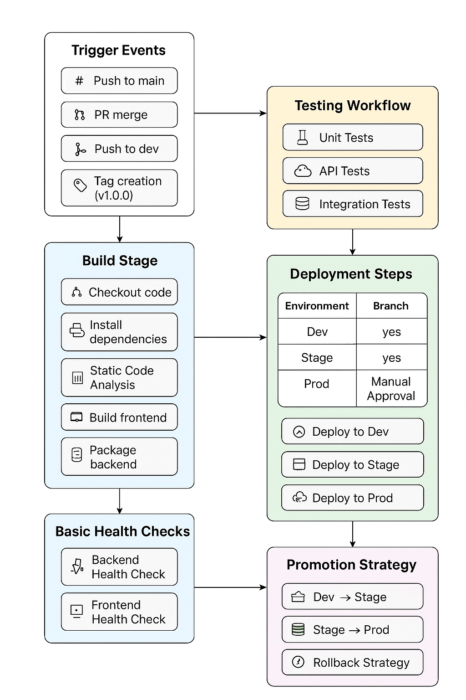
3. Database Architecture Design Choose any relational DB (Postgres/MySQL/MariaDB). Hosted or self-hosted is acceptable.

My choice mysql rds
Deployment:
- Managed: AWS RDS MySQL
- Self-hosted: EC2 instance + MySQL

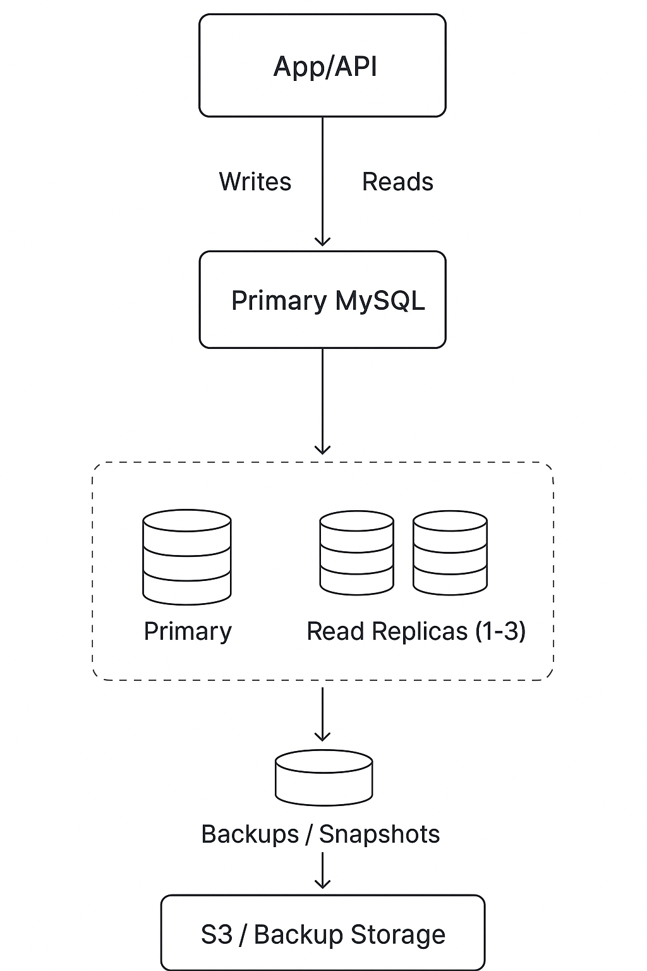
Multi-AZ Deployment (High Availability)
- Primary DB in AZ-A, standby in AZ-B
- AWS RDS handles automatic failover if primary fails
- Ensures minimal downtime (<1 minute failover)

2)API (Backend)
Backend API Architecture Design using EC2:
Where the API Runs
- Deploy the API on EC2 instances inside private subnets.
- Use Auto Scaling Group (ASG) to handle scaling automatically across multiple Availability Zones.

2️⃣ How Horizontal Scaling Works
- Configure Auto Scaling Group:
  - Scale out: When CPU > 70% or Memory > 70%
  - Scale in: When CPU < 30%
- Distribute EC2 instances across multiple AZs for high availability.

3️⃣ How Secrets Are Stored Securely
- Use AWS Secrets Manager or SSM Parameter Store.
- EC2 instances retrieve DB credentials, API keys via IAM role (no hardcoding).

4️⃣ How the API Communicates with the Database
- RDS MySQL deployed in private subnets.
- Security groups:
  - EC2 security group allows outbound traffic to RDS security group on port 3306.
- Use connection pooling in your application.

5️⃣ How Traffic Enters the Backend
- Use Application Load Balancer (ALB):
  - ALB receives internet traffic on HTTP/HTTPS
  - Routes requests to EC2 instances in ASG
  - Performs health checks
  - Handles SSL termination

6️⃣ Optional Enhancements
- Caching: Redis/ElastiCache
- Monitoring: CloudWatch + CloudWatch Alarms
- WAF / Rate limiting if exposed publicly

