**CAPSTONE PROJECT**

We Brainstormed on Fast Food Industries and They Are: -

1-**McDonald’s**: - A global fast-food chain known for its hamburgers, fries, and iconic golden arches.

2-**Subway**: - A sandwich shop offering customizable subs, salads, and wraps, with a focus on fresh ingredients.

3-**Starbucks**: - A renowned coffeehouse chain recognized for its specialty coffee drinks, teas, and pastries.

4-**Burger King**: - A fast-food restaurant famous for flame-grilled burgers, Whoppers, and a diverse menu of quick bites.

5-**Pizza Hut**: - A pizza restaurant chain known for its pizzas, pasta dishes, and a variety of sides, often available for delivery or dine-in.

**Now, We Chose Subway for Detailed Description**: -

SUBWAY

**Problem statement: -**

We choose subway because Regarding Subway, one problem with their brand in recent years has been related to inconsistency in their ingredient quality and freshness. Some customers have reported variations in the quality of ingredients from one location to another, which can affect the overall perception of the brand and its commitment to providing healthy options. This inconsistency can undermine trust and customer satisfaction. The subway food industry faces several challenges that need to be addressed to enhance its efficiency, customer satisfaction, and profitability. The primary problem areas include:

**1-Brand Challenges:** Subway faced significant challenges related to its brand image and perception in recent years. You can explore the decline in sales and customer trust following controversies such as the "footlong" sandwich length issue and questions about the authenticity of their ingredients.

**2-Health and Nutrition Concerns:** Subway markets itself as a healthier fast-food option, but there have been concerns about the nutritional content of their products. You could investigate the impact of changing consumer preferences towards healthier alternatives and how Subway responds to these demands.

**3-Competition:** Subway operates in a highly competitive industry, and you can analyze how it competes with other fast-food giants like McDonald's, Burger King, and healthier alternatives like salad bars and smoothie shops.

**4-Franchisee Relations:** Subway relies heavily on franchisees to run its outlets. Investigate issues related to franchisee relations, such as disputes, lawsuits, or financial challenges that can impact the brand's stability.

**5-Customer Experience:** Subway restaurants need to improve the overall customer experience, including order accuracy, speed of service, and in-store ambiance, to retain existing customers and attract new ones.

**6-Menu Optimization:** Subway needs to continually assess and optimize its menu offerings to meet changing consumer preferences and dietary trends, while also considering cost-effectiveness.

**7-Supply Chain Management:** Ensuring the consistent and timely supply of fresh ingredients to all locations is critical. Subway needs strategies to minimize disruptions and maintain quality.

**8-Sustainability:** There is a growing demand for sustainable and environmentally friendly practices in the food industry. Subway should explore ways to reduce its environmental footprint.

**DATA SETS OF THE COMPANY: -**

**Customer Feedback**: -

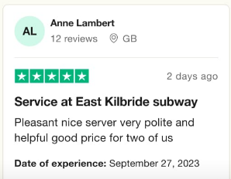

**SALES AND TRANSACTIONS: -**

American company established in 1965 by Fedrick Deluca with support of Peter Buch and also the partner of the company.

* Initial Investment - $1000(cr)

1. Worlds largest Single Brand Restaurant Chain
2. Worlds largest Restaurant operator
3. In India it comes in 2001 in New Delhi

* Franchise Fee -6.5 lakhs (INDIA)
* 12.5% Fees on Total Sales is charged per week. Total sales include 8% royalty and 4.5% advertisement Fee.
* Rs.6-8 lakhs in Interior for matching the standard of subway.
* Equipment cost- 30-50 lakhs.
* Location fees is 2-8 lakhs (In cities 8 lakhs but in tier is 2 lakhs).
* Securities fees =40k to 50k.
* Freight Charges is 45k to55k and Legal charges is 40k to 70k.
* When restaurant is opened then, advertising charges was 80k to 1.5 lakhs.
* Sign board charges- 75k and Inventory charges is 1.2-1.7 lakh, insurance charges 20-30k.
* Supply charges 20-30k and training charges around 1 lakh
* Miscellaneous charges- 50k to 2 lakhs.
* Additional capital is 3.5 to 5 lakhs.
* Investment to open a subway franchise varies from Rs 5.4 to 8.9 lakhs.

**INVENTORY AND SUPPLY CHAIN: -**

**Elements of the Supply Chain**

A simple supply chain is made up of several elements that are linked by the movement of products along it. The supply chain starts and ends with the customer.

**Customer: -** The customer starts the chain of events when they decide to purchase a product that has been offered for sale by a company. The customer contacts the sales department of the company, which enters the sales order for a specific quantity to be delivered on a specific date. If the product has to be manufactured, the sales order will include a requirement that needs to be fulfilled by the production facility.

**Planning: -** The requirement triggered by the customer’s sales order will be combined with other orders. The planning department will create a production plan to produce the products to fulfill the customer’s orders. To manufacture the products the company will then have to purchase the raw materials needed.

**Purchasing: -** The purchasing department receives a list of raw materials and services required by the production department to complete the customer’s orders. The purchasing department sends purchase orders to selected suppliers to deliver the necessary raw materials to the manufacturing site on the required date.

**Inventory: -** The raw materials are received from the suppliers, checked for quality and accuracy and moved into the warehouse. The supplier will then send an invoice to the company for the items they delivered. The raw materials are stored until they are required by the production department.

**Production: -** Based on a production plan, the raw materials are moved inventory to the production area. The finished products ordered by the customer are manufactured

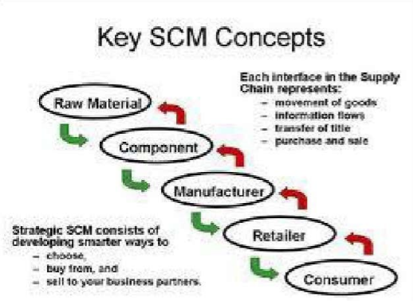

**ENVIRONMENTAL IMPACT-**

The environmental impact on the subway fast food industry refers to how subway restaurants and similar businesses affect the environment. This includes things like the use of resources (like water and energy), waste generation, and greenhouse gas emissions. Subway fast food restaurants can have both positive and negative environmental effects, depending on factors like their energy efficiency, waste management practices, and sourcing of ingredients. Efforts to reduce their environmental footprint might involve using eco-friendly materials, reducing food waste, and adopting sustainable sourcing practices.

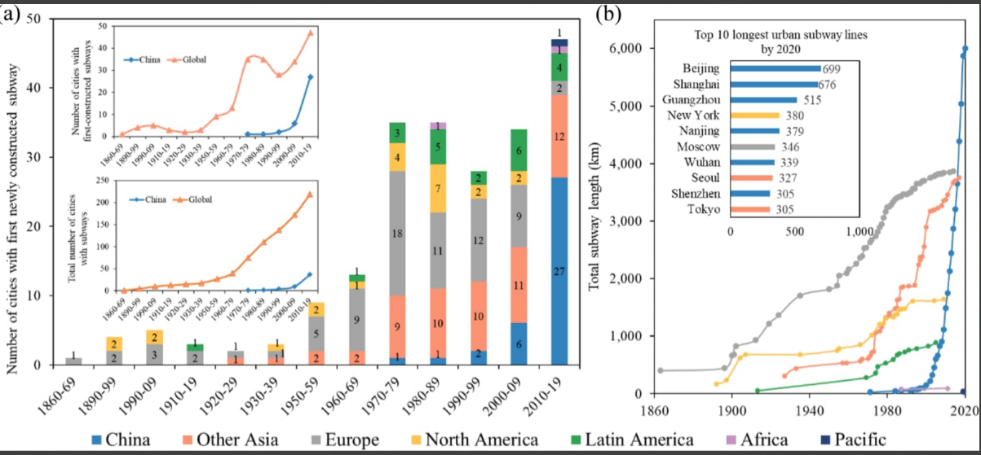

**MARKET RESEARCH: -**

Market research in the subway food industry involves studying customer preferences, competition, and trends. Key areas to explore include:

***Customer Demographics*:** Analyze the age, gender, income, and location of your target customers.

**Competitive Analysis:** Identify rival subway food chains, their offerings, pricing, and market share.

**Location Analysis:** Assess ideal locations for new outlets based on foot traffic and proximity to competitors.

**Pricing Strategy:** Determine competitive pricing that aligns with your target market.

**Marketing Channels:** Explore effective advertising and promotion strategies, including online and social media.

**Technology Integration:** Investigate digital ordering, delivery apps, and loyalty programs.

**Food Safety and Quality:** Ensure compliance with industry standards and address customer concerns.

**Growth Opportunities:** Identify untapped markets, potential partnerships, or franchise expansion.

**STRATEGIES: -**

To resolve these problems, Subway can implement several strategies:

**1-Technology Integration:** Invest in advanced POS systems, mobile ordering apps, and customer relationship management (CRM) tools to enhance the ordering process and collect valuable customer data.

2-**Menu Innovation**: Continuously update and innovate the menu to cater to changing tastes and dietary preferences. Use data analytics to identify popular items and develop new offerings.

3-**Supply Chain Optimization:** Implement data-driven supply chain management systems to minimize disruptions and ensure the availability of fresh ingredients.

4-**Sustainability Initiatives**: Develop and promote sustainable practices, such as reducing packaging waste, sourcing locally, and using renewable energy sources.

5-**Marketing and Branding**: Utilize market research data to tailor marketing campaigns and strengthen Subway's brand identity. Differentiate Subway from competitors through unique selling points.

**VALUES IT WILL BRING TO THE SOCIETY ARE: -**

Integrating technology, innovating the menu, improving supply chain management, focusing on sustainability, enhancing marketing and branding, and investing in employee training within the Subway food industry can bring several societal benefits:

**Convenience:** Technology integration can lead to faster service through online ordering and payment, making it more convenient for customers.

**Healthier** **Options**: Menu innovation can include healthier choices, contributing to improved public health.

**Reduced Environmental Impact**: Sustainability initiatives can reduce the environmental footprint of the food industry, such as using eco-friendly packaging and sourcing ingredients responsibly.

**Job Opportunities**: Employee training can provide valuable skills and job opportunities, benefitting local communities.

**Economic Growth**: A more efficient supply chain can stimulate economic growth in the regions where Subway operates.

**USER PERSONA AND USER STORY: -**

Our team will collaborate on various tasks by assigning responsibilities, setting clear goals, and maintaining open communication to ensure efficient and successful outcomes.

**Finance: - Manage by Dixit Surya and Sachin Sharma**

A finance manager in the Subway food industry would handle these strategies as follows:

Technology Integration: Manage budgets for implementing new technology solutions to improve efficiency in operations and customer experience.

**Menu Innovation:** Analyze the cost implications of introducing new menu items and assess their financial viability.

**Supply Chain Optimization:** Monitor and control costs within the supply chain, negotiate with suppliers for favorable terms, and assess the financial impact of supply chain decisions.

**Sustainability Initiative:** Allocate funds for sustainability projects and evaluate their long-term financial benefits, including cost savings and brand reputation enhancement.

**Marketing and Branding:** Allocate budgets for marketing campaigns, assess the return on investment, and ensure brand consistency while managing costs.

**Marketing: - Deepak Kumar and Adarsh Gaur**

A marketing manager in the Subway food industry would handle these strategies as follows:

**Technology Integration:** Implement digital ordering systems, mobile apps, and data analytics for customer insights.

**Innovation:** Develop new menu items based on customer preferences and dietary trends, and promote them effectively.

**Supply Chain Optimization:** Collaborate with suppliers to ensure efficient and sustainable sourcing, reducing costs and environmental impact.

**Sustainability Initiatives:** Promote Subway's commitment to sustainability through marketing campaigns and eco-friendly packaging.

**Marketing and Branding:** Create consistent branding messages that emphasize Subway's value, quality, and healthy options.

**HR: - Samriti Chauhan**

HR managers in the Subway food industry can handle these strategies as follows:

**Technology Integration:** Collaborate with IT to implement digital ordering and payment systems, and ensure employees are trained to use them effectively.

**Supply Chain Optimization:** Partner with procurement and logistics teams to streamline supply chains, ensuring timely deliveries and reducing waste.

**Sustainability Initiatives:** Develop sustainability programs, train employees on eco-friendly practices, and promote green initiatives within the company.

**Employee Training:** Create training programs for onboarding, customer service, and food safety, ensuring all employees are well-prepared.

**Continuous Improvement:** Establish processes for gathering feedback from employees and customers, and use this data to drive continuous improvement efforts.

In short, HR managers play a pivotal role in aligning human resources with these strategic initiatives, from training and development to fostering a culture of innovation and sustainability.

**Operations and supply chain management: -** **Yuvraj**

An operation and supply chain management manager in the Subway food industry can handle these strategies as follows:

**Technology Integration:** Embrace digital tools for inventory management, ordering systems, and data analytics to streamline operations and enhance customer experience.

**Supply Chain Optimization:** Implement efficient sourcing, distribution, and inventory control systems to reduce costs and ensure fresh ingredients.

**Sustainability Initiatives:** Source eco-friendly packaging, implement waste reduction measures, and seek sustainable sourcing options for ingredients.

**Marketing and Branding:** Coordinate marketing campaigns to promote Subway's unique offerings and values, focusing on health-conscious choices and freshness.

In summary, the manager should leverage technology, foster innovation, optimize the supply chain, promote sustainability, drive marketing efforts, invest in employee training, and prioritize continuous improvement to succeed in the Subway food industry.

**Research and Development: - Ankit**

**Physical Evidence:**

For a restaurant brand like Subway, its main physical evidence are its stores. Subway has more than 35,000 stores spread across the world. The ambience at the stores, the staff, location, maintenance etc. form the physical evidence of the brand.

**Primary research:**

The primary research which is used by Subway consists of online surveys which measure their customers' satisfaction when they visit Subway stores. Other primary research for Subway consists of their FAQ's which allows customers to ask Subway questions that they may have.

**Health and Nutrition:**

Keeping abreast of health and nutrition trends and developing menu options that cater to customers seeking healthier choices.

**Operational Efficiency:**

Optimizing store layouts, staffing models, and supply chain logistics to reduce costs and improve service speed.

**WIREFRAME:-**

**Creating a wireframe for our app involves sketching out the basic layout and structure of the user interface. Here's a textual and visual representation of a wireframe for our app:**

**1. Header:**

* Navigation Menu: Home, Menu, Specials, About Us, Contact Us.
* User Account: Login/Register buttons.
* Cart Icon: Indicating the number of items in the cart.

**2. Hero Section:**

* High-quality image or video slider showcasing popular food items.
* Catchy tagline or promotional text.
* Call-to-Action (CTA) button leading to the menu or ordering page.

**3. Menu Section:**

* Categories: Burgers, Pizzas, Drinks, Desserts, etc.
* List of food items under each category with prices.
* Add to Cart buttons for each item.

**4. Specials or Featured Items:**

* Display special offers, limited-time promotions, or new menu items.
* Images, descriptions, and prices for each special item.
* CTA buttons for quick ordering.

**5. About Us Section:**

* Brief information about the restaurant, its history, and values.
* Images of the restaurant or team members.
* Mission statement or commitment to quality.

**6. Contact Us Section:**

* Contact Form: Name, Email, Phone, Message.
* Address of the restaurant with a map.
* Social Media Links: Facebook, Twitter, Instagram.

**7. Footer:**

* Additional Navigation Links: Terms of Service, Privacy Policy, FAQs.
* Copyright information and year.
* Links to download the restaurant's mobile app (if applicable).

**8. Additional Features (Optional):**

* User Reviews and Ratings.
* Online Ordering System: Step-by-step process for placing an order.
* Loyalty Program Information.
* Blog or News Section: Updates about the restaurant, recipes, or food-related articles. Top of Form

