Document Object Model

The **document object** represents the whole html document.

When html document is loaded in the browser, it becomes a document object. It is the **root element** that represents the html document. It has properties and methods. By the help of document object, we can add dynamic content to our web page.

As mentioned earlier, it is the object of window. So

window.document

Is same as

document

According to W3C - *"The W3C Document Object Model (DOM) is a platform and language-neutral interface that allows programs and scripts to dynamically access and update the content, structure, and style of a document."*

## **Properties of document object**

Let's see the properties of document object that can be accessed and modified by the document object.

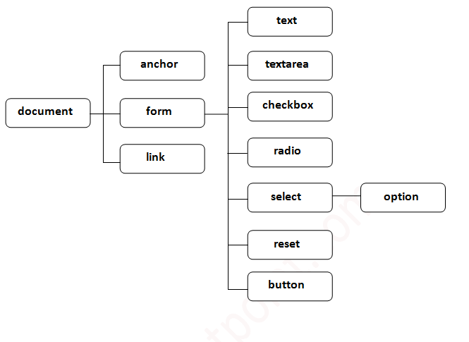

## **Methods of document object**

We can access and change the contents of document by its methods.

|  |  |
| --- | --- |
| **Method** | **Description** |
| write("string") | writes the given string on the doucment. |
| writeln("string") | writes the given string on the doucment with newline  character at the end. |
| getElementById() | returns the element having the given id value. |
| getElementsByName() | returns all the elements having the given name value. |
| getElementsByTagName() | returns all the elements having the given tag name. |
| getElementsByClassName() | returns all the elements having the given class name. |

The important methods of document object are as follows:

In this example, we are going to get the value of input text by user. Here, we are using **document.form1.name.value** to get the value of name field.

Here, **document** is the root element that represents the html document.

**form1** is the name of the form.

**name** is the attribute name of the input text.

**value** is the property, that returns the value of the input text.

Let's see the simple example of document object that prints name with welcome message.

Eg:

**<script** type="text/javascript"**>**

function printvalue(){

var name=document.form1.name.value;

alert("Welcome: "+name);

}

**</script>**

**<form** name="form1"**>**

Enter Name:**<input** type="text" name="name"**/>**

**<input** type="button" onclick="printvalue()" value="print name"**/>**

**</form>**

# Javascript - document.getElementById() method

The **document.getElementById()** method returns the element of specified id.

In the previous page, we have used **document.form1.name.value** to get the value of the input value. Instead of this, we can use document.getElementById() method to get value of the input text. But we need to define id for the input field.

Eg

**<script** type="text/javascript"**>**

function getcube(){

var number=document.getElementById("number").value;

alert(number*number*number);

}

**</script>**

**<form>**

Enter No:**<input** type="text" id="number" name="number"**/><br/>**

**<input** type="button" value="cube" onclick="getcube()"**/>**

**</form>**

# Javascript - document.getElementsByName() method

The **document.getElementsByName()** method returns all the element of specified name.

The syntax of the getElementsByName() method is given below:

document.getElementsByName("name")

Here, name is required.

### **Example of document.getElementsByName() method**

In this example, we going to count total number of genders. Here, we are using getElementsByName() method to get all the genders.

**<script** type="text/javascript"**>**

function totalelements()

{

var allgenders=document.getElementsByName("gender");

alert("Total Genders:"+allgenders.length);

}  **</script>**

**<form>**

Male:**<input** type="radio" name="gender" value="male"**>**

Female:**<input** type="radio" name="gender" value="female"**>**

**<input** type="button" onclick="totalelements()" value="Total Genders"**>**

**</form>**

# Javascript - document.getElementsByTagName() method

The **document.getElementsByTagName()** method returns all the element of specified tag name.

The syntax of the getElementsByTagName() method is given below:

document.getElementsByTagName("name")

Here, name is required.

### **Example of document.getElementsByTagName() method**

In this example, we going to count total number of paragraphs used in the document. To do this, we have called the document.getElementsByTagName("p") method that returns the total paragraphs.

**<script** type="text/javascript"**>**

function countpara(){

var totalpara=document.getElementsByTagName("p");

alert("total p tags are: "+totalpara.length);

}

**</script>**

**<p>**This is a pragraph**</p>**

**<p>**Here we are going to count total number of paragraphs by getElementByTagName() method.**</p>**

**<p>**Let's see the simple example**</p>**

**<button** onclick="countpara()"**>**count paragraph**</button>**

### **Another example of document.getElementsByTagName() method**

In this example, we going to count total number of h2 and h3 tags used in the document.

**<script** type="text/javascript"**>**

function counth2(){

var totalh2=document.getElementsByTagName("h2");

alert("total h2 tags are: "+totalh2.length);

}

function counth3(){

var totalh3=document.getElementsByTagName("h3");

alert("total h3 tags are: "+totalh3.length);

}

**</script>**

**<h2>**This is h2 tag**</h2>**

**<h2>**This is h2 tag**</h2>**

**<h3>**This is h3 tag**</h3>**

**<h3>**This is h3 tag**</h3>**

**<h3>**This is h3 tag**</h3>**

**<button** onclick="counth2()"**>**count h2**</button>**

**<button** onclick="counth3()"**>**count h3**</button>**

#### **Note: Output of the given examples may differ on this page because it will count the total number of para , total number of h2 and total number of h3 tags used in this document.**

# Javascript - innerHTML

The **innerHTML** property can be used to write the dynamic html on the html document.

It is used mostly in the web pages to generate the dynamic html such as registration form, comment form, links etc.

### **Example of innerHTML property**

In this example, we are going to create the html form when user clicks on the button.

In this example, we are dynamically writing the html form inside the div name having the id mylocation. We are identifing this position by calling the document.getElementById() method.

**<script** type="text/javascript" **>**

function showcommentform() {

var data="Name:**<input** type='text' name='name'**><br>**Comment:**<br><textarea** rows='5' cols='80'**></textarea>**

**<br><input** type='submit' value='Post Comment'**>**";

document.getElementById('mylocation').innerHTML=data;

}

**</script>**

**<form** name="myForm"**>**

**<input** type="button" value="comment" onclick="showcommentform()"**>**

**<div** id="mylocation"**></div>**

**</form>**

### **Show/Hide Comment Form Example using innerHTML**

<!DOCTYPE html**>**

**<html>**

**<head>**

**<title>**First JS**</title>**

**<script>**

var flag=true;

function commentform(){

var cform="**<form** action='Comment'**>**Enter Name:**<br><input** type='text' name='name'**/><br/>**

Enter Email:**<br><input** type='email' name='email'**/><br>**Enter Comment:**<br/>**

**<textarea** rows='5' cols='70'**></textarea><br><input** type='submit' value='Post Comment'**/></form>**";

if(flag){

document.getElementById("mylocation").innerHTML=cform;

flag=false;

}else{

document.getElementById("mylocation").innerHTML="";

flag=true;

}

}

**</script>**

**</head>**

**<body>**

**<button** onclick="commentform()"**>**Comment**</button>**

**<div** id="mylocation"**></div>**

**</body>**

**</html>**

# Javascript - innerText

The **innerText** property can be used to write the dynamic text on the html document. Here, text will not be interpreted as html text but a normal text.

It is used mostly in the web pages to generate the dynamic content such as writing the validation message, password strength etc.

## **Javascript innerText Example**

In this example, we are going to display the password strength when releases the key after press.

**<script** type="text/javascript" **>**

function validate() {

var msg;

if(document.myForm.userPass.value.length**>**5){

msg="good";

}

else{

msg="poor";

}

document.getElementById('mylocation').innerText=msg;

 }

**</script>**

**<form** name="myForm"**>**

**<input** type="password" value="" name="userPass" onkeyup="validate()"**>**

Strength:**<span** id="mylocation"**>**no strength**</span>**

**</form>**