**AKS Cluster:**

**Azure DNS Zone:**

Deployed external DNS on aks cluster to automatically update the DNS records to Azure DNS zone

External DNS pod logs:

**Let's Encrypt:**

Certificates which are generated automatically using let’s encrypt

Cert manager logs:

**Hasicorp vault:**

**Monitoring**

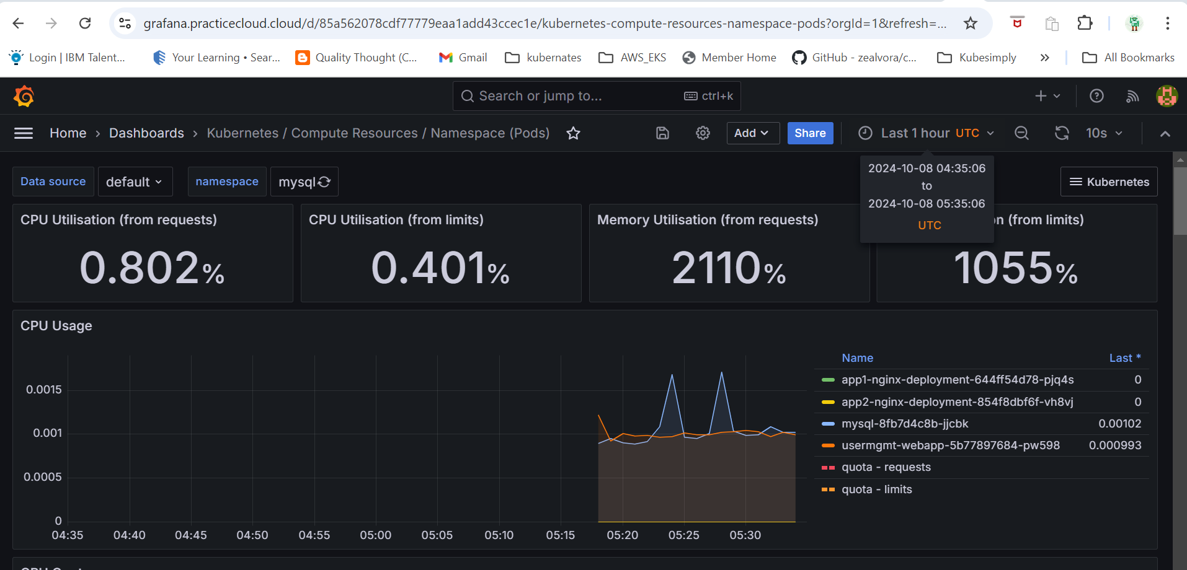

**Application deployed with SSL enable using Ingress and let’s encrypt**

