# Project tracking in github

I’d like to track our projects with github repositories, issues and projects

So, everyone please follow the instructions as follows:

* YunZhe
  + Create the kindy management repository. Add an issue for requirement specification
* Xuan
  + Create a repository for Katas and MCC prep
* Alimi
  + Create repo and issues for the 26th teaching event. Add an issue for LinkedIn accounts
* Lewis
  + Create a repository for your android project. Add the links and whatever info you have
* Arian
  + Create a repository for the skillshare newsletter project. Add links for the course you are using

## Creating the repository

1. Sign into github
2. Go to ‘Your repositories’

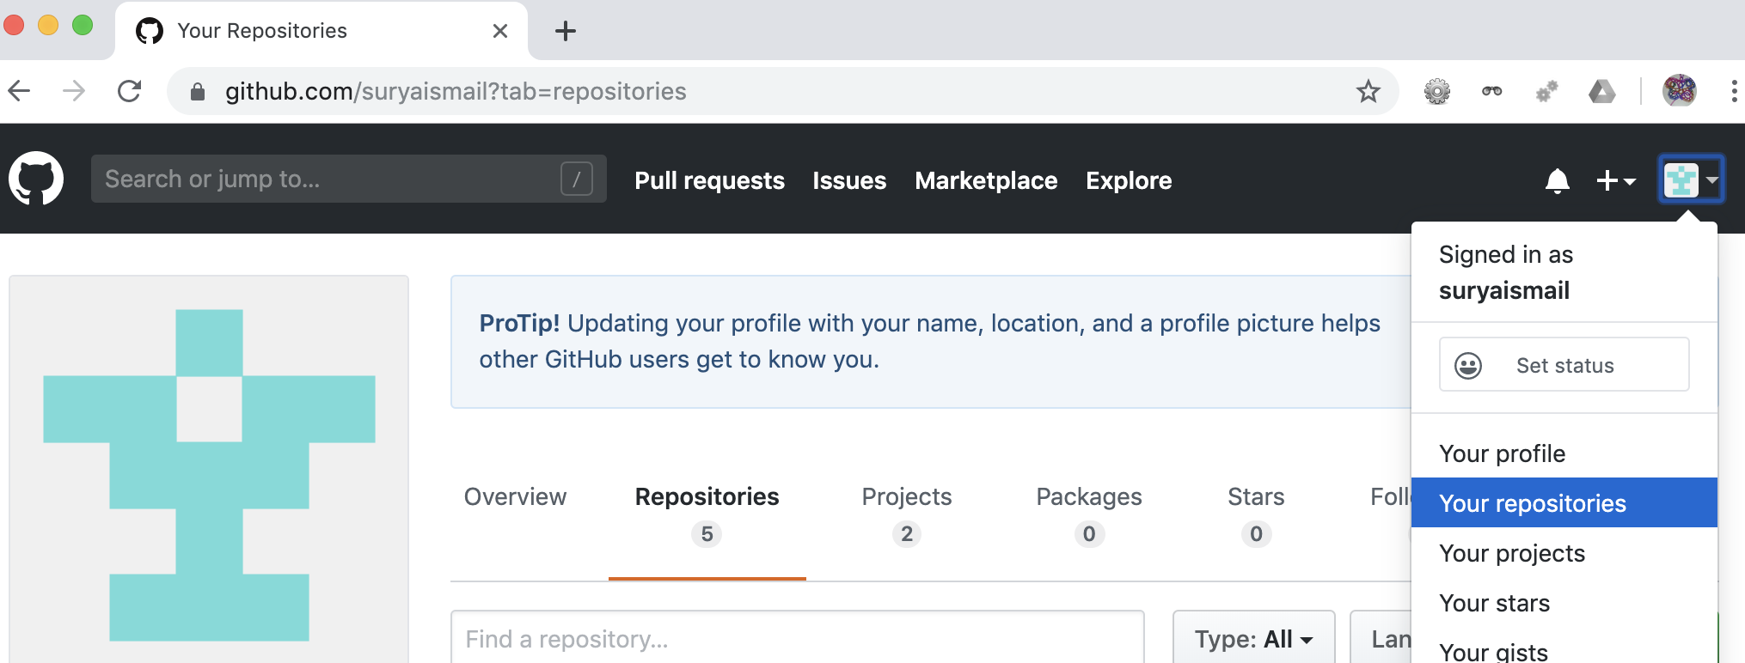

1. Create a new repository
   1. Make it public
   2. Add a description
   3. Edit the README with project details

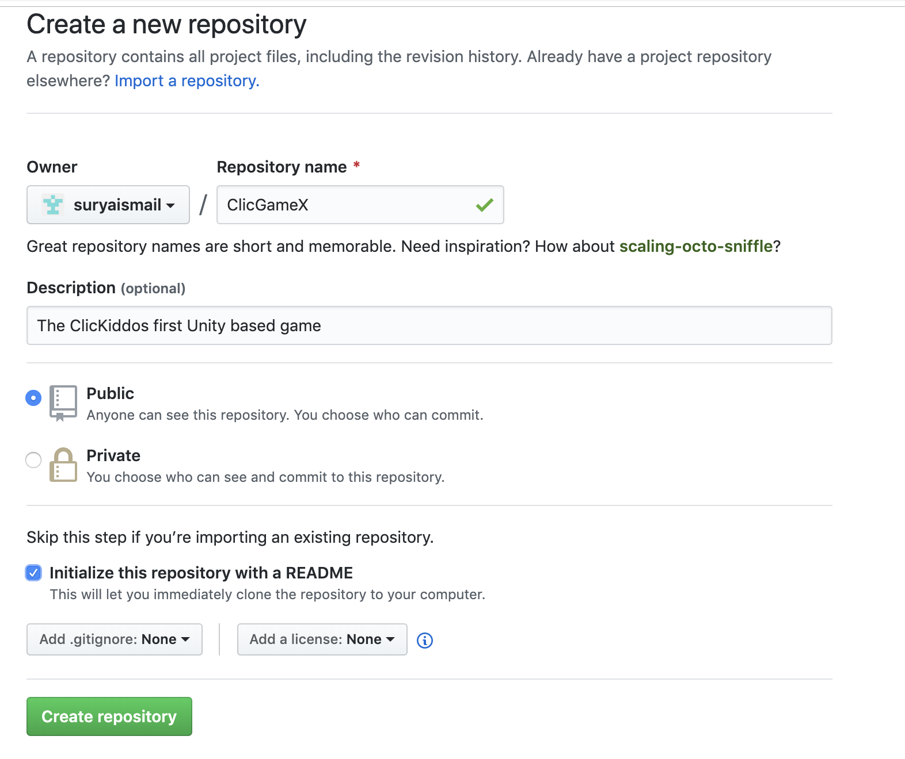

1. Edit the README. Add LOTS of details

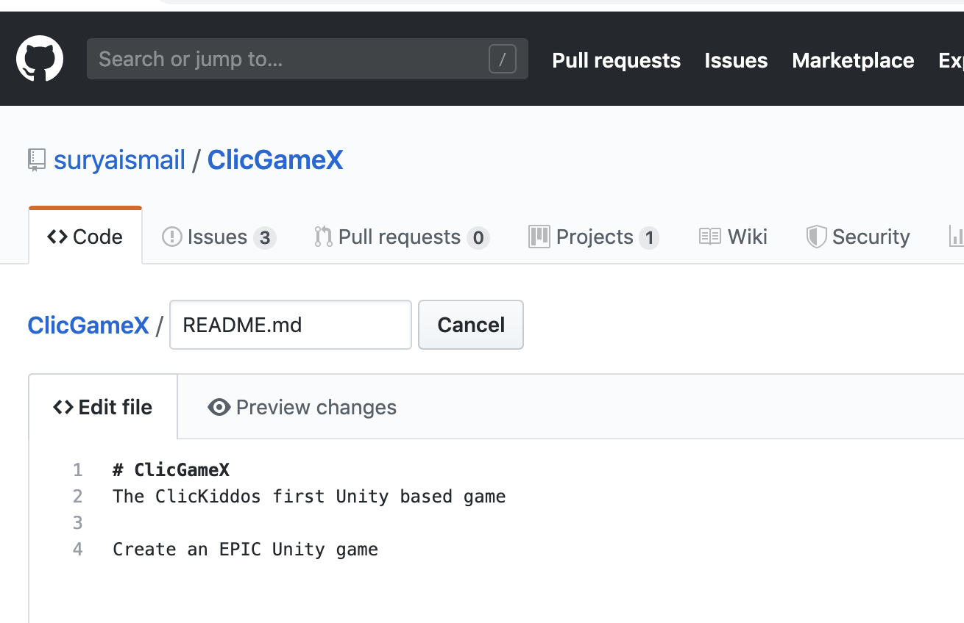

## Adding issues

1. Click on the issues tab, then click on ‘New issue’

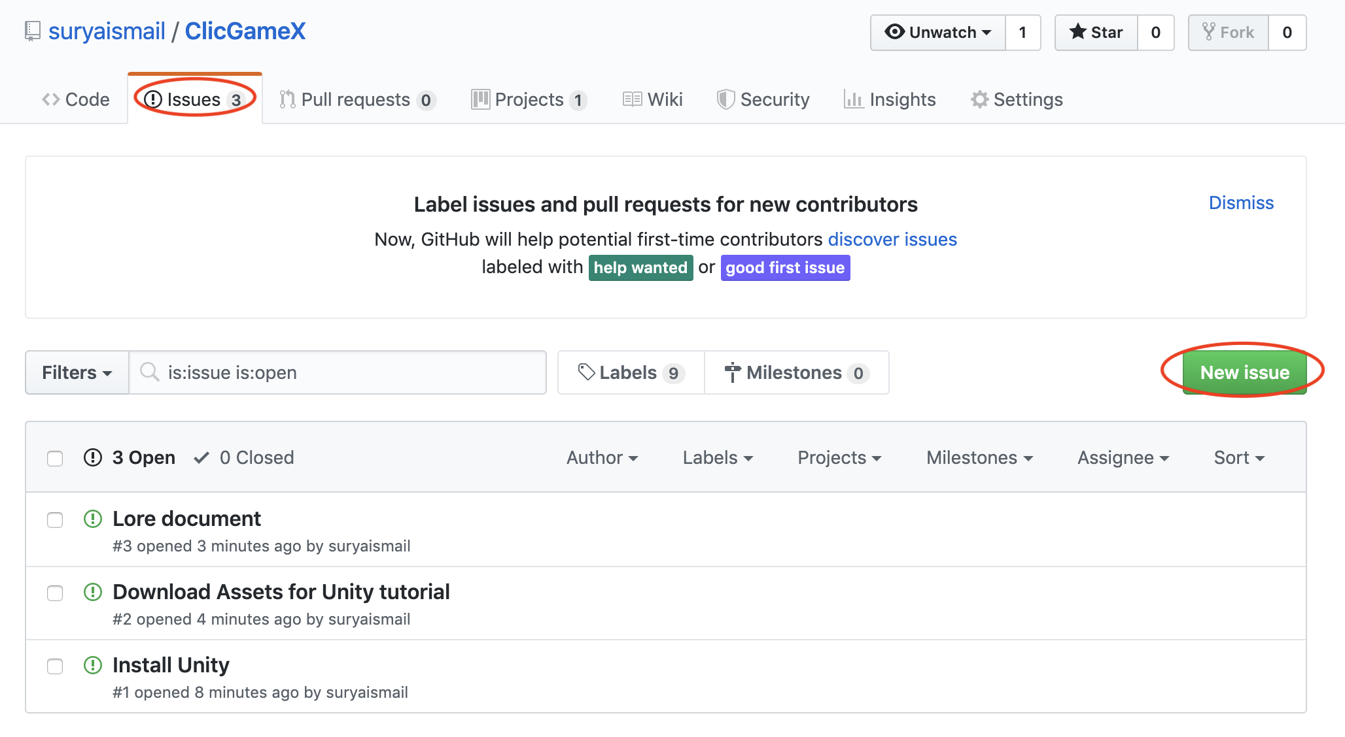

1. Create your issue, adding lots of details

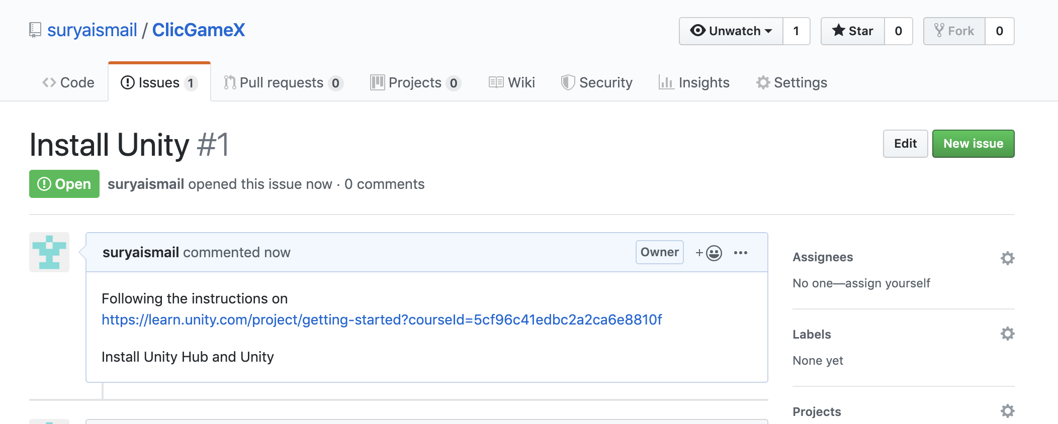

1. Create more issues

# Creating a project

1. Click on the ‘Projects’ tab and create a ‘New project’

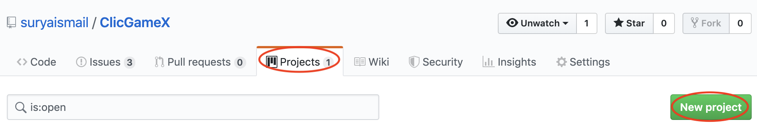

1. Add in the details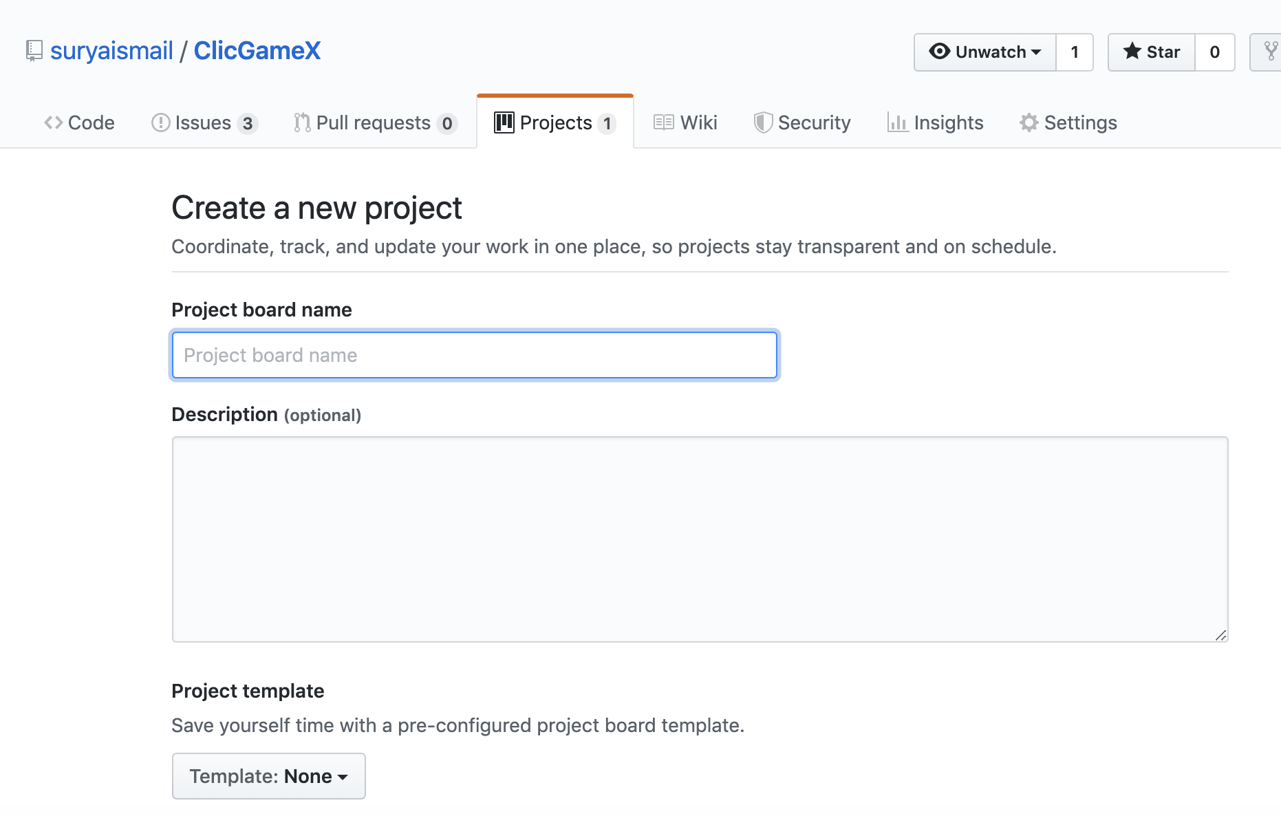
2. Add columns to your project to organize things. You don’t have to use the same column names I used.

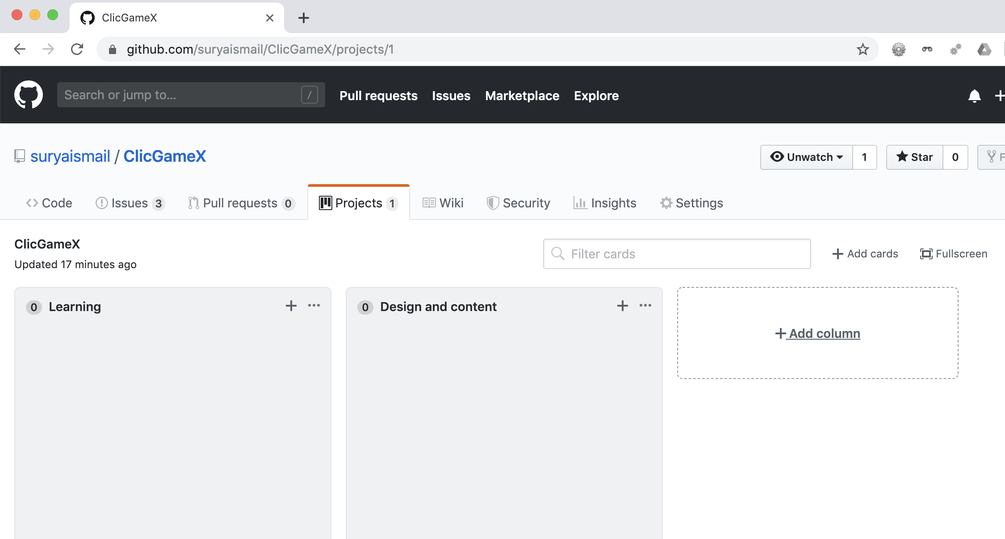

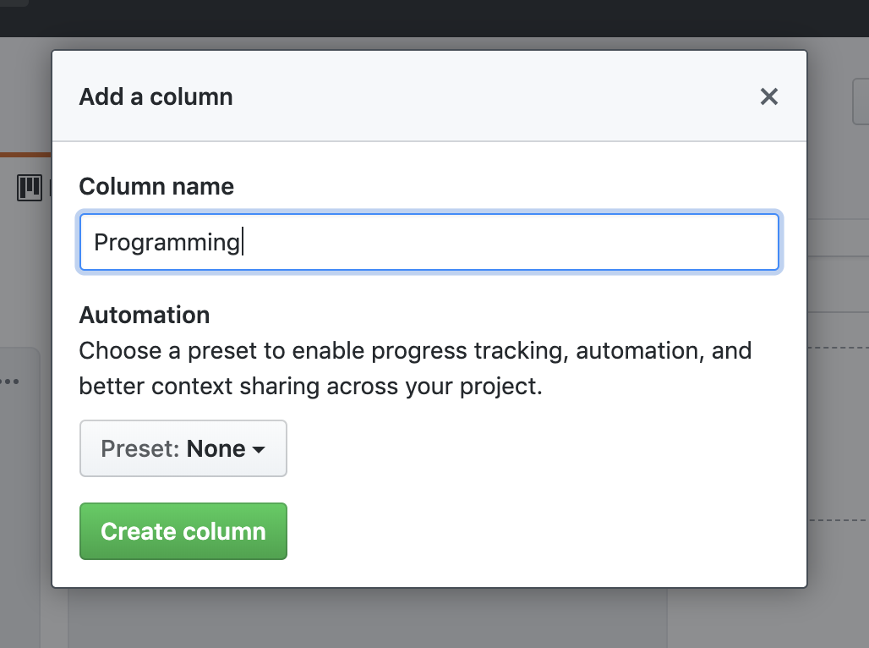

1. Cards are the issues we created earlier. Click on add cards, then drag them to the columns to organize them.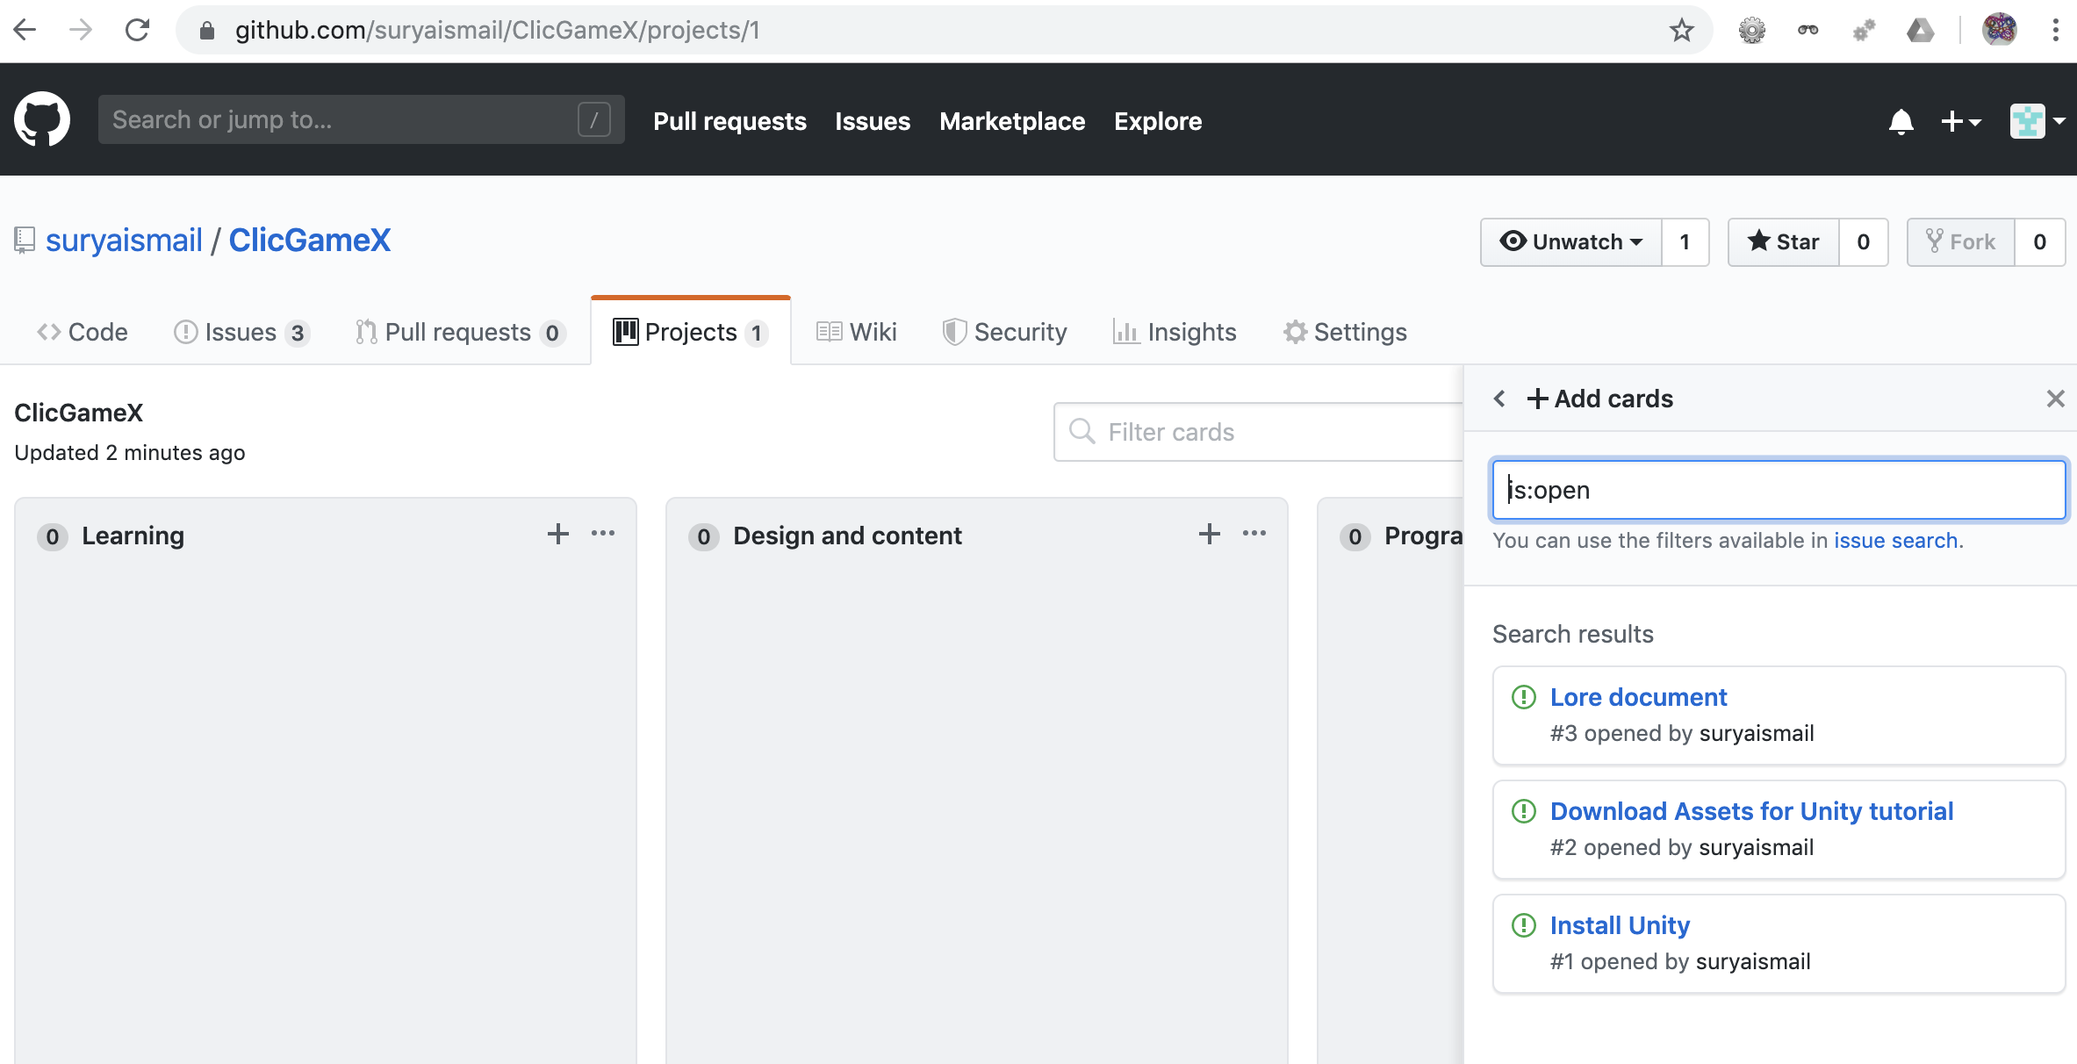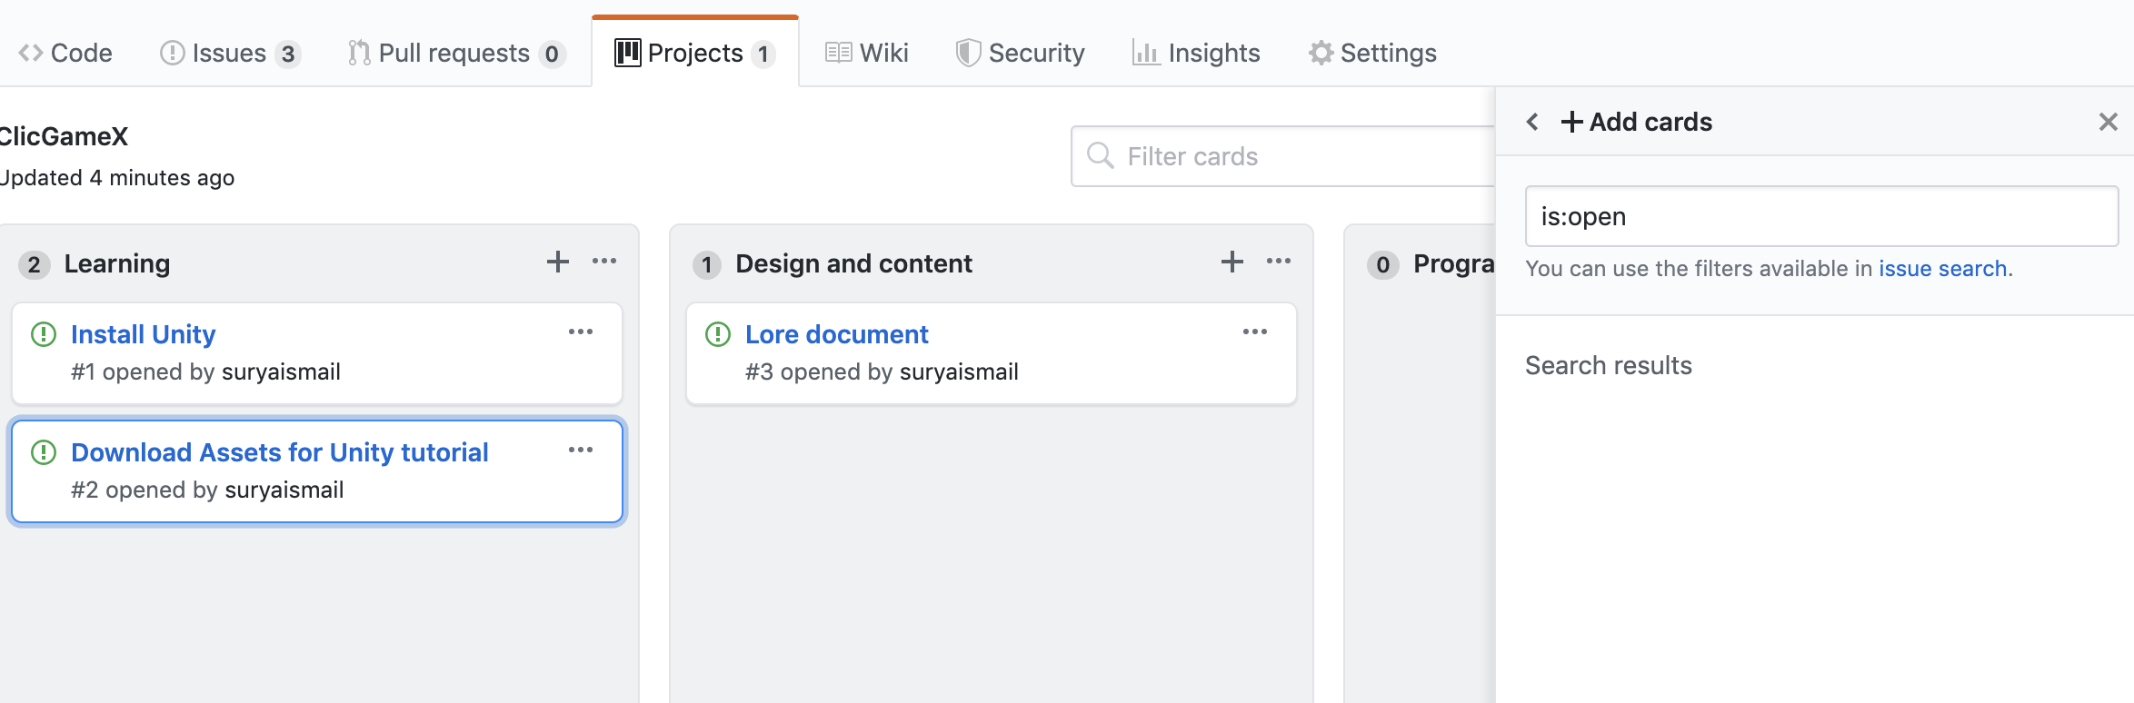

## Add collaborators

1. Click on the ‘Settings’ tab, the select ‘Collaborators’

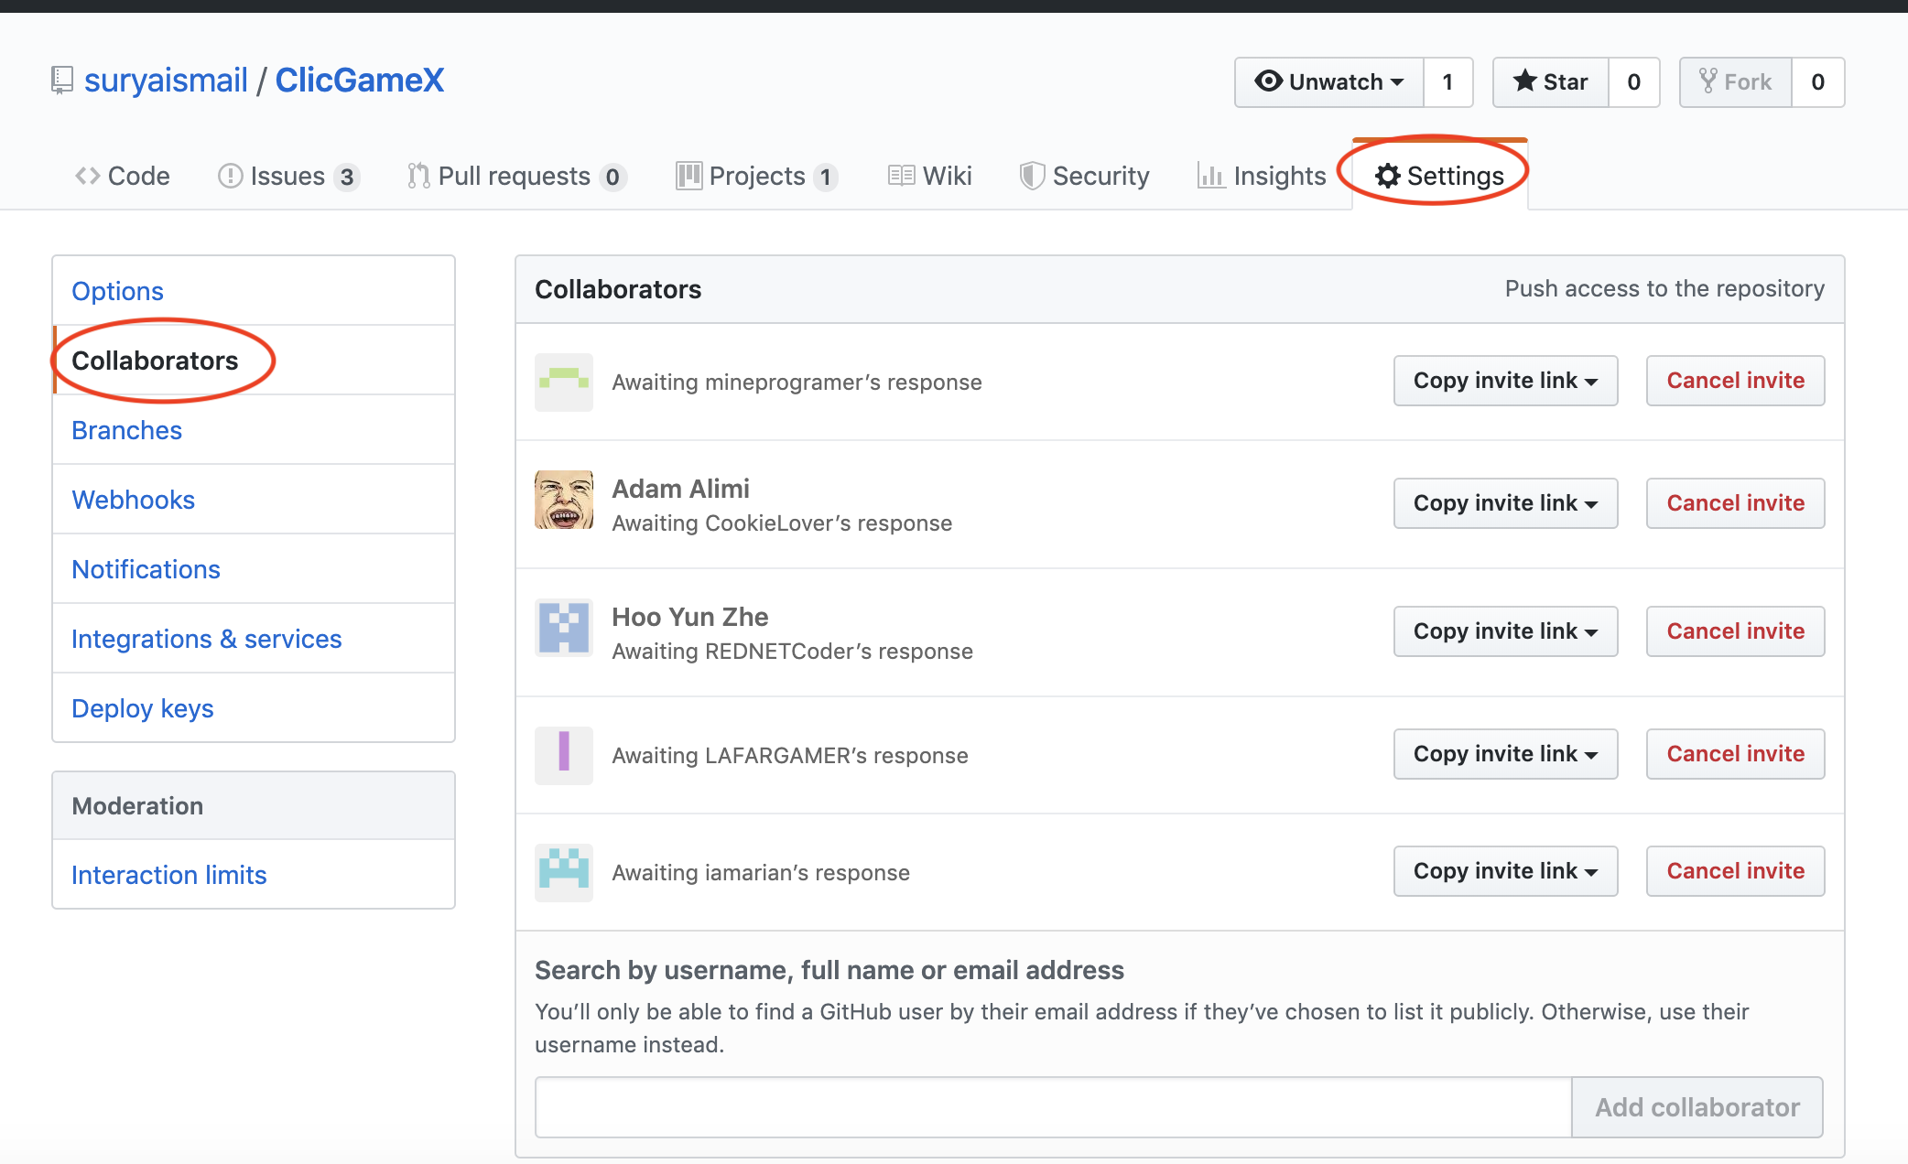

1. Add all of us as collaborators

suryaismail

mineprogramer

Adam Alimi

REDNETCoder

LAFARGAMER

iamarian