SAFETY ASSESSMENT HEXAPOD ROBOT FOR CAVE AND MINE INSPECTION

Dr. T.J. Jeyaprabha, Associate Professor
Electronics and Communication engineering
Sri Venkateswara College Of Engineering
Sriperumbudur,Kancheepuram,India jprabha@svce.ac.in
Balasaraswathy B
Electronics and Communication engineering
Sri Venkateswara college of engineering
Sriperumbudur,Kancheepuram,India 2022ec0039@svce.ac.in
Harinee VT
Electronics and Communication engineering
Sri Venkateswara college of engineering
Sriperumbudur,Kancheepuram,India 2022ec0425@svce.ac.in

Haresh Krishna GS
Electronics and Communication engineering
Sri Venkateswara college of engineering
Sriperumbudur,Kancheepuram,India 2022ec0458@svce.ac.in

Abstract— Underground mining environments present severe safety challenges due to hazardous gases, unpredictable terrain, and limited communication infrastructure. The need for real-time monitoring and timely detection of threats is critical to ensuring worker safety. This project addresses these challenges by developing a hexapod robot capable of navigating rough surfaces while continuously monitoring gas levels, mapping distances, and capturing visual data. Equipped with Zigbee communication, the robot transmits real-time information to users via a dedicated webpage, ensuring functionality in areas without internet connectivity. Powered by a LiPo battery for extended operations, the robot offers a proactive solution for improving situational awareness and enhancing safety protocols in hazardous underground settings.
Keywords- Hexapod Robot, Mine Safety, Gas Detection, Real-Time Monitoring, Zigbee Communication, Autonomous Navigation
I. Introduction
The mining industry, particularly underground mining, poses significant safety risks due to its challenging and unpredictable environments. The Chasnala mining disaster of 1975, which resulted in the tragic loss of 372 lives due to a methane gas explosion, highlights the critical need for improved safety measures in mining operations. According to the International Labour Organization, approximately 13,000 miners lose their lives annually due to accidents and hazardous conditions, with around 70% of these incidents attributed to gas-related hazards, cave-ins, and equipment failures.
Despite advancements in mining technology, traditional safety methods, such as manual inspections and basic gas monitoring, remain inadequate for preventing accidents in these environments. A survey conducted by the Mining Safety Association found that nearly 60% of miners reported delays in hazard detection due to insufficient monitoring systems. This underscores the urgent need for innovative solutions that can enhance safety protocols and provide timely information in underground operations.
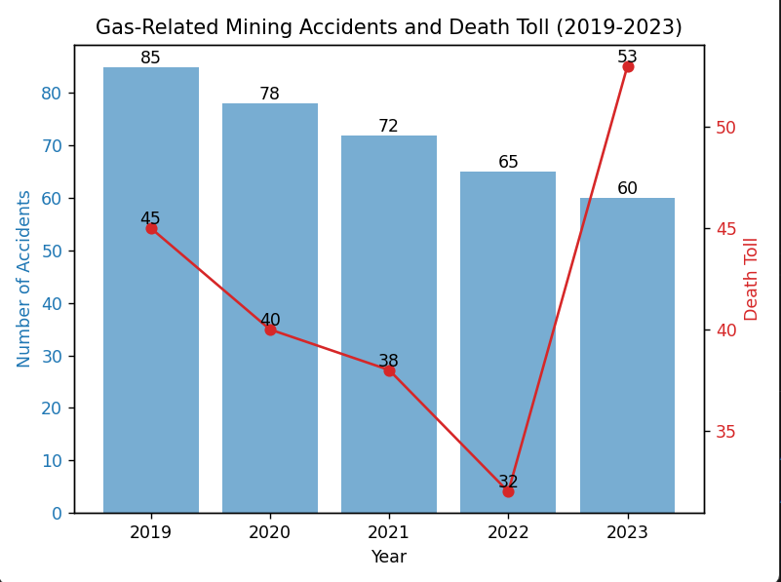
Fig.1 Statistics of accidents in coal mines

To address these challenges, this project proposes the development of a hexapod robot capable of traversing rough and uneven mining surfaces. Equipped with advanced sensors for gas detection, distance mapping, and visual capture, the robot will ensure continuous monitoring and real-time data transmission through Zigbee communication. This approach aims to improve situational awareness and emergency response in hazardous environments, ultimately enhancing the safety of mining operations.
II. Literature- survey
Hexapod Robots for Hazardous Environment Monitoring: Hexapod robots are increasingly utilized for exploring and monitoring hazardous environments, such as mining sites. These robots navigate rough terrain and gather critical data in unsafe areas. Existing hexapod systems often face limitations in payload capacity and sensor range, affecting data accuracy. Our hexapod project overcomes these limitations by incorporating advanced sensors for gas detection, distance mapping, and visual capture, ensuring comprehensive environmental monitoring in real time.
Robotic Solutions for Gas Detection in Mines: Several robotic systems have been developed for gas detection in underground mining operations, utilizing gas sensors and mapping technologies to identify hazardous conditions. While effective, many systems struggle with reliable communication in environments lacking Wi-Fi or cellular connectivity. Our hexapod robot employs Zigbee communication technology, enabling it to transmit real-time data even in remote areas, thus improving safety protocols without relying on conventional network infrastructure.
Autonomous Vehicles for Hazard Monitoring: Research on autonomous ground vehicles has demonstrated their potential for environmental monitoring. These vehicles often include gas detectors, cameras, and temperature sensors to assess hazards. However, their complexity and high implementation costs limit their use in mining. Our hexapod project focuses on a cost-effective design, leveraging off-the-shelf components while maintaining functionality and adaptability to various terrains, making it more accessible for mining operations.
Robotic Systems with Zigbee Communication: Recent advancements in robotic systems that use Zigbee technology for remote monitoring have shown promise. These systems transmit environmental data reliably, yet they often lack the ability to navigate complex terrains autonomously. Our hexapod robot's design integrates advanced locomotion capabilities, enabling it to traverse uneven cave surfaces while simultaneously sending real-time data to a central monitoring station.
Sensor- Integrated Wearable Technologies :Although primarily focused on personal safety, sensor-integrated wearable technologies offer insights into environmental monitoring. Existing wearable devices can track physiological parameters but often lack robust environmental sensors. By embedding advanced sensors within our hexapod robot, we ensure comprehensive monitoring of both environmental and gas levels, enhancing situational awareness and response capabilities in hazardous conditions.

III. Proposed system
The proposed hexapod robot is engineered for effective monitoring of hazardous environments in mining operations. It is equipped with an MQ-2 gas sensor for detecting hazardous gas concentrations, along with ultrasonic, infrared (IR), and LiDAR sensors for distance mapping and environmental analysis. These advanced sensors enable the robot to navigate rough terrain while gathering critical data. Utilizing Zigbee communication, the robot transmits real-time information about environmental conditions to a central monitoring station. One Zigbee module is placed on the hexapod while another is worn by the worker or located at a central point, allowing for effective communication over segmented distances. This setup ensures reliable connectivity even in remote areas without Wi-Fi. Its cost-effective design employs readily available components, making it accessible for mining applications. With robust locomotion capabilities, the hexapod can access difficult-to-reach areas, continuously monitoring environmental parameters to identify and respond to hazardous conditions promptly.
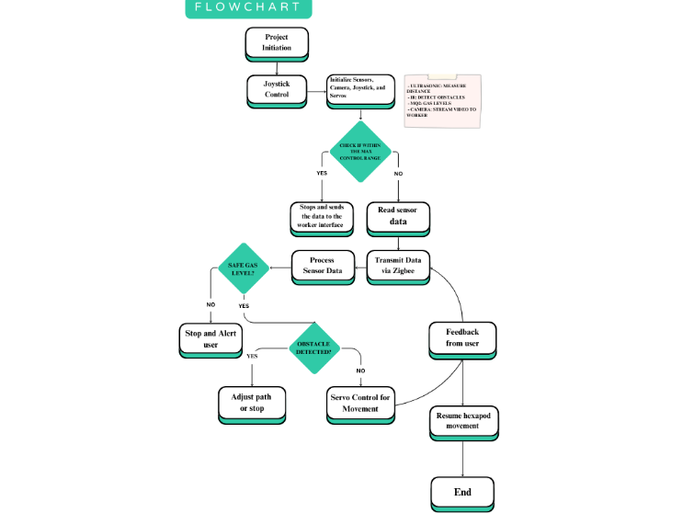
Fig.2 Workflow

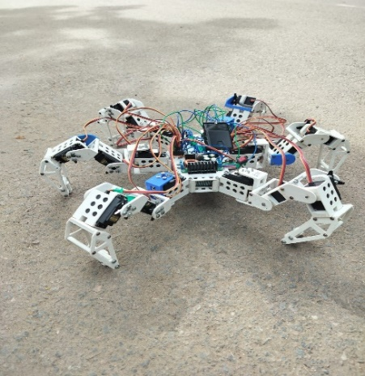
Fig.3 Hexapod structur

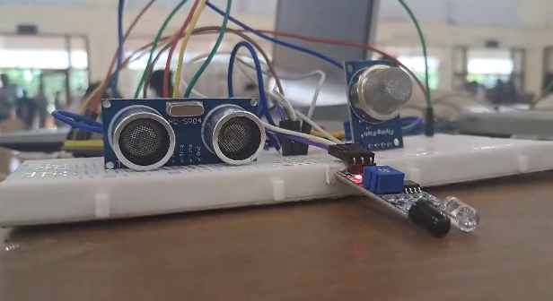
Fig.4 Sensor setup

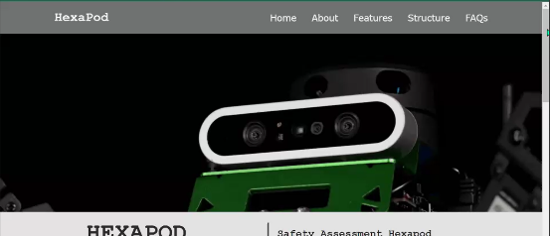
Fig.5 User interface

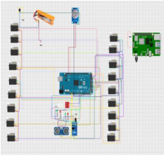
Fig.6 Circuit Diagram

IV. System Description
MQ-2 Gas Sensor
Monitors concentrations of various gases, including methane and propane, to ensure worker safety by detecting hazardous levels.
Ultrasonic Sensor
Measures distance to obstacles, aiding in navigation and obstacle avoidance in complex environments..

Infrared (IR) Sensor
Detects obstacles and measures proximity, enhancing the robot’s ability to navigate tight spaces.
LiDAR Sensor
Provides high-resolution distance mapping and environmental scanning, creating accurate 3D maps of the terrain

Zigbee Communication Module
Facilitates real-time data transmission to a central monitoring station, ensuring continuous connectivity even in remote locations. The dual-module setup allows communication over segmented distances, enhancing the robustness of the system.
Arduino Mega 2560 Microcontroller
The Arduino Mega serves as the central controller for the hexapod, processing sensor data, managing servo movements, and handling communication with other components like the Zigbee and sensors to execute tasks efficiently during inspections.
Locomotion Mechanism
Enables the hexapod to traverse uneven and challenging terrain, enhancing its operational capability in hazardous environments.
Power Supply (LiPo Battery)
Provides reliable and extended power for the robot's operations, ensuring prolonged functionality in the field.
PS2 wireless controller and receiver
The PS2 controller is used to remotely control the hexapod, allowing manual navigation and movement adjustments in real-time during cave and mine inspections.

V. Uniqueness
1)Comprehensive Environmental Monitoring: Equipped with multiple sensors—including MQ-2, ultrasonic, IR, and LiDAR—the robot provides a multifaceted approach to monitoring, ensuring accurate detection of gas levels and real-time mapping of its surroundings.

2)Reliable Communication in Remote Areas: Utilizing Zigbee technology, the hexapod ensures consistent data transmission even in areas lacking Wi-Fi or cellular connectivity, enhancing safety protocols in isolated mining environments.

3)Real-Time Data Analysis: The robot continuously monitors and transmits environmental data to a central station, allowing for prompt decision-making and immediate response to hazardous conditions.

4) Cost-Effective and Modular Design: The use of off-the-shelf components not only reduces costs but also allows for easy upgrades, making the hexapod adaptable for various monitoring needs in different environments..

VI. Advantages/Disadvantages
Advantages
The hexapod robot enhances safety in hazardous environments by autonomously navigating rough terrain and monitoring air quality, thereby minimizing risks to human workers. Its integration of advanced sensors, including gas detection and distance mapping, ensures comprehensive data collection and real-time situational awareness. The use of Zigbee communication allows for reliable data transmission even in remote areas, facilitating prompt response to detected hazards. Additionally, the robot’s cost-effective design makes it accessible for various mining operations, improving safety protocols without requiring extensive infrastructure.
Disadvantages
The hexapod may encounter challenges related to battery life, potentially limiting its operational time in the field. While designed for rugged terrain, its mobility may be affected by extremely uneven surfaces or obstacles, which could hinder effective navigation. Maintenance of the robot is crucial, as wear and tear on components can impact functionality. Additionally, reliance on technology raises concerns regarding system failures or malfunctions during critical monitoring tasks, which could compromise safety measures.

VII. Use-Cases
1)Mining Workers: The hexapod enhances safety by monitoring gas levels and environmental conditions, alerting workers to hazardous situations, and allowing them to evacuate safely.
2)Mine Safety Personnel: Safety officers can use real-time data from the hexapod to assess conditions in the mine, enabling informed decision-making and improving emergency response protocols.
3)Mining Operations Managers: The robot provides valuable insights into environmental hazards, helping managers implement better safety measures and optimize operational efficiency.
4)Rescue Teams: In the event of an emergency, rescue teams can deploy the hexapod to locate trapped workers and assess dangerous conditions, improving the chances of successful rescue operations.
5)Regulatory Authorities: The data collected by the hexapod supports compliance with safety regulations and standards, providing evidence for audits and inspections to ensure mining operations adhere to legal requirements..

VII. Future-Scope
The future scope of the hexapod project includes integrating more advanced sensors, such as thermal imaging and multi-gas detection capabilities, to enhance environmental monitoring and hazard identification in mining operations. Improving navigation algorithms will enable the robot to maneuver more effectively through complex terrains, increasing its operational efficiency. Additionally, incorporating machine learning techniques could allow the hexapod to analyze environmental data for predictive insights, improving safety measures before hazards arise. Exploring autonomous charging solutions will ensure prolonged field operations without the need for manual recharging, enhancing the robot's reliability in remote mining sites..

VIII. Conclusion
In conclusion, the development of the hexapod robot marks a significant advancement in environmental monitoring technology, particularly in hazardous mining operations. By integrating a suite of sensors, including gas detection, ultrasonic, infrared, and LiDAR, the robot effectively identifies and responds to potential dangers in real-time. Its robust Zigbee communication system ensures reliable data transmission to monitoring stations, enhancing situational awareness and safety protocols. This innovation aims to improve safety for mining personnel by facilitating immediate responses to hazardous conditions, ultimately reducing risks associated with underground operations. As the project evolves, further enhancements and integration with emerging technologies could broaden its applications, providing more comprehensive solutions for monitoring and safety in challenging environments..

IX. Acknowledgement
We would like to express our heartfelt gratitude to our professor, Dr. T.J. Jeyaprabha, for her invaluable guidance, support, and encouragement throughout the development of the hexapod robot project. Her expertise and insights have been instrumental in shaping our approach and enhancing our understanding of the technologies involved. We are also thankful to Sri Venkateswara College of Engineering for providing the resources and supportive environment that facilitated our research. Additionally, we extend our appreciation to the authors of various research papers that provided foundational knowledge and inspiration for our work. Lastly, we extend our deepest appreciation to our families for their unwavering support and understanding throughout this journey.

X. References

[1] Spider Bot – A Quadruped Robot for Data Gathering:https://www.researchgate.net/publication/366578699_Spider_Bot__A_Quadruped_Robot_for_Data_Gathering.

[2] Agheli, M., Qu, L., & Nestinger, S. S. (2014). SHeRo: Scalable hexapod robot for maintenance, repair, and operations. Robotics and Computer-Integrated Manufacturing, 30(5), 478-488.

[3] Botello, O. E. L., García, M. L. B., Robledo, P. D. C. Z., & Velazquez, A. R. R. (2010, September). Design of a hexapod robot based on insects. In IEEE Electronics, Robotics and Automotive Mechanics Conference (CERMA), Morelos, Mexico, (pp. 347-354).

[4 Burkus, E., Fodor, J. C., & Odry, P. (2013, September). Structural and gait optimization of a hexapod robot with particle swarm optimization. In IEEE 11th International Symposium on Intelligent Systems and Informatics (SISY), Subotica, Serbia, (pp. 147-152).

[5] Choi, S., Cho, C. N., & Kim, H. J. (2015, October). Development of hexapod robot for machining. In 15th International Conference on Control, Automation and Systems (ICCAS), Busan, South Korea, (pp. 738-740).

[6] K.Hamza, K.Satoshi, F.Marco, C.Marco, B.Victor, F.Roy, C.G.Darwin, and S.Claudio, “Development of the Lightweight Hydraulic Quadruped Robot – MiniHyQ,” In 2015 IEEE International Conference on Technologies for Practical Robot Applications (TePRA), 2015, pp.1-6.

