4.2

Associated Data Files

<https://drive.google.com/file/d/0Bxr27gVaXO5sVjQ5QW0wQ3RCTUU/view?usp=sharing>

The fields are arranged like:

Company Name|Product Name|Size in inches|State|Pin Code|Price

2. **Write a Map Reduce program to calculate the total units sold for each Company**

Code: refer attached java files

Ass4Task2.java

Ass4Task2Mapper.java

Ass4Task2Reducer.java

Zipped in testjar4.jar

Command to run the jar >> hadoop jar testjar4.jar hadoop.Ass4Task2 /user/ec2-user/ass1_1_in /user/ec2-user/ass1_2_out

Result: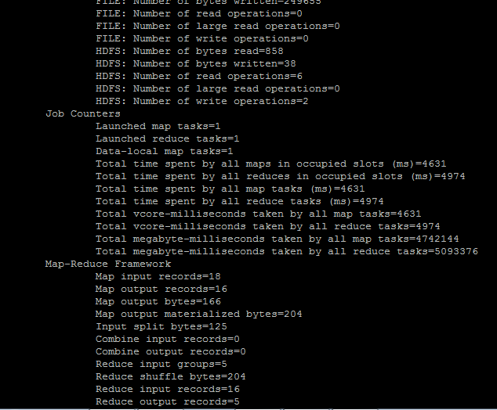

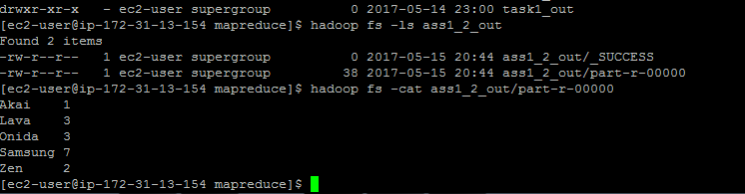

3**. Write a Map Reduce program to calculate the total units sold in each state for Onida company.**

Code: refer attached java files

Ass4Task3.java

Ass4Task3Mapper.java

Ass4Task3Reducer.java

Zipped in testjar4.jar

Command to run the jar > hadoop jar testjar4.jar hadoop.Ass4Task3 /user/ec2-user/ass1_1_in /user/ec2-user/ass1_3_out

Result:

