Assignment 20.1

**Problem Statement 1. Perform UPSERT in Sqoop export.**

Read a file from HDFS and based on the id field, perform UPSERT in MySQL table. In UPSERT, if the field exists, then it is updated else it is inserted.

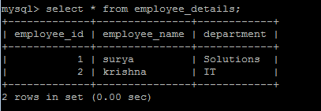

sqoop export --connect jdbc:mysql://54.233.173.172:3306/mydb --username sqoop --password Sqoop_123 --table employee_details --update-key employee_id --export-dir '/user/ec2-user/sqoopout' --input-fields-terminated-by ',' --update-mode allowinsert -m 1 --columns employee_name,department

file in sqoopout dir:



Sqoop inserted two rows in mysql after running the above query.

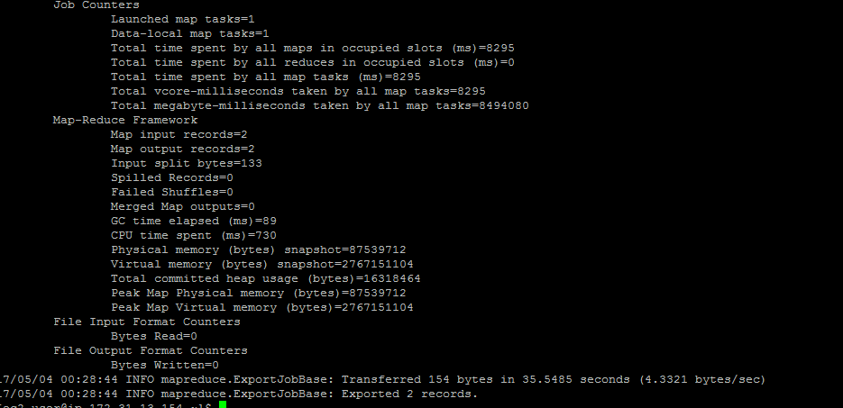

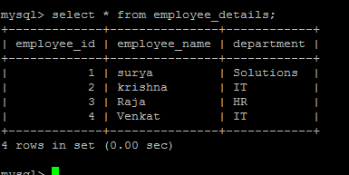

**Now trying update**

sqoop export --connect jdbc:mysql://54.233.173.172:3306/mydb --username sqoop --password Sqoop_123 --table employee_details --update-key employee_id --export-dir '/user/ec2-user/sqoopout' --input-fields-terminated-by ',' --update-mode allowinsert -m 1 --columns employee_id ,employee_name,department

file in sqoopout dir >

(Modifying Raja to IT and Venkat to Solutions)



