Project 1 - USA Crime Analysis

This dataset contains attributes related to crimes taking place in various areas like type of crime, FBI code related to that criminal case, arrest frequency, location of crime etc.

Associated Data Files <https://drive.google.com/file/d/0B1QaXx7tpw3SaUJHOHBZclBXWG8/view?usp=sharing>

Dataset Description: ID,Case Number,Date,Block,IUCR,Primary Type,Description,Location Description,Arrest,Domestic,Beat,District,Ward,Community Area,FBICode,X Coordinate,Y Coordinate,Year,Updated On,Latitude,Longitude,Location

crime_data = load '/user/ec2-user/pigdata/ usacrime/Crimes_-_2001_to_present.csv' using PigStorage(',') as (ID:INT,Case_Number:chararray,Date:chararray,Block:chararray,IUCR:chararray,Primary_Type:chararray,Description:chararray,Location_Description:chararray,Arrest:chararray,Domestic:chararray,Beat:chararray,District:chararray,Ward:chararray,Community_Area:chararray,FBICode:chararray,XCoordinate:chararray,YCoordinate:chararray,Year:INT,Updated_On:chararray,Latitude:chararray,Longitude:chararray,Location:chararray);

Problem Statement

**1.Write a mapreduce/pig program to calculate the number of cases investigated under each FBI code**

1. group cases by fbi code

**case_fbi_group = group crime_data by FBICode;**

2.find COUNT for each group

**number_od_cases_per_fbicode = foreach case_fbi_group generate group as fbicode, COUNT(crime_data) as numberofcases;**

**2.Write a mapreduce/pig program to calculate the number of cases investigated under FBI code 32.**

**number_of_cases_fbicode_32 = FILTER number_of_cases_per_fbicode by fbicode=='32';**

**3.Write a mapreduce/pig program to calculate the number of arrests in theft district wise.**

cases_in_theft = FILTER crime_data by Primary_Type=='THEFT';

arrest_in_theft = FILTER cases_in_theft by Arrest matches '(?i).*TRUE.*';

district_wise_theft_arrest = group arrest_in_theft by District;

**number_of_district_wise_arrest_in_theft = foreach district_wise_theft_arrest generate group as district, COUNT(arrest_in_theft) as numberOfArrest;**

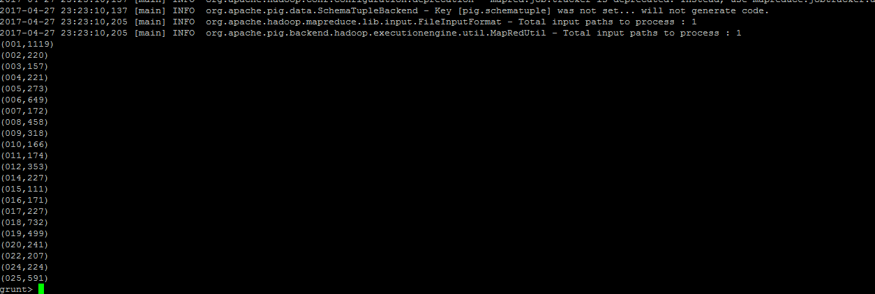

**4.Write a mapreduce/pig program to calculate the number of arrests done between october 2014 and october 2015.**

total_arrests = FILTER crime_data by Arrest matches '(?i).*TRUE.*';

date_of_arrests = FOREACH total_arrests GENERATE Date;

clean the date field

a = foreach date_of_arrests generate REGEX_EXTRACT_ALL(Date,'(\\d+)/(\\d+)/(\\d+).*') as date:(month, day, year);

construct date format

date_concat = foreach a generate CONCAT(date.month,'/',date.day,'/',date.year) as dateconcat;

convert to datetime

todate_data = foreach date_concat generate ToDate(dateconcat,'MM/dd/yyyy') as (date_time:DateTime);

filter the date range, 2014 oct to 2015 oct

filtered = filter todate_data by date_time>=ToDate('10/01/2014','MM/dd/yyyy') AND date_time<ToDate('10/01/2015','MM/dd/yyyy');

find the count by group all

group_filtered_date = GROUP filtered ALL;

number_of_arrests = foreach group_filtered_date generate COUNT(filtered) as numberOfArrests;

dump number_of_arrests

(63173)

