Project 1.3 Titanic Data analysis

Introduction The data set contains information about passengers who boarded Titanic ship.

It contains data points like: • Passenger’s age • Their native place • Details of who survived • Fare details of various travel classes • Number of casualties from various classes etc.

Associated Data Files <https://drive.google.com/file/d/0ByJLBTmJojjzNmV0dk1EMmwwQ1U/view?usp=sharing>

DATA SET DESCRIPTION Column 1 : PassengerId Column 2 : Survived (survived=0 & died=1) Column 3 : Pclass Column 4 : Name Column 5 : Sex Column 6 : Age Column 7 : SibSp Column 8 : Parch Column 9 : Ticket Column 10 : Fare Column 11 : Cabin Column 12 : Embarked

Problem Statement You can use any of the technologies like Map Reduce, Pig or Hive of your choice.

Note:You need to copy the data set into HDFS using flume and send the screen shot of that with the project solution

**Copied data from local directory to HDFS**

***Flume.conf***

*agent.sources = localdir*

*agent.channels = channel_f*

*agent.sinks = HDFS*

*# For each one of the sources, the type is defined*

*agent.sources.localdir.type = spooldir*

*# The channel can be defined as follows.*

*agent.sources.localdir.channels = channel_f*

*agent.sources.localdir.spoolDir = /home/flumedata/flumespool*

*agent.sources.localdir.fileHeader = false*

*agent.sources.localdir.fileSuffix = .COMPLETED*

*# Each sink's type must be defined*

*agent.sinks.HDFS.type = hdfs*

*#Specify the channel the sink should use*

*agent.sinks.HDFS.channel = channel_f*

*agent.sinks.HDFS.hdfs.path = hdfs://localhost/user/ec2-user/flume/titanic/*

*agent.sinks.HDFS.hdfs.fileType = DataStream*

*agent.sinks.HDFS.hdfs.writeFormat = Text*

*agent.sinks.HDFS.hdfs.batchSize = 1000*

*agent.sinks.HDFS.hdfs.rollSize = 268435456*

*agent.sinks.HDFS.hdfs.rollInterval = 0*

*agent.sinks.HDFS.hdfs.rollCount = 50000000*

*# Each channel's type is defined.*

*agent.channels.channel_f.type = file*

*# Other config values specific to each type of channel(sink or source)*

*# can be defined as well*

*# In this case, it specifies the capacity of the memory channel*

*agent.channels.memoryChannel.capacity = 10000*

*agent.channels.memoryChannel.transactionCapacity = 100*

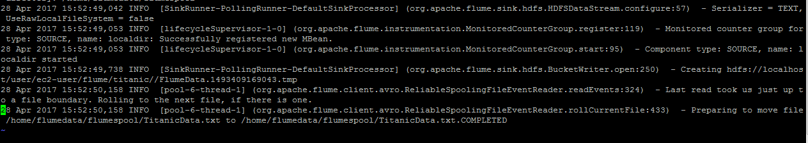

USING PIG

titanic_data = load '/user/ec2-user/flume/titanic/FlumeData.1493409169043' using PigStorage(',') as (passenger_id:INT,survived:INT,pclass:chararray,name:chararray,sex:chararray,age:INT,sibsp:chararray,parch:chararray,ticket:chararray,fare:float,cabin:chararray,embarked:chararray);

**1.In this problem statement we will find the average fare of each class.**

group_by_class = GROUP titanic_data by pclass;

avg_fare_by_class = foreach group_by_class generate group as class, AVG(titanic_data.fare) as avgfare;

dump avg_fare_by_class

(1,84.15468752825701)

(2,20.66218318109927)

(3,13.675550210257411)



**2.In this problem statement we will find the number of people alive in each class and are embarked in Southampton.**

As per problem statement , Survived (survived=0 & died=1)

people_survived_from_S = FILTER titanic_data by survived==0 AND embarked=='S';

grp = GROUP people_survived_from_S all;

number_of_ppl_survived = foreach grp generate COUNT(people_survived_from_S);

(854)



**3.In this problem statement we will find out number of male and female people died in each class.**

female_died = FILTER titanic_data by survived==1 AND sex matches '(?i).*female.*';

grp_female_died_by_class = GROUP female_died by pclass;

num_female_died = foreach grp_female_died_by_class generate group as class, COUNT(female_died);

(1,182)

(2,140)

(3,144)

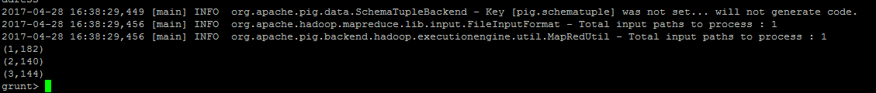

male_died = FILTER titanic_data by survived==1 AND sex=='male';

grp_male_died_by_class = GROUP male_died by pclass;

num_male_died = foreach grp_male_died_by_class generate group as class, COUNT(male_died);

(1,90)

(2,34)

(3,94)

