# Project 2.1

**Step 1:**

Copy dataset from local file system to HDFS using flume.



**Step 2:** Input file is in the XML format use Map reduce or pig to parse the data and get the results for the below problem statements

**Register piggybank to use xml loader**

REGISTER '/home/ec2-user/Installations/pig/piggybank-0.15.0.jar';

**Load the xml file to pig using xml loader from piggybank**

B = LOAD '/user/ec2-user/flume/logdata/FlumeData.1493463472503' using org.apache.pig.piggybank.storage.XMLLoader('row') as (xmlrows:chararray);

**Make data suitable for analysis**

data = FOREACH B GENERATE FLATTEN(REGEX_EXTRACT_ALL(xmlrows,'<row>\\s*<State_Name>(.*)</State_Name>\\s*<District_Name>(.*)</District_Name>\\s*<Project_Objectives_IHHL_BPL>(.*)</Project_Objectives_IHHL_BPL>\\s*<Project_Objectives_IHHL_APL>(.*)</Project_Objectives_IHHL_APL>\\s*<Project_Objectives_IHHL_TOTAL>(.*)</Project_Objectives_IHHL_TOTAL>\\s*<Project_Objectives_SCW>(.*)</Project_Objectives_SCW>\\s*<Project_Objectives_School_Toilets>(.*)</Project_Objectives_School_Toilets>\\s*<Project_Objectives_Anganwadi_Toilets>(.*)</Project_Objectives_Anganwadi_Toilets>\\s*<Project_Objectives_RSM>(.*)</Project_Objectives_RSM>\\s*<Project_Objectives_PC>(.*)</Project_Objectives_PC>\\s*<Project_Performance-IHHL_BPL>(.*)</Project_Performance-IHHL_BPL>\\s*<Project_Performance-IHHL_APL>(.*)</Project_Performance-IHHL_APL>\\s*<Project_Performance-IHHL_TOTAL>(.*)</Project_Performance-IHHL_TOTAL>\\s*<Project_Performance-SCW>(.*)</Project_Performance-SCW>\\s*<Project_Performance-School_Toilets>(.*)</Project_Performance-School_Toilets>\\s*<Project_Performance-Anganwadi_Toilets>(.*)</Project_Performance-Anganwadi_Toilets>\\s*<Project_Performance-RSM>(.*)</Project_Performance-RSM>\\s*<Project_Performance-PC>(.*)</Project_Performance-PC>\\s*</row>')) AS (state_name:chararray, district:chararray,po_ihhl_bpl:INT, po_ihhl_apl:INT, po_ihhl_total:INT,po_scw:INT,po_schl_toilets:INT,po_anganwadi_toilets:INT,po_rsm:INT,po_pc:INT,pp_ihhl_bpl:INT,pp_ihhl_apl:INT,pp_ihhl_total:INT,pp_scw:INT,pp_schl_toilets:INT,pp_anganwadi_toilets:INT,pp_rsm:INT,pp_pc:INT);

**store the data file in hdfs**

STORE data INTO '/user/ec2-user/india_state_wise_progress/' USING PigStorage(',');

**Problem statement 1:**

1. Find out the districts who achieved 100 percent objective in BPL cards

Export the results to mysql using sqoop

**Calculating performance indicator greater than objectives indicator (Project_Performance-IHHL_BPL > Project_Objectives_IHHL_BPL)**

data_1 = foreach data generate state_name,district,po_ihhl_bpl,pp_ihhl_bpl;

filtered_data1 = FILTER data_1 by pp_ihhl_bpl>po_ihhl_bpl;

**storing the result to hdfs to use in sqoop export**

store filtered_data1 into '/user/ec2-user/districts1/' USING PigStorage(',');

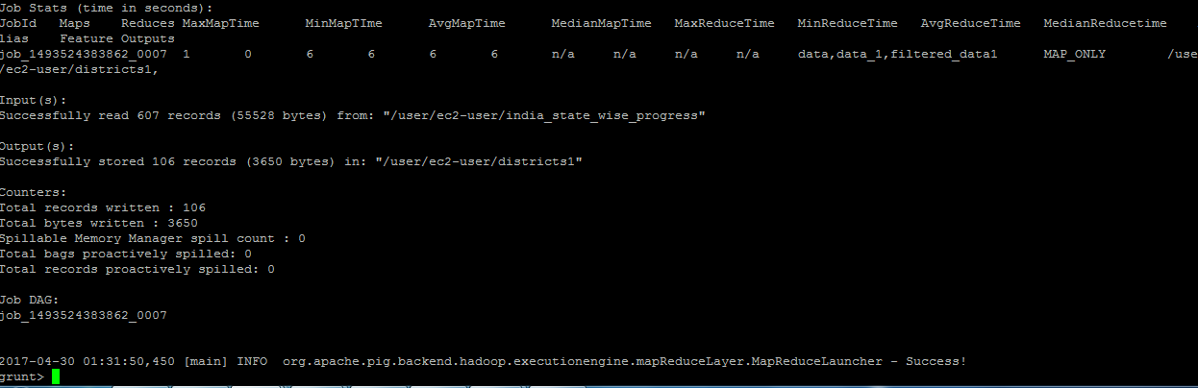

**Create table in mysql to export the result**

create table district_achieved_objectives (State varchar(50),District varchar(50), objective_indicator INT, performance_indicator INT);

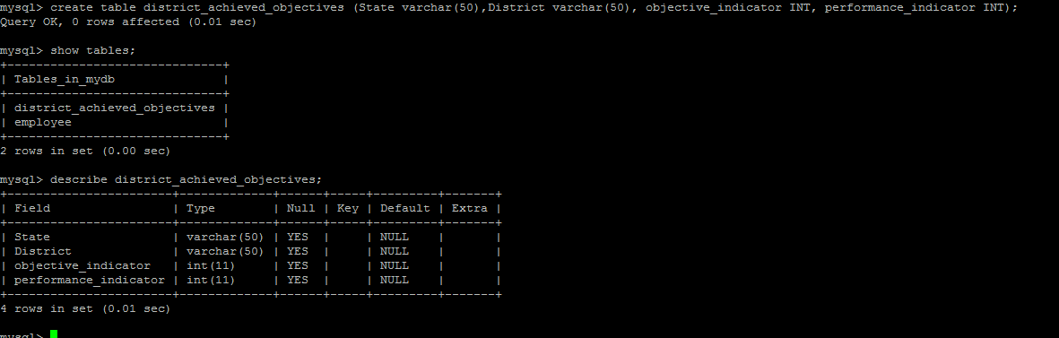

**Sqoop export to Mysql DB**

sqoop export --connect jdbc:mysql://54.233.145.80:3306/mydb --username sqoop --password Sqoop_123 --table district_achieved_objectives --export-dir '/user/ec2-user/districts1' --input-fields-terminated-by ',' -m 1 --columns State,District,objective_indicator,performance_indicator

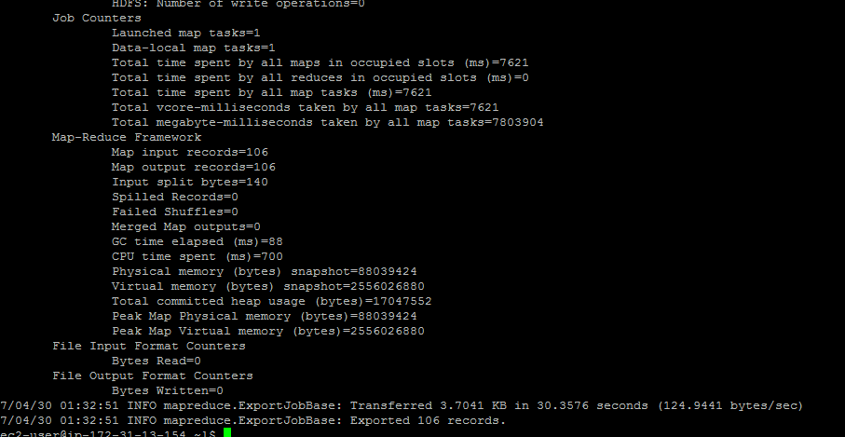

**Exported Data in mysql**

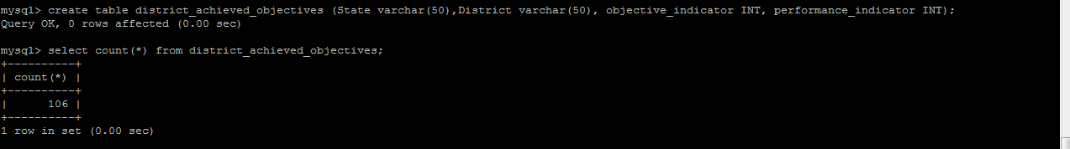

**Problem statement 2:**

2. Write a Pig UDF to filter the districts who have reached 80% of objectives of BPL cards.

Export the results to mysql using sqoop.

pigudf2.java is attached in the project folder

**Registering the udfjar**

REGISTER '/home/ec2-user/Installations/pig/pigudf2.jar';

**Defining alias**

DEFINE PigUdf2 hadoop.pig.PigUdf2();

**Taking previously loaded data from hdfs**

data = load '/user/ec2-user/india_state_wise_progress/' USING PigStorage(',') as (state_name:chararray,district:chararray,po_ihhl_bpl:INT,po_ihhl_apl:INT,po_ihhl_total:INT,po_scw:INT,po_schl_toilets:INT,po_anganwadi_toilets:INT,po_rsm:INT,po_pc:INT,pp_ihhl_bpl:INT,pp_ihhl_apl:INT,pp_ihhl_total:INT,pp_scw:INT,pp_schl_toilets:INT,pp_anganwadi_toilets:INT,pp_rsm:INT,pp_pc:INT);

**taking only the data required for calculation**

data_1 = foreach data generate state_name,district,po_ihhl_bpl,pp_ihhl_bpl;

using udf function to fetch data in which (**Project_Performance-IHHL_BPL /Project_Objectives_IHHL_BPL) > 0.8 >>achieving more than 80 % of objective.**

data_2 = foreach data_1 generate PigUdf2(state_name,district,po_ihhl_bpl,pp_ihhl_bpl) as data;

**code snippet**

@Override

**public** Tuple exec(Tuple input) **throws** IOException {

**if** (input == **null** || input.size() == 0)

**return** **null**;

Integer objective = (Integer)input.get(2);

Integer performance = (Integer)input.get(3);

// System.out.println("objective > "+objective+" performance > "+performance);

**int** o = objective.intValue();

**int** p = performance.intValue();

**if**(o>0){

**double** percentage = p/o;

**if**(percentage>0.8){

**return** input;

}

}

**return** **null**;

}

**Removing null values**

data_3 = filter data_2 by data is not null;

**Storing data to hdfs to sqoop out to mysql**

store data_3 into '/user/ec2-user/district_80/' USING PigStorage(',');

**Mysql table create**

create table district_eighty (State varchar(50),District varchar(50), objective_indicator INT, performance_indicator INT);

**Sqoop Export**

sqoop export --connect jdbc:mysql://54.233.145.80:3306/mydb --username sqoop --password Sqoop_123 --table district_achieved_objectives --export-dir '/user/ec2-user/district_80' --input-fields-terminated-by ',' -m 1 --columns State,District,objective_indicator,performance_indicator