Install istSOS v2.0 on Windows xp / 7

Operating System: Windows xp/ 7
Web Server: WAMPP/ XAMPP/ ms4w mapserver.
Programming platform: Python 2.6 / 2.7
Database: PostgreSQL 8.4 with PostGIS 1.5

A. Installation Steps:
- I am assuming you already have Apache 2.x or ms4w or WAMPP or XAMPP, Python v2.6, PostgreSQL 8.4/9.1, PostGIS 1.5/2.1 and istSOS 2.0.
- If not then visit following sites to download and install,
Install any one Apache server from serial number 1. (I recommend ms4w, the choice is yours)
Install PostGIS 1.5 / 2.1 only after successful install of PostgreSQL 8.4 / 9.1
Extract istSOS do and paste it in htdocs directory / any virtual directory of your web server
SN | Software / Package | URL
1 | Apache | http://www.apachelounge.com/download/
1 | ms4w | http://www.maptools.org/ms4w/index.phtml?page=downloads.html
1 | WAMPP | http://www.wampserver.com/en/
1 | XAMPP | http://www.apachefriends.org/en/xampp-windows.html
2 | Python | http://www.python.org/download/releases/
3 | PostgreSQL 8.4 | http://www.enterprisedb.com/products-services-training/pgdownload#windows
4 | PostGIS 1.5 | http://download.osgeo.org/postgis/windows/pg84/
5 | istSOS 2.0 | http://code.google.com/p/istsos/downloads/list
- Apache
  - To start Apache via command line, open the DOS terminal as administrator, navigate to the bin folder in the installation path of Apache and execute the command ‘httpd.exe -k install’ to install it as service
or
Read the Readme.txt from ms4w
or
help pages for WAMPP / XAMPP
  - If an error signals a missing dll, download and install Microsoft Visual C++ from http://www.microsoft.com/en-us/download/details.aspx?id=5555 then try again to install Apache
  - Apache mod_wsgi Configuration:
- Get the Apache module mod_wsgi for Apache 2.2 and Python 2.6 / 2.7 from http://code.google.com/p/modwsgi/wiki/DownloadTheSoftware?tm=2
- Rename the module mod_wsgi.so, copy it and paste it in the folder /modules of the Apache installation folder (e.g. for /ms4w /ms4w/Apache/modules)

- Check if the path to Python is inserted in the Environment Variables:
  - Computer > right click > properties > advanced system settings > Environment Variables.
  - In System Variables check if the path to Python26 exists in the variable Path,
  - If not insert it, using a ';' as separator from the preceding variable

- PostgreSQL related
- In PostgreSQL using PgAdmin III or pg console create a new database and call it 'istsos' with template postgis database

- Apache Related
- For windows xp / 7 (without virtual host configuration). Configure httpd.conf and add virtual directory
- In apache installation open file httpd.conf location may vary in your case e.g. /ms4w/Apache/conf/httpd.conf
- Add or uncomment (remove #) line
LoadModule wsgi_module modules/mod_wsgi.so
- Save and close httpd.conf

- In apache installation open folder httpd.d (for ms4w /ms4w/httpd.d/)
- Create new file with name 'httpd_istsos.conf' and add following content
WSGIScriptAlias /istsos "C:/ms4w/Apache/htdocs/istsos/application.py"
<Directory "C:/ms4w/Apache/htdocs/istsos/">
AllowOverride None
Options Indexes FollowSymLinks Multiviews
Order allow,deny
Allow from all
</Directory>

Alias /istsos/admin "C:/ms4w/Apache/htdocs/istsos/interface"
<Directory "C:/ms4w/Apache/htdocs/istsos/admin/">
AllowOverride None
Options Indexes FollowSymLinks Multiviews
Order allow,deny
Allow from all
</Directory>
- Save and close file. Move to next step (7)
- For windows xp / 7 (with virtual host configuration)
- Go to the folder where Apache is installed, modify the permissions of conf/httpd.txt and of conf/extra/httpd-vhosts.txt so that they are writable
- Open conf/httpd.txt and add the line 'LoadModulewsgi_module modules/mod_wsgi.so' where the other "LoadModule" lines are. Delete the # from the line "Include conf/extra/httpd-vhosts.conf". Save and close the document
- Open conf/extra/httpd-vhosts.txt, delete the two examples of <VirtualHost> and paste the following code. Modify all the paths so that they correspond to the Apache and istSOS folders.
<VirtualHost *:80>
ServerAdminwebmaster@localhost
#DocumentRoot "C:/istsos/interface"
DocumentRoot "C:/Apache2/htdocs"
<Directory />
Options FollowSymLinks
AllowOverride None
</Directory>

#<Directory C:/istsos/interface/>
<Directory C:/Apache2/htdocs/>
Options Indexes FollowSymLinksMultiViews
AllowOverride None
Order allow,deny
allow from all
</Directory>

ScriptAlias /cgi-bin/ "c:/Apache2/cgi-bin/"
<Directory "c:/Apache2/cgi-bin">
AllowOverride None
Options +ExecCGI -MultiViews +SymLinksIfOwnerMatch
Order allow,deny
Allow from all
</Directory>

ErrorLog "c:/Apache2/logs/error.txt"
LogLevel warn
CustomLog "c:/Apache2/logs/access.txt" combined

Alias /doc/ "c:/Apache2/manual/"
<Directory "c:/Apache2/manual/">
Options Indexes MultiViewsFollowSymLinks
AllowOverride None
Order deny,allow
Deny from all
Allow from 127.0.0.0/255.0.0.0 ::1/128
</Directory>

WSGIScriptAlias /istsos "c:/istsos/application.py"
<Location "/istsos">
Options Indexes MultiViewsFollowSymLinks
AllowOverride None
Order deny,allow
Deny from all
Allow from 127.0.0.0/255.0.0.0 ::1/128
</Location>
Alias /istsos/admin "c:/istsos/interface"
</VirtualHost>
- Save and close the file and move to next step (7)

- Restart Apache Web Server
- Go to control panel> system and security> administrative tools> services.
Click on Apache2.2 and then on restart.
or
For ms4w same as above or go to ms4w/Apache/bin execute ApacheMonitor.exe to start / stop server
or
For WAMPP/ XAMPP there is GUI for server restart

- Important Apache files for error analysis / debug
- error.log /.txt
- access.log /.txt
- Other issues that may arise
- Problem: on windows 7 ms4w is not getting installed
Solution: execute the apache-install.bat with administrator permissions.
i. Start the command prompt 'cmd' as administrator
ii. execute the apache-install.bat
- Feel free to report other issues to (suryakant54321@gmail.com)/ to save time just use good search engine (recommend Google)

B. Configuration Steps:
- Check the installation success on the browser by loading the page http://localhost/istsos/admin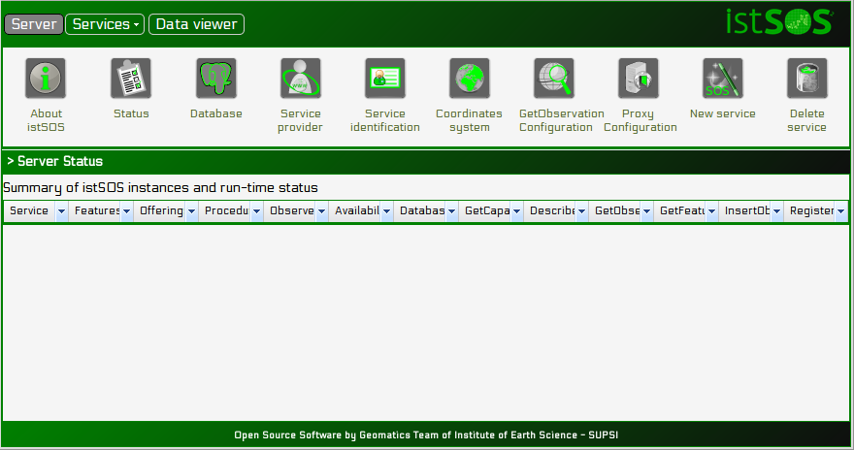

- Database Password Configure
Open file <web server folder>/istsos/services/default.cfg
Change the database password from respective line under [connection]
Save and close the file
- Configure the server providing the requested information, and create a new service
 | Server >Database  user: postgres  password: postgres  host: localhost  port: 5432  DB name: istsos
 | Server > Service provider  use your institutional information
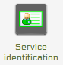 | Server > Service identification  describe the service with metadata
 | Server > Coordinates system  set your default EPSG code, other permitted  coord. systems, name of the axis
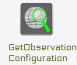 | Server >GetObservation configuration  set maximum interval per request  andno data aggregation value
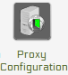 | Server > Proxy configuration  set the address of the istsos service
 | Server > New service  set the service name (*demo*) and  optionally EPSG and database connections
 | Server > Status  verify that database is active  and Availability is up

- Check the service with GetCapabilities by loading the page http://localhost/istsos/demo?request=GetCapabilities&version=1.0.0&service=SOS

- Go under services, demo and insert properties, measures and procedures
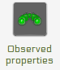 | demo > Observed properties  Name: air-temperature  Definition URN: urn:ogc:def:parameter:x-istsos:1.0:meteo:air:temperature  Description: air temperature at 2 meters above terrain  Name: air-rainfall  Definition URN: urn:ogc:def:parameter:x-istsos:1.0:meteo:air:rainfall  Description: liquid precipitation or snow water equivalent  Name: air-relative-humidity  Definition URN: urn:ogc:def:parameter:x-istsos:1.0:meteo:air:humidity:relative  Description: absolute humidity relative to the maximum for that air pressure and temperature  Name: air-wind-velocity  Definition URN: urn:ogc:def:parameter:x-istsos:1.0:meteo:air:wind:velocity  Description: wind speed at 10 meters above terrain
 | demo > Unit of measures  Code: mm  Description:millimiter  Code: °C  Description: Celsius degree  Code: %  Description:percentage  Code: m/s  Description:metre per second
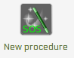 | demo > New procedure  Name: T_LUGANO  Description: temperature weather station in Lugano  Keywords: weather, meteorological, IST  System type:insitu-fixed-point  Sensor type: PTC thermistors of the "switching" type  FOI name: LUGANO  EPSG: 4326  Coordinates: x: 8.96127 y: 46.02723 z: 344.1  Outputs:  Observed property: urn:ogc:def:parameter:x-istsos:1.0:meteo:air:temperature  Unit od measure: °C  Description: conversion from resistance to temperature  quality index check: from -40 to +60  Optional parameters:  fill at your own need and willing
To add other procedures look at the tool for “copy configuration from existing procedure”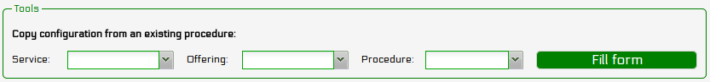
demo > New procedure

Name: P_LUGANO
Description: rainfall weather station in Lugano
Keywords: weather, meteorological, IST

System type:insitu-fixed-point
Sensor type: tipping bucket rain gauge

FOI name: LUGANO
EPSG: 4326
Coordinates: x: 8.96127 y: 46.02723 z: 344.1

Outputs:
Observed property: urn:ogc:def:parameter:x-istsos:1.0:meteo:air:rainfall
Unit od measure: mm
Description: -
quality index check: from 0 to +500

demo > New procedure

Name: LOCARNO
Description: temperature and rainfall weather station in Locarno
Keywords: weather, meteorological, IST

System type: insitu-fixed-point
Sensor type: Davis weather station

FOI name: LOCARNO
EPSG: 4326
Coordinates: x: 8.79212 y: 46.15515 z: 197.8

Outputs:
Observed property: urn:ogc:def:parameter:x-istsos:1.0:meteo:air:rainfall
Unit od measure: mm
Description: -
quality index check: from 0 to +500

Observed property: urn:ogc:def:parameter:x-istsos:1.0:meteo:air:temperature
Unit od measure: °C
Description: conversion from resistance to temperature
quality index check: from -40 to +60

demo > New procedure

Name: BELLINZONA
Description: weather station in Bellinzona
Keywords: weather, meteorological, IST

System type: insitu-fixed-point
Sensor type: Davis weather station

FOI name: BELLINZONA
EPSG: 4326
Coordinates: x: 9.01976 y: 46.20322 z: 226.3

Outputs:
Observed property: urn:ogc:def:parameter:x-istsos:1.0:meteo:air:rainfall
Unit od measure: mm
Description: -
quality index check: from 0 to +500

Observed property: urn:ogc:def:parameter:x-istsos:1.0:meteo:air:temperature
Unit od measure: °C
Description: conversion from resistance to temperature
quality index check: from -40 to +60

Observed property: urn:ogc:def:parameter:x-istsos:1.0:meteo:air:humidity:relative
Unit od measure: %
Description: -
quality index check: from 0 to 100

Observed property: urn:ogc:def:parameter:x-istsos:1.0:meteo:air:wind:velocity
Unit od measure: m/s
Description: -
quality index check: from 0 to 200
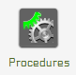 | demo > Procedures  it provides you a table with sensors and relative offerings and observedProperties
 | demo > Offering editor  Name: workshop  Description: demo dataset for GRASS meeting  Expiration: 2013-02-28T00:00:00+01:00  Validity: Enabled  Offering-procedure memberships: add all of the procedures
- New data is inserted with an ASCII file with sensor data formatted according to istSOS-ASCII-format. This format is a CSV with a header as first line containing the URI names of the observed properties, and the following lines containing the data.
urn:ogc:def:parameter:x-istsos:1.0:time:iso8601,urn:ogc:def:parameter:x-istsos:1.0:meteo:air:temperature
2013-01-01T00:10:00.000000+0100,0.446000
2013-01-01T00:20:00.000000+0100,0.862000
2013-01-01T00:30:00.000000+0100,0.932000
2013-01-01T00:40:00.000000+0100,0.384000
- Files containing data for the configuration that is presented above can be found at following addresses:
Bellinzona | http://istgeo.ist.supsi.ch/software/istsos/_downloads/BELLINZONA.DAT
Locarno | http://istgeo.ist.supsi.ch/software/istsos/_downloads/LOCARNO.DAT
P_Lugano | http://istgeo.ist.supsi.ch/software/istsos/_downloads/P_LUGANO.DAT
T_Lugano | http://istgeo.ist.supsi.ch/software/istsos/_downloads/T_LUGANO.DAT
- When the files are downloaded, open a DOS terminal, go to the C:/istsos folder and execute following commands. The last path should be the one where you downloaded the .DAT files

- python cmdimportcsv.py --h
- python cmdimportcsv.py -s demo -u http://localhost/istsos -p T_LUGANO -w [path to .DAT files]
- python cmdimportcsv.py -s demo -u http://localhost/istsos -p P_LUGANO -w [path to .DAT files]
- python cmdimportcsv.py -s demo -u http://localhost/istsos -p LOCARNO -w /home/user/Download
- python cmdimportcsv.py -s demo -u http://localhost/istsos -p BELLINZONA -w [path to .DAT files]
- To check if everything is working fine, go to Data viewer > Data Editor, where there is an interface for viewing the imported data

