CAPSTONE PROJECT

Bash Scripting Suite
for System Maintenance

OBJECTIVE:
Write a suite of Bash scripts to automate system maintenance tasks such as backup, system updates, and log monitoring

CODE

i. main_1.sh

#!/bin/bash
# Bash System Maintenance Toolkit (v2.0)
# Author: Your Name
# Description: Interactive menu interface
# Define paths for external scripts (adjust if paths differ)
BACKUP_SCRIPT="./backup.sh"
MAINTENANCE_SCRIPT="./maintenance.sh"
LOG_MONITOR_SCRIPT="./log_monitor.sh"

# ---------- Helper Function ----------
pause() {
echo
read -rp "Press Enter to return to the main menu..."
}

# ---------- Main Menu ----------
while true; do
clear
echo "==========================================="
echo " SYSTEM MAINTENANCE SUITE"
echo "==========================================="
echo "1) Backup System Files"
echo "2) Perform System Maintenance (Update & Clean)"
echo "3) Monitor Logs for Failed Entries"
echo "4) Quit"
echo "-------------------------------------------"
read -rp "Select an option [1-4]: " choice

case "$choice" in
1)
echo -e "\n Starting Backup..."
if [[ -x "$BACKUP_SCRIPT" ]]; then
"$BACKUP_SCRIPT"
else
echo "Error: Backup script not found or not executable."
fi
;;
2)
echo -e "\n Running Maintenance Tasks (sudo required)..."
if [[ -x "$MAINTENANCE_SCRIPT" ]]; then
sudo "$MAINTENANCE_SCRIPT"
else
echo "Error: Maintenance script not found or not executable."
fi
;;
3)
echo -e "\n Monitoring System Logs (sudo required)..."
if [[ -x "$LOG_MONITOR_SCRIPT" ]]; then
sudo "$LOG_MONITOR_SCRIPT"
else
echo "Error: Log monitor script not found or not executable."
fi
;;
4)
echo -e "\n Exiting System Maintenance Suite. Have a great day!"
break
;;
*)
echo -e "\n Invalid input. Please choose a number between 1 and 4."
;;
esac

pause
done

ii. backup_1.sh

#!/bin/bash
set -e # Exit immediately if a command fails

# --- Configuration ---
SOURCE_DIR="/home/kali/Documents/WIPRO_PROJECT/Capstone_Project/Bash_Scripting"
BACKUP_DIR="/home/kali/Documents/Backup/my project"
FILENAME="backup_$(date +'%Y-%m-%d_%H-%M-%S').tar.gz"

# --- Error Handling ---
if [ ! -d "$SOURCE_DIR" ]; then
echo "ERROR: Source directory $SOURCE_DIR does not exist."
echo "Backup failed."
exit 1 # Exit with a failure code
fi

# --- Script Body ---
mkdir -p "$BACKUP_DIR"
echo "Starting backup of $SOURCE_DIR..."
tar -czvf "$BACKUP_DIR/$FILENAME" "$SOURCE_DIR"
echo "Backup complete! File created: $BACKUP_DIR/$FILENAME"

iii. maintenance_1.sh

#!/bin/bash
set -e # Exit immediately if a command exits with a non-zero status.
echo "Starting system maintenance..."
# --- 1. Update Package Lists ---
# Fetches the list of available updates from the repositories.
echo "Updating package lists..."
sudo apt update
# --- 2. Perform Upgrades ---
# Installs the newest versions of all packages currently installed.
# The '-y' flag automatically answers 'yes' to all prompts.
echo "Installing system updates..."
sudo apt upgrade -y
# --- 3. Autoremove Old Packages ---
# Removes packages (like old kernels) that were automatically installed
# to satisfy dependencies but are no longer needed.
echo "Removing old and unused packages..."
sudo apt autoremove -y
# --- 4. Clean Package Cache ---
# Clears out the local cache of retrieved package files.
# This frees up disk space, as the .deb files are no longer needed
# After installation.
echo "Cleaning up package cache..."
sudo apt clean
echo "System maintenance complete!"
iv. log_monitor_1.sh

#!/bin/bash
set -e # Exit immediately if a command fails
# --- Configuration ---
LOG_FILE="/var/log/auth.log"
KEYWORD="Failed"
# --- Error Handling ---
if [ ! -r "$LOG_FILE" ]; then
echo "ERROR: Log file $LOG_FILE does not exist or is not readable."
echo "Log monitor failed."
exit 1 # Exit with a failure code
fi
# --- Script Body ---
echo "Starting log scan for '$KEYWORD' in $LOG_FILE..."
MATCHES=$(grep -i -n "$KEYWORD" "$LOG_FILE" || true)

if [ -n "$MATCHES" ]; then
echo "----------------------------------------"
echo "ALERT: Potential issues found!"
echo "----------------------------------------"
echo "$MATCHES"
else
echo "Scan complete. No issues found."
fi

SCREENSHOTS

i. main_1.sh
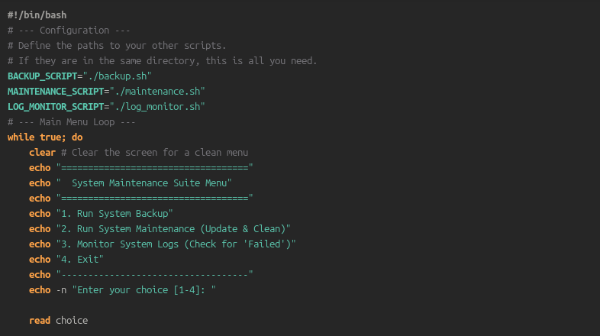
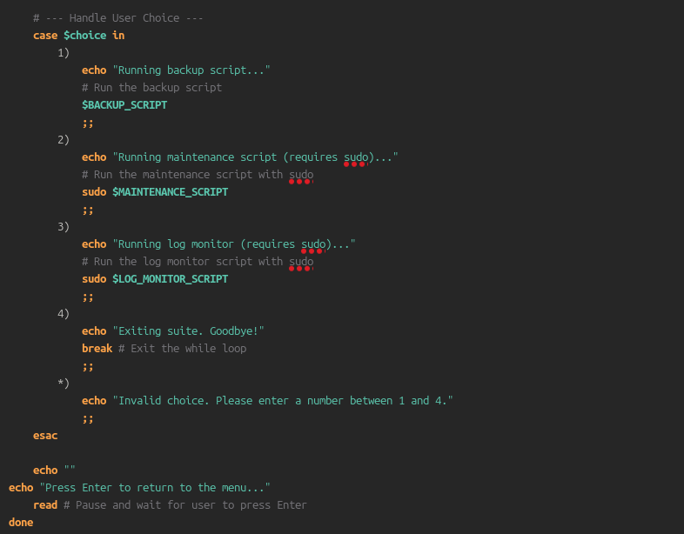

ii. backup_1.sh
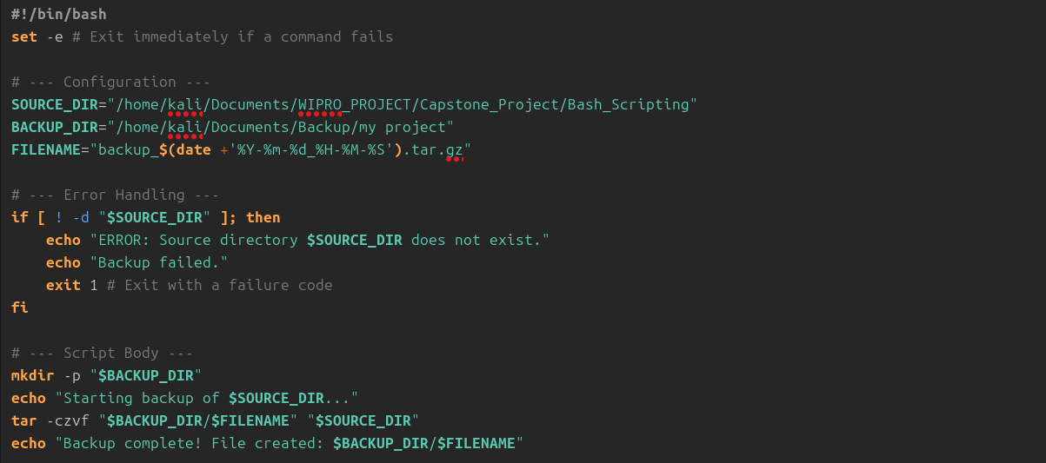

iii. maintenance_1.sh
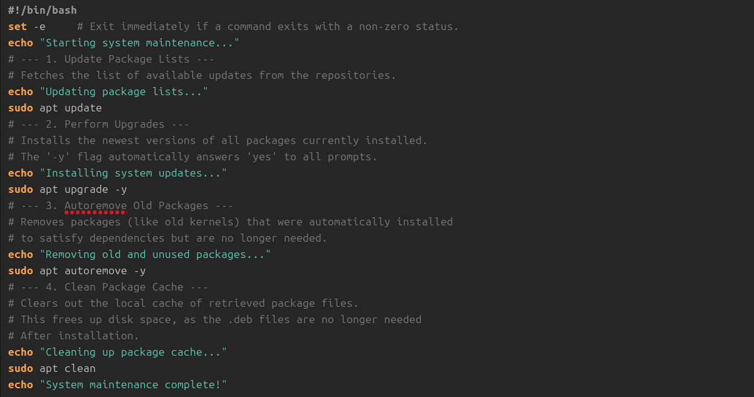
iv. log_monitor_1.sh
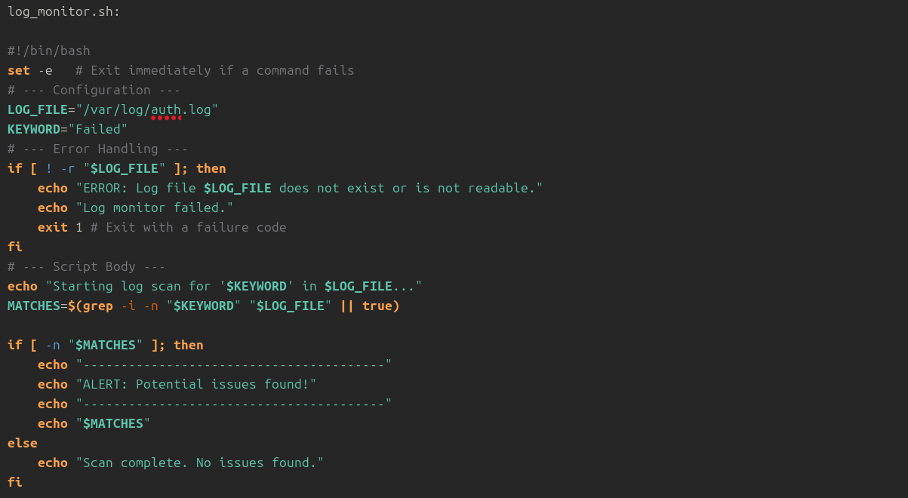

v. output
