TASK ONE

NUMBERS AND VARIABLES

1. Create three variables in a single line and assign values to them in such a manner that each one of

them belongs to a different data type.

E.g. :

a = 1,

b = 2.01,

c = 'string'

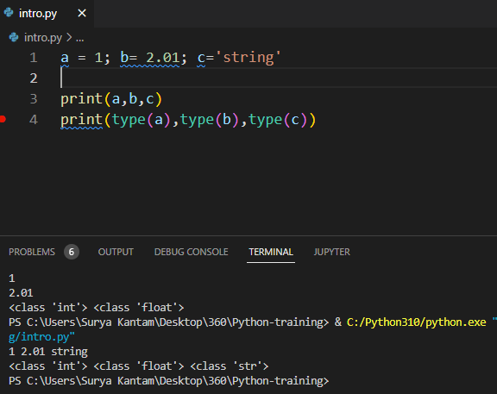

2. Create a variable of type complex and swap it with another variable of type integer.

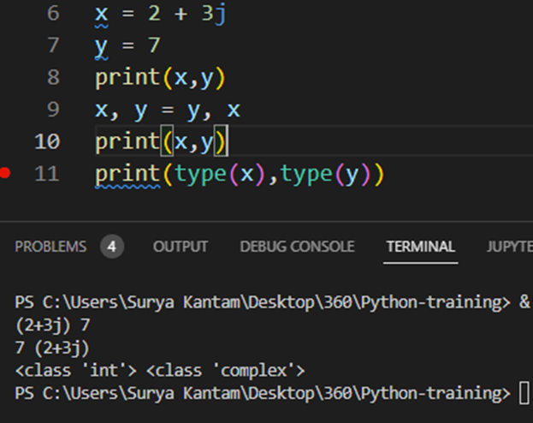

3. Swap two numbers using a third variable and do the same task without using any third variable.

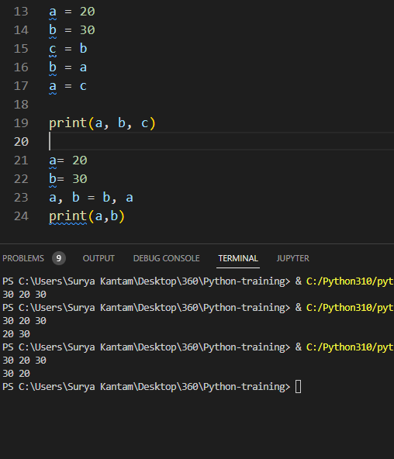

4. Write a program that takes input from the user and prints it using both Python 2.x and Python 3.x

Version.

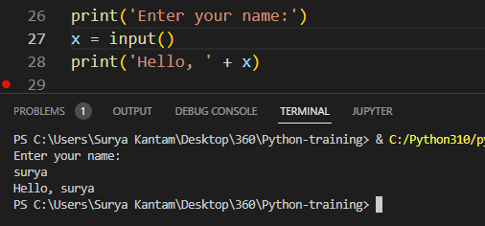

5. Write a program to complete the task given below:

Ask users to enter any 2 numbers in between 1-10 , add the two numbers and keep the sum in

another variable called z. Add 30 to z and store the output in variable result and print result as the

final output.

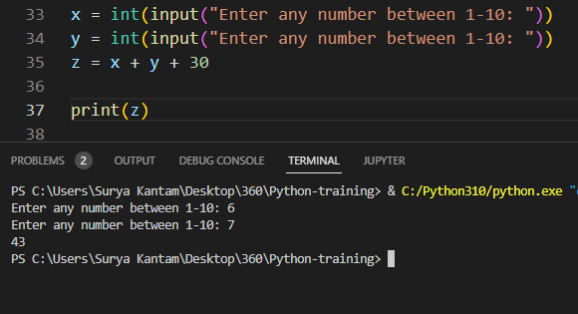

6. Write a program to check the data type of the entered values.

HINT: Printed output should say - The data type of the input value is : int/float/string/etc 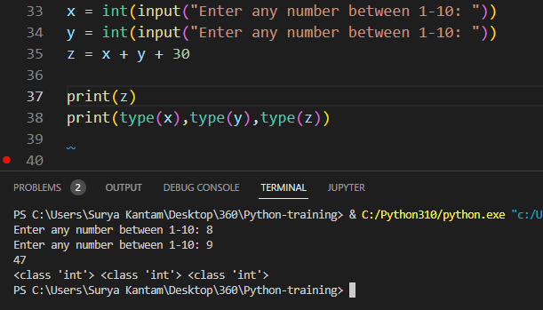

7. Create Variables using formats such as Upper CamelCase, Lower CamelCase, SnakeCase and

UPPERCASE.

(Refer: <https://capitalizemytitle.com/camel-case/>)

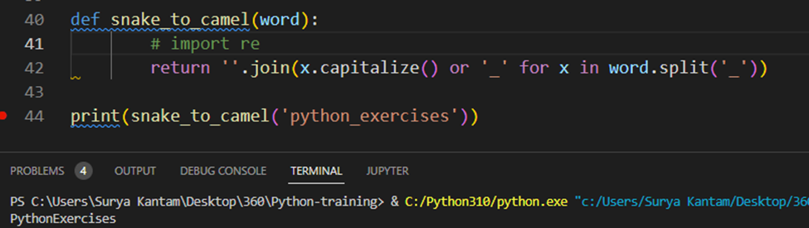

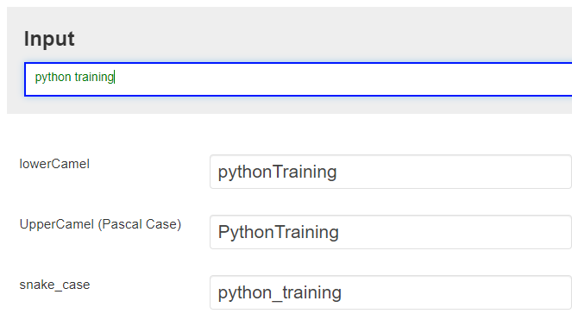

8. If one data type value is assigned to ‘a’ variable and then a different data type value is assigned to ‘a’

again. Will it change the value? If Yes then Why?

Yes we can change the data type, this feature make the Python more flexible to use all the available data types and different operation we can perform to utilize the benefits of all the data types, to improve the quality of code and to get the desired result.

