1.

a. Step sequence function:-

function [ s,n ] = step1( k,n1,n2 )

n=n1:n2

s=[(n-k)>=0]

end

b. Impulse sequence function:-

function [ del,n ] = impulse1( k,n1,n2 )

n=n1:n2

del=[(n-k)==0]

end

c. Signal addition function:-

function [ y,n ] = sigadd( x1,n1,x2,n2 )

n=min(min(n1),min(n2)):max(max(n1),max(n2));

y1=zeros(1,length(n));

y2=zeros(1,length(n));

y1(find((n>=min(n1))&(n<=max(n1))))=x1;

y2(find((n>=min(n2))&(n<=max(n2))))=x2;

y= y1+y2;

end

d. Signal multiplication function:-

function [ y,n ] = sigmul( x1,n1,x2,n2 )

n=min(min(n1):min(n2)):max(max(n1),max(n2));

y1=zeros(1,length(n));

y2=zeros(1,length(n));

y1(find((n>=min(n1))&(n<=max(n1))))=x1;

y2(find((n>=min(n2))&(n<=max(n2))))=x2;

y= y1.\*y2;

end

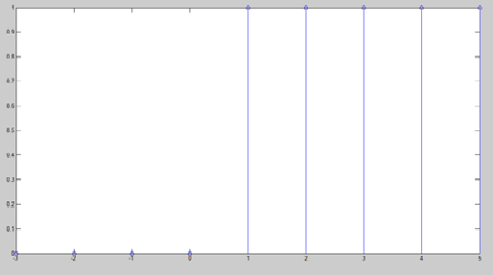

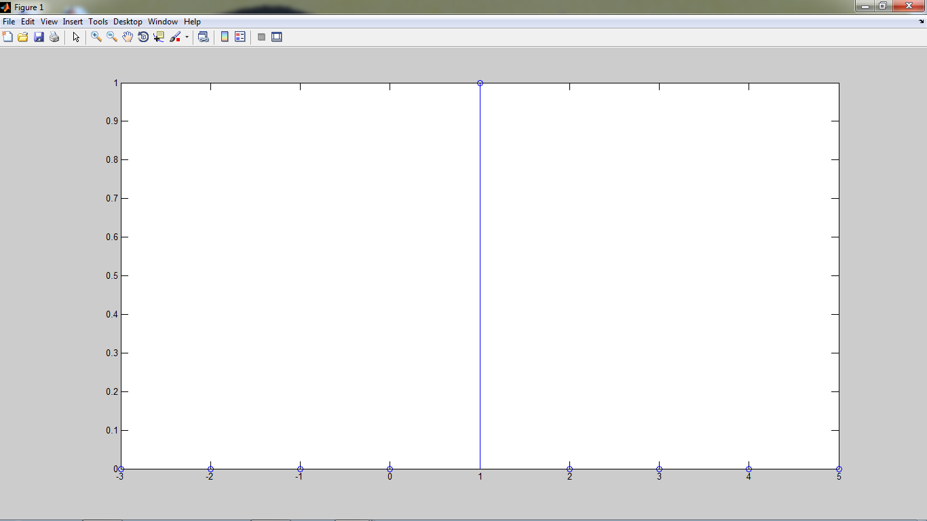

e. Signal shifting function:-

function [ y,m ] = sigshift( x,n,k )

y= x;

m= n+k;

end

f. Signal folding function:-

function [ y,n ] = sigfold( x,m )

y= fliplr(x);

n= -fliplr(m);

end

g. Even and odd function:-

function [ xe,ne,xo,no ] = evenodd( x,n )

[y,m]=sigfold(x,n);

[xe,ne]=sigadd(x,n,y,m);

xe=(0.5).\*xe;

[xo,no]=sigadd(x,n,-y,m);

xo=(0.5).\*xo;

end

2. a.

clc;

clear all;

close all;

x1=[-2 -1 0 1 2];

p=5;

xper=x1'\*ones(1,p);

xper=xper(:);

xper=xper';

stem(xper)

b.

clc;

clear all;

close all;

n=0:30;

[x1,n]=step1(0,0,30);

[x2,n]=step1(20,0,30);

x=(x1-x2).\*exp(0.1.\*n);

p=3;

xper=x'\*ones(1,p);

xper=xper(:);

xper=xper';

stem(xper)

C.

clc;

clear all; close all;

n=0:30;

[x1,n]=step1(0,0,30);

[x2,n]=step1(10,0,30);

x=(x1-x2).\*sin(0.1.\*n.\*pi);

p=4;

xper=x'\*ones(1,p);

xper=xper(:);

xper=xper';

stem(xper)

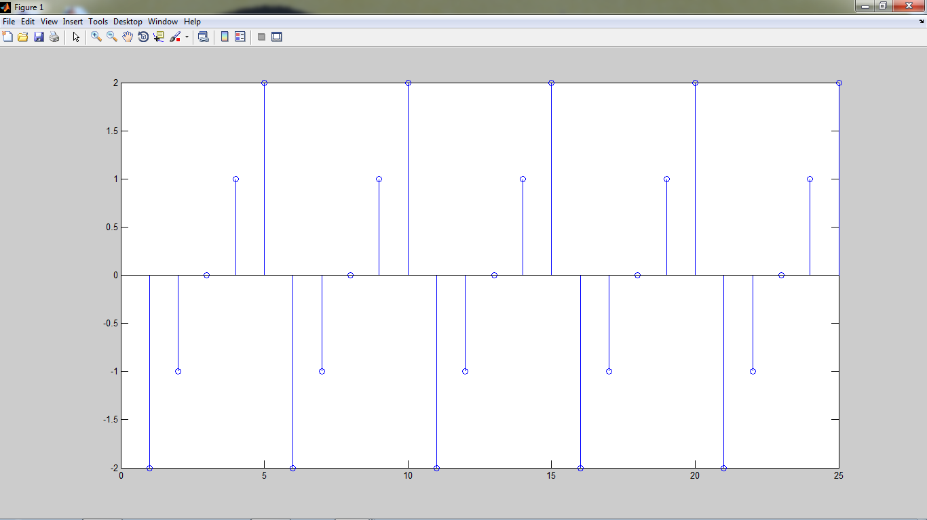

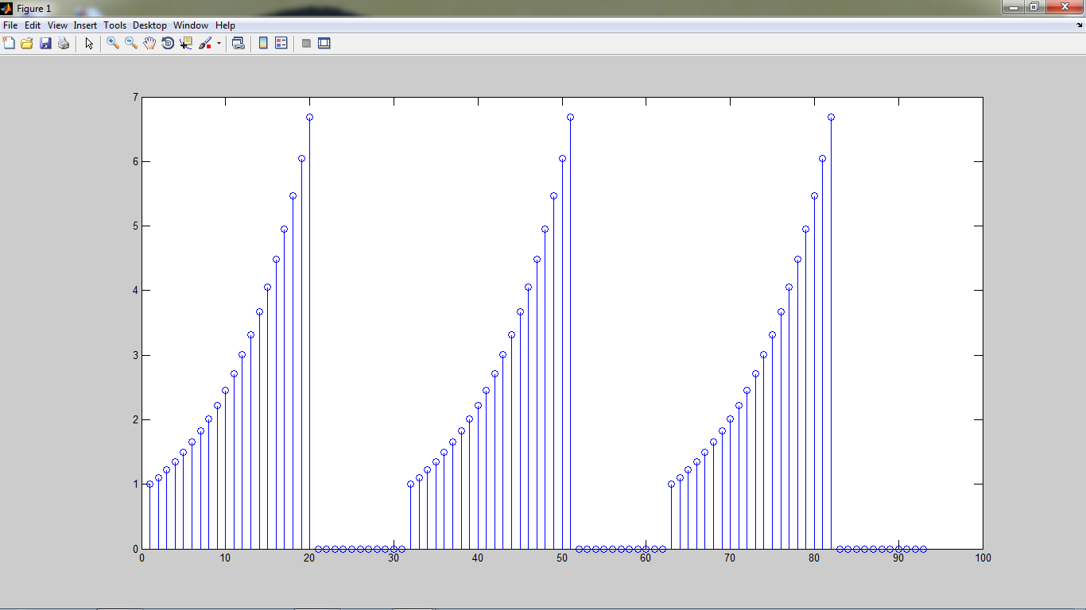

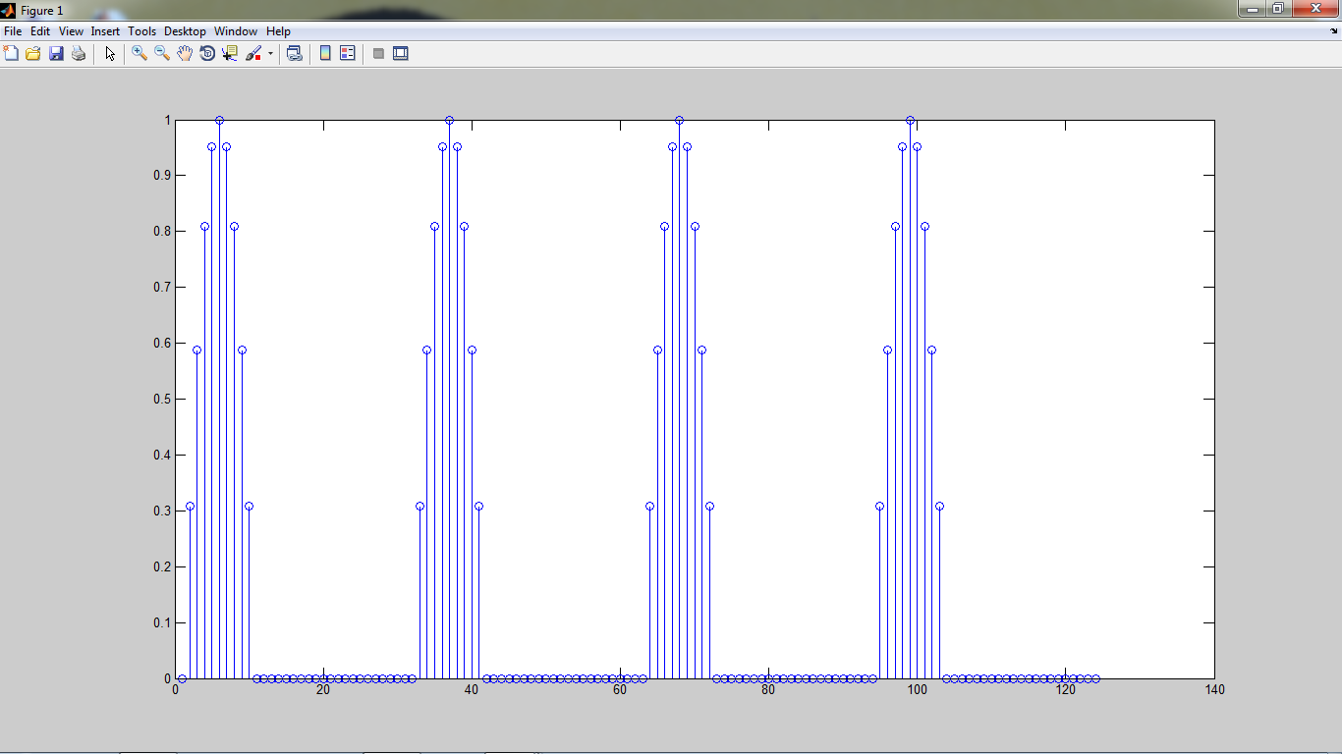

3. a.

clc;

clear all;

close all;

n=0:6;

x=[2 4 -3 1 -5 4 7];

[x1,n1]=sigshift(x,n,3);

[x2,n2]=sigshift(x,n,-4);

[y1,n3]=sigadd(2.\*x1,n1,3.\*x2,n2);

[y2,n4]=sigadd(y1,n3,-x,n);

stem(n4,y2)

b.

clc;

clear all;

close all;

n=0:6;

x=[2 4 -3 1 -5 4 7];

[x1,n1]=sigshift(x,n,-4);

[x2,n2]=sigshift(x,n,-5);

[y1,n3]=sigadd(4.\*x1,n1,5.\*x2,n2);

[y2,n4]=sigadd(y1,n3,2.\*x,n);

stem(n4,y2)

C.

clc;

clear all;

close all;

n=0:6;

x=[2 4 -3 1 -5 4 7];

[x1,n1]=sigshift(x,n,-3);

[x2,n2]=sigshift(x,n,2);

[y1,n5]=sigmul(x1,n1,x2,n2);

[x3,n3]=sigfold(x,n);

[x4,n4]=sigshift(x3,n3,1);

[x5,n8]=sigshift(x,n,-1);

[y2,n6]=sigmul(x4,n4,x5,n8);

[y3,n7]=sigadd(y1,n5,y2,n6);

stem(n7,y3)

