

**PRACTICAL JOURNAL OF**

**COMPUTER NETWORKS (IT-502)**

**BTECH: Third Year**

**Department of Information Technology**

|  |  |  |
| --- | --- | --- |
| **Name of Student** | **:** | **__Suryakaran Tiwari_____________________.** |
| **Branch & Section** | **:** | **____IT-2____________________.** |
| **Roll Number** | **:** | **____0827IT181104___________________.** |
| **Year** | **:** | **____III year____________________.** |

**Experiment-12**

**Aim:-**

**Case study of Network Topology.**

**Network topology :-**

Topology is physical or logical way in which network is laid down. It is arrangement of  various elements like node,links,repeaters,hub etc. In which nodes are connected using link between them.In this two or more links are connected for form a topology. It is arrangement of  various elements like node,links,repeaters,hub etc.

Types of Topology:-

1) Mesh Topology

2) Star Topology

3) Bus Topology

4) Ring Topology

## **Point-to-Point**

Point-to-point networks contains exactly two hosts such as computer, switches or routers, servers connected back to back using a single piece of cable. Often, the receiving end of one host is connected to sending end of the other and vice-versa.



If the hosts are connected point-to-point logically, then may have multiple intermediate devices. But the end hosts are unaware of underlying network and see each other as if they are connected directly.

## **Bus Topology**

In case of Bus topology, all devices share single communication line or cable.Bus topology may have problem while multiple hosts sending data at the same time. Therefore, Bus topology either uses CSMA/CD technology or recognizes one host as Bus Master to solve the issue. It is one of the simple forms of networking where a failure of a device does not affect the other devices. But failure of the shared communication line can make all other devices stop functioning.

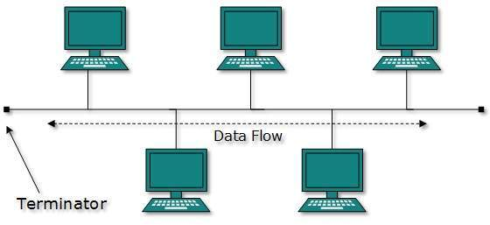

Both ends of the shared channel have line terminator. The data is sent in only one direction and as soon as it reaches the extreme end, the terminator removes the data from the line.

## **Star Topology**

All hosts in Star topology are connected to a central device, known as hub device, using a point-to-point connection. That is, there exists a point to point connection between hosts and hub. The hub device can be any of the following:

* Layer-1 device such as hub or repeater
* Layer-2 device such as switch or bridge
* Layer-3 device such as router or gateway

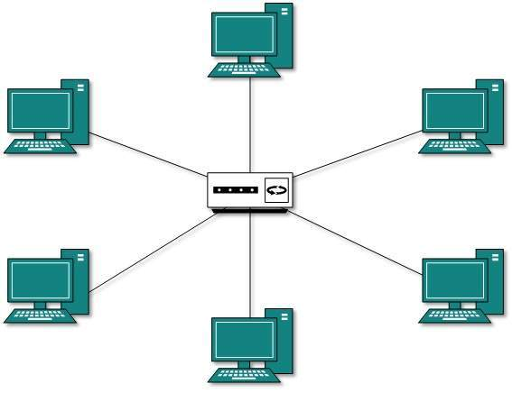

As in Bus topology, hub acts as single point of failure. If hub fails, connectivity of all hosts to all other hosts fails. Every communication between hosts, takes place through only the hub.Star topology is not expensive as to connect one more host, only one cable is required and configuration is simple.

## **Ring Topology**

In ring topology, each host machine connects to exactly two other machines, creating a circular network structure. When one host tries to communicate or send message to a host which is not adjacent to it, the data travels through all intermediate hosts. To connect one more host in the existing structure, the administrator may need only one more extra cable.

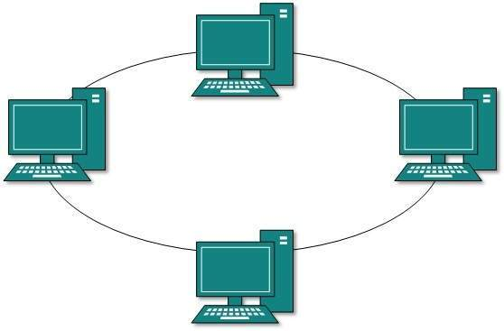

Failure of any host results in failure of the whole ring.Thus, every connection in the ring is a point of failure. There are methods which employ one more backup ring.

## **Mesh Topology**

In this type of topology, a host is connected to one or multiple hosts.This topology has hosts in point-to-point connection with every other host or may also have hosts which are in point-to-point connection to few hosts only.

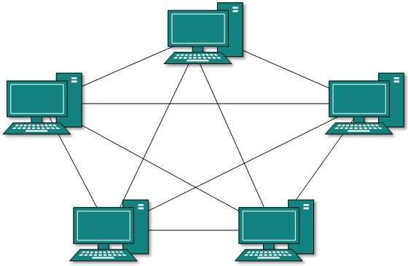

Hosts in Mesh topology also work as relay for other hosts which do not have direct point-to-point links. Mesh technology comes into two types:

* **Full Mesh**: All hosts have a point-to-point connection to every other host in the network. Thus for every new host n(n-1)/2 connections are required. It provides the most reliable network structure among all network topologies.
* **Partially Mesh**: Not all hosts have point-to-point connection to every other host. Hosts connect to each other in some arbitrarily fashion. This topology exists where we need to provide reliability to some hosts out of all.

## **Tree Topology**

Also known as Hierarchical Topology, this is the most common form of network topology in use presently.This topology imitates as extended Star topology and inherits properties of bus topology.

This topology divides the network in to multiple levels/layers of network. Mainly in LANs, a network is bifurcated into three types of network devices. The lowermost is access-layer where computers are attached. The middle layer is known as distribution layer, which works as mediator between upper layer and lower layer. The highest layer is known as core layer, and is central point of the network, i.e. root of the tree from which all nodes fork.

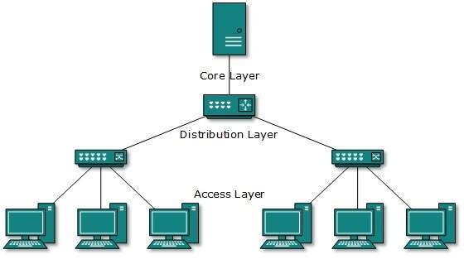

All neighboring hosts have point-to-point connection between them.Similar to the Bus topology, if the root goes down, then the entire network suffers even.though it is not the single point of failure. Every connection serves as point of failure, failing of which divides the network into unreachable segment.

## **Daisy Chain**

This topology connects all the hosts in a linear fashion. Similar to Ring topology, all hosts are connected to two hosts only, except the end hosts.Means, if the end hosts in daisy chain are connected then it represents Ring topology.



Each link in daisy chain topology represents single point of failure. Every link failure splits the network into two segments.Every intermediate host works as relay for its immediate hosts.

## **Hybrid Topology**

A network structure whose design contains more than one topology is said to be hybrid topology. Hybrid topology inherits merits and demerits of all the incorporating topologies.

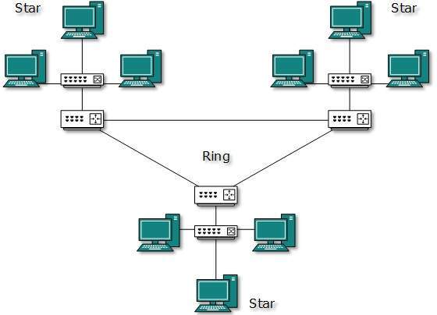

The above picture represents an arbitrarily hybrid topology. The combining topologies may contain attributes of Star, Ring, Bus, and Daisy-chain topologies. Most WANs are connected by means of Dual-Ring topology and networks connected to them are mostly Star topology networks. Internet is the best example of largest Hybrid topology

**Comparative Study of all topology in a tabular form**

|  |  |  |  |  |  |
| --- | --- | --- | --- | --- | --- |
| **Topology** | **Star** | **Bus** | **Ring** | **Mesh** | **Tree** |
| **Architecture/organization** | A network topology in which peripheral nodes are connected to a central node(such as a hub, switch, or router) which rebroadcasts all transmissions received from any peripheral node to all peripheral nodes on the network, including the originating node. All peripheral nodes may thus communicate with all others by transmitting to, and receiving from, the central node only | is a network topology in which there is a single line (the bus) to which all nodes are connected, and the nodes connect only to this bus. This is a bus line going through a city. The cable has a small cap installed at the end, called a terminator. The terminator prevents signals from bouncing back and causing network errors. Like a series of pipes that water travels through | A network topology in which every node has exactly two branches connected to it. A star-wired ring topology may appear (externally) to be the same as a star topology. Internally, the MAU (multi station access unit) of a star-wired ring contains wiring that allows information to pass from one device to another in a circle or ring. point-to point links in a closed loop. | A network topology in which there are at least two nodes with two or more paths between them. | The nodes are arranged as a tree. The tree topology is a generalization of the bus topology. The transmission medium is a branching cable with no closed loops. The tree layout begins at a point known as the head end(Root), where one or more cables start, and each of these may have branches. The branches in turn may have additional branches to allow quite complex layouts. |
| **Routing Methodology** | All information passes through the central network connection. | One computer at a time sends information. Information goes along the cable and the computer accesses the information off the cable. | Information goes in one direction around the ring and passes along the ring until it reaches the correct computer. | Often used across long distances. Information transfer can happen indifferent ways, depending on the other topologies. | a transmission from any station Propagates throughout the medium and can be received by all other stations. . A host that is a branch off from the main tree is called a  ‘leaf’. |
| **Complexity** | Very simple(Used for LANs) | The Simple stone(Used for LANs) | (Used for LANs) | Used for WANs | Used for WANs |
| **Expansion** | Add a new computer by plugging in a new cable from the computer to the connection device. | To add a computer, you must shut down the network and disconnect the cable from the existing computers. | Cable between the computers must be broken to add a new computer, so the network is down until the new device is back online. | Connection devices make combining different networks and different topologies easy. | The simplest to install and extend extra Stations in a daisy chain manner, |
| **Reliability** | When one computer goes down, the rest of the network is unaffected. If the connection device goes down, then the network is down. | If one computer malfunctions, the entire network goes down. | If there's a break in the cable or an error in the network, information continues to transfer through the rest of the ring until reaching the point of the break. This makes trouble shooting easy. | Troubleshooting is most difficult in this topology because of the variety of technologies. | N.W partitioned easily, but partitions still work. |
| **Cost** | More expensive of the simple topologies, it requires costly connection device. Usually cheaper than a hybrid network. | A cheaper network since there is usually one continuous copper cable. | One of the more expensive topologies due to high cable costs. | Expensive, large, and usually complicated. | Costly because it is heavily cabled |
| **Cabling Concerns** | Uses twisted pair cable. Requires large amounts of cable. No more than 100meters from the computer to the connection device. | Single continuous cable connects the devices. Terminator is required at each end of the cable. Uses coaxial or twisted pair cabling. | Requires more cabling than other topologies. Uses twisted pair. | Cabling depends on the types of networks. Can use twisted pair and coaxial cable. Also incorporates fiber optic cabling overlong distances. | Overall length of each segment is limited by the type of cabling used. |
| **Security** | denial of service attack | Not secure cause broadcast | The least security as the information Intended for one machine must pass all the others | A mesh needs secure links, routing, and forwarding | Low security as it physically star but logically bus |
| **Delay/Response time** | Excellent in terms of distance | Delay cause broadcast | Good | Trade off with cost | Not bad (No data collisions.) |