

**PRACTICAL JOURNAL OF**

**COMPUTER NETWORKS (IT-502)**

**BTECH: Third Year**

**Department of Information Technology**

|  |  |  |
| --- | --- | --- |
| **Name of Student** | **:** | **___Suryakaran Tiwari____________________.** |
| **Branch & Section** | **:** | **____IT-2____________________.** |
| **Roll Number** | **:** | **____0827IT181104__________________.** |
| **Year** | **:** | **____III year____________________.** |

**Experiment-13**

**Create a Star topology of 4 computer**

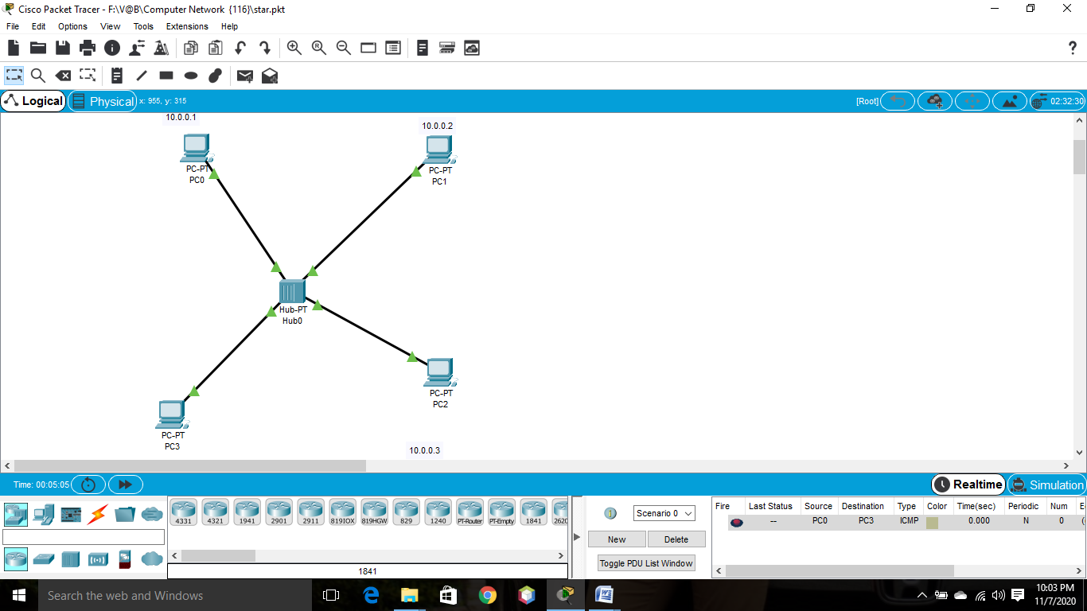

**Create a Ring topology of 4 computer**

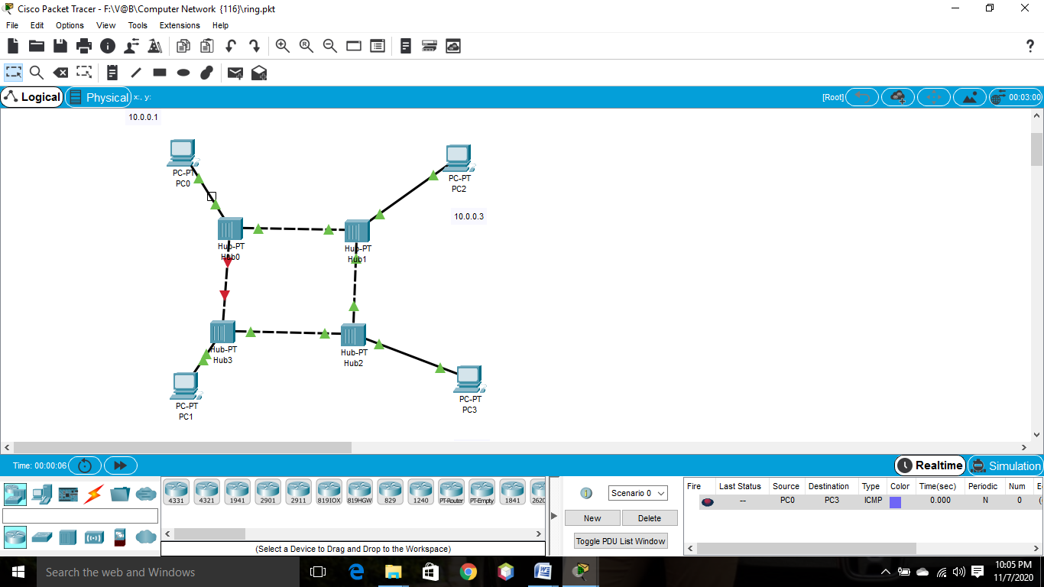

**Create a Mesh topology of 4 computer**

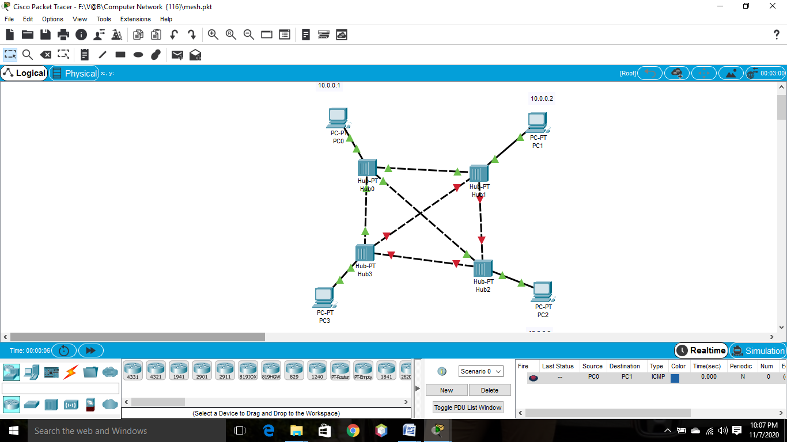

**Create a bus topology of 4 computer**

