

**PRACTICAL JOURNAL OF COMPUTER NETWORKS**

**B. TECH : Third Year**

**Department of Information Technology**

##### Name :

**S uryakaran Tiwari**

**Branch & Section :**

**I nformation Technology (IT-2)**

**Roll Number :**

**0 827IT181104**

**Year :**

**3 r d Year**

**Experiment-4**

**Aim**:-

**Run Network commands and display their output.**

1. Hostname:

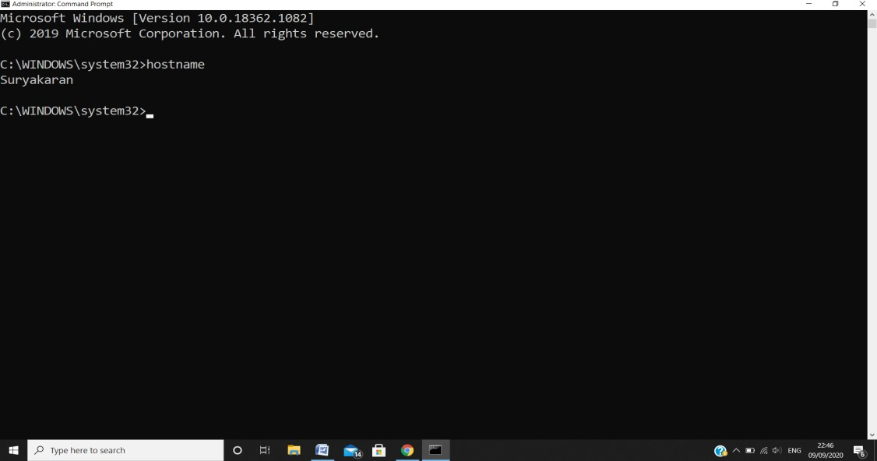

1. Ping:

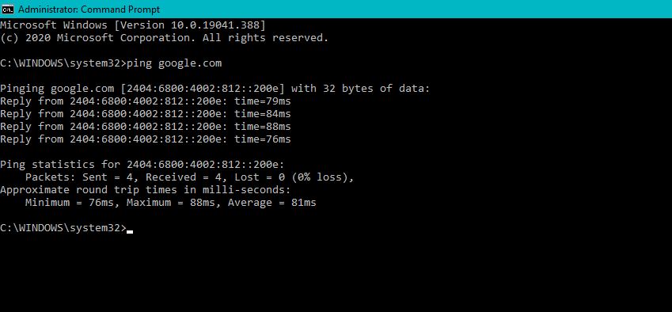

1. Arp:

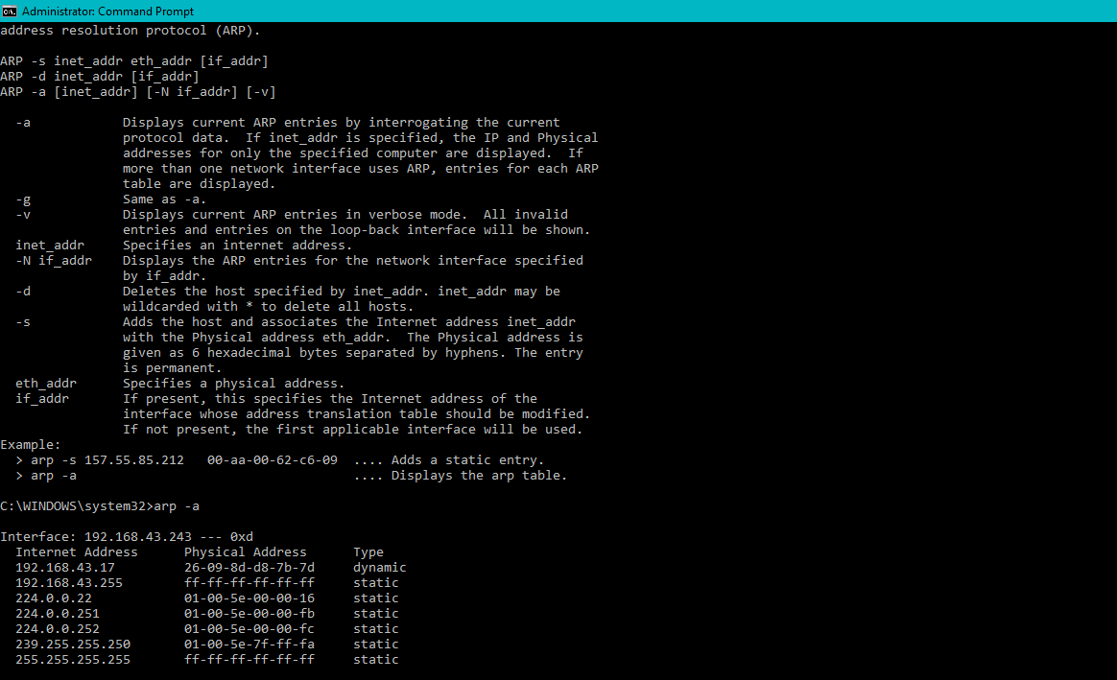

1. Tracert:

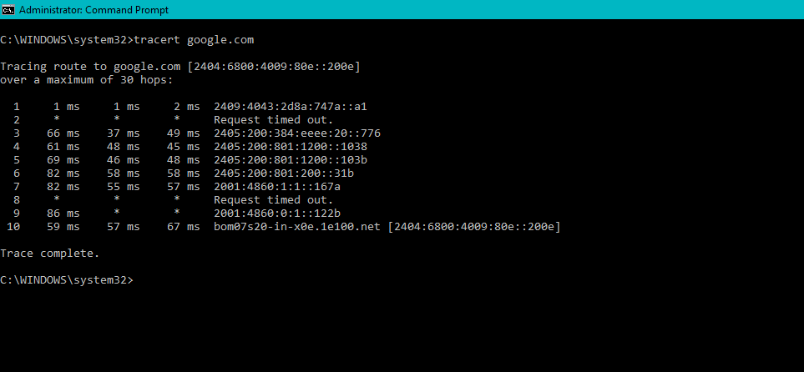

1. Netstat:

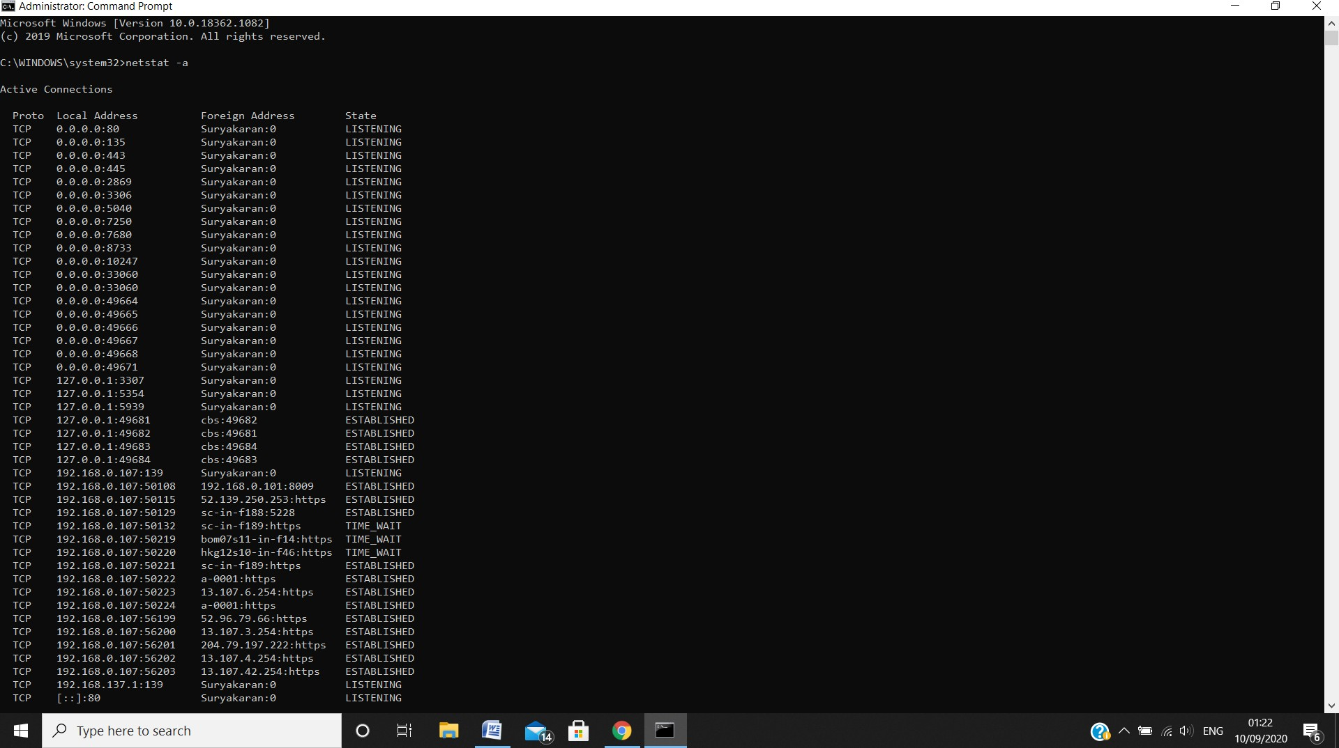

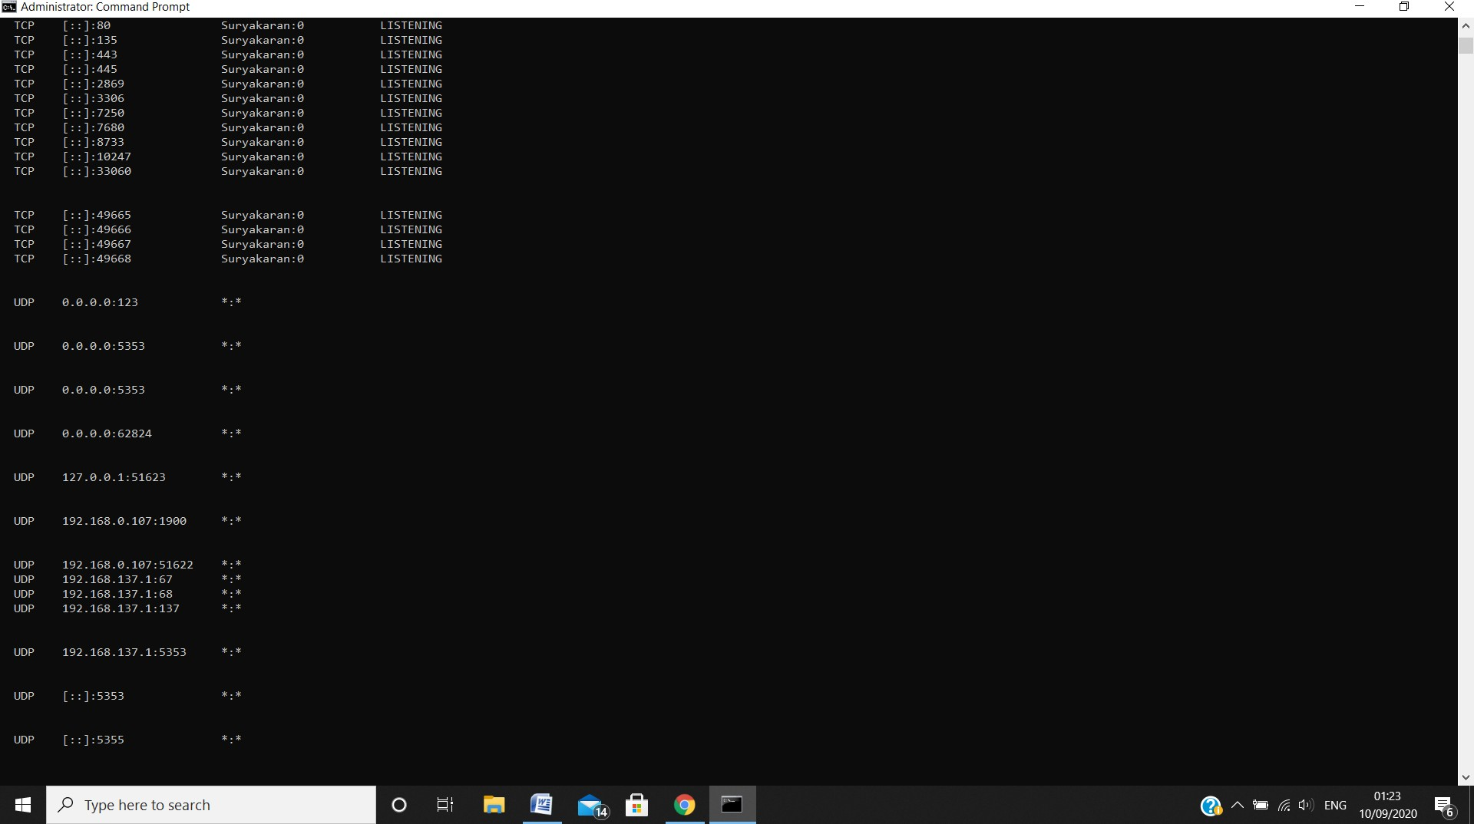

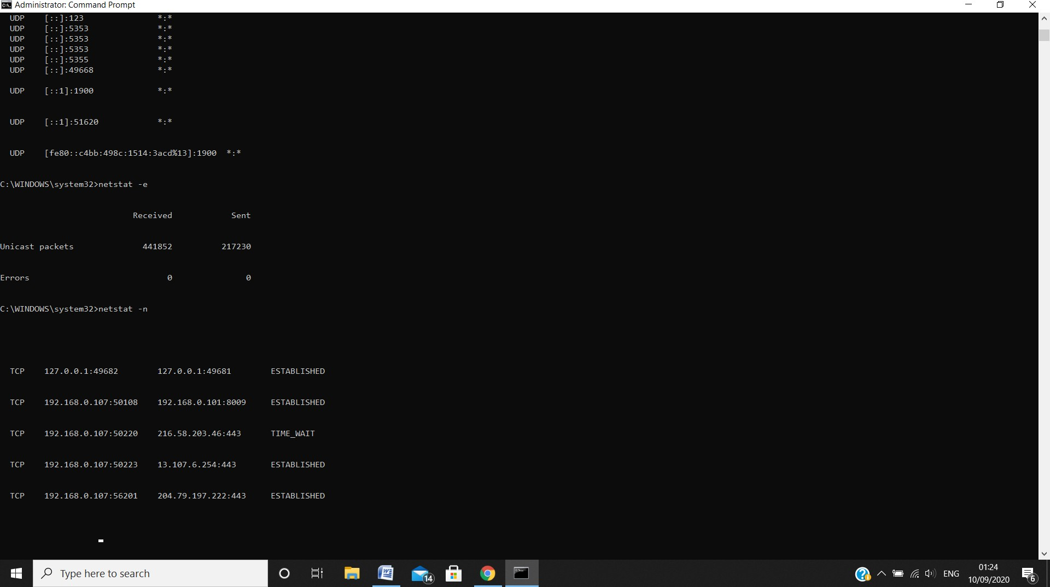

1. Ipconfig:

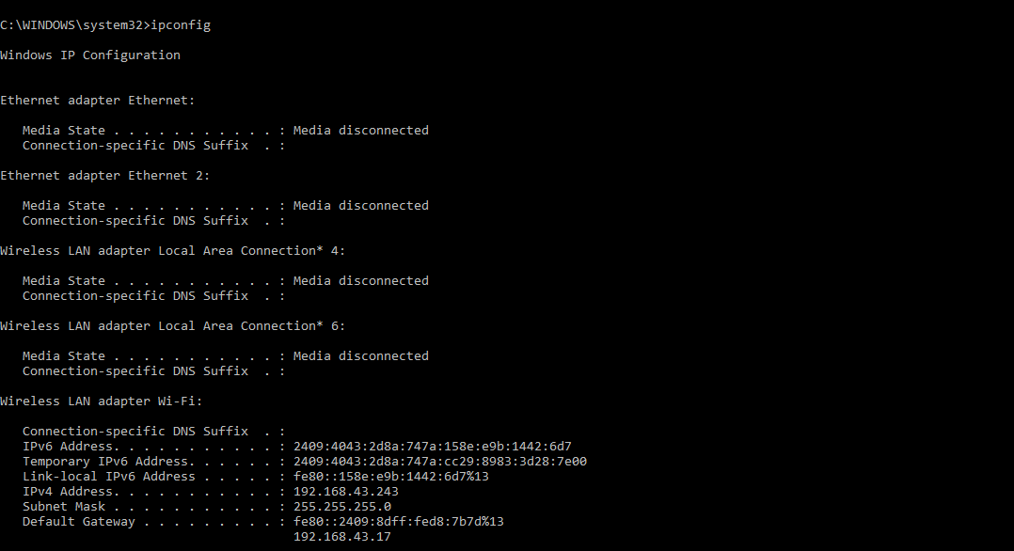

1. Ipconfig all:

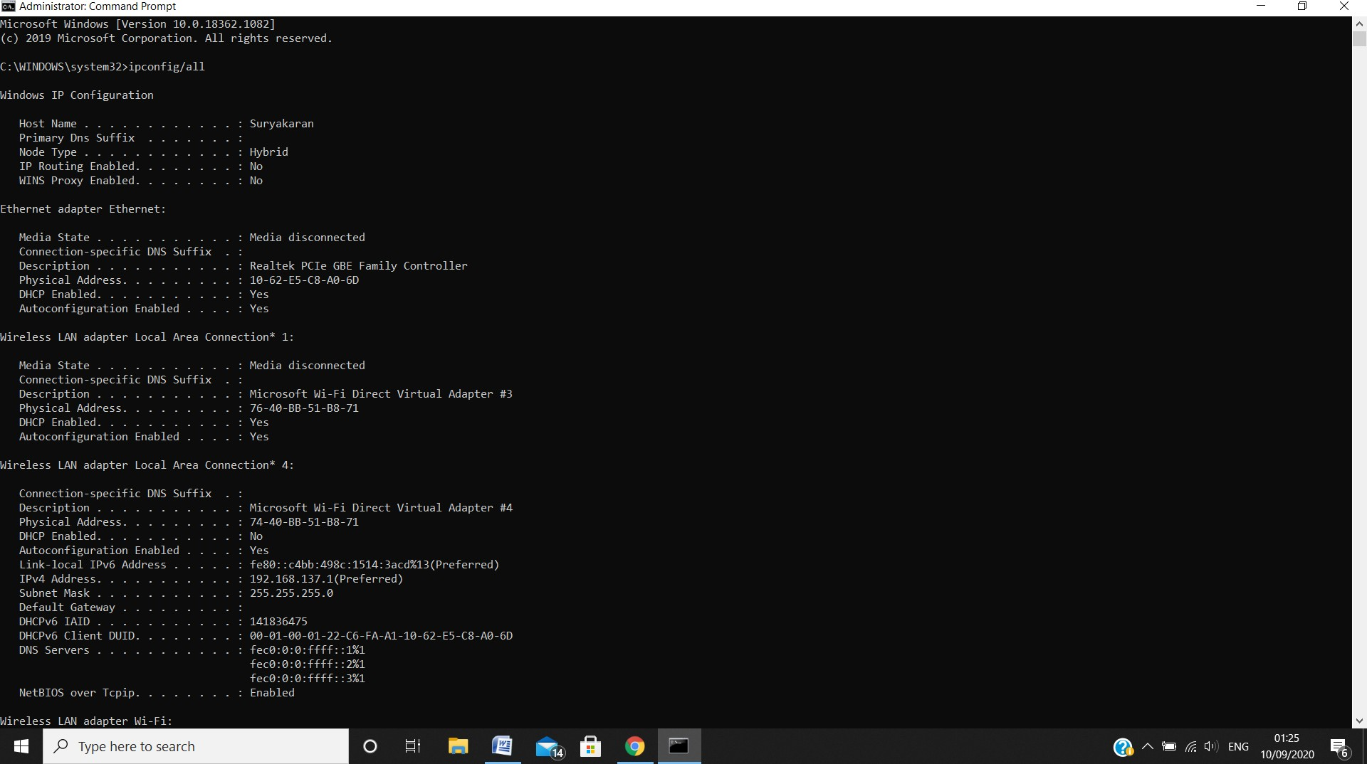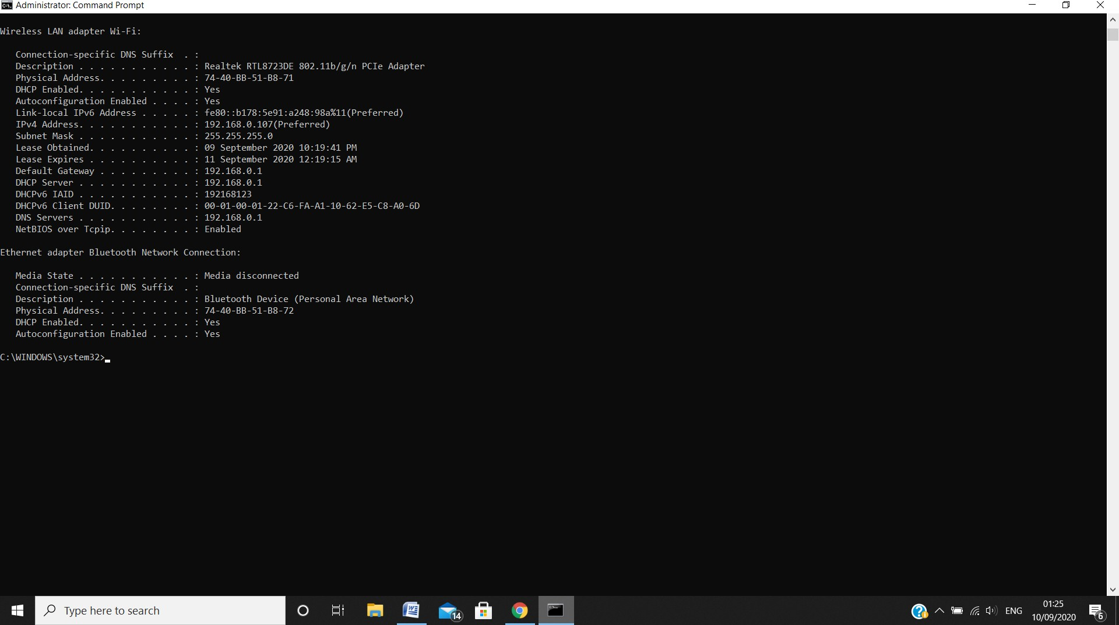

1. Getmac:

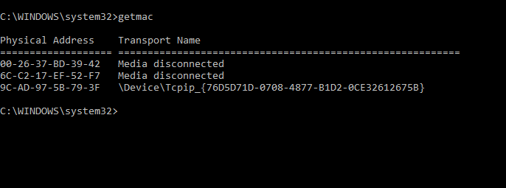

1. Nbtstat:

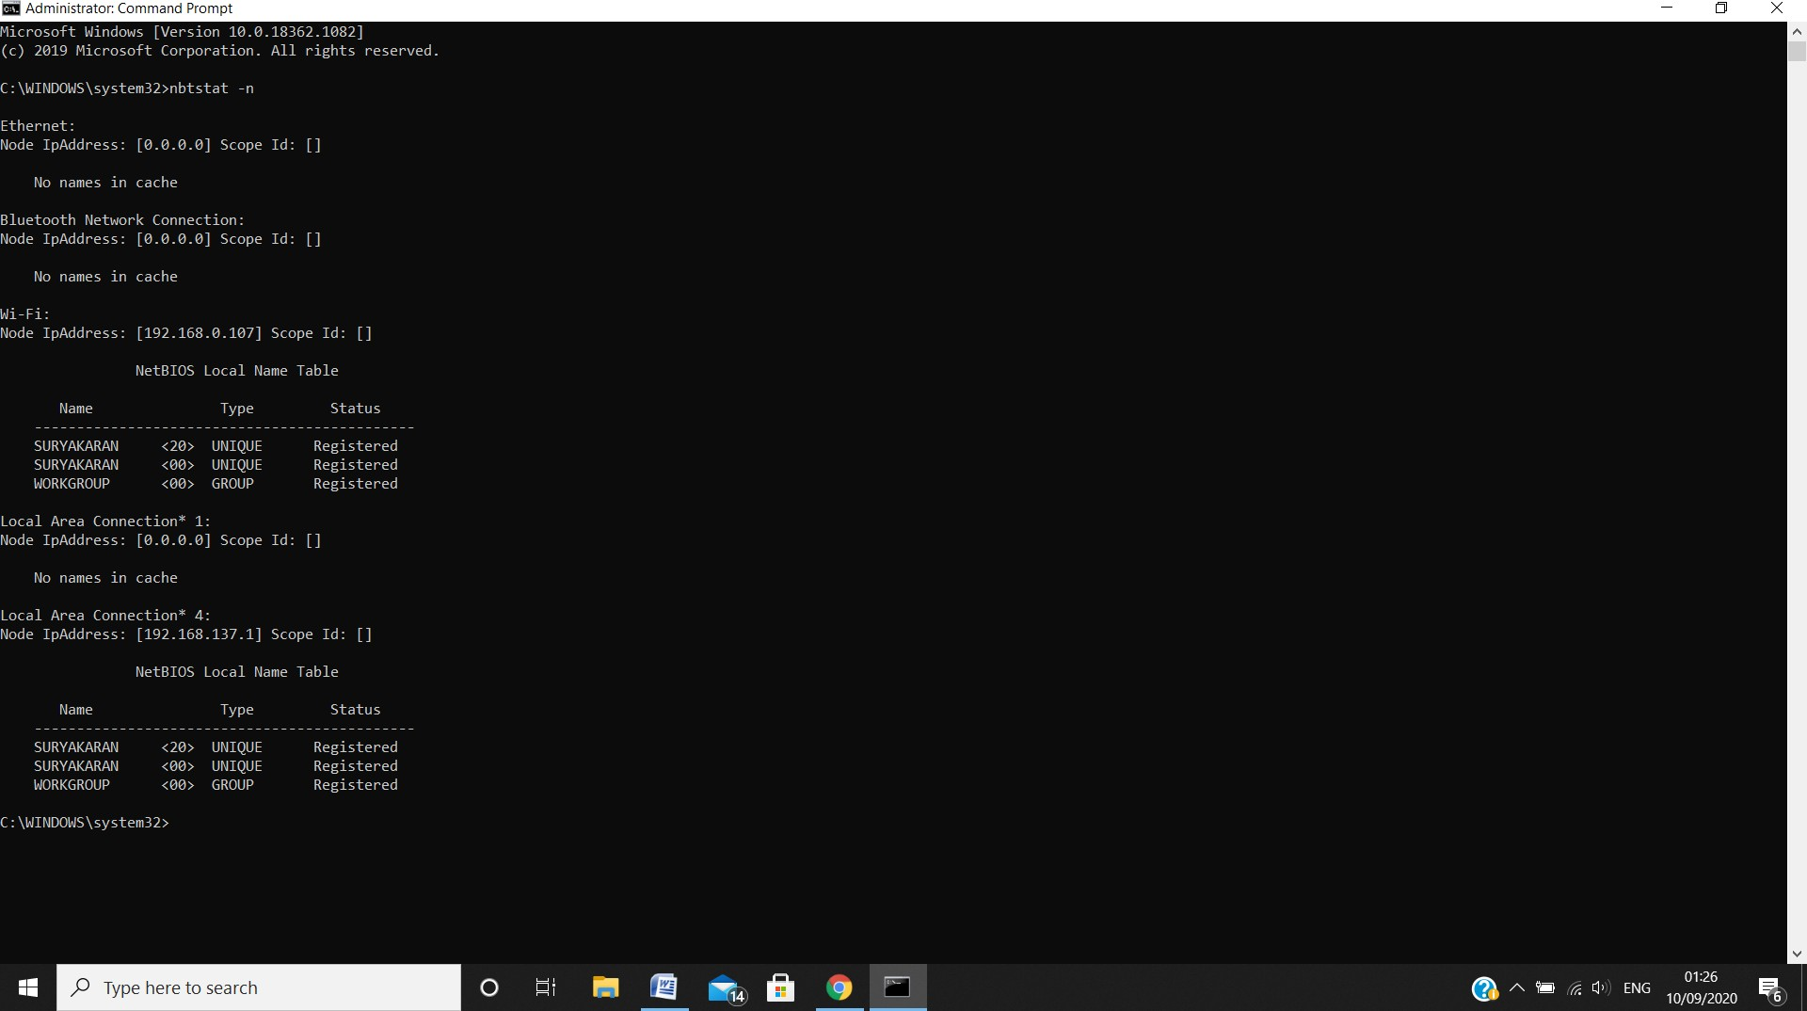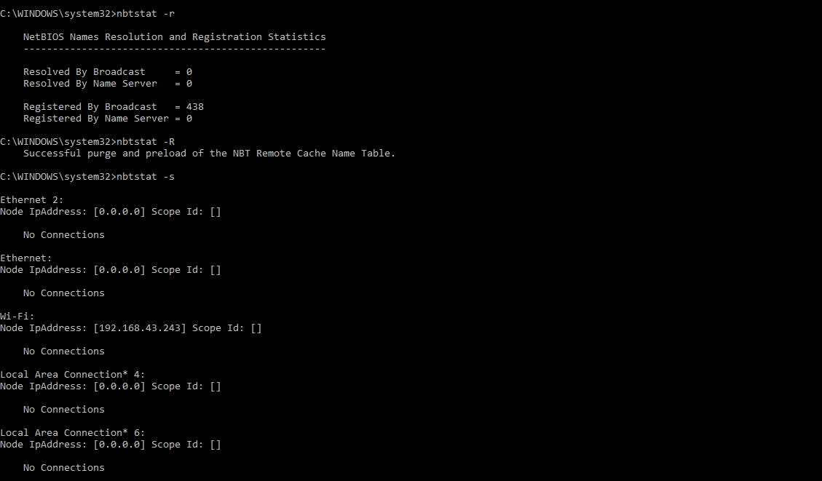

10 .Nslookup:

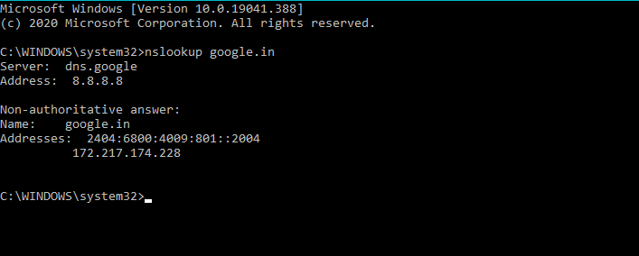

11. Route:

