

**PRACTICAL JOURNAL OF**

**COMPUTER NETWORKS (IT-502)**

**BTECH: Third Year**

**Department of Information Technology**

|  |  |  |
| --- | --- | --- |
| **Name of Student** | **:** | **__Suryakaran Tiwari_____________________.** |
| **Branch & Section** | **:** | **____IT-2____________________.** |
| **Roll Number** | **:** | **____0827IT181104____________________.** |
| **Year** | **:** | **____III year____________________.** |

**Department of Information Technology**

**AITR, INDORE**

**Experiment-3**

**How to configure LAN network**

1. Open control panel and select network and internet:

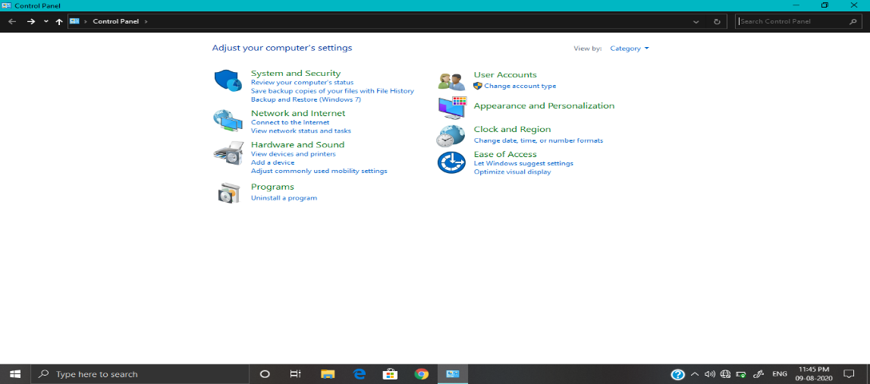

1. Then select network and sharing center:

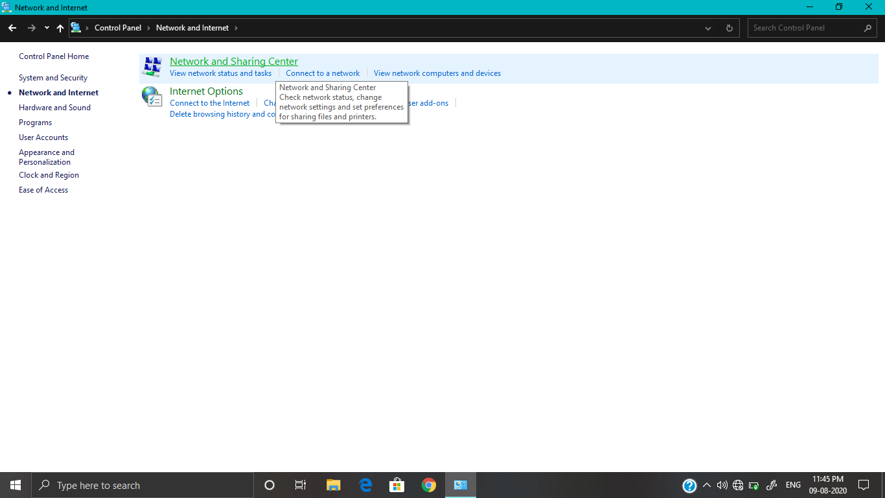

1. Click change adapter settings:

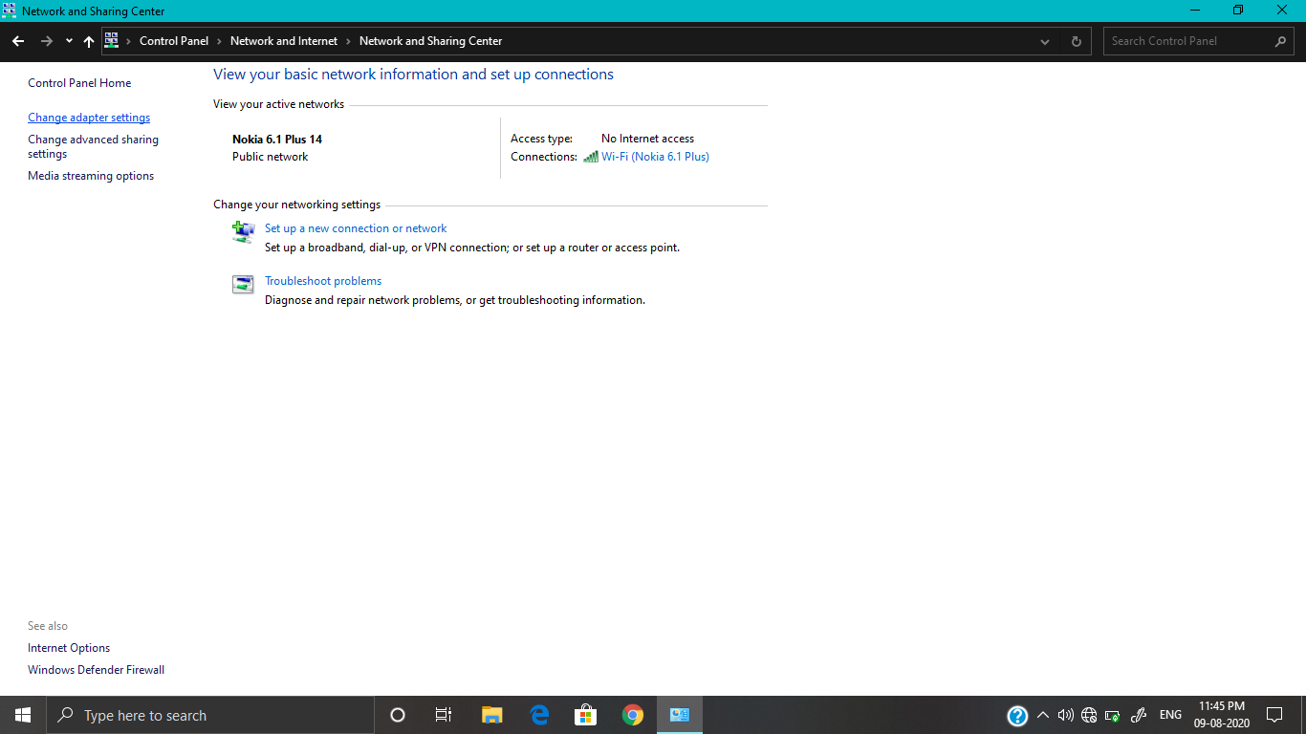

1. Right click on ethernet:

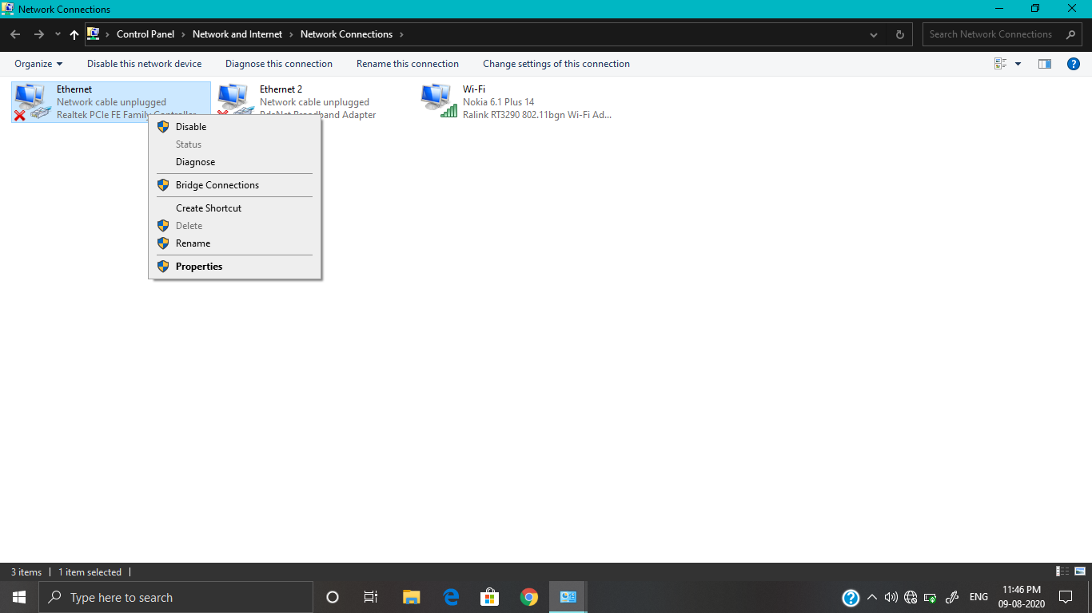

1. Go to properties:

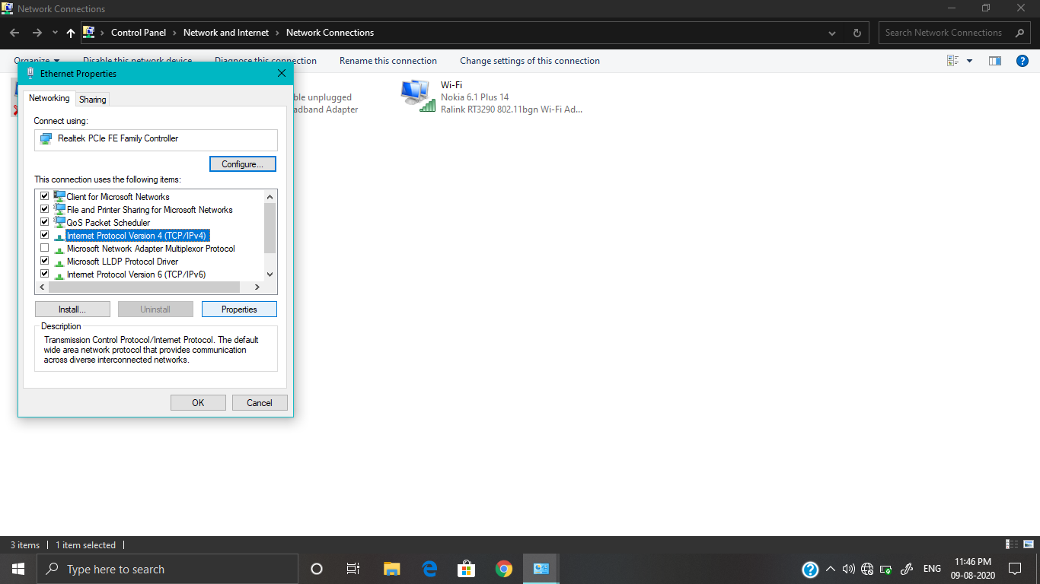

1. Open Internet protocol 4 properties:

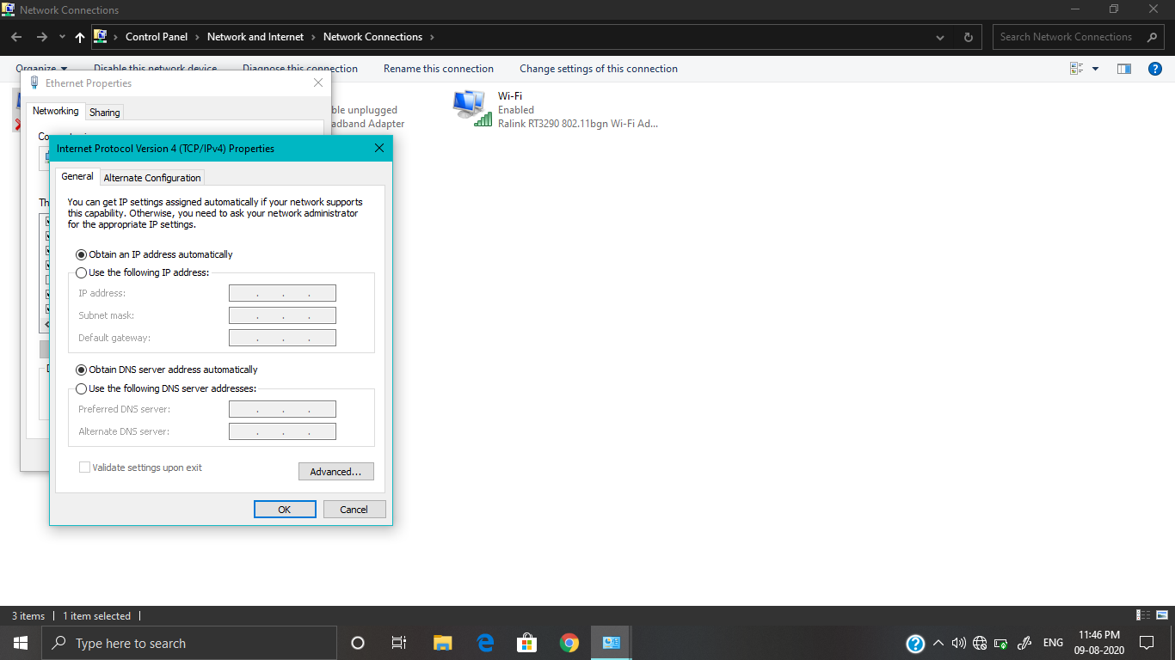

And then configure the details according to ISP.