|  |  |  |  |  |
| --- | --- | --- | --- | --- |
| Name of Student: Suryakaran Tiwari | | | | Class: IT-2 |
| Enrolment No: 0827IT181104 | | | | Batch: 2 |
| Date of Experiment: 1-10-20 | Date of Submission: 7-10-20 | | | Submitted on: |
| Remarks by faculty: | | | Grade: | |
| Signature of student: | | Signature of Faculty: | | |

**Experiment 10**

**LAN of 8 computers using 2 switch**

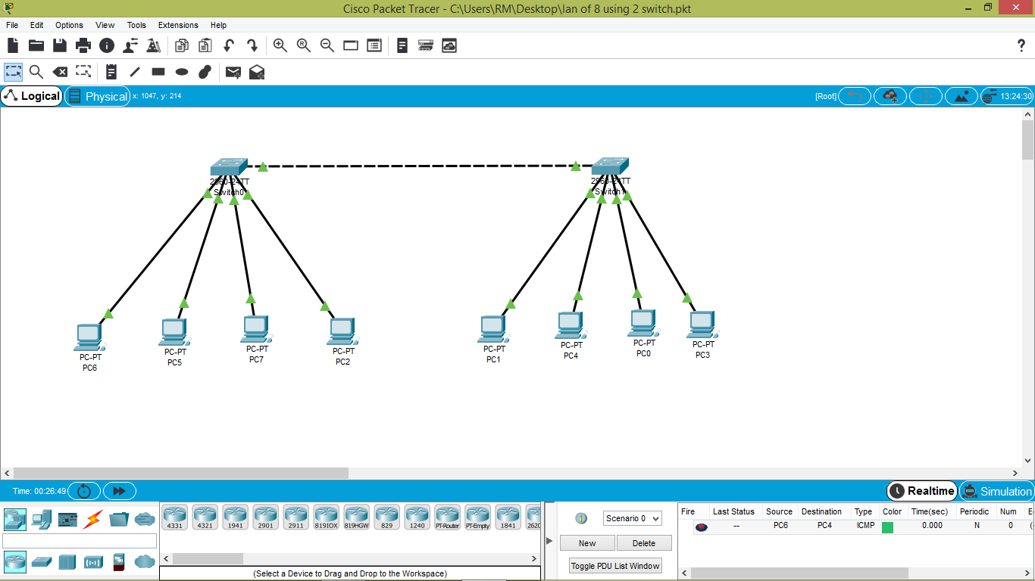

**Using PING command:**

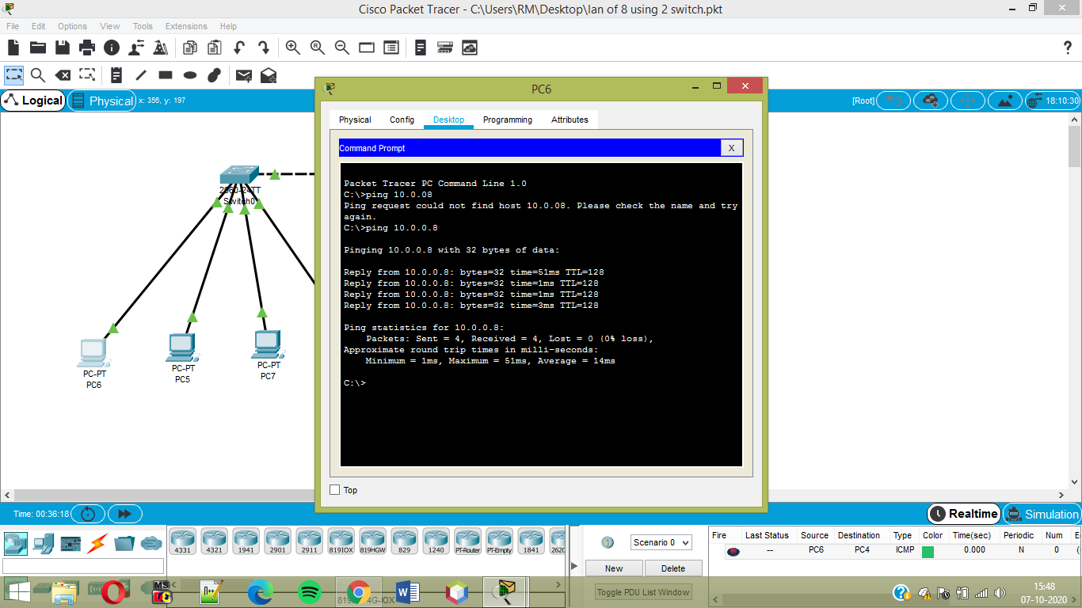

**Using PDU :**

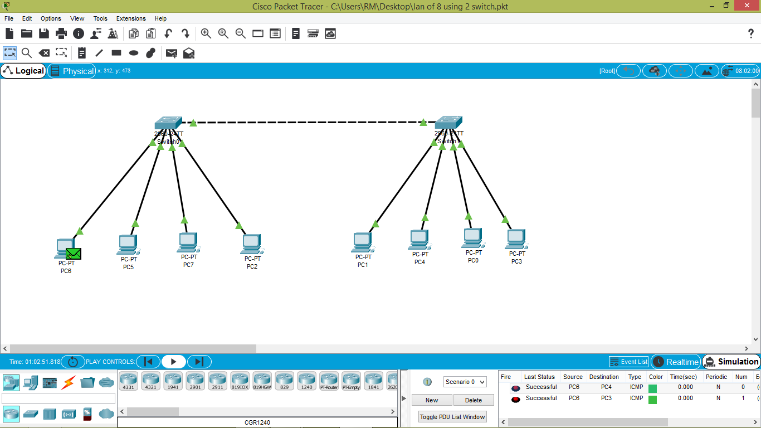

**LAN of 4 computers using a switch:**

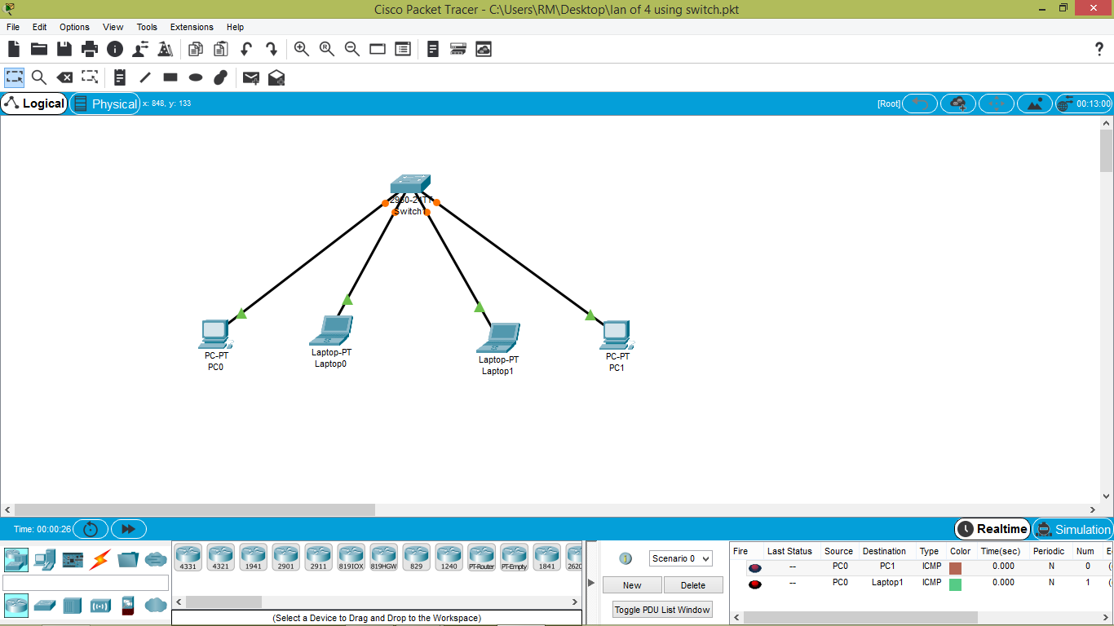

**Using PING command**

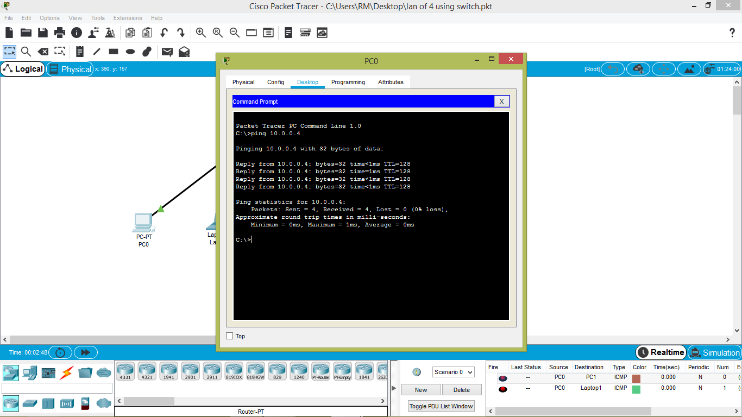

**Using PDU**

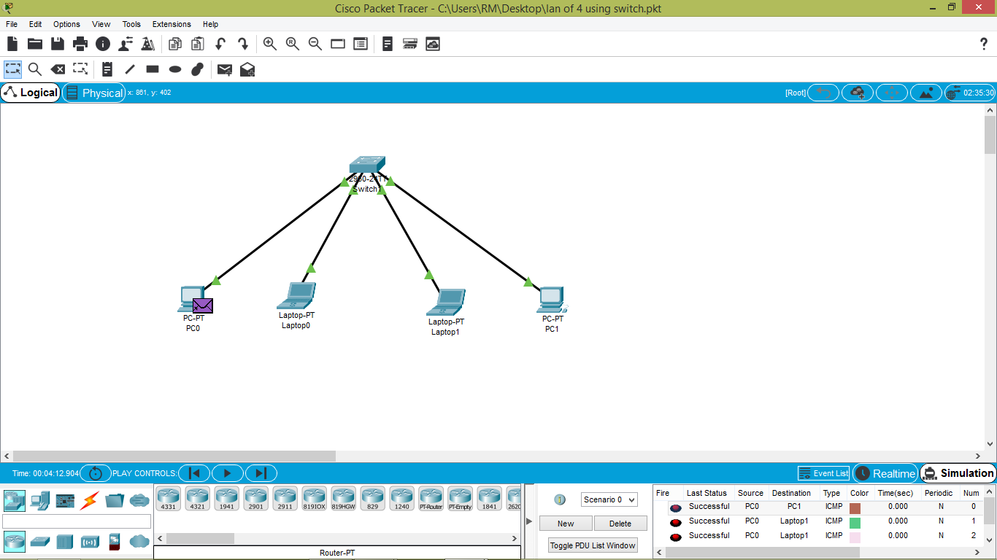

**LAN of 8 computers using 2 switch& one router**

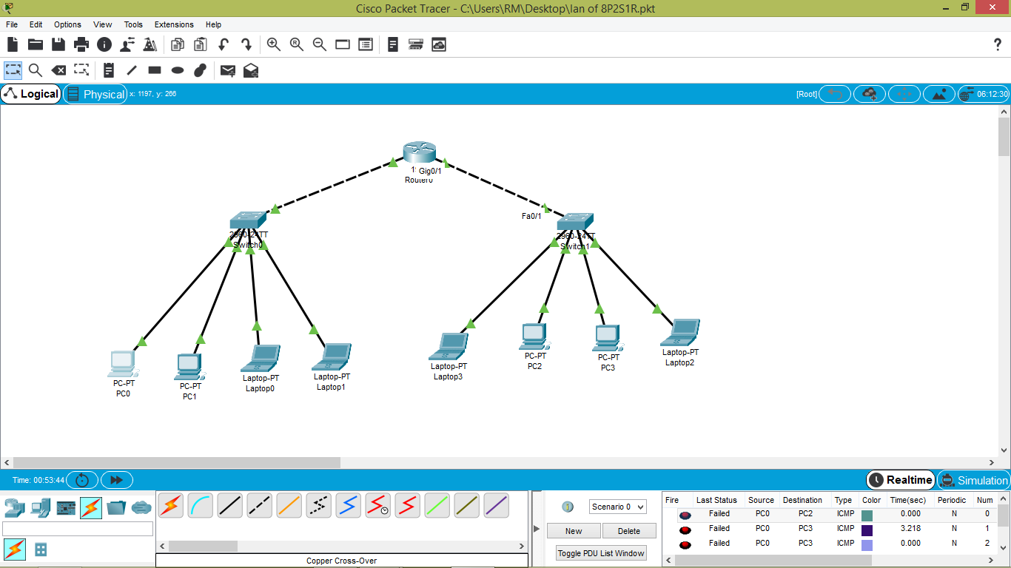

**Ping command:**

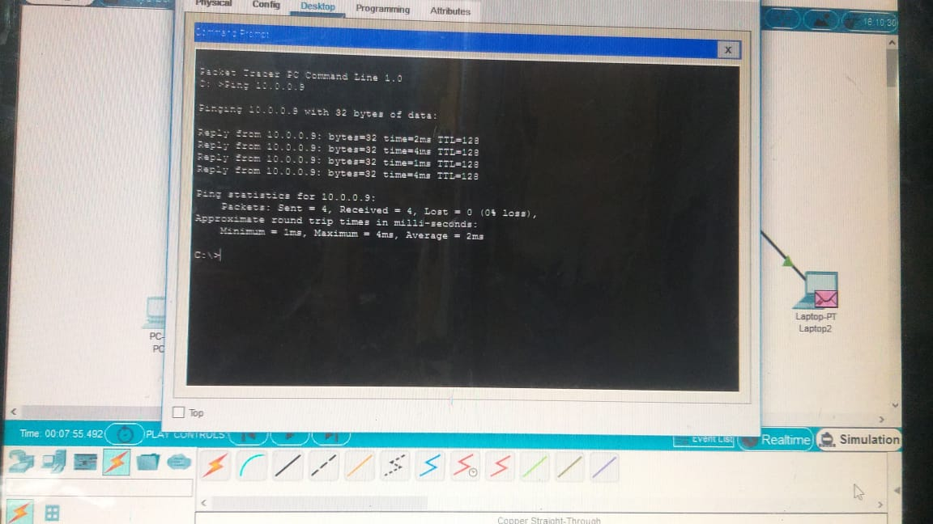

**Using PDU**

