**Computer Network**

**Assignment-11**

**Submitted by:-**

Suryakaran Tiwari

IT-2

III year

0827IT181104

**Question .1**

Explain Network Devices and its different types with their properties and applications alongwith diagram/pics.

**Answer.1**

**Network Devices**

The devices which are used for communication between different hardware’s used in the computer network are known as network devices. These devices are also known as physical devices, networking hardware, and network equipment otherwise computer networking devices.

**Types of Network Devices**

There are different types of network devices used in a computer network which include the following.

* Network Hub
* Network Switch
* Modem
* Network Router
* Bridge
* Repeater
* **Network Hub**

The network hub is one kind of networking device in a computer network, used to communicate with various network hosts and also for data transferring. The transferring of data in a computer network can be done in the form of packets. Whenever the [data processing](https://www.elprocus.com/data-processing-types-and-its-applications/) can be done from a host to a network hub, then the data can transmit to all the connected ports. Similarly, all the ports identify the data path which leads to inefficiencies & wastage. Because of this working, a network hub cannot be so safe and secure.

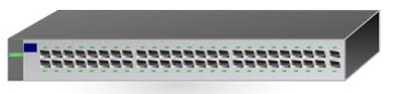

### Network Switch

Similar to a hub, this is also working at the layer in the LAN and a switch is more clever compare with a hub. As the hub is used for data transferring, whereas a switch is used for filtering & forwarding the data. So this is the more clever technique to deal with the data packets.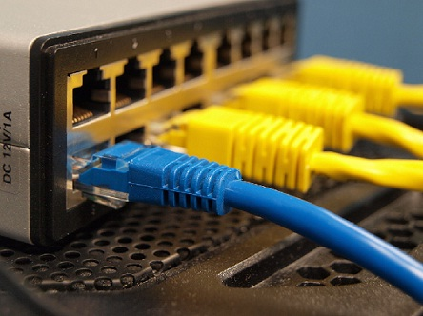

Whenever a data packet is obtained from the interfaces in the switch, then the data packet can be filtered & transmits to the interface of the proposed receiver.

### Modem

A modem is the most important network device and it is used daily in our life. If we notice the internet connection to homes was given with the help of a wire. then wire carries internet data from one place to another. But, every computer gives digital or binary data in the form of zeros & ones.

The full form of the modem is a modulator and a demodulator. So it modulates as well as demodulates the signal among the computer and a telephone line because the computer generates digital data whereas the telephone line generates an [analog signal](https://www.elprocus.com/differences-between-analog-signal-and-digital-signal/).

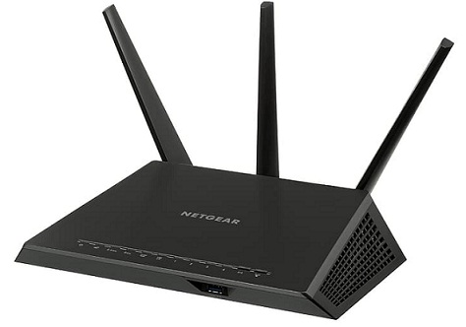

### Network Router

A network router is one kind of network device in a computer network and it is used for routing traffic from one network to another. These two networks could be private to a public company network. For example, here a router is considered as traffic police at the junction, he directs dissimilar traffic networks to dissimilar directions.

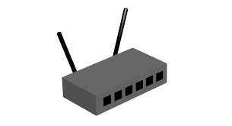

### Bridge

A Bridge in the computer network is used to unite two or more network segments. The main function of a bridge in network architecture is to store as well as transmit frames among the various segments. Bridges use MAC (Media Access Control) hardware for transferring frames.

These are also used for connecting two physical local area networks to a larger logical local area network. In the OSI model, bridges work at the data link & physical layers to divide the networks from larger to smaller by controlling the data flow between the two. In recent years, bridges are replaced by switches to provide more functionality.

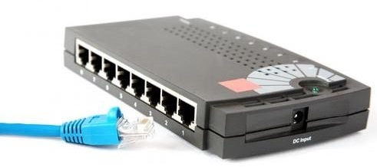

### Repeater

The operating of a repeater can be done at the physical layer. The main function of this device is to reproduce the signal on a similar network before the signal gets weak otherwise damaged. The significant point to be noted regarding these devices is that they do not strengthen the signal. Whenever the signal gets weak, then they reproduce it at the actual strength. A repeater is a two-port device.

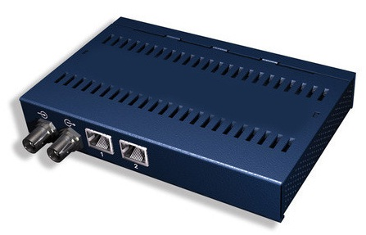

### Gateway

Generally, a gateway performs at the session & transport layers in the OSI model. Gateways offer conversion between networking technologies like OSI (Open System Interconnection) & [TCP/IP](https://www.elprocus.com/tcp-ip-protocol-architecture-and-its-layers/). Because of this, these are connected to two or many autonomous networks, where each network has its own domain name service, routing algorithm, topology, protocols, and procedures of network administration & policies.

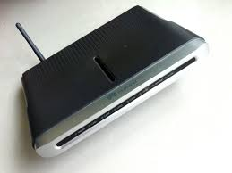

**Comparative study of networking devices in tabular form.**

|  |  |  |  |  |  |  |
| --- | --- | --- | --- | --- | --- | --- |
| **Criteria** | **Repeater** | **Hub** | **Bridge** | **Switch** | **Router** | **Gateway** |
| **Main Work** | Regenerate the signal | Send Data to all Node | Send data | To send data at destination port in frame. | To connect LAN-WAN  and decide route. | To connect different network architecture and protocol  For data send. |
| **Deal with** | Signal (Bits) | Bits | Frame | Frame | Packet | Packet/Message |
| **Layer** | Physcial Layer | Physical Layer | Data link Layer | Data link Layer | Network Layer | Network,  Application,  Presentation and Session Layer. |
| **Addressing** | 1-1 port | Broadcast | MAC Addressing | MAC Addressing | IP Address | IP Address |
| **Routing Decision** | NO | NO | NO | NO | YES | YES |
| **Cost** | Cheapest | Low | Low | Medium | High | High |
| **Deployment** | Plug and Play | Plug and Play | Plug and Play | Plug and Play | Installation ,Administration | Installation ,Administration |
| **Broadcasting** | No | Yes | yes | Yes | Yes | Yes |
| **Filtering** | No | no | YES(Based on MAC Address) | Yes | YES(Based on IP Address) | YES(Based on IP Address) |
| **No. of Port** | 2(one for incoming and 1 for outgoing) | More than 2 | 2(one for incoming and 1 for outgoing) | Multi Port | More than 2 | 2port |
| **Intelligent Device** | No | no | no | Yes(moderate) | yes | Yes |