**Work Acceptance Letter**

From: KAUSALLIYA R

Hariharan illam(H)

Chalikkadavu,muvattupuzha

Ernakulam

Pin :686673

To: Altos Technologies,

Carnival Infopark Phase I, First Floor,

Infopark Campus, Kakkanad, Kochi, Kerala 682042

Work List:

Training website

Start Date: 11/04/2023

End Date: 12/04/2023

Sir,

I do accept the above mentioned work and I will submit that on or before deadline without any corrections and errors. In future if any error occurs in my work, it’s my responsibility to solve that. I do here by solemnly affirm and declare that all information and particulars furnished here by me are true and correct to the best of my knowledge.

Date:11/04/2023

Place: Muvattupuzha

Yours Faithfully

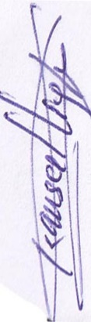

Kausalliya R