**ASSIGNMENT-3**

1. **. What is Flask, and how does it differ from other web frameworks?**

Flask is a micro web framework for Python based on Werkzeug, Jinja2, and good intentions. It is designed to be lightweight and modular, allowing developers to build web applications quickly and easily. Here are some key characteristics of Flask and how it differs from other web frameworks:

1. **Micro-framework**: Flask is often referred to as a micro-framework because it provides only the essential components for building web applications. This minimalist approach allows developers to have more flexibility and control over their code compared to larger, more opinionated frameworks.

2. **Flexibility**: Flask follows the principle of "convention over configuration," meaning it imposes few restrictions on how developers should structure their applications. This flexibility allows developers to choose their preferred tools and libraries for various tasks such as database integration, form validation, and authentication.

3. **Modularity**: Flask is highly modular, meaning it is composed of several independent components that can be used individually or together. For example, Flask includes a built-in development server, but developers can easily replace it with more robust servers like Gunicorn or uWSGI for production deployment.

4. **Extensibility**: Flask provides a simple yet powerful extension system that allows developers to add additional functionality to their applications. There are numerous Flask extensions available for tasks such as handling authentication, interacting with databases, and integrating with third-party services.

5. **Template engine**: Flask uses the Jinja2 templating engine, which is known for its simplicity and flexibility. Jinja2 allows developers to create HTML templates with placeholders for dynamic content, making it easy to generate dynamic web pages.

6. **URL routing**: Flask provides a built-in URL routing system that allows developers to define routes for different parts of their application. This routing system makes it easy to map URL patterns to specific view functions, providing a clean and organized way to handle incoming requests.

Overall, Flask's simplicity, flexibility, and extensibility make it a popular choice for developers who want to build web applications with Python. While it may not provide all the features and conveniences of larger frameworks like Django, its lightweight nature and minimalist design make it well-suited for a wide range of projects, from small personal websites to large-scale web applications.

1. **Describe the basic structure of a Flask application.**

A Flask application typically follows a basic structure that includes several key components. Here's a breakdown of the basic structure of a Flask application:

1. **Application Setup**: The first step in creating a Flask application is to set up the application instance. This involves importing the Flask class from the Flask package and creating an instance of it.

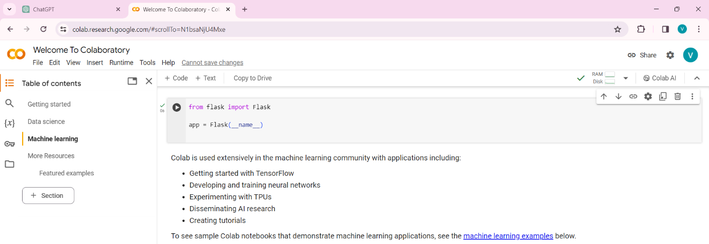

1. **Routes**: Routes are URL patterns that define how the application responds to incoming requests. In Flask, routes are typically defined using the **@app.route** decorator. Each route is associated with a specific view function that handles the request and returns a response.

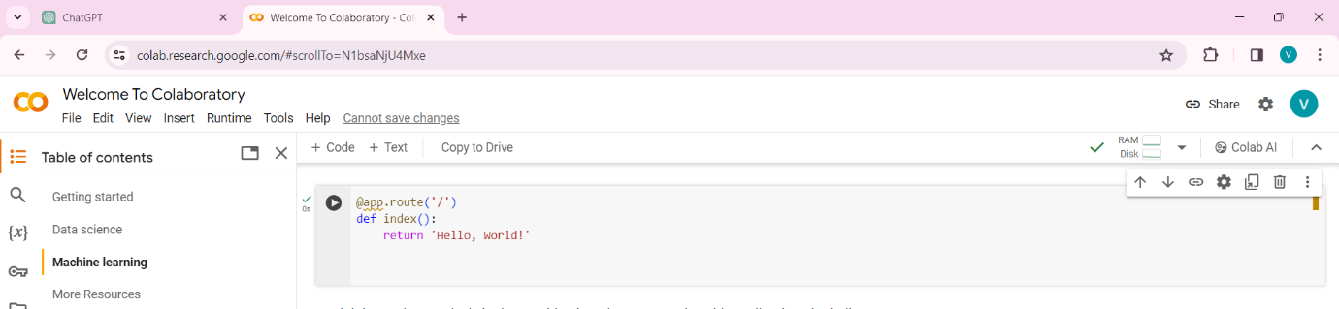

1. **Vew Fiunctions**: View functions are Python functions that handle requests and generate responses. These functions are associated with specific routes using the **@app.route** decorator. Inside a view function, you can perform tasks such as fetching data from a database, rendering templates, or processing form submissions.

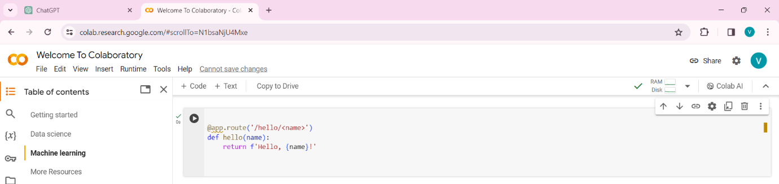

**Templates**: Templates are HTML files that contain placeholders for dynamic content. Flask uses the Jinja2 templating engine to render templates and inject dynamic data into them. Templates are typically stored in a directory called **templates** within the Flask application directory.

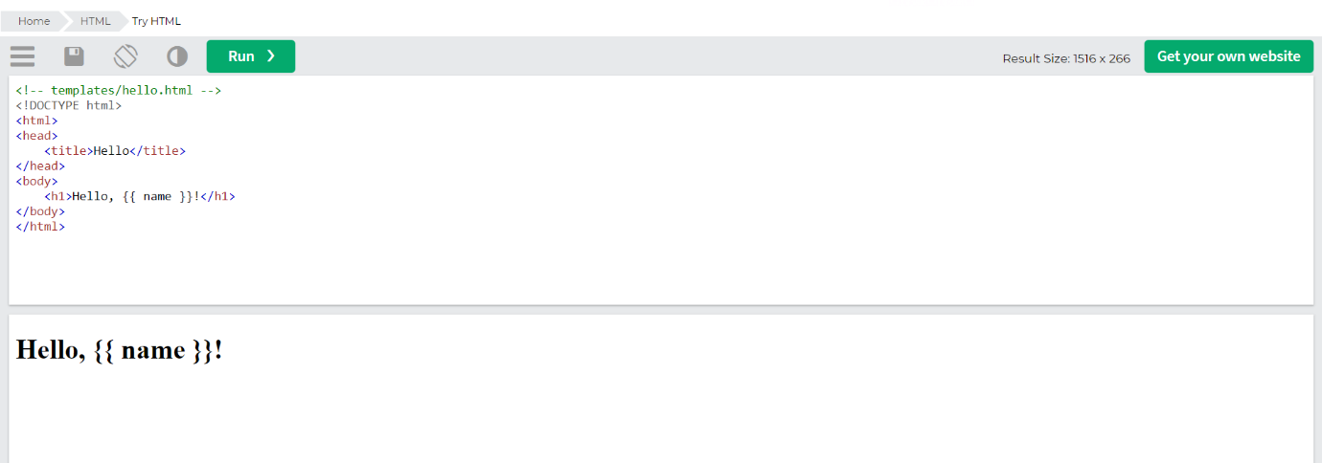

1. **Static Files**: Static files such as CSS stylesheets, JavaScript files, and images are served directly by the web server without any processing by the Flask application. These files are typically stored in a directory called **static** within the Flask application directory.
2. **Configuration**: Flask applications can be configured using configuration variables that control various aspects of the application's behavior. Configuration variables can be set directly on the **app** object or loaded from configuration files.

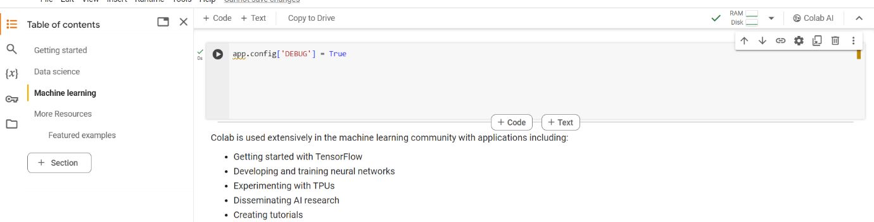

**Application Entry Point**: Finally, the Flask application needs to be run using the **run()** method of the application instance. This starts the development server and listens for incoming requests.

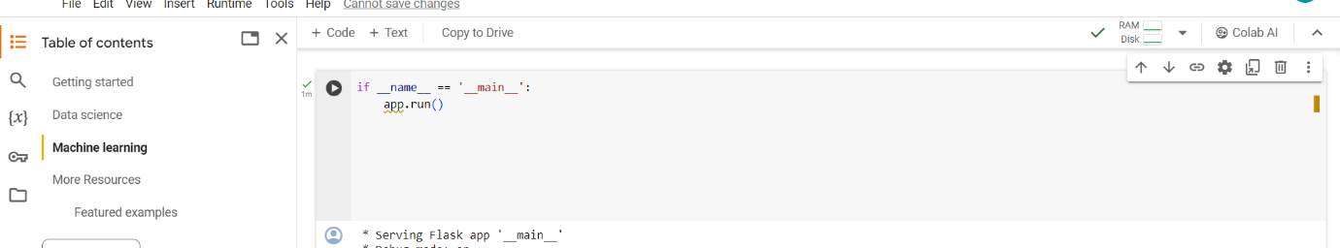This basic structure provides a foundation for building Flask applications, but as mentioned earlier, Flask is highly modular and flexible, allowing developers to customize and extend their applications as needed.

**3. How do you install Flask and set up a Flask project?**  
To install Flask and set up a Flask project, you can follow these steps:

1. **Install Python**: First, ensure you have Python installed on your system. You can download and install Python from the official website: <https://www.python.org/downloads/>
2. **Install Flask**: Once Python is installed, you can install Flask using pip, which is Python's package installer. Open a terminal or command prompt and type the following command:

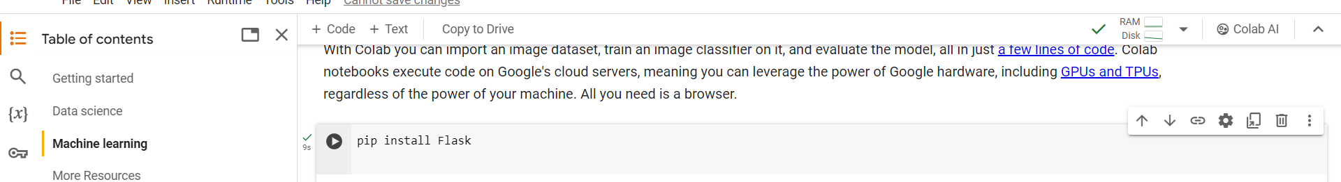

**Create a Flask Project Directory**: Create a new directory for your Flask project. You can do this using the command line or through your file explorer.

**Set Up a Virtual Environment** (Optional but recommended): It's a good practice to use a virtual environment for your Flask project to isolate its dependencies from other projects. Navigate to your project directory in the terminal and create a virtual environment:

**Code: python -m venv venv**

Activate the virtual environment:

* On Windows:

**Code: venv\Scripts\activate**

On macOS and Linux:

**Code: source venv/bin/activate**

**Create Flask App**: Inside your project directory, create a Python file for your Flask application. You can name it **app.py** or any other appropriate name. Here's a basic example of a Flask app:

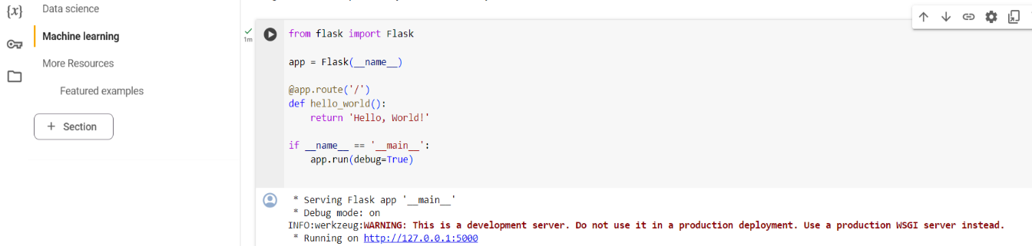

**Run the Flask App**: In the terminal, navigate to your project directory and run the Flask app:

**Code: python app.py**

1. This will start the development server. You should see output indicating that the Flask app is running.
2. **Access Your Flask App**: Open a web browser and navigate to **http://127.0.0.1:5000/** or **http://localhost:5000/**. You should see the "Hello, World!" message displayed, indicating that your Flask app is working correctly.

That's it! You have now installed Flask and set up a basic Flask project. From here, you can continue to develop your Flask application by adding routes, templates, and other features as needed.

**4.Explain the concept of routing in Flask and how it maps URLs to Python functions.**

In Flask, routing refers to the process of mapping URLs (Uniform Resource Locators) to specific Python functions within your Flask application. These Python functions are called view functions, and they handle HTTP requests sent to particular URLs.

Here's how routing works in Flask:

1. **Defining Routes**: In your Flask application, you define routes using the **@app.route()** decorator provided by Flask. This decorator associates a URL pattern (route) with a Python function.

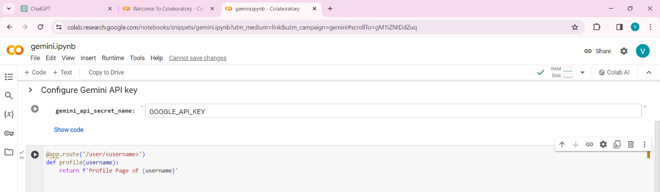  
In this example, we have three routes: **/**, **/about**, and **/contact**, each mapped to a specific view function (**index()**, **about()**, and **contact()** respectively).

1. **URL Mapping**: When a client makes an HTTP request to your Flask application, the Flask server examines the requested URL and matches it against the defined routes. If a matching route is found, Flask calls the associated view function to handle the request.

For example, if a client requests the URL **/about**, Flask will invoke the **about()** function and return the response generated by that function.

1. **Dynamic Routes**: Flask also supports dynamic routes, where parts of the URL can vary. You can define dynamic routes using placeholders in the URL pattern. These placeholders capture variable parts of the URL and pass them as arguments to the associated view function.



1. In this example, the **<username>** placeholder in the route pattern **/user/<username>** captures any string provided in the URL after **/user/**, and passes it as an argument to the **profile()** function.
2. **HTTP Methods**: You can also specify HTTP methods (GET, POST, PUT, DELETE, etc.) for routes. By default, routes accept GET requests, but you can specify other methods using the **methods** parameter of the **@app.route()** decorator.

**Code: @app.route('/login', methods=['GET', 'POST'])**

**def login():**

**# Code to handle login**

In this example, the **login()** function handles both GET and POST requests to the **/login** URL.

Routing in Flask allows you to create clean and structured URLs for your web application, making it easy to organize and manage different parts of your application's functionality. By mapping URLs to Python functions, Flask provides a flexible and intuitive way to handle incoming HTTP requests and generate appropriate responses.

**5. What is a template in Flask, and how is it used to generate dynamic HTML content?**

In Flask, a template is an HTML file that contains placeholders and control structures which Flask replaces with actual values when rendering the HTML page. Templates allow you to generate dynamic HTML content by combining static HTML with dynamic data from your Flask application.

Here's how templates are used to generate dynamic HTML content in Flask:

**Rendering Templates**: Flask uses a templating engine, typically Jinja2, to render templates. To render a template, you use the **render_template()** function provided by Flask, passing the name of the template file and any necessary data.

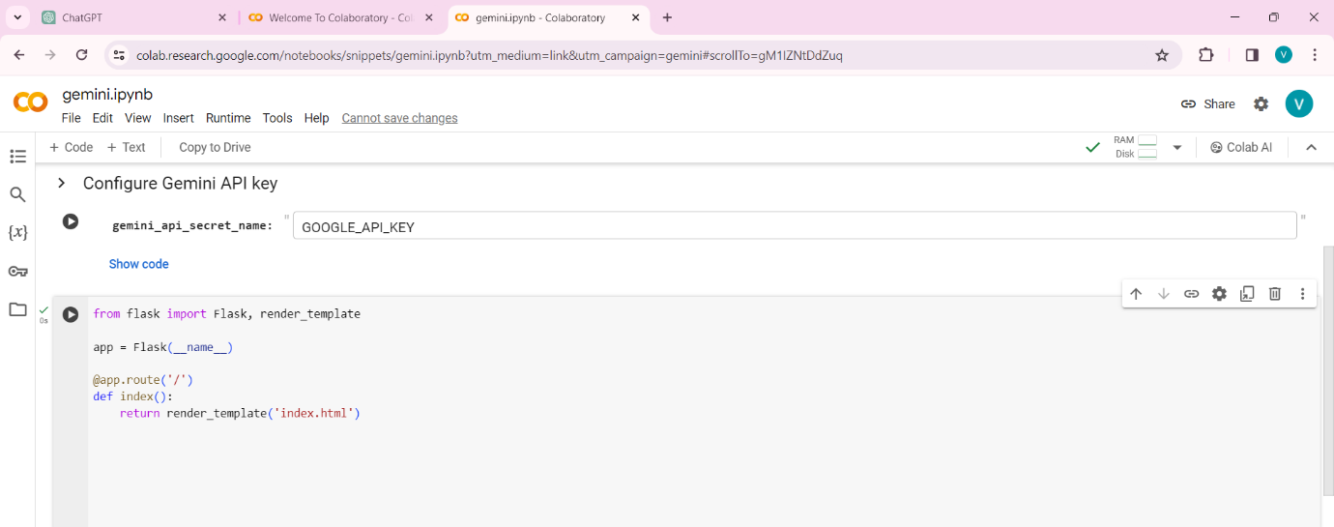

In this example, when a request is made to the root URL (**/**), Flask renders the **index.html** template.

**Passing Data to Templates**: You can pass data from your Flask view functions to templates by providing additional arguments to the **render_template()** function. These data can be variables, lists, dictionaries, etc.

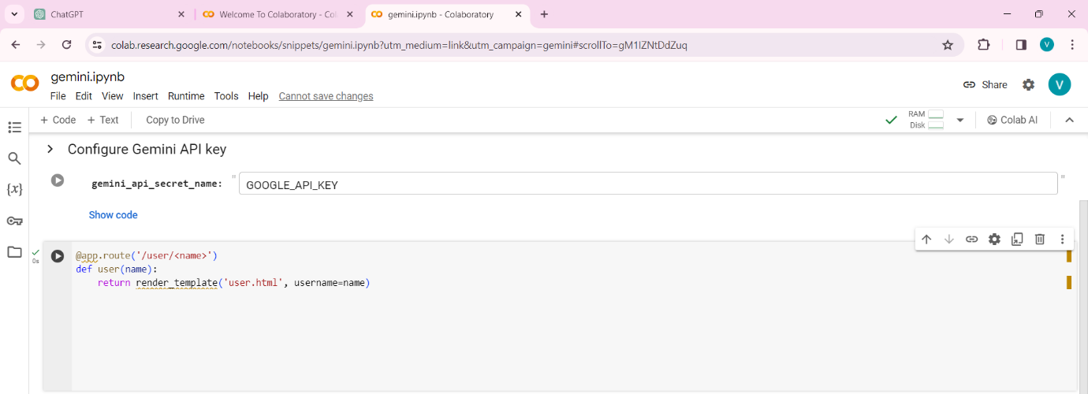

In this example, the **user()** function passes the **username** variable to the **user.html** template, which can then be accessed and displayed within the HTML content.

**Template Syntax**: Jinja2, the default templating engine for Flask, provides powerful features for generating dynamic content within templates. This includes variables, control structures (such as loops and conditionals), template inheritance, and filters.

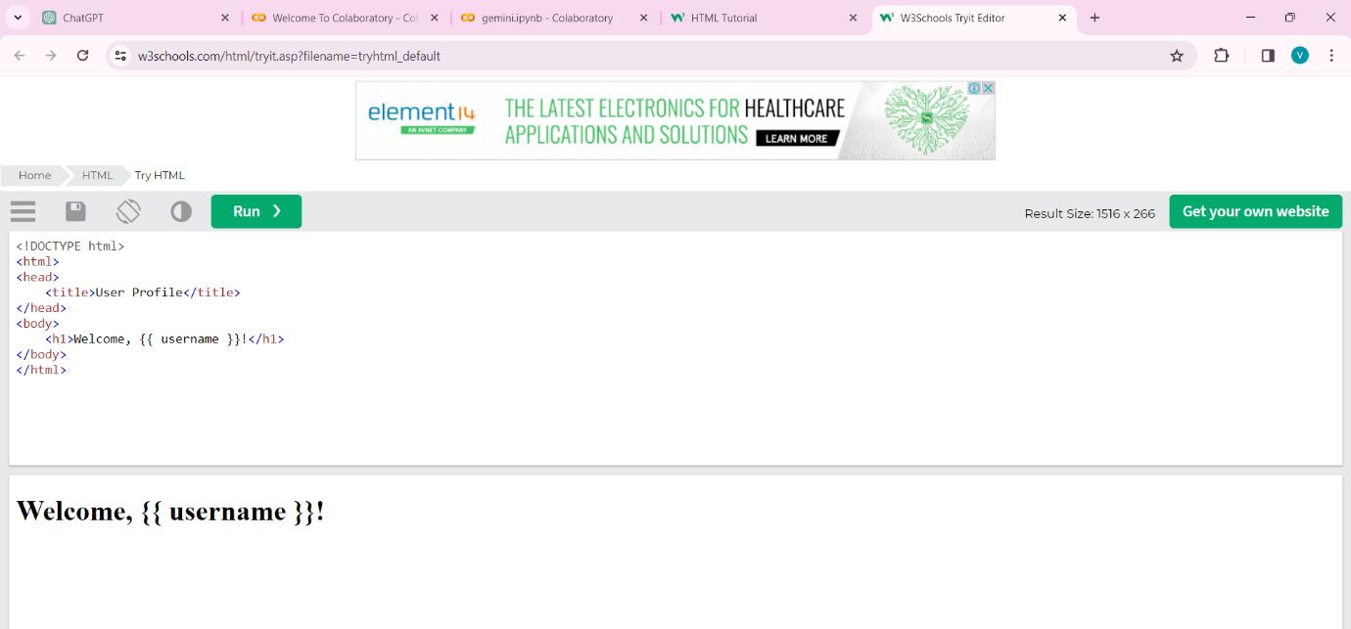

In this example, **{{ username }}** is a placeholder that Jinja2 will replace with the value of the **username** variable passed from the Flask view function.

**Dynamic HTML Generation**: By combining static HTML structure with dynamic data and control structures within templates, you can generate HTML content dynamically based on the current state of your Flask application.

Templates in Flask provide a clean and maintainable way to separate the presentation layer from the application logic. They enable you to create reusable HTML components and generate dynamic content, making it easier to build complex web applications with Flask.Top of Form

* 1. **Describe how to pass variables from Flask routes to templates for rendering.**

In Flask, passing variables from routes to templates for rendering is a fundamental aspect of building dynamic web applications. Here's how you can achieve this:

1. **Create a Flask Application**: First, ensure you have a Flask application set up. You can create a basic Flask application like this:

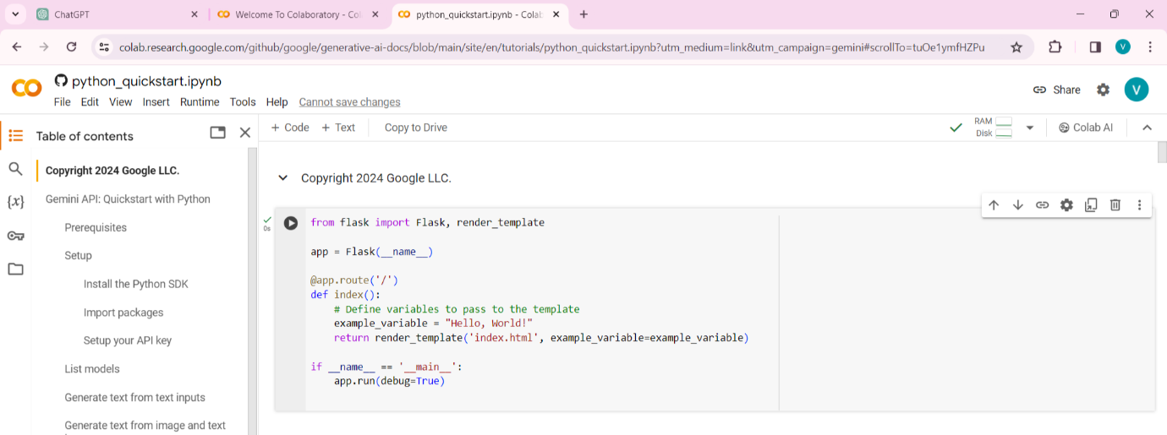

1. **Define Routes**: In your Flask application, define routes that will handle requests and pass variables to the templates. In the example above, we have a route for the homepage (**/**) that renders the **index.html** template and passes an **example_variable** to it.
2. **Render Templates**: Use the **render_template** function provided by Flask to render HTML templates. This function takes the name of the template as its first argument and any variables you want to pass to the template as keyword arguments. In the example above, we pass the **example_variable** to the **index.html** template.
3. **Create HTML Templates**: Create HTML templates in the **templates** directory of your Flask application. In the example above, Flask expects to find an **index.html** template in the **templates** directory. Within this template, you can access the variables passed from the route using Jinja2 syntax.
4. **Access Variables in Templates**: In the HTML template, you can access the variables passed from the Flask route using Jinja2 syntax. For example, to access the **example_variable** in the **index.html** template:

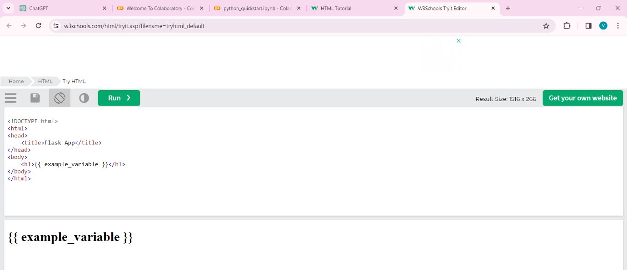

In this example, the **{{ example_variable }}** syntax is Jinja2 syntax for rendering the value of the **example_variable** passed from the Flask route.

By following these steps, you can easily pass variables from Flask routes to templates for rendering, enabling you to build dynamic web applications with Flask.

**7.How do you retrieve form data submitted by users in a Flask application?**

To retrieve form data submitted by users in a Flask application, you can use the **request** object provided by Flask. Here's a step-by-step guide on how to do it:

1. **Create a Form**: First, you need to create an HTML form in your template (**index.html** for example). The form should have an action attribute specifying the route where the form data will be submitted (typically the same route where the form is displayed), and a method attribute specifying the HTTP method to use (usually POST).

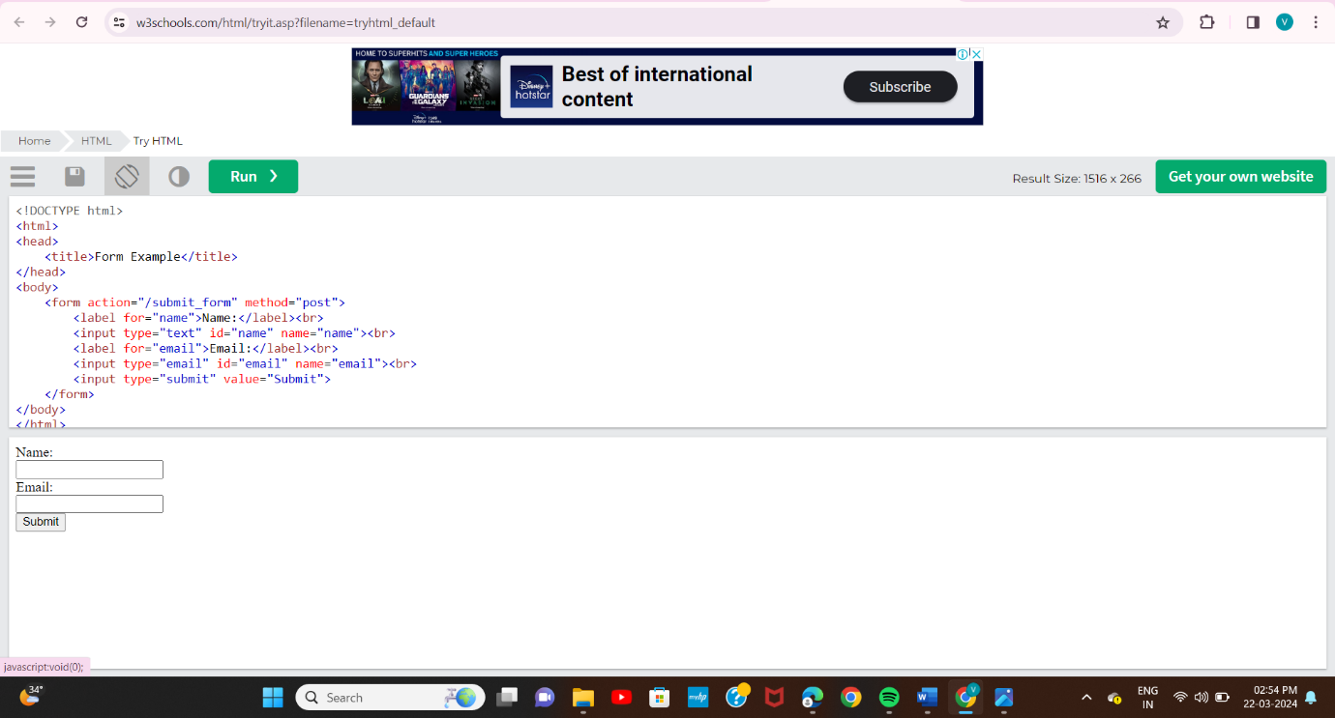**Handle Form Submission in Flask**: In your Flask application, define a route that handles the form submission. You can use the **request** object to access form data submitted by the user.

**Code: from flask import Flask, render_template, request**

**app = Flask(__name__)**

**@app.route('/')**

**def index():**

**return render_template('index.html')**

**@app.route('/submit_form', methods=['POST'])**

**def submit_form():**

**name = request.form['name']**

**email = request.form['email']**

**# Process the form data (e.g., save to database, perform calculations)**

**return f"Received form data: Name - {name}, Email - {email}"**

**if __name__ == '__main__':**

**app.run(debug=True)**

1. **Access Form Data in Flask Route**: In the route that handles the form submission (**submit_form** in this example), use the **request.form** dictionary to access form data. Form data is accessed using the name attribute of the form input fields as keys.
2. **Process the Form Data**: Once you've retrieved the form data, you can process it as needed. This might involve validation, saving to a database, or any other business logic required by your application.

By following these steps, you can retrieve form data submitted by users in a Flask application and process it accordingly.Top of FormBottom of Form

**8. What are Jinja templates, and what advantages do they offer over traditional HTML?**

Jinja templates are a type of template engine used in web development, particularly with Python-based web frameworks such as Flask and Django. They allow developers to generate dynamic content by embedding Python-like code directly into HTML files.

Advantages of Jinja templates over traditional HTML include:

1. **Dynamic Content Generation**: Jinja templates allow for the insertion of dynamic content into HTML files. This means that web pages can be generated dynamically based on user input, database queries, or other factors.

2. **Template Inheritance**: Jinja templates support template inheritance, which allows developers to create a base template with common elements (such as headers, footers, navigation bars) and then extend or override specific sections in child templates. This promotes code reusability and maintainability.

3. **Logic and Control Structures**: Jinja templates support logic and control structures such as loops, conditionals, and macros. This enables developers to write more complex and dynamic HTML templates compared to traditional static HTML.

4. **Integration with Python**: Since Jinja templates use Python-like syntax, developers familiar with Python can leverage their existing knowledge and skills to create dynamic web applications. This simplifies the learning curve for developers who already have experience with Python.

5. **Security**: Jinja templates provide built-in security features to prevent common web vulnerabilities such as Cross-Site Scripting (XSS) attacks. They automatically escape content by default, making it harder for attackers to inject malicious code into web pages.

6. **Separation of Concerns**: Jinja templates help maintain a clear separation between application logic (handled by Python code) and presentation logic (handled by HTML templates). This separation of concerns makes codebases easier to manage and understand.

Overall, Jinja templates offer developers a powerful tool for creating dynamic web applications with Python-based frameworks, providing flexibility, security, and ease of maintenance.

**9. Explain the process of fetching values from templates in Flask and performing arithmetic calculations.**

In Flask, fetching values from templates and performing arithmetic calculations typically involves a series of steps:

1. **Passing Data to the Template**: Before you can fetch values from templates, you need to pass the necessary data to the template from your Flask application. This is usually done by rendering the template with specific data using the **render_template** function. For example:

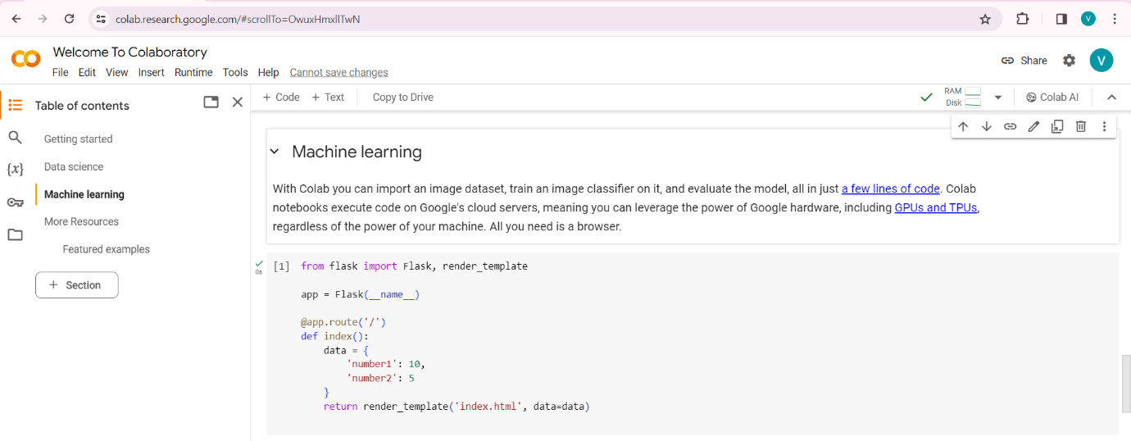

**Accessing Data in Templates**: In your HTML template file (**index.html** in this example), you can access the passed data using the variable name you specified in the **render_template()** function. For example:

**Code: <p>Number 1: {{ data.number1 }}</p>**

**<p>Number 2: {{ data.number2 }}</p>**

**Performing Arithmetic Calculations**: You can perform arithmetic calculations directly within the template using expressions enclosed within **{% %}** tags. For example:

**Code: <p>Sum: {{ data.number1 + data.number2 }}</p>**

**<p>Product: {{ data.number1 * data.number2 }}</p>**

**<p>Difference: {{ data.number1 - data.number2 }}</p>**

**<p>Quotient: {{ data.number1 / data.number2 }}</p>**

1. Here, we're performing addition, multiplication, subtraction, and division of the passed numbers.
2. **Displaying Results**: The results of the arithmetic operations will be calculated and displayed dynamically when the template is rendered.

Remember to handle potential errors, such as division by zero, if your calculations involve user-provided data.

By following these steps, you can fetch values from templates in Flask and perform arithmetic calculations within those templates. This allows you to create dynamic web pages that display calculated results based on data provided by your Flask applicatio

**10. Discuss some best practices for organizing and structuring a Flask project to maintain scalability and readability.**

Organizing and structuring a Flask project effectively is crucial for maintaining scalability, readability, and maintainability as the project grows. Here are some best practices to consider:

1. **Blueprints for Modularization**: Use Flask Blueprints to organize your application into smaller, modular components. Each Blueprint can represent a feature or a logical group of related functionality. This helps in keeping your codebase organized and makes it easier to understand and maintain.

2. **Separation of Concerns**: Follow the principle of separation of concerns to keep your codebase clean and maintainable. Separate your application logic, data access, and presentation layers into different modules or packages. For example, keep your routes in one file, database models in another, and views in yet another.

3. **Application Factory Pattern**: Implement the application factory pattern to create your Flask application instance. This pattern allows you to create multiple instances of your application with different configurations, which is useful for testing, development, and production environments.

4. **Configuration Management**: Store your application configurations in separate configuration files. Use different configuration files for development, testing, and production environments. Flask provides a built-in configuration mechanism that allows you to easily switch between different configurations.

5. **Use of Extensions**: Leverage Flask extensions to add additional functionality to your application. There are many Flask extensions available for common tasks such as database integration, authentication, authorization, and more. Using extensions can save you time and effort and also ensure that you're following best practices in those areas.

6. **Directory Structure**: Organize your project directory structure in a logical and consistent manner. For example, you could have directories for static files, templates, blueprints, configuration files, tests, and so on. Following a consistent directory structure makes it easier for developers to find their way around the project.

7. **Error Handling**: Implement centralized error handling to handle exceptions and errors gracefully. Flask provides mechanisms such as error handlers and exception handling to help you manage errors effectively. Consider implementing custom error pages to provide a better user experience.

8. **Testing**: Write comprehensive tests for your Flask application to ensure its correctness and reliability. Use testing frameworks such as pytest or unittest to write unit tests, integration tests, and end-to-end tests. Testing helps you catch bugs early, maintain code quality, and make future changes with confidence.

9. **Documentation**: Document your code, especially complex or critical parts, to make it easier for other developers (including future you) to understand how it works. Use docstrings, comments, and README files to provide context, usage instructions, and explanations for your code.

10. **Version Control**: Use a version control system like Git to manage your codebase. Keep your codebase clean by following best practices for branching, committing, and code reviews. This allows you to track changes, collaborate with other developers, and revert to previous versions if needed.

By following these best practices, you can organize and structure your Flask project in a way that promotes scalability, readability, and maintainability, making it easier to manage and extend as your project grows.