**SimAss3 - Creating own CNN via Transfer Learning and AlexNet**

1. **Submit a screenshot of the directory, folders, and subfolders you set up**

1. **Submit all the modified programs you wrote.**

1. **Submit the training performance printout of your CNN.**

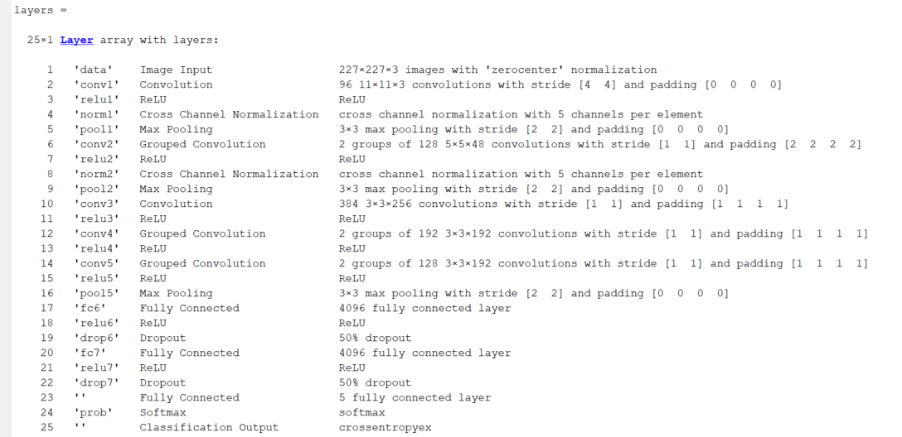

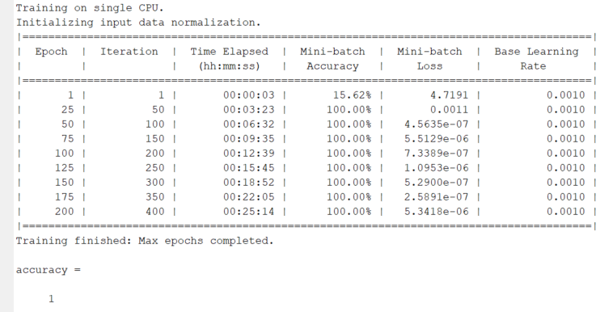

1. **Submit at least three screenshots of your CNN in action. Each shot recognizing different objects you trained.**

1. **Comment on the usefulness of CNN for control applications.**

* Transfer learning can be used in AV/ADAS applications to classify road conditions like snow, gravel, smooth road, mud etc. to automatically change driving modes like Sport Mode/Snow Mode/Eco mode/Off road mode etc.
* It can be used to recognize road signs and speed limit signs to alert/warn the driver if the driver is not following the limits.

Transfer learning for CNN is extremely useful and is widely being applied in ADAS applications.