PRACTICAL – 7
Code:
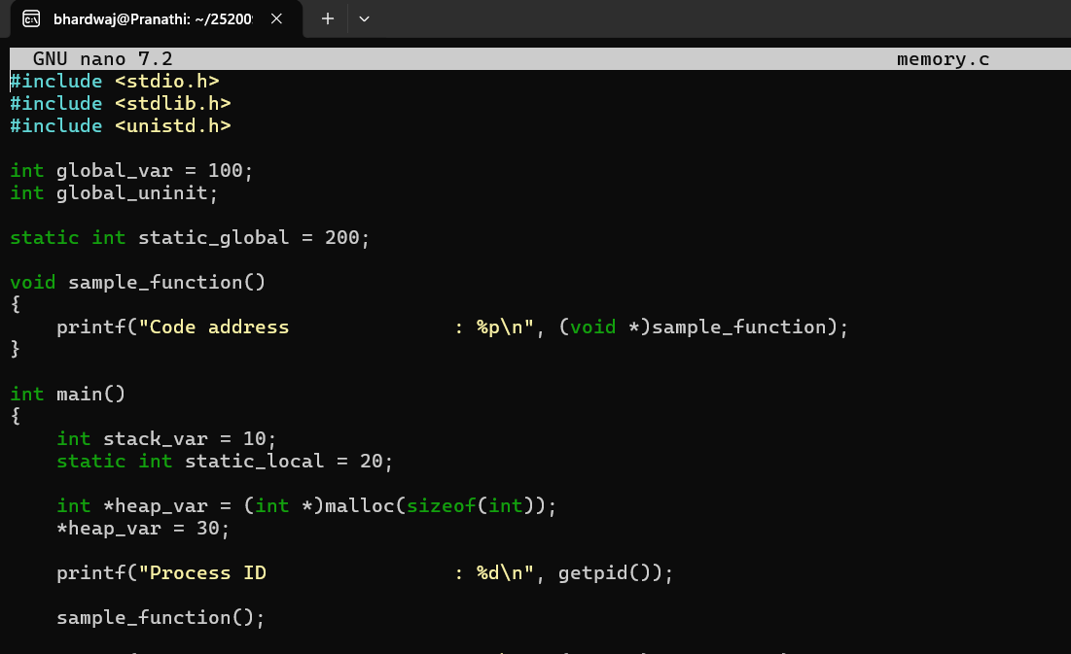
Output:
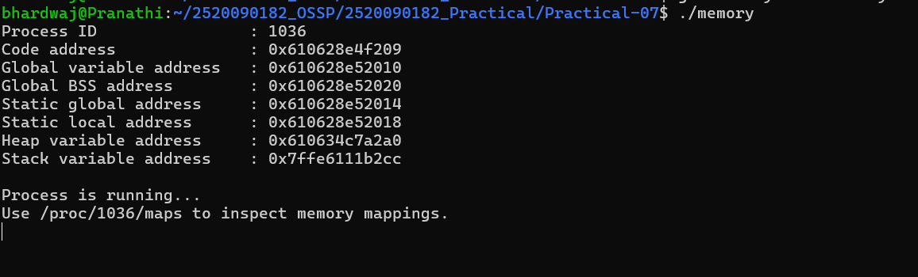
Check /proc/PID/maps
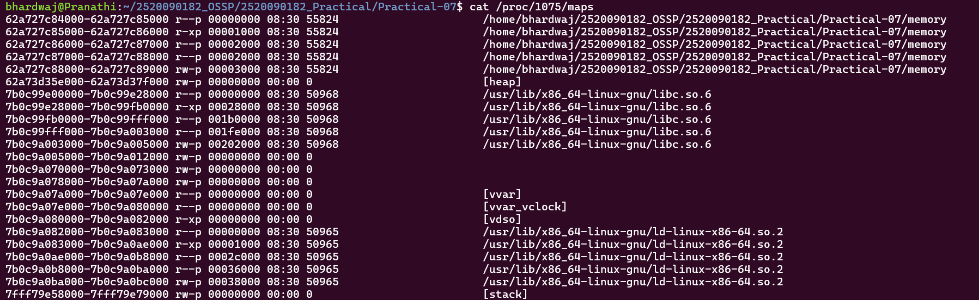
Use pmap
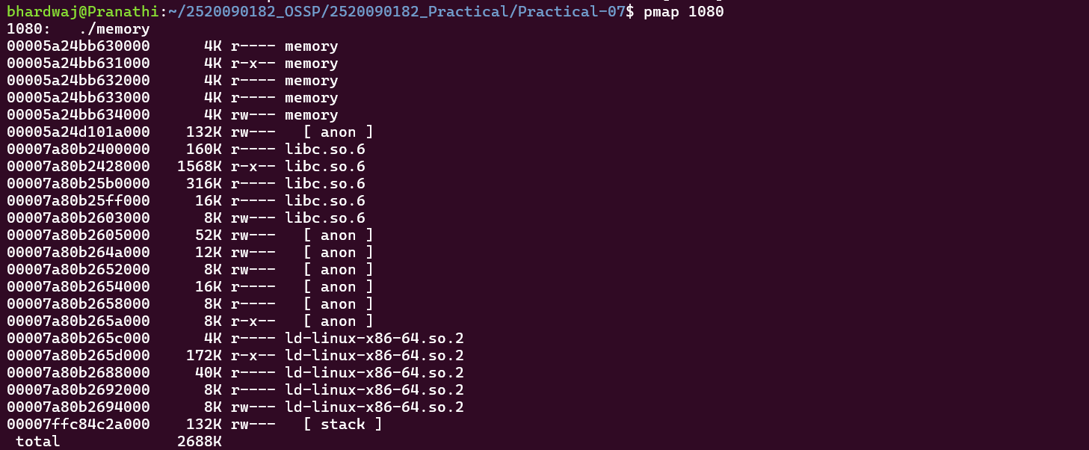
Check Memory Statistics
Optional — Filter Heap and Stack

