PRACTICAL_8
Code:
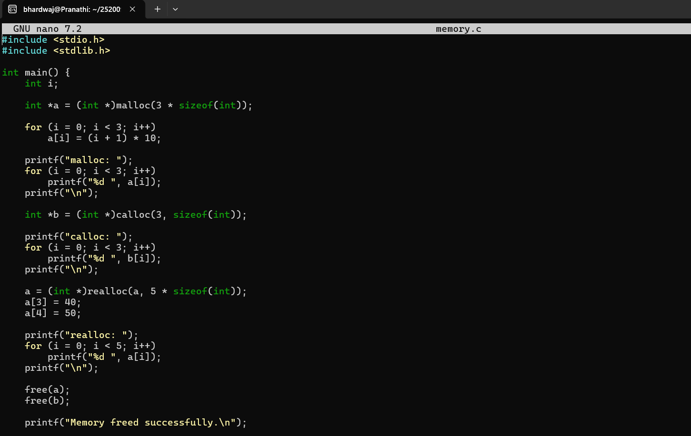
Output: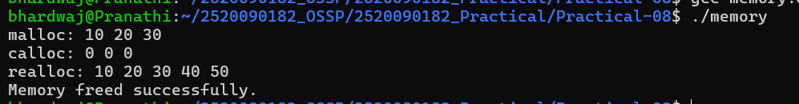
Run Valgrind
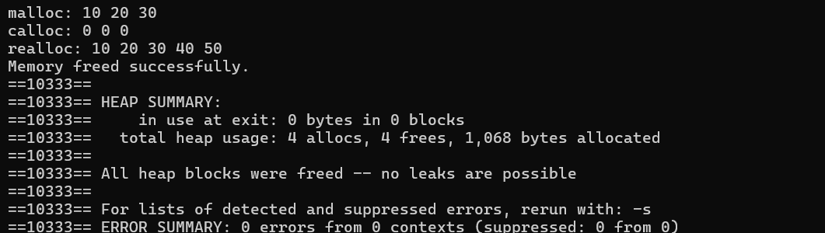
PROGRAM 2: Copy-on-Write after fork()
Code:
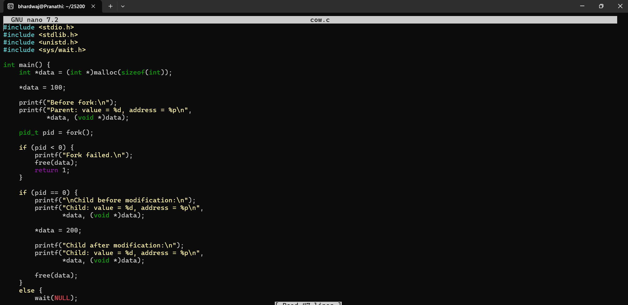
Output:
