PRACTICAL – 6
CODE:
Server:
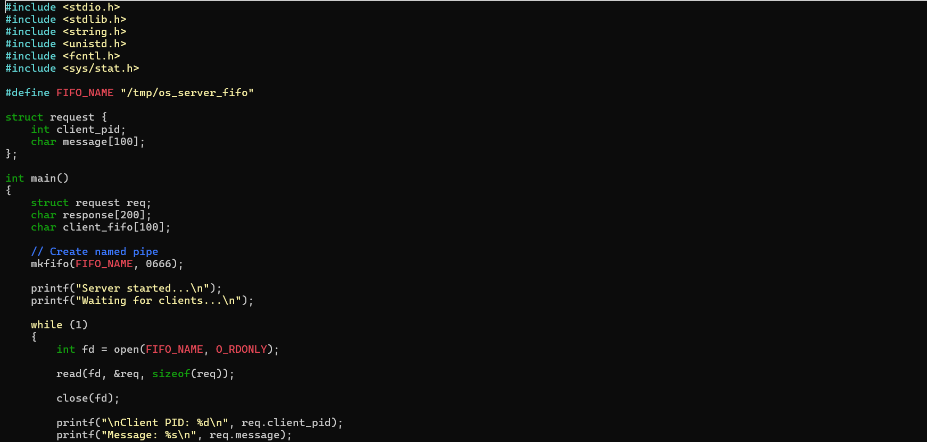
Client:
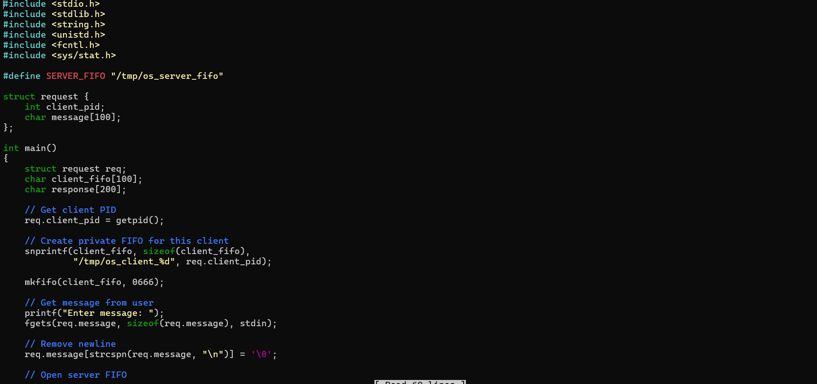
Output:
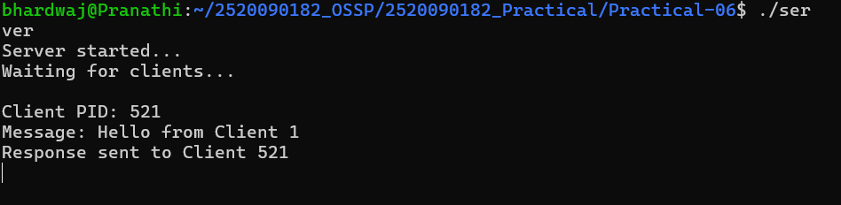
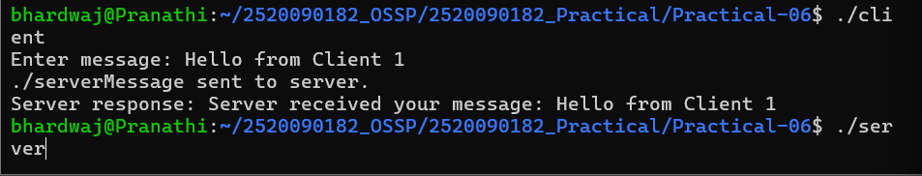
Multiple Clients:
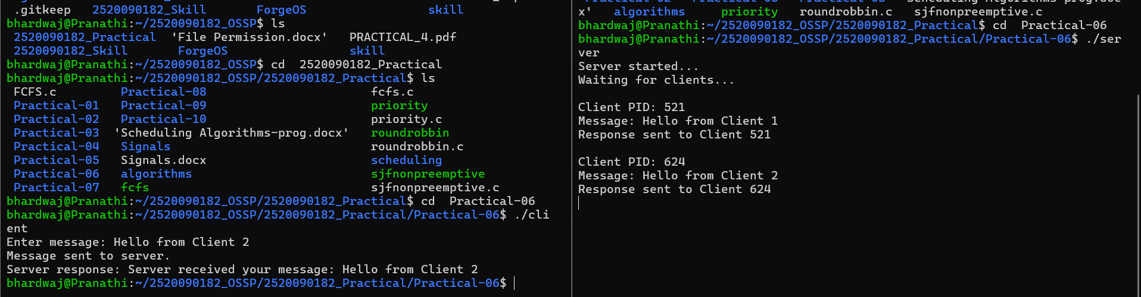
Check the FIFO:
Part B:
Output:
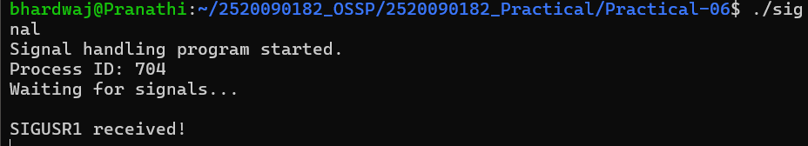
Sigterm:
