SKILL -1
UNDERSTANDING THE BASICS OF THE OS(SKILL)
1)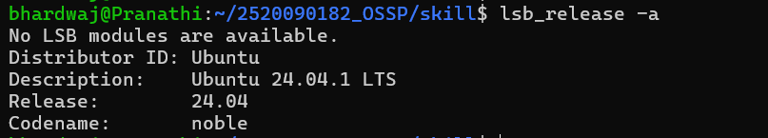
2) 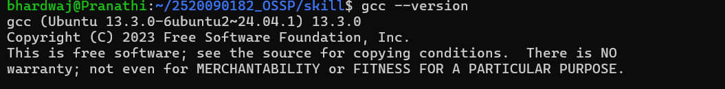
CREATING A PROGRAM