SIGNALS:
Program 1: Simple Signal Handler — SIGINT:
Code:
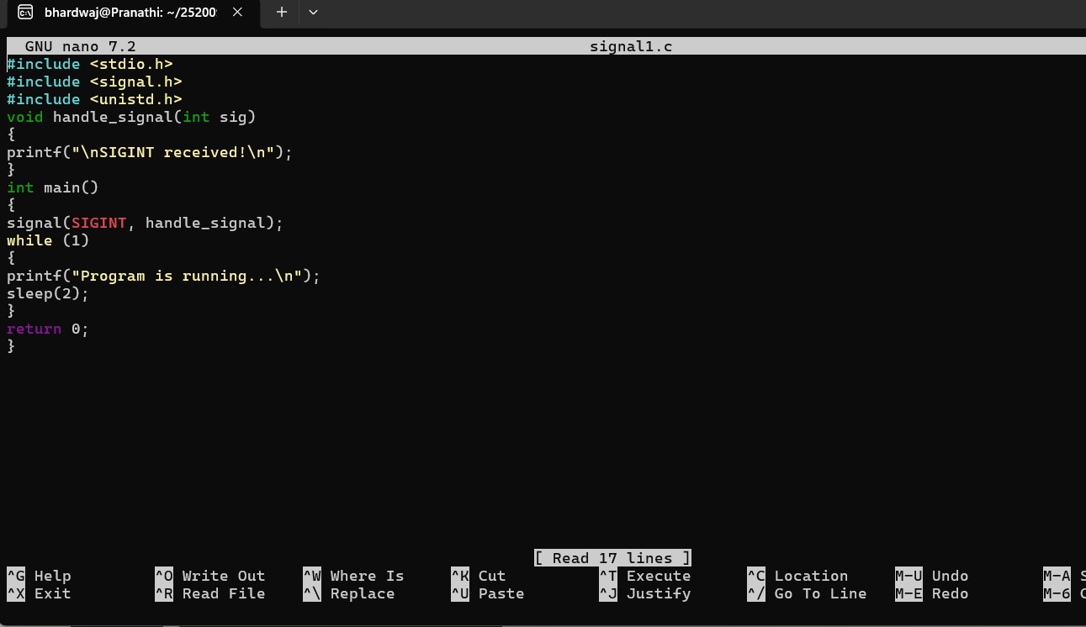
Output:
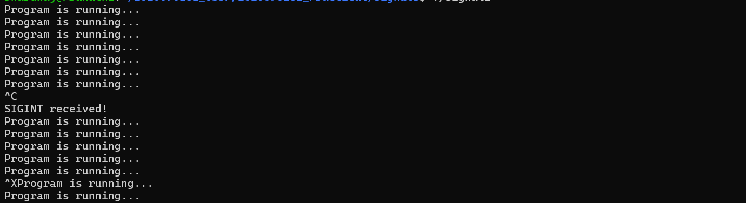
Program 2: SIGINT Without a Handler:
Code:
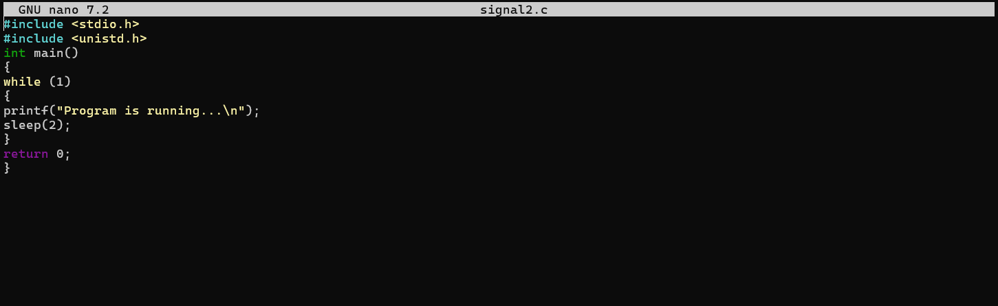
Output:
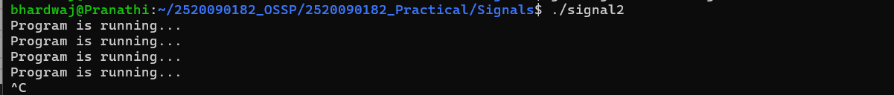
Program 3: SIGCHLD - Child Process Signal:
Code:
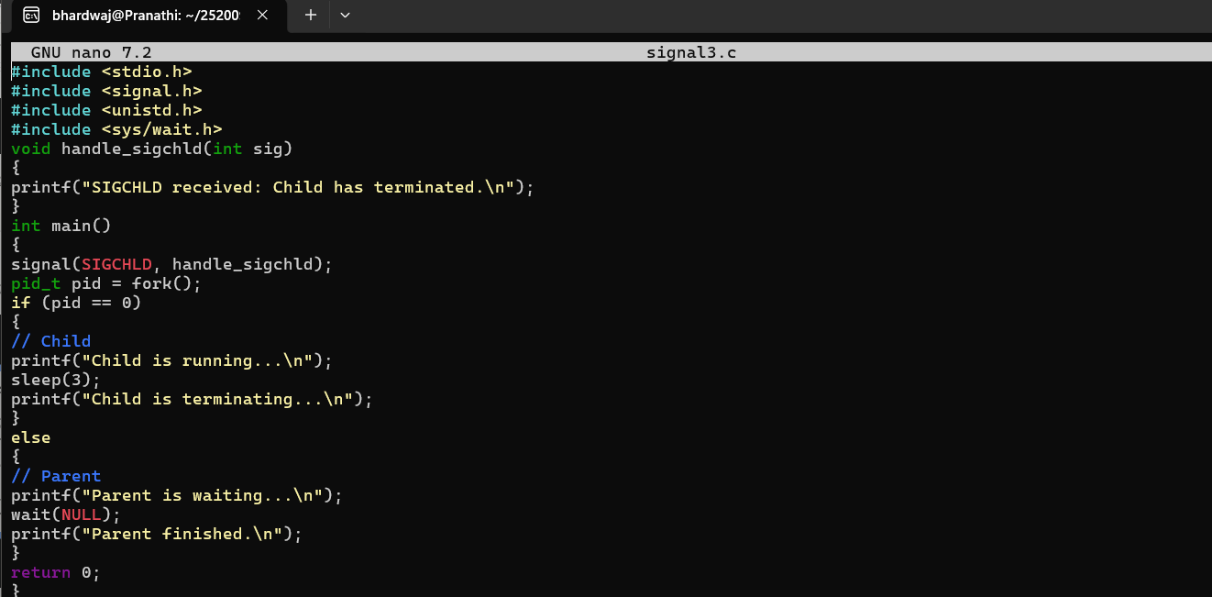
Output:
Program 4 - SIGPIPE - Broken Pipe
Code:
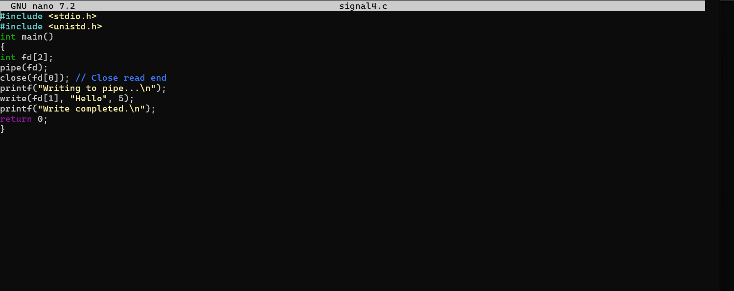
Output:
Program 5 - kill() program
Code:
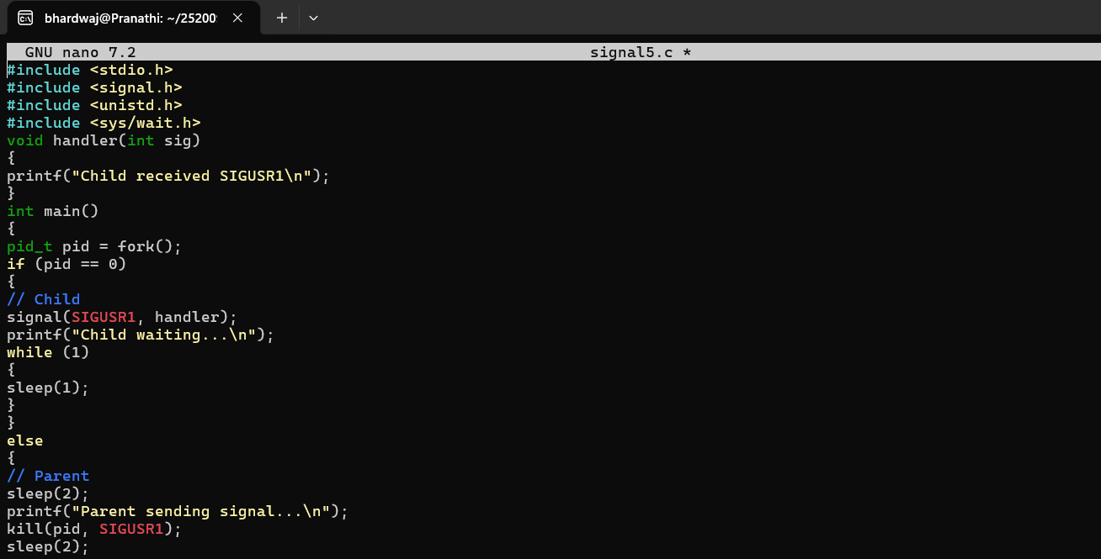
Output:
Program 6 - SIGABRT — Abort
Code:
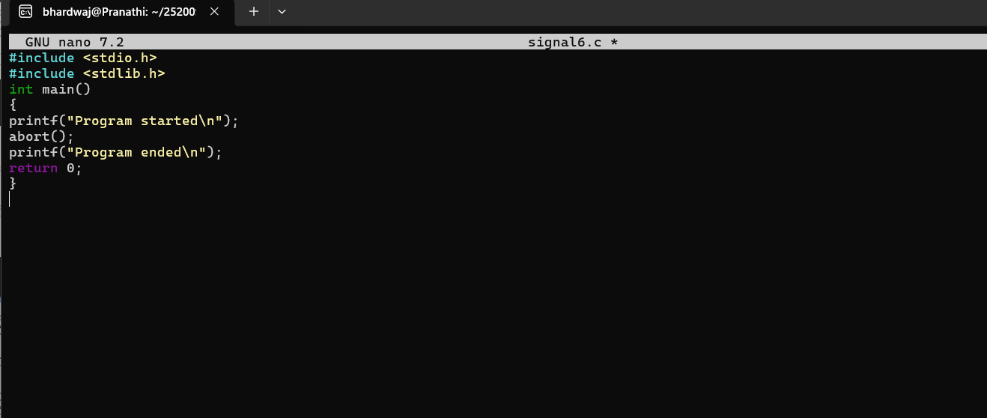
Output:
Program 7: SIGSEGV - Invalid Memory Access
Code:
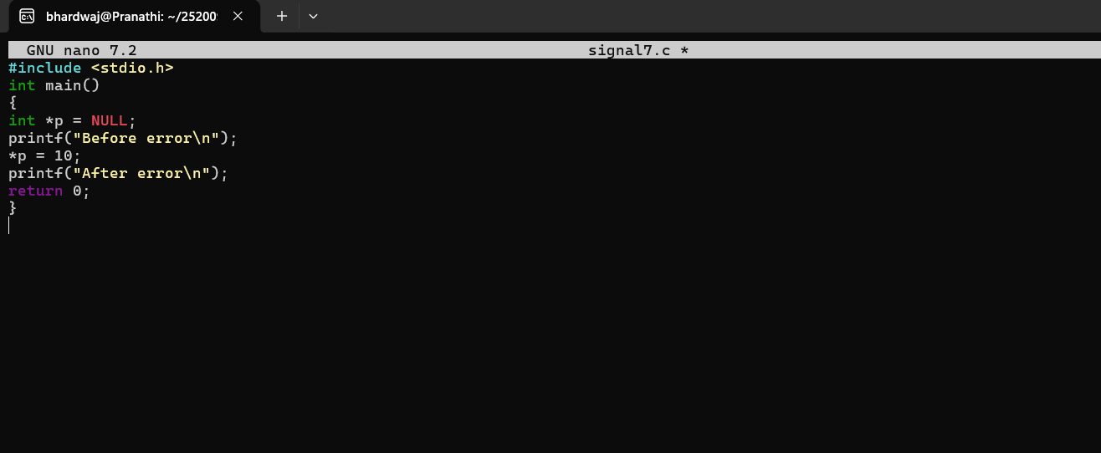
Output:

