Practical-5:
Code:
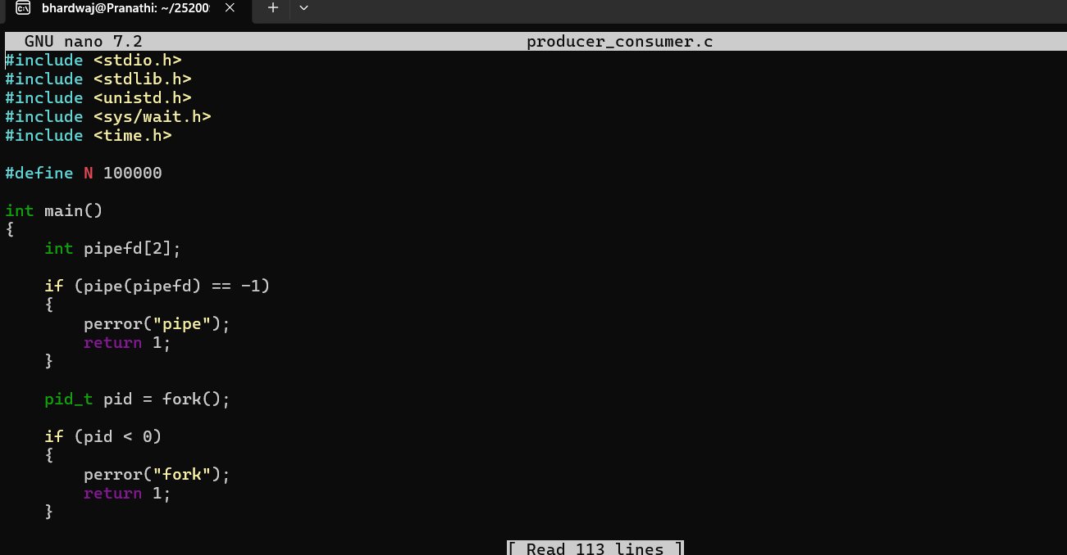
Output:
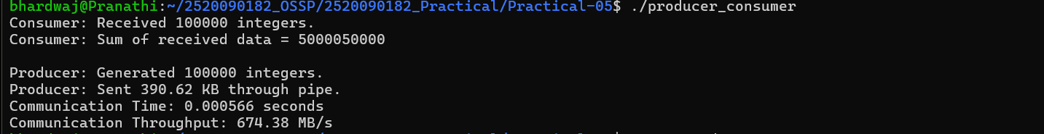
PROGRAM 2: ls -l | grep ".c" Using System Calls
Code:
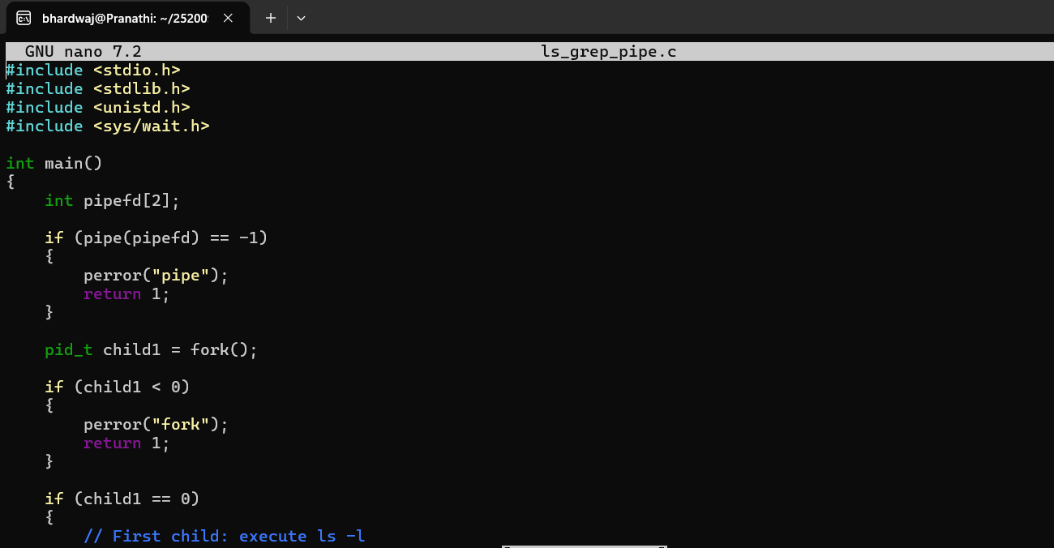
Output:
