SKILL – 3
Code(Command History & Input Buffer):
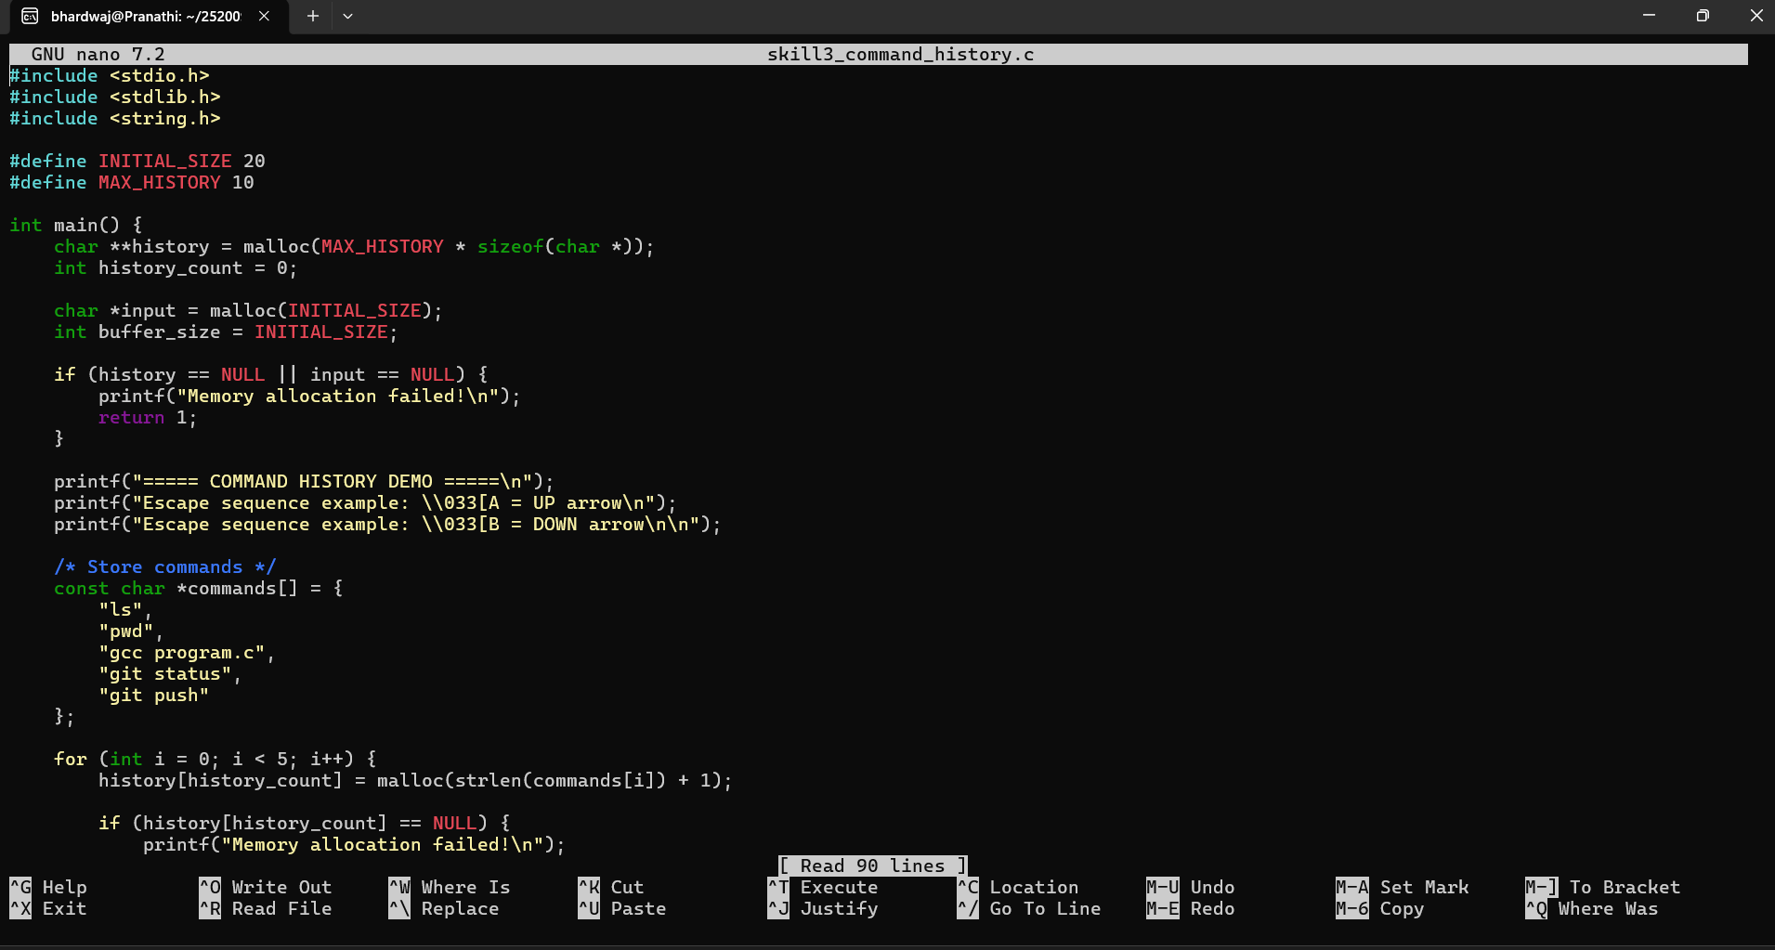
Output:
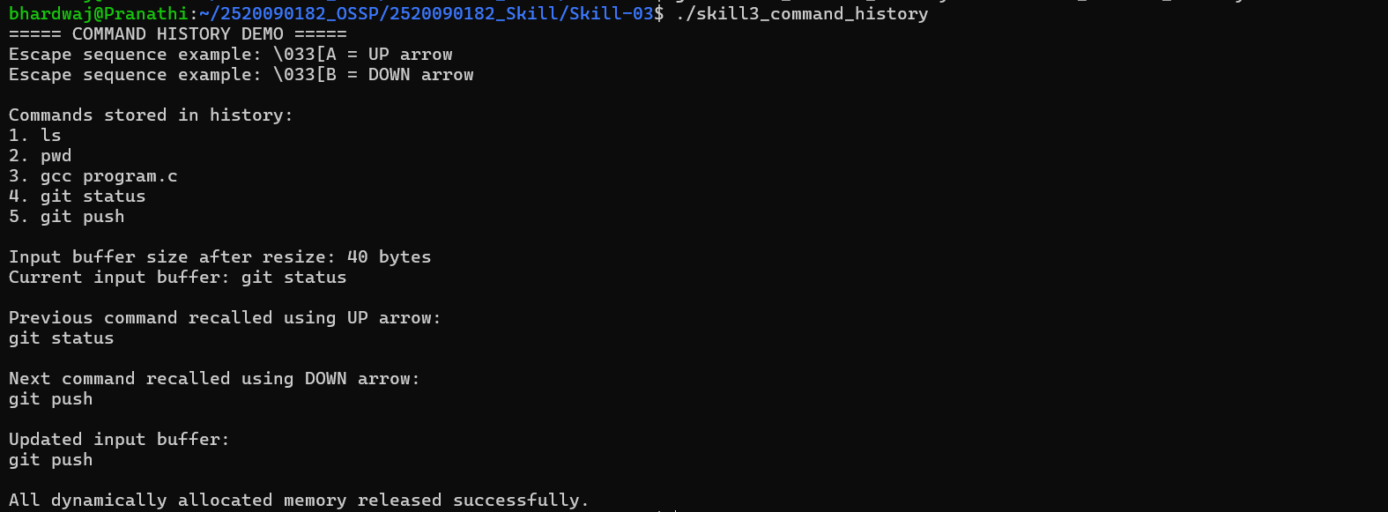
Part – B:
Code(Dynamic Buffer + Linked List):
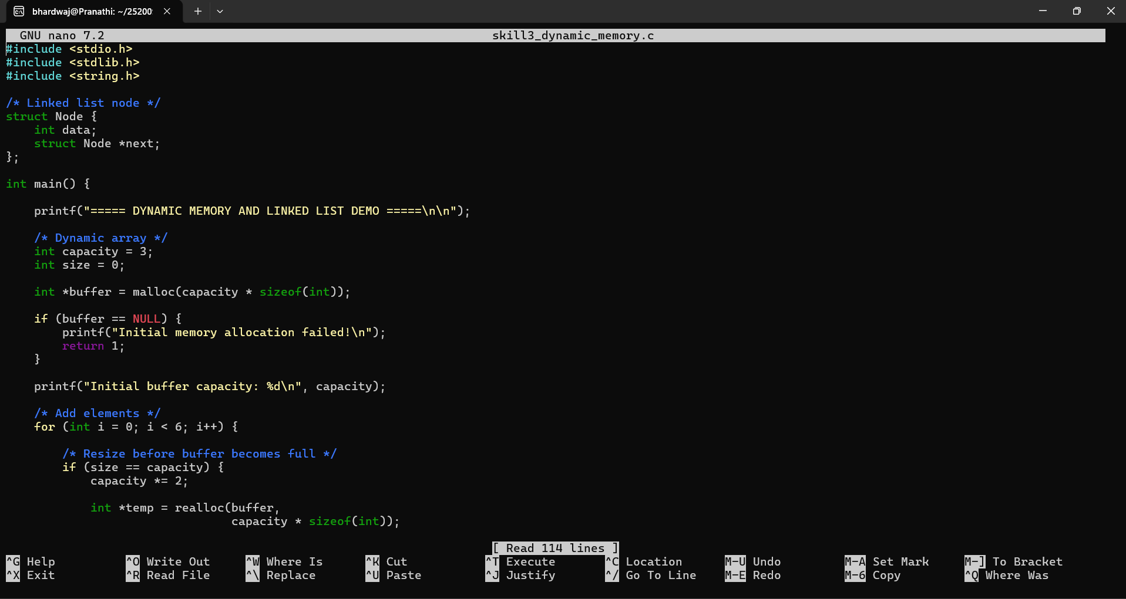
Output:
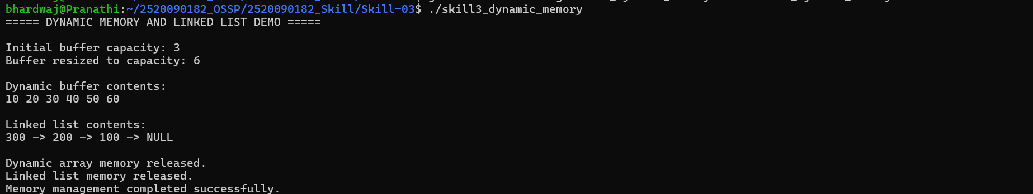
Check for the Valgrind :