PRACTICAL – 9:
Part A:
Code:
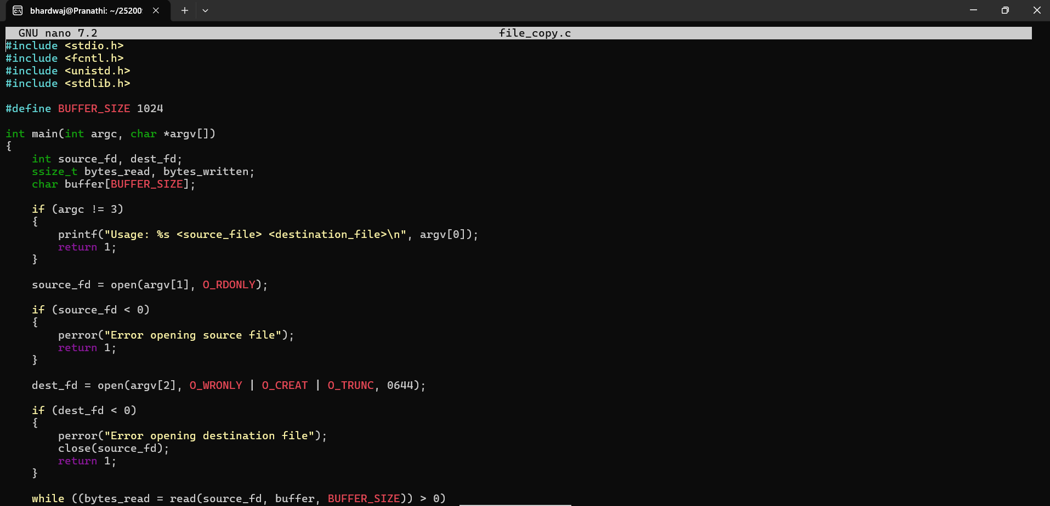
Output:
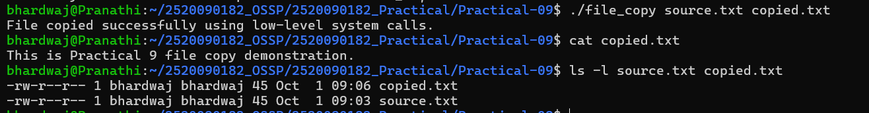
Part B:
Code:
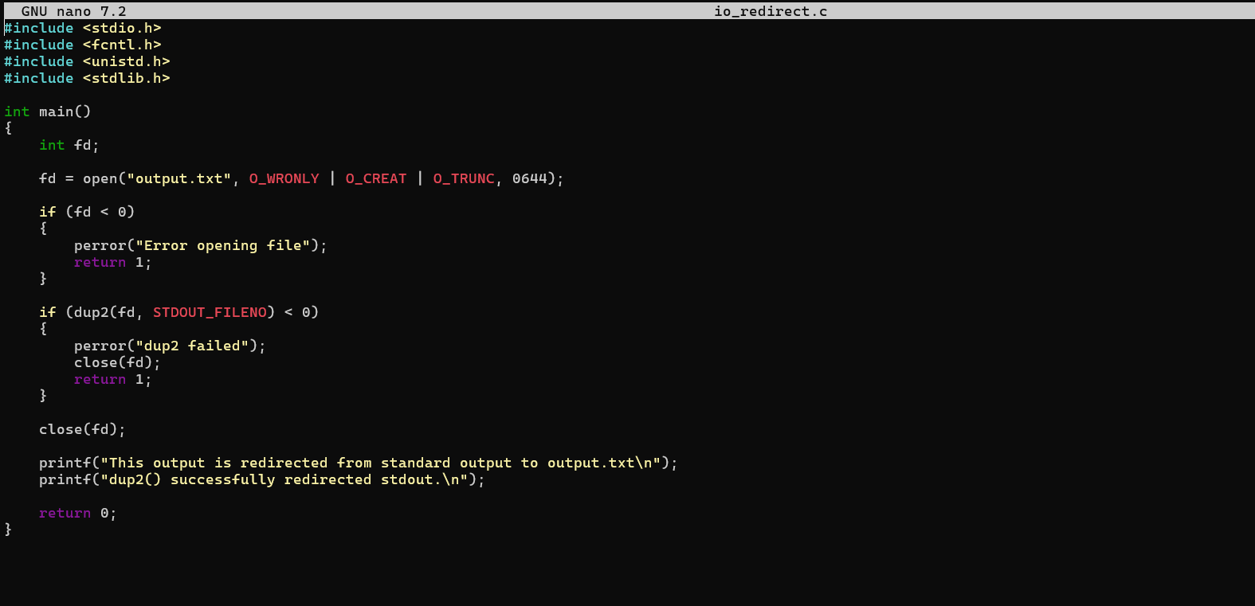
Output:
Part C:
Output:
