SKILL – 2
AWS Root User Sign-In Page
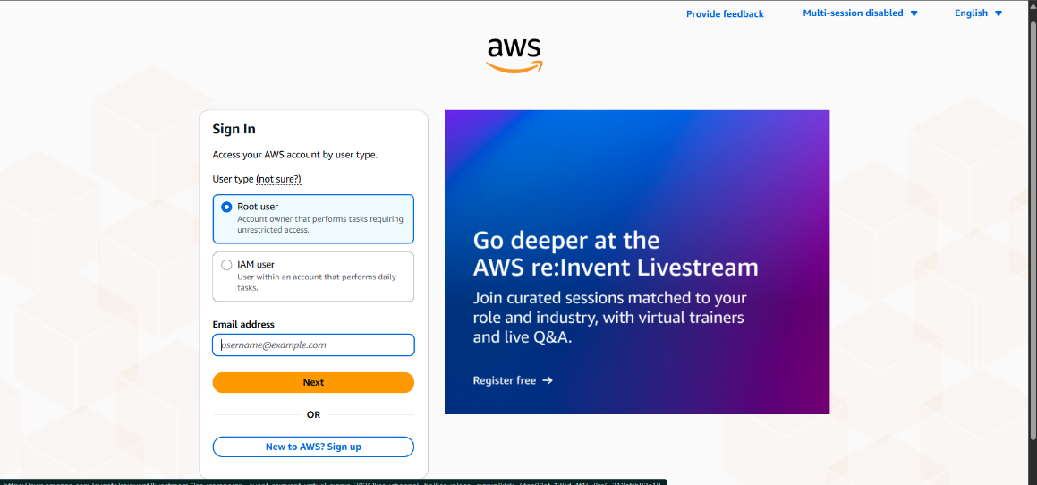
Entering Root User Password
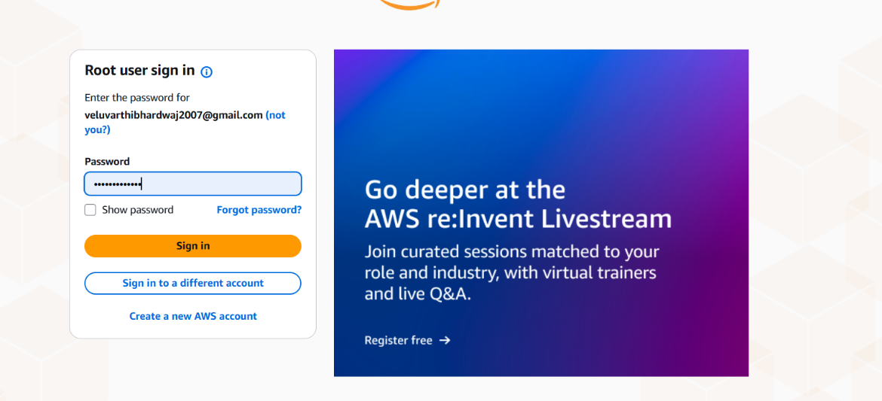
Root User MFA Verification
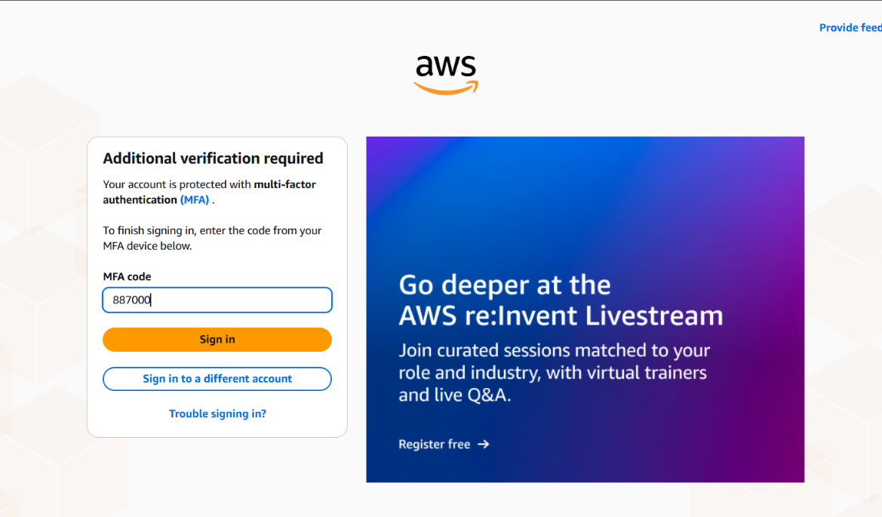
AWS Management Console Home Page
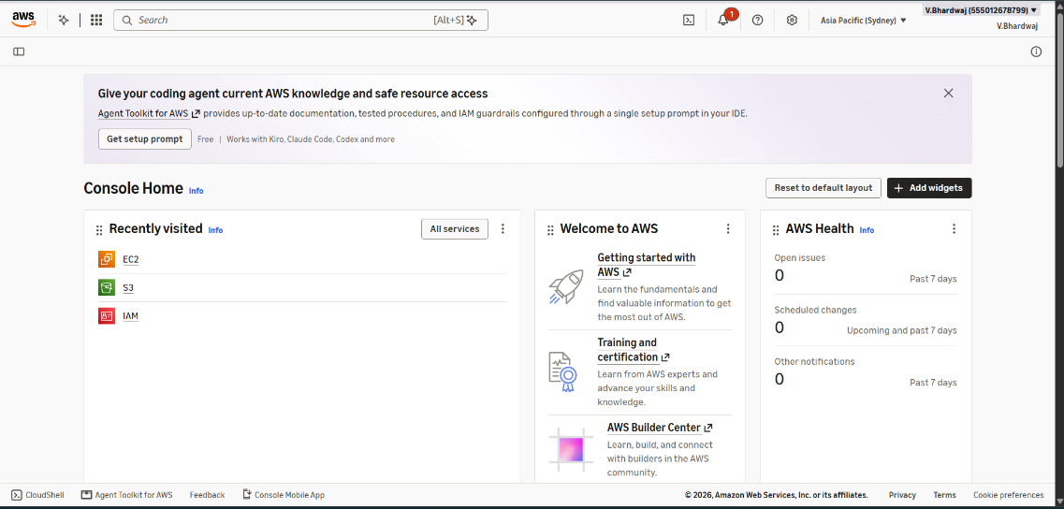

Accessing Root User Security Credentials
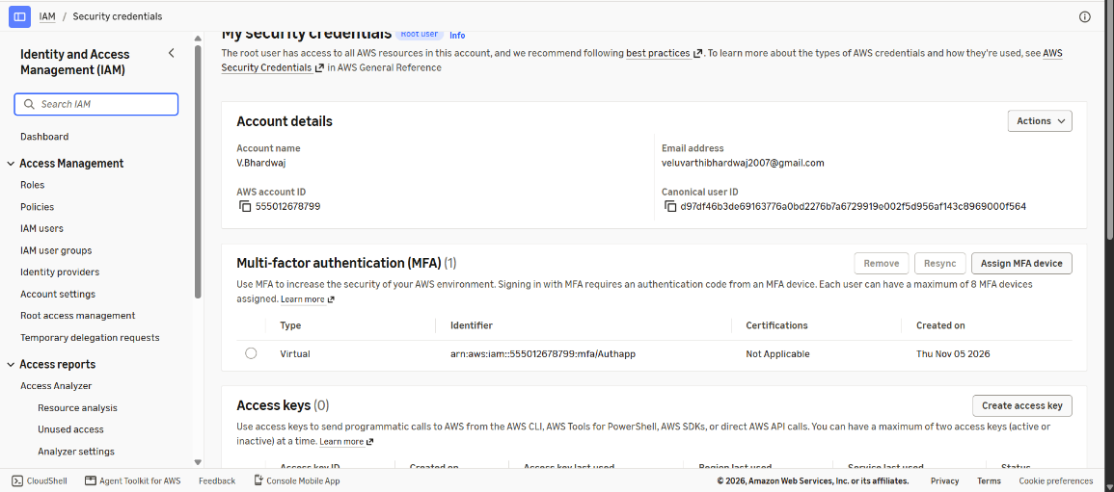
Selecting the MFA Device
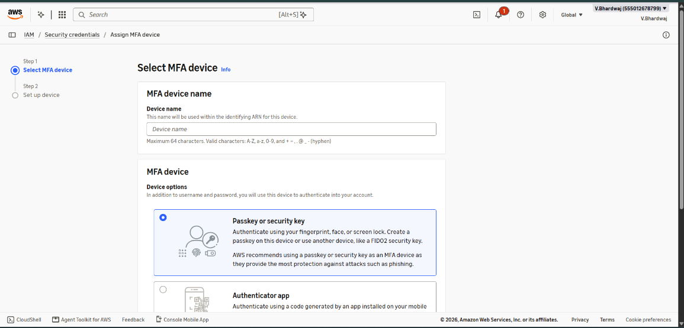
Available MFA Device Types
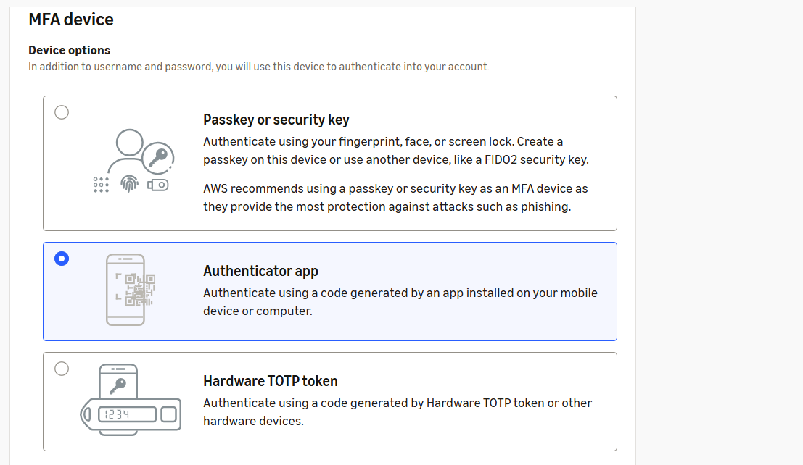
Configuring the Virtual MFA Device
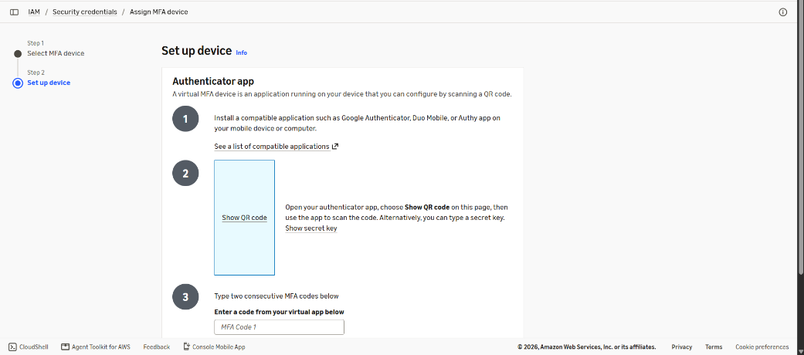
MFA Successfully Enabled on Root User


