Skill – 3
Step 1: Sign In to the AWS Management Console
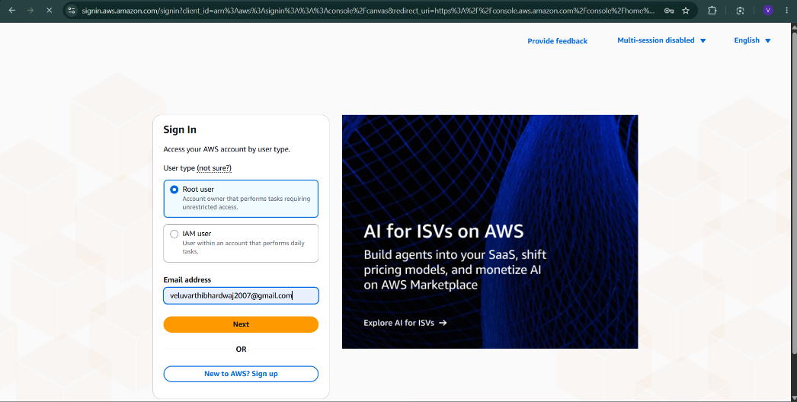
Step 2: Complete the Additional Verification
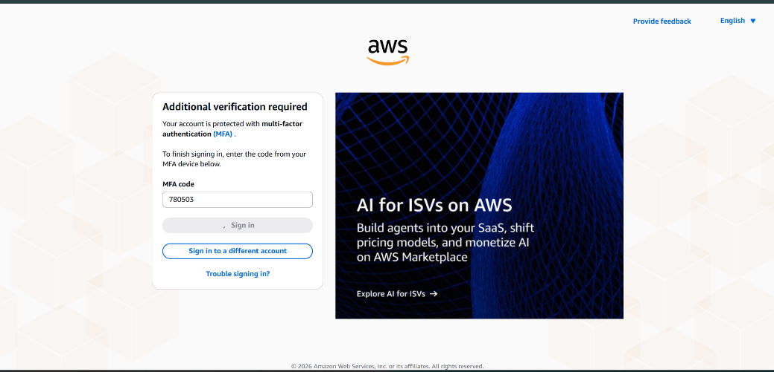
Step 3: Open the Amazon EC2 Dashboard
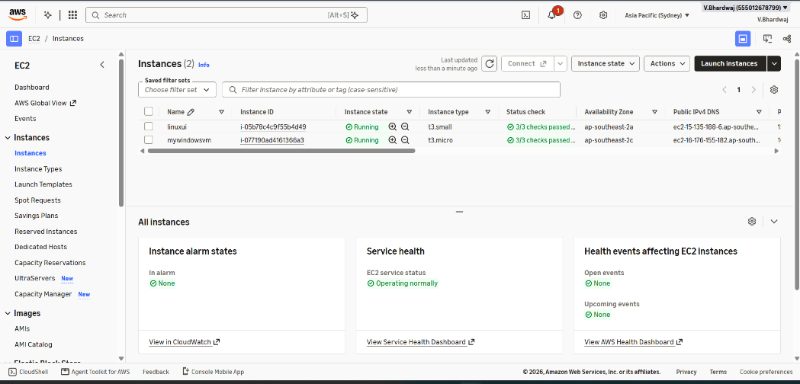
Step 4: Launch the EC2 Instance
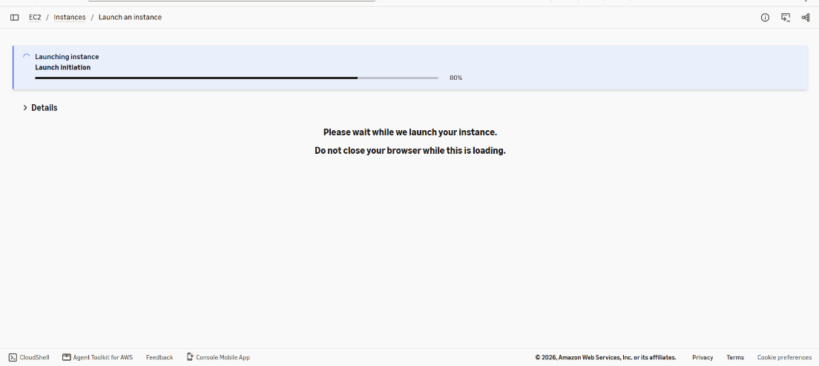
Step 5: Connect to the Linux Instance
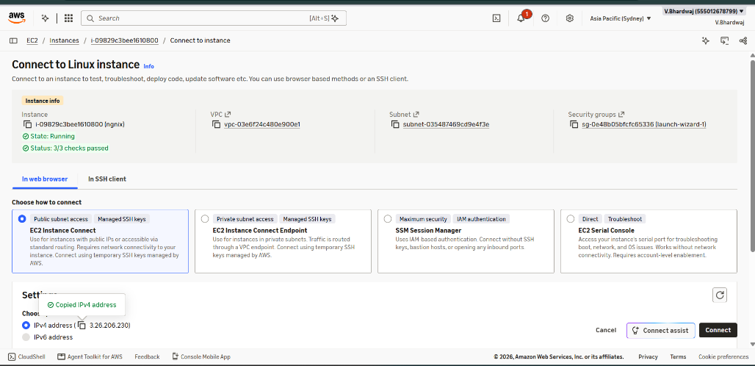
Step 6: Verify the Ubuntu Instance Connection


