PRACTICAL – 2

AWS EC2 Instance Configuration
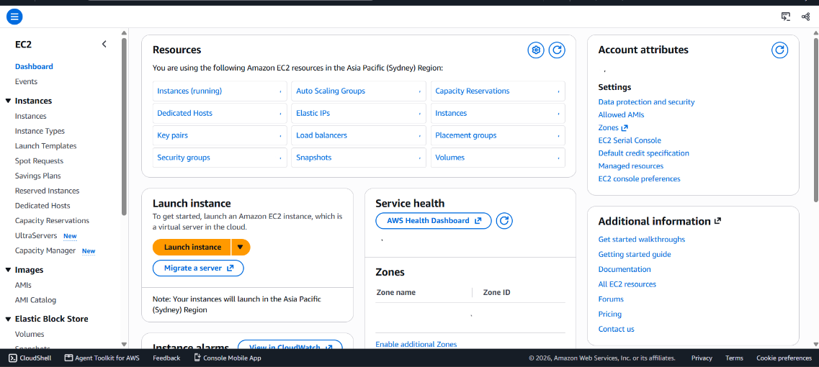
Reviewing EC2 Instance Settings
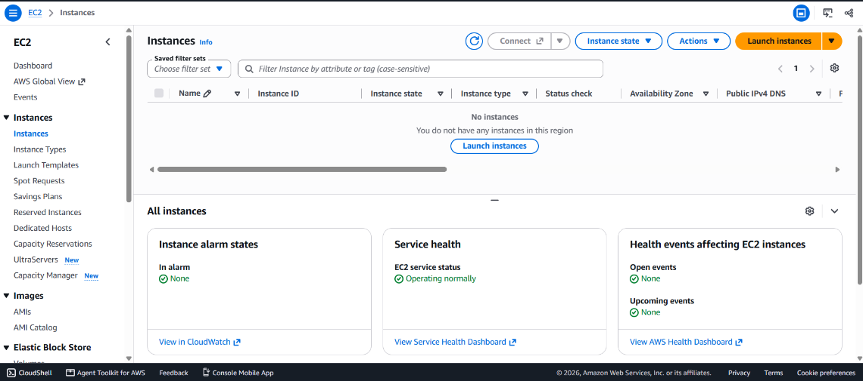
Launching the EC2 Instance
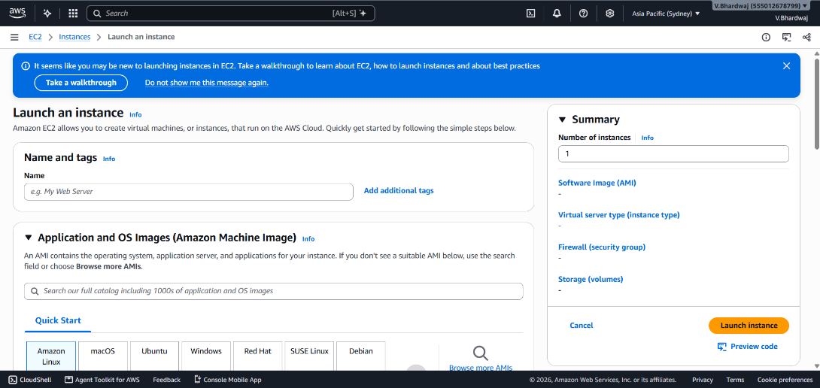
EC2 Instance Launch Status
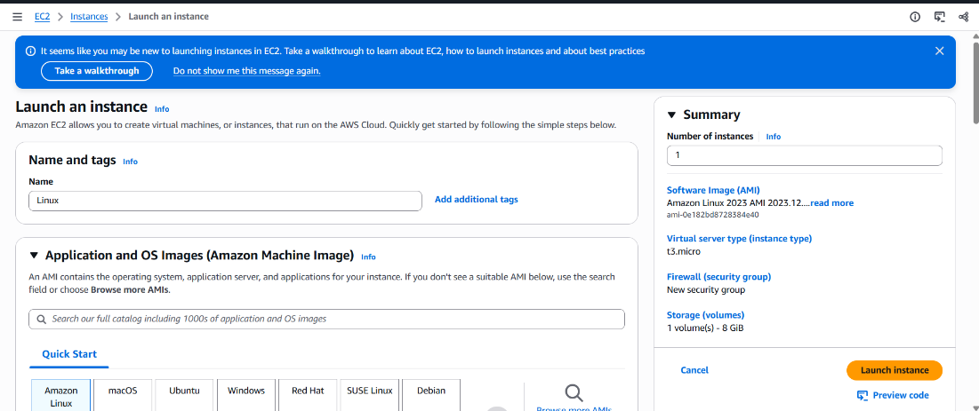
Viewing the EC2 Instance Details
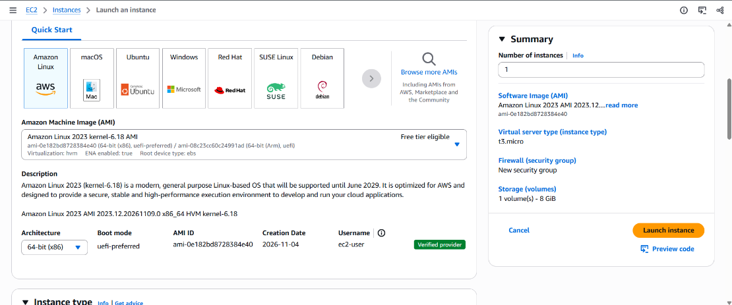
EC2 Instance Networking and Security
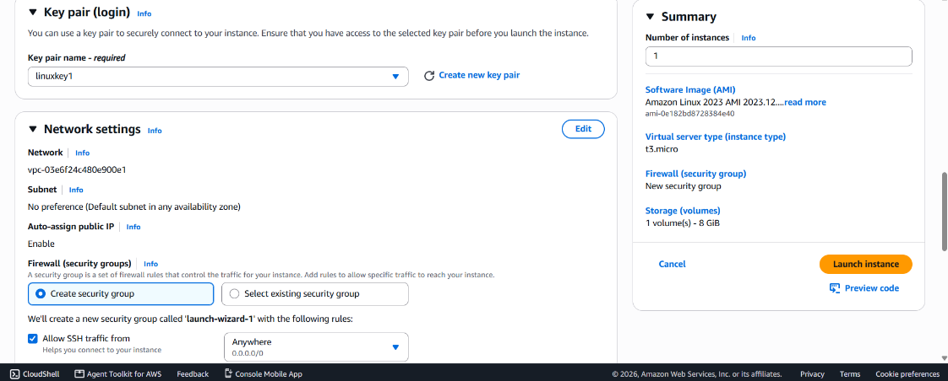
Managing EC2 Instance Settings
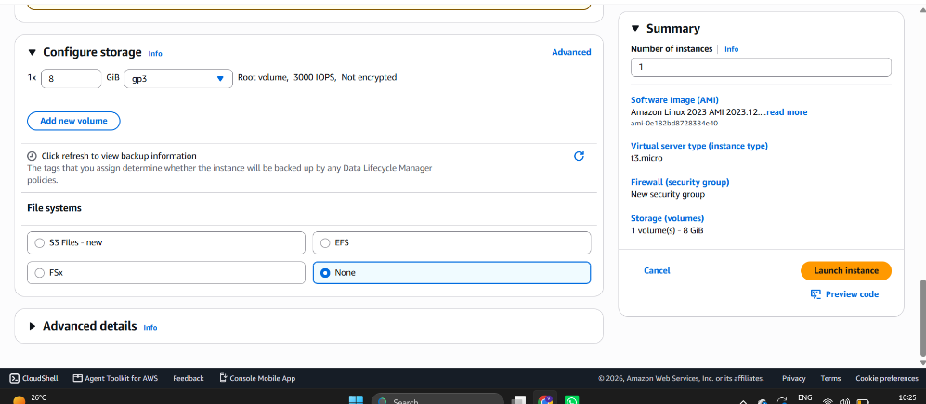
Connecting to the EC2 Instance
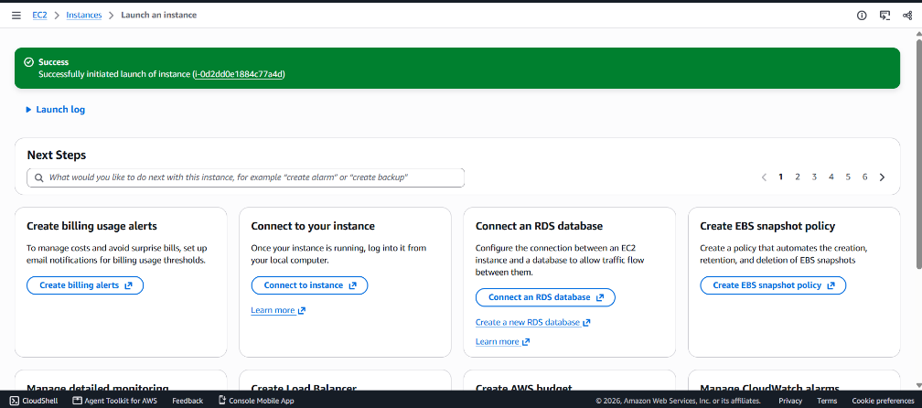
EC2 Instance Management
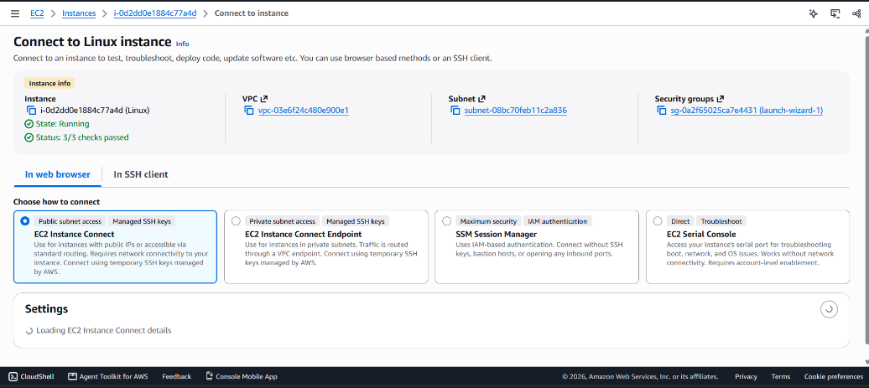
EC2 Instance Status and Details
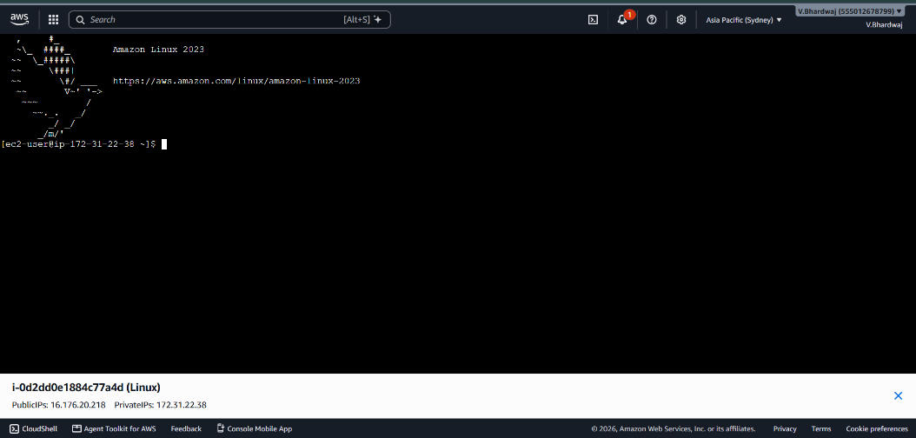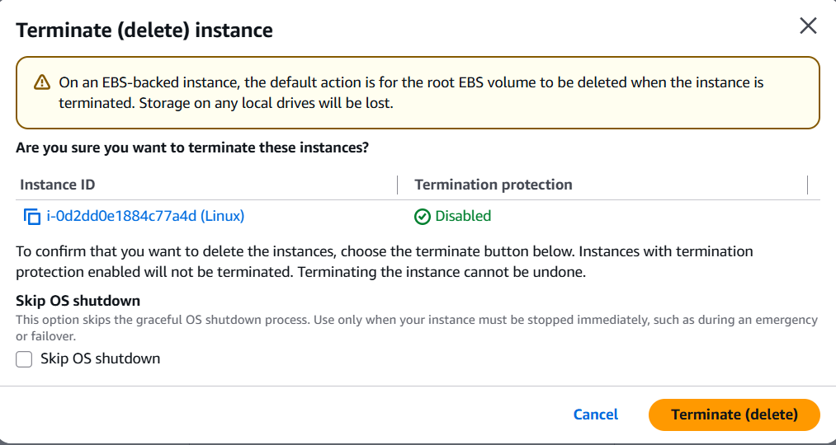
EC2 Instance Connection and Terminal
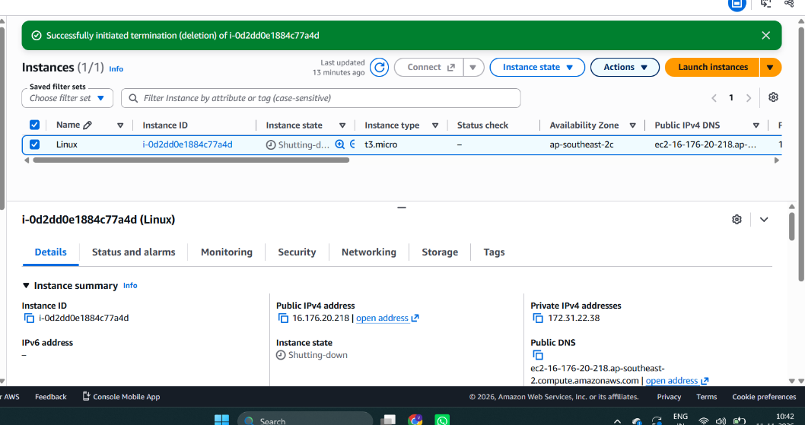
EC2 Instance Configuration Details
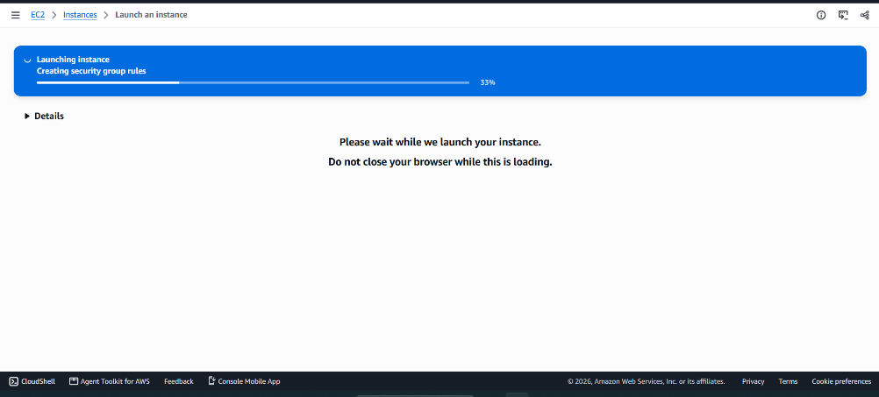
Reviewing EC2 Instance Information
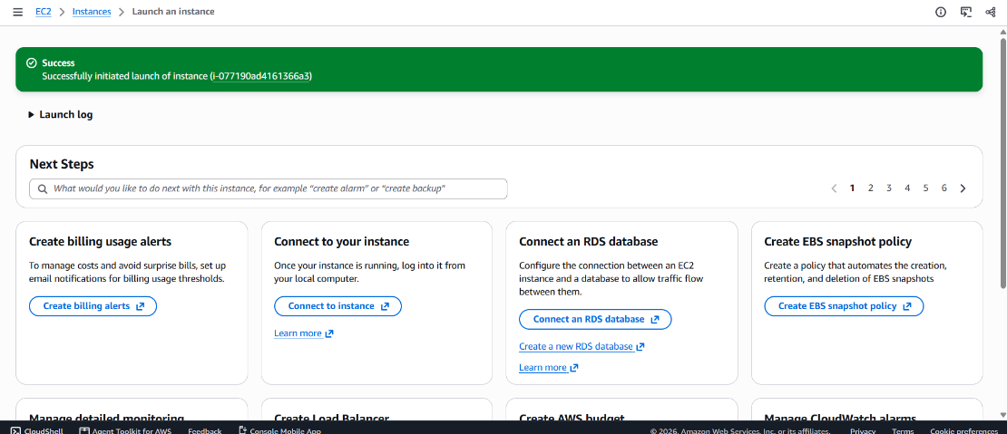
EC2 Instance Access Settings
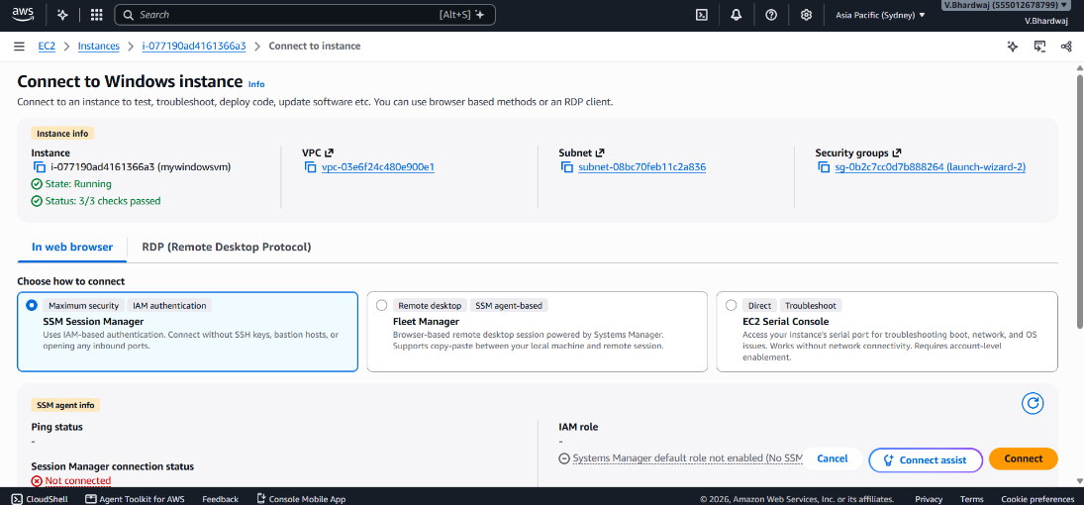
EC2 Instance Launch Configuration
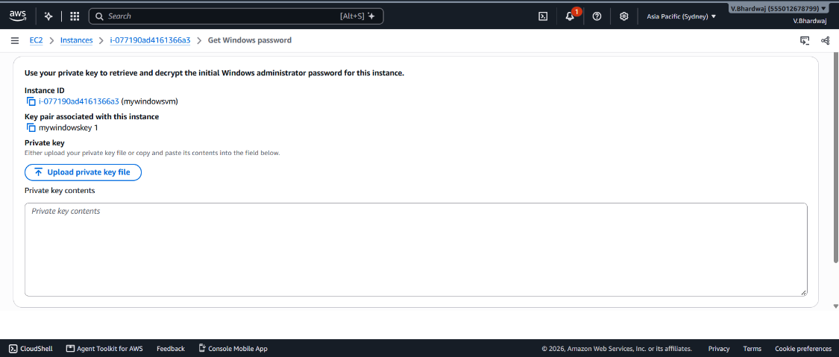
EC2 Instance Connection Options
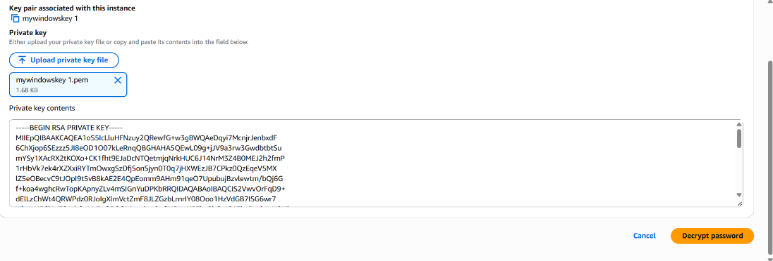
Accessing the EC2 Instance
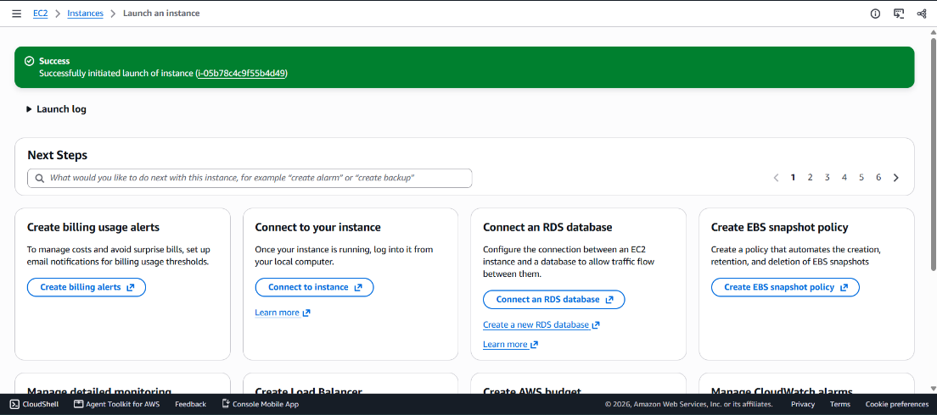
EC2 Instance Remote Connection
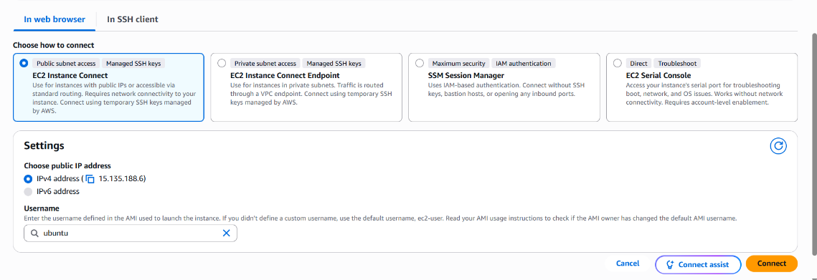
EC2 Instance Termination
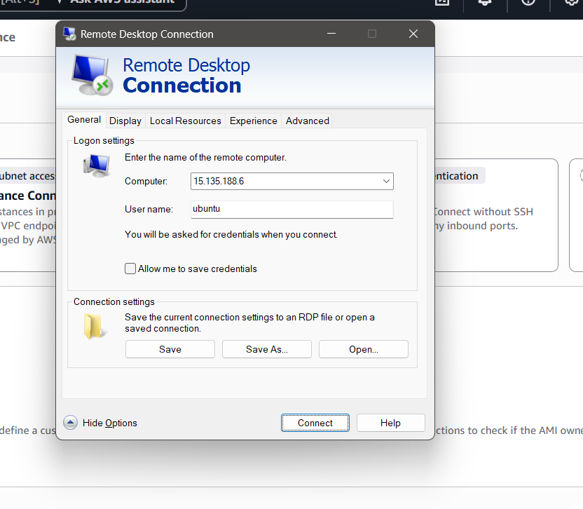
Bucket:
Amazon S3 Bucket Dashboard
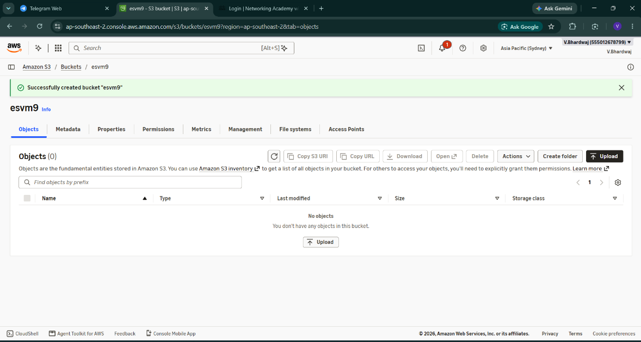
Creating an Amazon S3 Bucket
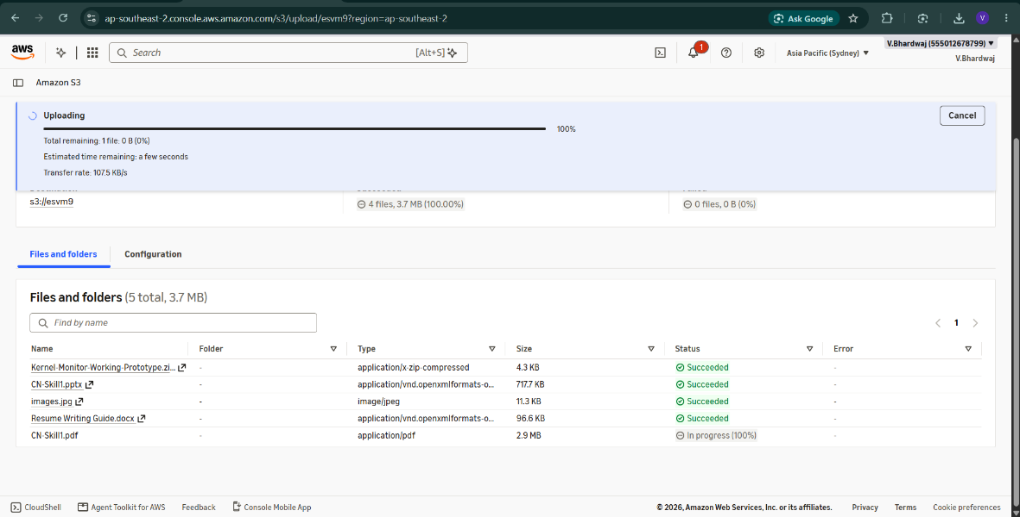
Configuring S3 Bucket Settings
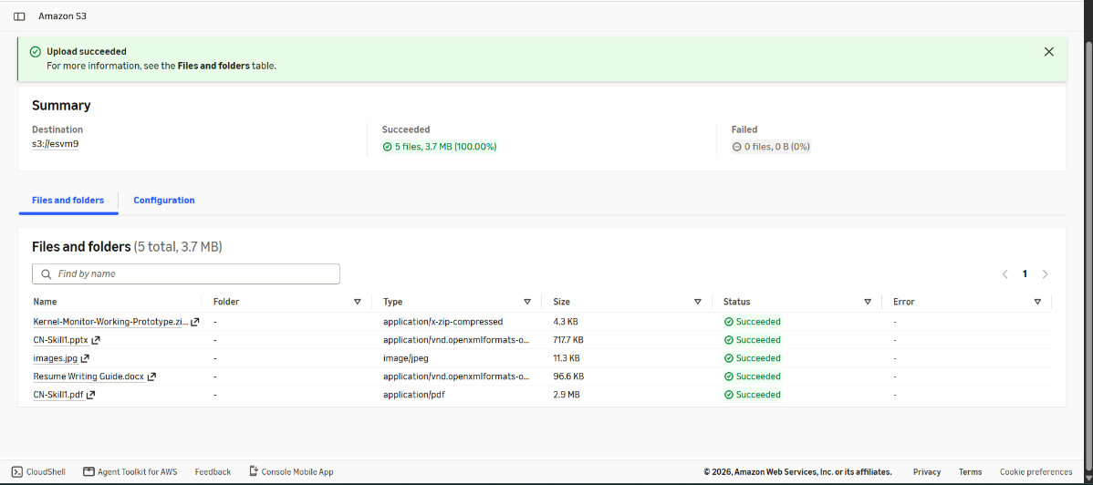
Viewing the Created S3 Bucket
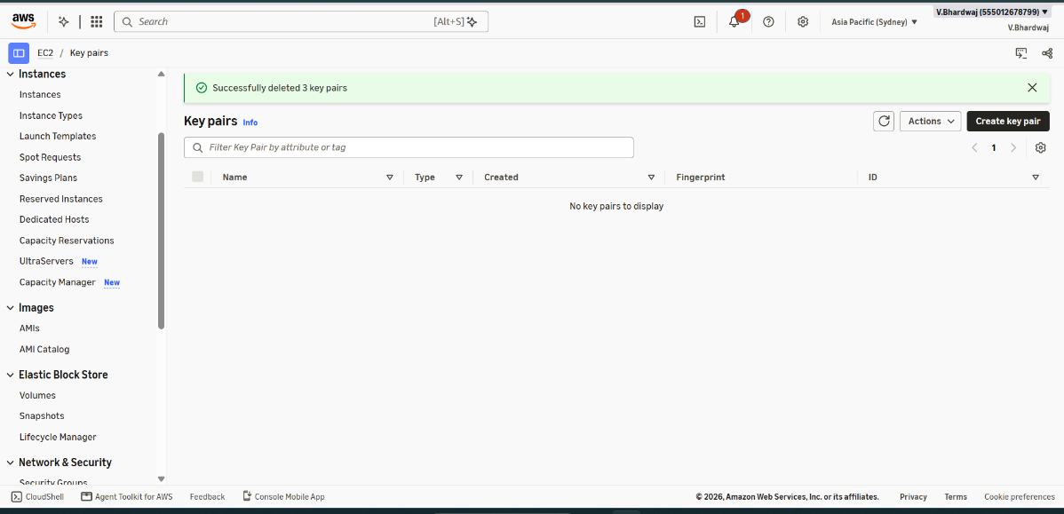
Opening the S3 Bucket
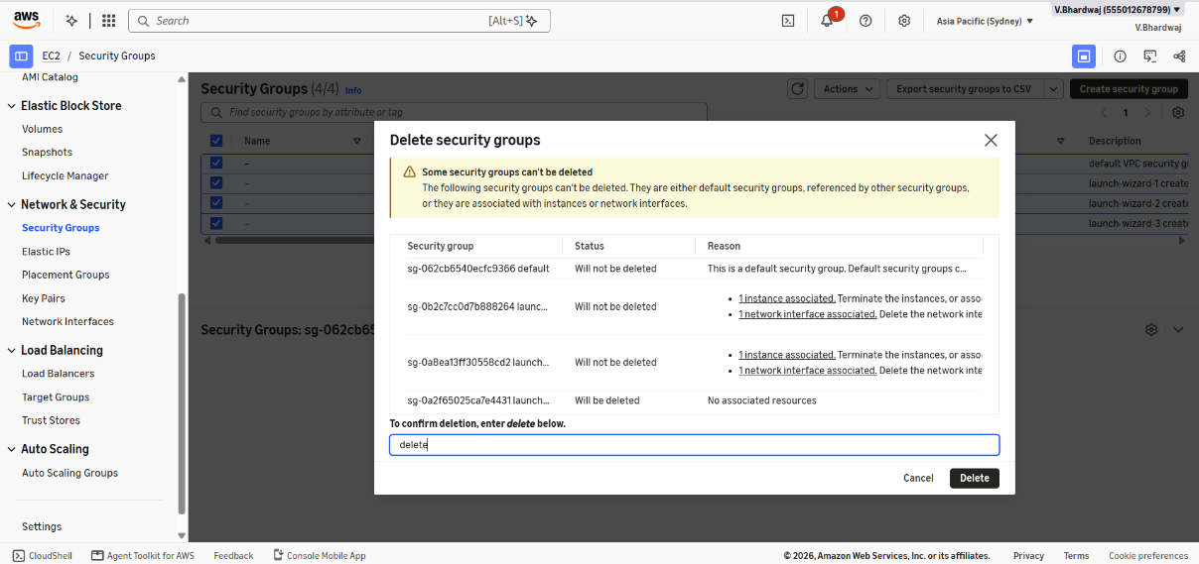
Managing S3 Bucket Objects
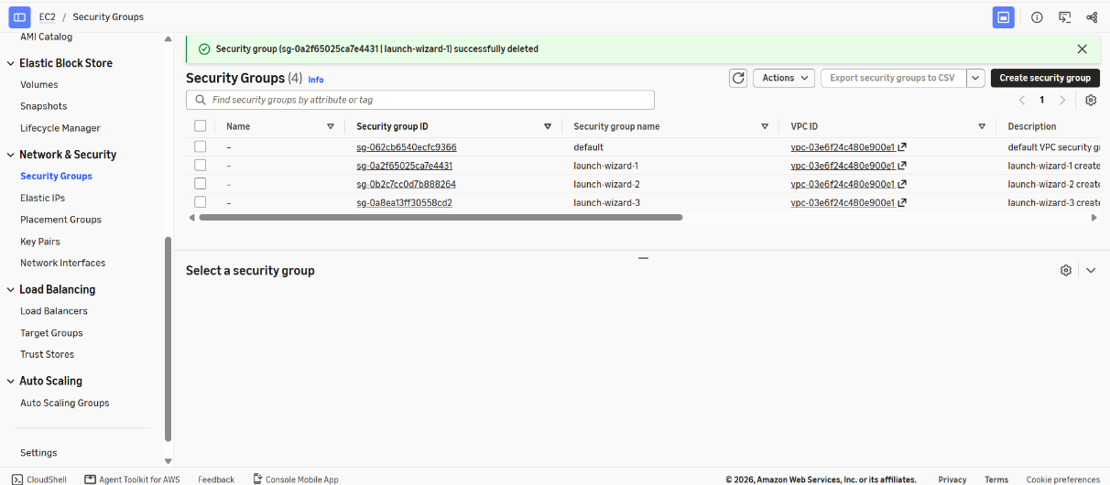
Verifying S3 Bucket Contents
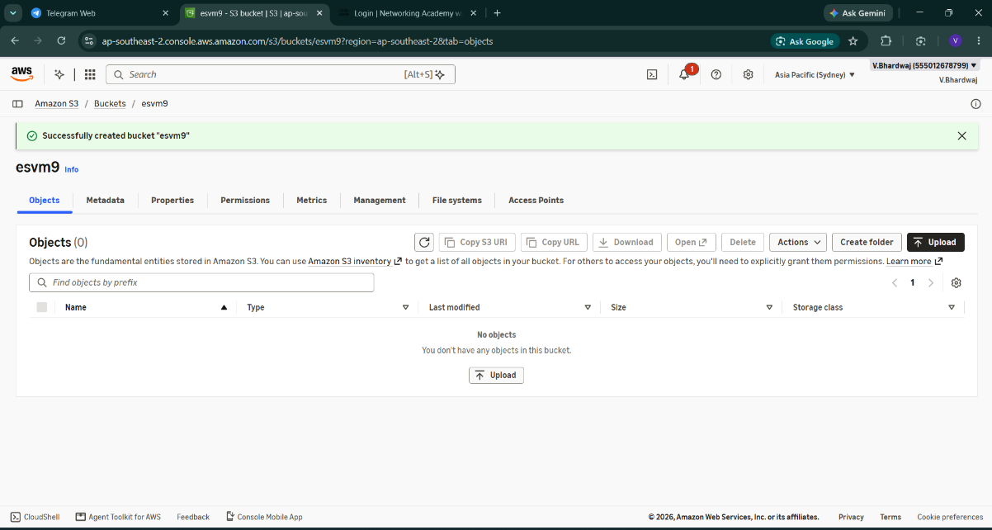
Ubuntu Code:
#!/bin/bash
apt update -y
DEBIAN_FRONTEND=noninteractive apt install -y xfce4 xfce4-goodies xrdp
echo "xfce4-session" > /home/ubuntu/.xsession
chown ubuntu:ubuntu /home/ubuntu/.xsession
adduser xrdp ssl-cert
echo "ubuntu:ChangeThisPassword@123" | chpasswd
systemctl enable xrdp
systemctl restart xrdp

