A CASE-STUDY BASED REPORT
ON
Credit Card Fraud Detection Using Logistic Regression and Isolation-Forest Anomaly Detection
submitted in partial fulfilment of the requirements for the Course
MACHINE LEARNING
BACHELOR OF TECHNOLOGY
in
A.Y.: 2026-27
by
V. Bhardwaj roll 2520090182
P. Uday roll 2520090089
A. Sri Chaitanya roll 2520090094
Under the Esteemed guidance of
Dr.Y.Lakshmi Prasanna
Asst.Professor, Dept. of CS&IT




INDEX
Abstract 3
Introduction 3
Background 3
Motivation for the Project 3
Overview of the Work Carried Out 4
Scope and Responsible-Use Statement 4
Problem Statement 4
Case-Study Scenario 4
Central Case-Study Question 5
Formal Problem Definition 5
Objectives that Guide the Study 5
Assumptions and Limitations 6
Dataset and Exploratory Data Analysis 7
About the Dataset 7
Purpose of EDA 7
Preparation Steps Actually Performed 7
EDA Exploration - Implementation 8
Summary of EDA Findings 15
Algorithm Selection and Implementation 16

Conclusion 23

Signature of the Team members

Abstract
Credit-card fraud is rare but expensive. In the dataset used in this case study only 492 of 284,807 transactions (about 0.17%) are fraudulent, so a model that approves every transaction would still appear to be 99.8% accurate while detecting no fraud at all. This case study places the team in the role of data scientists in a bank’s Risk Analytics department and builds a two-layer fraud-detection system. Layer 1 is a Logistic Regression classifier, trained with balanced class weights, that learns known fraud patterns from labelled transactions. Layer 2 is an Isolation Forest, trained without labels, that flags unusual transactions which may represent new types of fraud.
The work follows the full machine-learning workflow: exploratory data analysis (missing values, 1,081 duplicate records, class imbalance, skewed Amount, informative features), preprocessing (duplicate removal, robust scaling of Time and Amount, stratified 80/20 split), model training, and evaluation using Accuracy, Precision, Recall, F1-score, ROC-AUC, PR-AUC and confusion matrices. Logistic Regression was the stronger individual model (Recall 0.959, ROC-AUC 0.997, 94 of 98 test frauds detected), while Isolation Forest (Recall 0.112, ROC-AUC 0.873) acted as a complementary anomaly signal. The two models were finally combined into a High / Medium / Low fraud-risk strategy that a bank can use to block, verify or approve transactions.
Keywords: credit-card fraud, class imbalance, Logistic Regression, Isolation Forest, anomaly detection, ROC-AUC, PR-AUC.
Introduction
Background
Card payments are now the default way to pay, and customers expect every purchase to be approved within moments. Behind that convenience, a bank must make sure that stolen or misused cards are stopped before money is lost. Every undetected fraud causes a direct financial loss, chargeback costs and damage to customer trust, which is why fraud detection is a core function of any card-issuing institution.
Fraud detection is difficult for a data-driven system because genuine fraud is a tiny fraction of all transactions. This case study works on the widely used Credit Card Fraud Detection dataset, where frauds form only about 0.17% of the records, and studies how machine learning can be used to find them reliably.
Motivation for the Project
The project is motivated by the practical difficulties that make fraud detection different from an ordinary classification task:
- Class imbalance: a model that labels every transaction as “legitimate” would be correct more than 99.8% of the time, yet it would never catch a single fraud. Accuracy alone is therefore misleading.
- Known and unknown fraud: some fraud follows patterns seen in the past, while new fraud techniques look different from anything recorded before.
- False alarms: blocking genuine customers’ transactions is costly and annoying, so the number of false alerts must be kept under control.
These difficulties motivate the use of two complementary techniques – a supervised classifier for known fraud and an unsupervised anomaly detector for unusual behaviour – evaluated with metrics that suit imbalanced data.
Overview of the Work Carried Out
The following work was carried out in this case study:
- Loaded the transaction dataset and performed exploratory data analysis: structure and data types, missing values, duplicate records, statistical summary of Time and Amount, class distribution, amount and time behaviour, and the features most related to fraud.
- Preprocessed the data by removing duplicate records, scaling Time and Amount with a RobustScaler and creating a stratified 80/20 training and testing split.
- Trained a Logistic Regression model with balanced class weights to predict the probability of fraud.
- Trained an Isolation Forest, without using the labels, to detect anomalous transactions.
- Combined both models into a single rule and into High / Medium / Low risk levels.
- Evaluated all approaches using Accuracy, Precision, Recall, F1-score, ROC-AUC, PR-AUC, confusion matrices and ROC / Precision–Recall curves, and compared them.
Scope and Responsible-Use Statement
Scope. The study is limited to a binary classification problem (legitimate vs. fraudulent) on the ULB / Kaggle credit-card transaction dataset, using two techniques – Logistic Regression and Isolation Forest – and one combination rule. The models are evaluated offline on a held-out test set; they are not deployed in a live payment system.
Responsible use. The dataset contains no personal information: its original features were transformed with Principal Component Analysis (PCA) and anonymised for confidentiality, and it is used here only for academic learning. In practice, the output of such a system should support human decision-making rather than replace it. A flagged transaction should lead to verification (for example an SMS / OTP check or a review queue) instead of automatic permanent blocking, so that genuine customers are not unfairly penalised. Any real deployment would also need continuous monitoring, threshold tuning and privacy and fairness review.
Problem Statement
Case-Study Scenario
A leading financial institution (referred to as “the Bank”) issues credit cards to millions of customers and processes a very large number of card transactions every day. Customers expect every purchase to be approved instantly, while the Bank must make sure that stolen or misused cards are blocked before money is lost. Every undetected fraud causes a direct financial loss, chargeback costs and damage to customer trust.
You are a data scientist in the Bank’s Risk Analytics team. The Bank has shared a historical credit-card transaction dataset with the following attributes: Time, V1–V28, Amount and Class, where Class = 0 represents a legitimate transaction and Class = 1 represents a fraudulent transaction. Your task is to design an intelligent, two-layer Credit Card Fraud Detection System:
- Layer 1 – Logistic Regression (supervised): learns from labelled past transactions to detect known fraud patterns.
- Layer 2 – Isolation Forest (unsupervised anomaly detection): flags transactions whose behaviour is unusual, even if they do not resemble past fraud.
The Bank expects a working fraud-detection pipeline that catches as many fraudulent transactions as possible (high recall) while keeping false alarms at a manageable level, together with a clear comparison of the two techniques and a recommendation on how to use them together in practice.
Central Case-Study Question
How can the Bank’s Risk Analytics team combine a supervised Logistic Regression classifier with an unsupervised Isolation Forest so that as many fraudulent transactions as possible are caught (high recall) while the number of false alarms stays at a manageable level?
Formal Problem Definition
Let D = {(xᵢ, yᵢ)} be the set of historical transactions, where xᵢ is a vector of 30 numerical features (Time, V1–V28 and Amount) and yᵢ ∈ {0, 1} is the Class label (0 = legitimate, 1 = fraudulent). The task is to:
- learn a supervised model f(x) that outputs the probability of fraud P(y = 1 | x) and, with a decision threshold, a predicted class;
- learn an unsupervised anomaly model g(x), without using y, that outputs an anomaly score and flags the most unusual transactions;
- define a combined decision rule that labels a transaction as Fraudulent / Suspicious if either model raises an alert, and assigns a risk level based on how many models raise an alert;
- evaluate every approach with metrics that remain meaningful under extreme class imbalance (Precision, Recall, F1-score, ROC-AUC, PR-AUC and the confusion matrix) rather than accuracy alone.
Objectives that Guide the Study
The Bank assigned the following four tasks, which act as the objectives of this study:
1. Data preprocessing and EDA: perform preprocessing and exploratory analysis on the dataset – identify missing values, duplicate records, class distribution, important features and the class-imbalance problem.
2. Logistic Regression: classify transactions as legitimate or fraudulent, handle class imbalance appropriately, and evaluate using accuracy, precision, recall, F1-score, ROC-AUC and PR-AUC.
3. Isolation Forest: detect anomalous transactions, analyse its performance using suitable metrics and compare it with Logistic Regression.
4. Combined strategy: compare both approaches and develop a suitable fraud-risk detection strategy that combines supervised fraud prediction with anomaly detection to identify suspicious transactions.
Assumptions and Limitations
Assumptions
- The historical dataset is representative of the transactions the Bank wants to protect, and its Class labels are correct.
- The PCA-transformed features V1–V28, together with Time and Amount, contain enough information to separate fraud from legitimate behaviour.
- Duplicate records are data-entry repetitions and can be removed without losing fraud cases (all 492 frauds were retained).
- A decision threshold of 0.5 is used for Logistic Regression, and the contamination parameter of Isolation Forest is set to the fraud rate of the training data.
Limitations
- The data covers only two days of transactions from European cardholders, so patterns that change over time are not captured.
- Because the features are anonymised, the models cannot be explained in terms of real-world attributes such as merchant or location.
- At the default threshold, Logistic Regression has low precision, and the OR-combination of both models adds further false alarms; threshold tuning and cost-based evaluation are not carried out here.
- Performance is measured on a single stratified train / test split, without cross-validation.
Dataset and Exploratory Data Analysis
About the Dataset
The dataset used in this case study is the widely used Credit Card Fraud Detection dataset (ULB Machine Learning Group, available on Kaggle). It contains credit-card transactions made by European cardholders over two days in September 2013. For confidentiality, the original features were transformed using Principal Component Analysis (PCA), so most columns are anonymised.
Attribute | Description
Records | 284,807 transactions
Columns | 31 (30 input features + 1 target)
Time | Seconds elapsed between each transaction and the first transaction in the dataset
V1 – V28 | Anonymised numerical features obtained through PCA
Amount | Transaction amount
Class (target) | 0 = Legitimate transaction, 1 = Fraudulent transaction
Fraud cases | 492 frauds (about 0.17% of all transactions) – highly imbalanced

Purpose of EDA
Exploratory Data Analysis (EDA) is carried out before any model is trained. In this case study its purpose is to understand the structure, quality and class distribution of the data and the features that matter most, so that preprocessing and modelling decisions are based on evidence. In particular, the EDA is used to:
- check the structure and data types, and whether any categorical encoding is required;
- find missing values and duplicate records;
- measure the class-imbalance problem;
- study the behaviour of Amount and Time for legitimate and fraudulent transactions;
- identify the features most related to fraud and check whether the features are correlated with one another.
Each EDA step below shows the Python code followed by its output and an observation.
Preparation Steps Actually Performed
The EDA findings led to the following preparation steps, which were applied to the data before modelling. (The EDA in the next subsection is deliberately run on the raw data, so that the duplicates and the skew of Amount are visible.) The preparation consisted of: removing missing values (none were found) and the 1,081 duplicate records, scaling Time and Amount with a RobustScaler, and splitting the data into training and testing sets with stratification.
Step 3: Preprocessing (missing values, duplicates, feature scaling)
print("Missing values before :", df.isnull().sum().sum())
print("Duplicates before :", df.duplicated().sum())

df = df.dropna() # handle missing values
df = df.drop_duplicates() # remove duplicate records

# Scale the non-PCA numerical features (V1-V28 are already PCA-transformed).
# RobustScaler is used because Amount is heavily skewed with large outliers.
scaler = RobustScaler()
df[["Time", "Amount"]] = scaler.fit_transform(df[["Time", "Amount"]])

print("Missing values after :", df.isnull().sum().sum())
print("Duplicates after :", df.duplicated().sum())
print("Shape after cleaning :", df.shape)
print("Fraud transactions :", df["Class"].sum())
Output:
Missing values before : 0
Duplicates before : 1081
Missing values after : 0
Duplicates after : 0
Shape after cleaning : (283726, 31)
Fraud transactions : 492
Observation: The 1,081 duplicate records were removed, leaving 283,726 transactions; all 492 frauds were retained. Time and Amount were scaled with a RobustScaler, which is less affected by the large Amount outliers.
Step 4: Split into training and testing datasets
X = df.drop(columns="Class")
y = df["Class"]

X_train, X_test, y_train, y_test = train_test_split(
X, y, test_size=0.20, random_state=42, stratify=y) # stratify keeps the fraud ratio

print("Training set :", X_train.shape, "| frauds:", y_train.sum())
print("Testing set :", X_test.shape, "| frauds:", y_test.sum())
Output:
Training set : (226980, 30) | frauds: 394
Testing set : (56746, 30) | frauds: 98
Observation: A stratified 80/20 split keeps the fraud ratio the same in both sets: 226,980 training transactions (394 frauds) and 56,746 test transactions (98 frauds).
EDA Exploration - Implementation
EDA 1: Import libraries and load the dataset
import numpy as np
import pandas as pd
import matplotlib
matplotlib.use("Agg")
import matplotlib.pyplot as plt
import seaborn as sns

sns.set_style("whitegrid")
df = pd.read_csv("creditcard.csv")
print("Shape of the dataset:", df.shape)
print(df[["Time", "V1", "V2", "V3", "V28", "Amount", "Class"]].head())
Output:
Shape of the dataset: (284807, 31)
Time V1 V2 V3 V28 Amount Class
0 0.0 0.746387 0.826627 -0.923961 0.477352 36.23 0
1 1.0 1.756349 -0.541498 -2.937876 0.090380 37.82 0
2 4.0 2.507730 -0.736199 -1.575590 -0.263735 6.25 0
3 4.0 -0.190918 -2.646389 -1.946057 0.250039 6.52 0
4 6.0 3.675298 -2.423719 -1.118067 -0.498307 11.56 0
Observation: The dataset contains 284,807 transactions and 31 columns, so each row is one transaction described by Time, V1–V28, Amount and the target Class.
EDA 2: Dataset structure and data types
print("Total transactions :", df.shape[0])
print("Total columns :", df.shape[1])
print("\nData types:")
print(df.dtypes.value_counts())
Output:
Total transactions : 284807
Total columns : 31

Data types:
float64 30
int64 1
Name: count, dtype: int64
Observation: All 30 input features are numeric (float64) and Class is an integer, so no categorical encoding is required.
EDA 3: Missing values and duplicate records
print("Total missing values :", df.isnull().sum().sum())
print("Duplicate records :", df.duplicated().sum())
Output:
Total missing values : 0
Duplicate records : 1081
Observation: There are no missing values. However, 1,081 duplicate records exist; they are removed during preprocessing so that the same transaction is not counted twice (and does not leak between training and test sets).
EDA 4: Statistical summary of Time and Amount
print(df[["Time", "Amount"]].describe().round(2))
Output:
Time Amount
count 284807.00 284807.00
mean 93208.77 70.45
std 47600.12 184.79
min 0.00 0.04
25% 50839.00 9.23
50% 86492.00 24.52
75% 137278.00 65.60
max 172799.00 14127.10
Observation: Time ranges from 0 to about 172,800 seconds (two days). Amount is highly right-skewed: the mean (≈ 70) is far above the median (≈ 24.5) and the maximum is more than 14,000. Because of these outliers, Time and Amount need scaling, and a robust scaler is a good choice.
EDA 5: Class distribution and the class imbalance problem
counts = df["Class"].value_counts()
pct = df["Class"].value_counts(normalize=True) * 100
print("Legitimate (Class 0):", counts[0], f"({pct[0]:.3f}%)")
print("Fraudulent (Class 1):", counts[1], f"({pct[1]:.3f}%)")
print(f"Imbalance ratio : 1 fraud for every {counts[0] // counts[1]} legitimate transactions")

fig, ax = plt.subplots(1, 2, figsize=(10, 4))
sns.countplot(x="Class", data=df, hue="Class", palette=["#2e86ab", "#d1495b"], legend=False, ax=ax[0])
ax[0].set_title("Class distribution (count)")
ax[0].set_xticks([0, 1], ["Legitimate", "Fraud"])
ax[1].pie(counts, labels=["Legitimate", "Fraud"], autopct="%1.3f%%",
colors=["#2e86ab", "#d1495b"], explode=(0, 0.15))
ax[1].set_title("Class distribution (percentage)")
plt.tight_layout()
plt.savefig("figs/class_distribution.png", dpi=150)
Output:
Legitimate (Class 0): 284315 (99.827%)
Fraudulent (Class 1): 492 (0.173%)
Imbalance ratio : 1 fraud for every 577 legitimate transactions
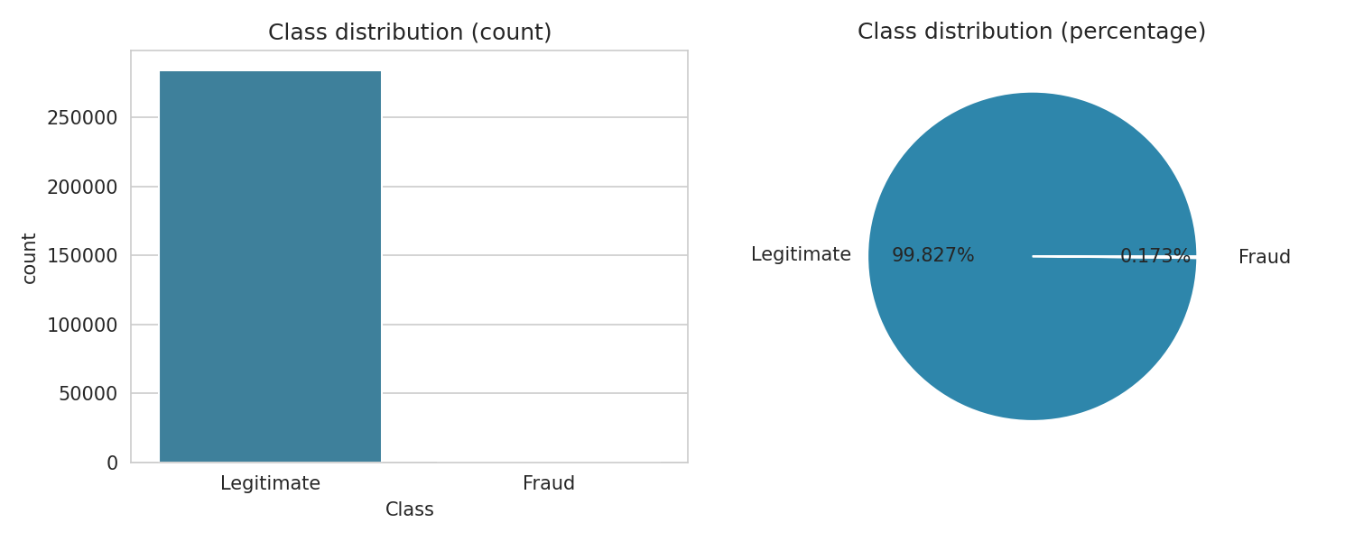
Figure 1: Class distribution of legitimate and fraudulent transactions
Observation: Only 492 of the 284,807 transactions are fraudulent (≈ 0.17%), i.e. roughly one fraud for every 577 legitimate transactions. This severe class imbalance is the central problem: a model that predicts “legitimate” for everything would reach ≈ 99.8% accuracy while detecting no fraud. Therefore class weighting and metrics such as Recall, Precision, F1, ROC-AUC and PR-AUC are used instead of accuracy alone.
EDA 6: Transaction amount analysis
print(df.groupby("Class")["Amount"].describe().round(2))

fig, ax = plt.subplots(1, 2, figsize=(10, 4))
sns.histplot(np.log1p(df.loc[df.Class == 0, "Amount"]), bins=50, color="#2e86ab", ax=ax[0])
ax[0].set_title("Legitimate: log(1 + Amount)")
sns.histplot(np.log1p(df.loc[df.Class == 1, "Amount"]), bins=30, color="#d1495b", ax=ax[1])
ax[1].set_title("Fraud: log(1 + Amount)")
plt.tight_layout()
plt.savefig("figs/amount_distribution.png", dpi=150)
Output:
count mean std min 25% 50% 75% max
Class
0 284315.0 70.4 184.41 0.04 9.23 24.53 65.60 14127.10
1 492.0 96.4 340.84 0.05 4.41 17.45 71.18 5004.46
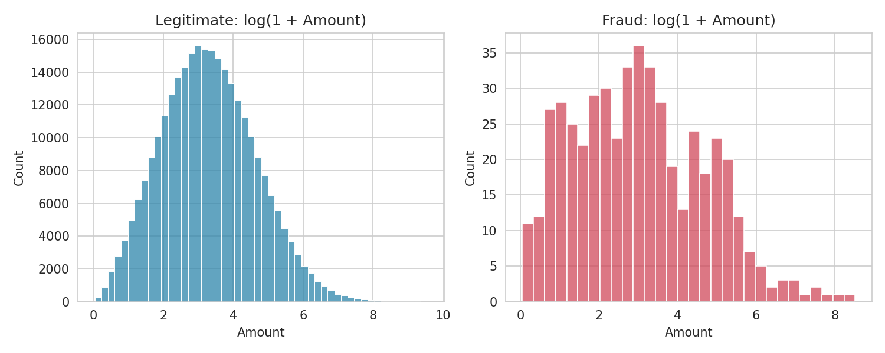
Figure 2: Distribution of log(1 + Amount) for legitimate and fraudulent transactions
Observation: Fraudulent transactions have a lower median amount (≈ 17) than legitimate ones (≈ 24.5) but a much larger spread and some very large values, so Amount alone cannot separate the classes.
EDA 7: Transaction time analysis
df["Hour"] = (df["Time"] // 3600) % 24
hourly = df.groupby("Hour")["Class"].agg(["count", "sum"])
hourly["fraud_rate_%"] = (hourly["sum"] / hourly["count"] * 100).round(3)
print(hourly.sort_values("fraud_rate_%", ascending=False).head(5))

fig, ax = plt.subplots(figsize=(10, 4))
ax.bar(hourly.index, hourly["fraud_rate_%"], color="#d1495b")
ax.set_xlabel("Hour of the day")
ax.set_ylabel("Fraud rate (%)")
ax.set_title("Fraud rate by hour of the day")
plt.tight_layout()
plt.savefig("figs/fraud_by_hour.png", dpi=150)
df.drop(columns="Hour", inplace=True)
Output:
count sum fraud_rate_%
Hour
2.0 2664 8 0.300
20.0 13880 34 0.245
15.0 17210 41 0.238
23.0 8068 19 0.235
11.0 17694 38 0.215
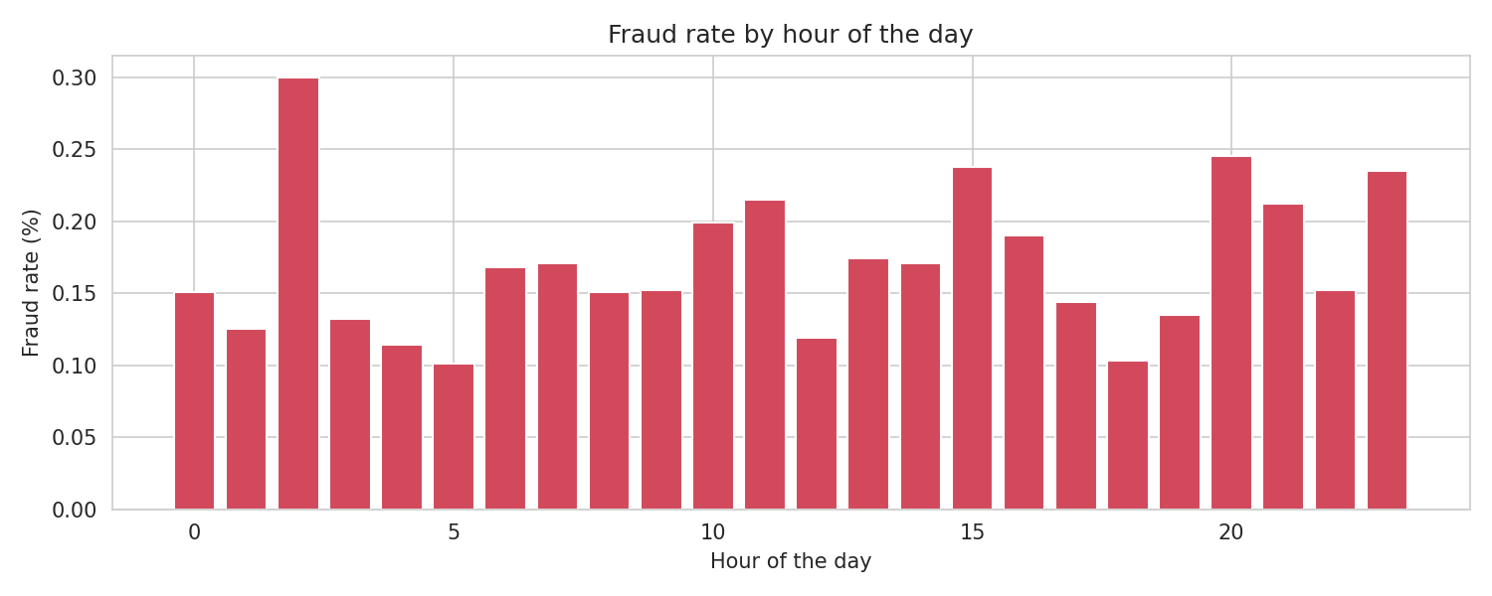
Figure 3: Fraud rate by hour of the day
Observation: The fraud rate is not uniform across the day; some hours (for example 2 AM, 8 PM and 3 PM) show higher fraud rates. Hours with few transactions give less reliable rates, so Time is useful but only as a supporting feature.
EDA 8: Important features - correlation with Class
corr = df.corr()["Class"].drop("Class").sort_values(key=abs, ascending=False)
print("Top 10 features most correlated with Class:")
print(corr.head(10).round(4))

fig, ax = plt.subplots(figsize=(8, 5))
top = corr.head(10).sort_values()
ax.barh(top.index, top.values, color=["#d1495b" if v > 0 else "#2e86ab" for v in top.values])
ax.set_title("Top 10 features correlated with Class")
ax.set_xlabel("Pearson correlation")
plt.tight_layout()
plt.savefig("figs/feature_correlation.png", dpi=150)
Output:
Top 10 features most correlated with Class:
V14 -0.0905
V17 -0.0743
V12 -0.0676
V4 0.0648
V10 -0.0594
V11 0.0377
V16 -0.0361
V3 -0.0354
V2 0.0299
V1 -0.0296
Name: Class, dtype: float64
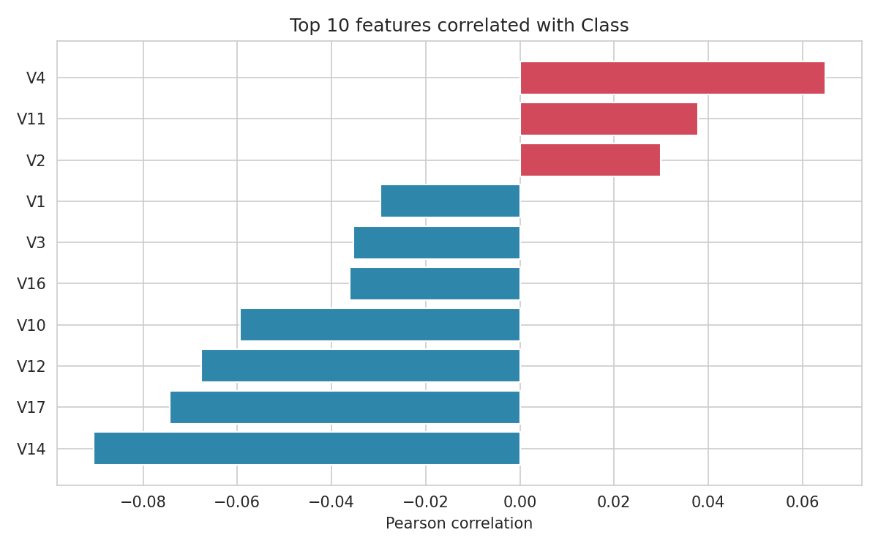
Figure 4: Top 10 features correlated with Class
Observation: V14, V17, V12 and V10 are negatively correlated with Class, while V4 and V11 are positively correlated. Individual correlations are weak because fraud is so rare, which shows that a model must combine many features together.
EDA 9: Feature distributions for fraud vs. legitimate transactions
top4 = list(corr.head(4).index)
fig, axes = plt.subplots(2, 2, figsize=(10, 7))
for ax, col in zip(axes.ravel(), top4):
sns.kdeplot(df.loc[df.Class == 0, col], label="Legitimate", color="#2e86ab", fill=True, ax=ax)
sns.kdeplot(df.loc[df.Class == 1, col], label="Fraud", color="#d1495b", fill=True, ax=ax)
ax.set_title(f"Distribution of {col}")
ax.legend()
plt.tight_layout()
plt.savefig("figs/feature_distributions.png", dpi=150)
print("Plotted features:", top4)
Output:
Plotted features: ['V14', 'V17', 'V12', 'V4']
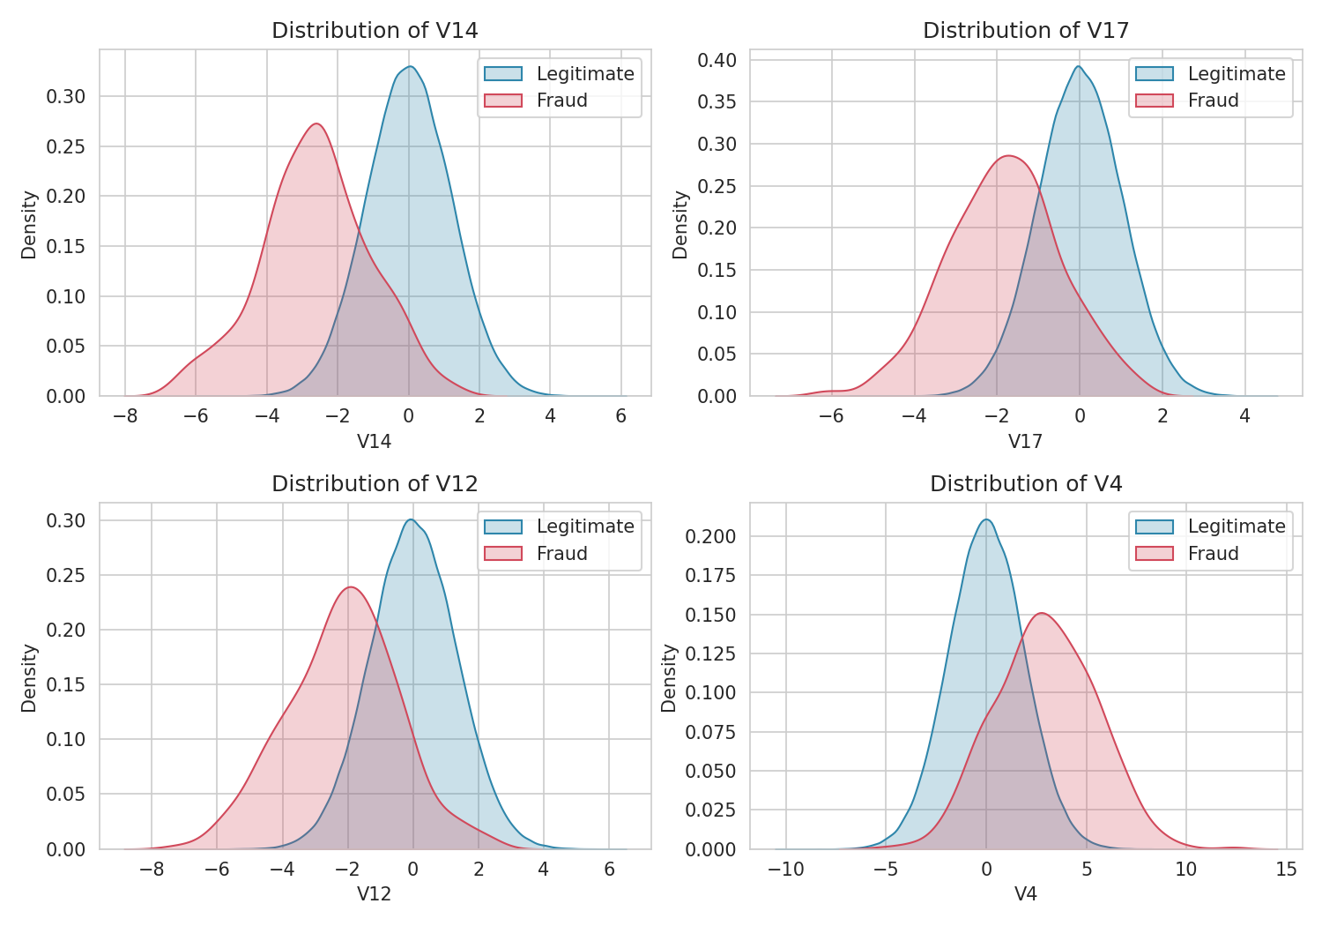
Figure 5: Density of the top four features for fraud vs. legitimate transactions
Observation: The fraud and legitimate densities of V14, V17, V12 and V4 are clearly shifted from each other, confirming that these features carry useful signal for classification.
EDA 10: Correlation heatmap of the most important features
cols = list(corr.head(10).index) + ["Class"]
plt.figure(figsize=(8, 6))
sns.heatmap(df[cols].corr(), cmap="coolwarm", center=0, annot=True, fmt=".2f", annot_kws={"size": 7})
plt.title("Correlation heatmap (top 10 features and Class)")
plt.tight_layout()
plt.savefig("figs/correlation_heatmap.png", dpi=150)
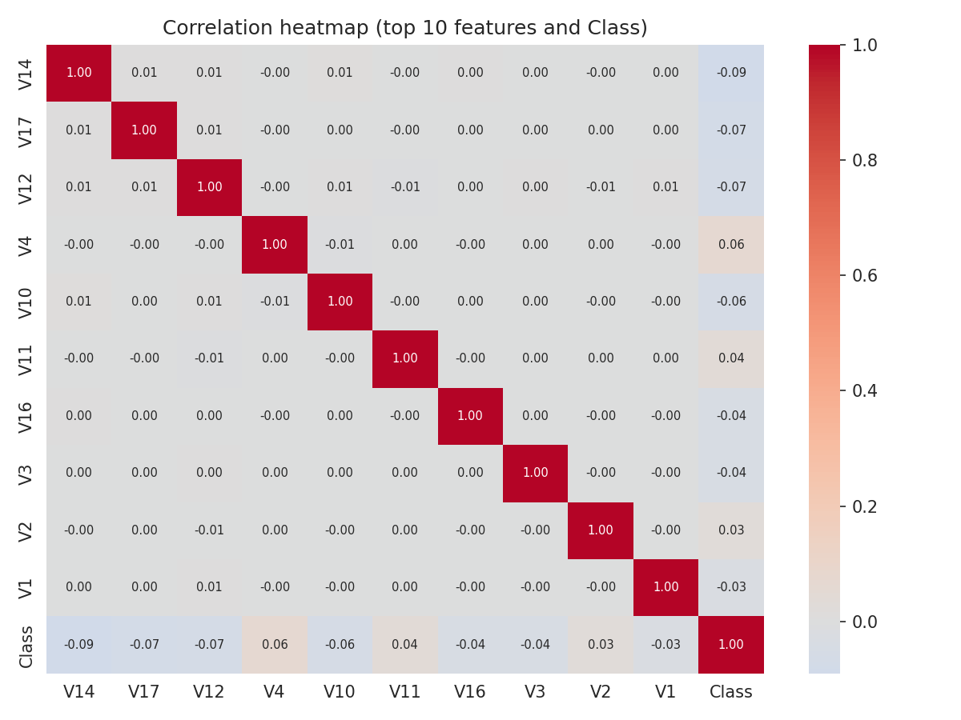
Figure 6: Correlation heatmap of the top 10 features and Class
Observation: The V-features show almost no correlation with one another (they are PCA components), so multicollinearity is not a concern for Logistic Regression.
Summary of EDA Findings
- The dataset has no missing values but contains 1,081 duplicate rows that must be removed.
- Fraud is only about 0.17% of all transactions, so the data is severely imbalanced and accuracy cannot be trusted.
- Amount (and Time) are skewed and unscaled, while V1–V28 are already PCA-transformed; Time and Amount need scaling.
- Features V14, V17, V12, V10, V4 and V11 are the most informative for separating fraud from legitimate transactions.
- These findings guided the preparation steps and the choice of algorithm: remove duplicates, scale Time and Amount, split the data with stratification, use class weights in Logistic Regression and set the contamination parameter of Isolation Forest to the fraud rate.
Algorithm Selection and Implementation
Algorithm Selection
Credit-card fraud detection is a binary classification problem with an extremely imbalanced target. Because frauds are so rare, the problem needs more than a standard classifier:
- Supervised learning (Logistic Regression): uses the Class labels to learn a decision boundary between legitimate and fraudulent transactions. Class weights are used to stop the majority class from dominating.
- Unsupervised anomaly detection (Isolation Forest): ignores the labels and isolates transactions that are rare and different from normal behaviour, which helps detect unseen fraud types.
- Suitable metrics: since accuracy is misleading, models are judged using Precision, Recall, F1-Score, ROC-AUC, PR-AUC and the Confusion Matrix.
The goal is to build, evaluate and compare both techniques and then combine them into a single fraud-risk detection strategy.
Algorithm
Title: Credit Card Fraud Detection Using Logistic Regression and Isolation-Forest Anomaly Detection
Step 1: Start.
Step 2: Load the credit card transaction dataset.
Step 3: Preprocess the dataset by handling missing values, removing duplicate records, and scaling the numerical features.
Step 4: Split the dataset into training and testing datasets.
Step 5: Train the Logistic Regression model using the training dataset.
Step 6: Predict the probability of fraud for the test transactions using Logistic Regression.
Step 7: Train the Isolation Forest model to detect unusual or anomalous transactions.
Step 8: Identify transactions classified as anomalies by the Isolation Forest model.
Step 9: Combine the results of Logistic Regression and Isolation Forest.
Step 10: If a transaction is predicted as fraudulent or detected as an anomaly, classify it as Fraudulent/Suspicious; otherwise, classify it as Legitimate.
Step 11: Evaluate the detection performance using Accuracy, Precision, Recall, F1-Score, and Confusion Matrix.
Step 12: Display the final fraud detection results.
Step 13: Stop.
Implementation
The algorithm is implemented below in Python (pandas and scikit-learn). Each part of the code is mapped to the algorithm step(s) it performs and is followed by its output.
Steps 1–2: Start and load the dataset
import numpy as np
import pandas as pd
import matplotlib
matplotlib.use("Agg")
import matplotlib.pyplot as plt
import seaborn as sns
from sklearn.model_selection import train_test_split
from sklearn.preprocessing import RobustScaler
from sklearn.linear_model import LogisticRegression
from sklearn.ensemble import IsolationForest
from sklearn.metrics import (accuracy_score, precision_score, recall_score, f1_score,
roc_auc_score, average_precision_score, confusion_matrix,
classification_report, roc_curve, precision_recall_curve,
ConfusionMatrixDisplay)

df = pd.read_csv("creditcard.csv")
print("Dataset loaded. Shape:", df.shape)
Output:
Dataset loaded. Shape: (284807, 31)
Observation: The libraries are imported and the dataset is loaded with 284,807 rows and 31 columns (Algorithm Steps 1 and 2).
Steps 3 and 4 (preprocessing and the train / test split) were carried out in the subsection “Preparation Steps Actually Performed” and are not repeated here; the code below continues from those steps.
Steps 5–6: Train Logistic Regression and predict fraud probability
# class_weight="balanced" handles the class imbalance
lr = LogisticRegression(class_weight="balanced", max_iter=1000, random_state=42)
lr.fit(X_train, y_train)

lr_prob = lr.predict_proba(X_test)[:, 1] # probability of fraud
lr_pred = (lr_prob >= 0.5).astype(int) # decision threshold = 0.5

print("Sample fraud probabilities (first 5 test transactions):")
print(lr_prob[:5].round(4))
print("\nTransactions predicted as fraud by Logistic Regression:", lr_pred.sum())
Output:
Sample fraud probabilities (first 5 test transactions):
[0.0005 0.0148 0. 0.0001 0. ]

Transactions predicted as fraud by Logistic Regression: 1142
Observation: Logistic Regression is trained with balanced class weights so that fraud errors are penalised more heavily. It outputs a fraud probability for each test transaction and, with a 0.5 threshold, flagged 1,142 transactions as fraud.
Steps 7–8: Train Isolation Forest and identify anomalies
# Isolation Forest is unsupervised: it is trained WITHOUT the Class labels.
# contamination = expected proportion of anomalies (fraud rate in training data)
fraud_rate = y_train.mean()
iso = IsolationForest(n_estimators=200, contamination=fraud_rate,
random_state=42, n_jobs=-1)
iso.fit(X_train)

iso_raw = iso.predict(X_test) # +1 = normal, -1 = anomaly
iso_pred = (iso_raw == -1).astype(int) # convert to 1 = anomaly
iso_score = -iso.decision_function(X_test) # higher = more anomalous

print("Contamination used:", round(fraud_rate, 5))
print("Transactions flagged as anomalies by Isolation Forest:", iso_pred.sum())
Output:
Contamination used: 0.00174
Transactions flagged as anomalies by Isolation Forest: 123
Observation: Isolation Forest was trained without using the labels and flagged 123 transactions as anomalies, close to the expected fraud rate set through the contamination parameter.
Steps 9–10: Combine both models and classify transactions
# Rule: fraud predicted by Logistic Regression OR anomaly found by Isolation Forest
combined_pred = ((lr_pred == 1) | (iso_pred == 1)).astype(int)

result = pd.DataFrame({
"Actual": y_test.values,
"LR_Fraud": lr_pred,
"IF_Anomaly": iso_pred,
"Combined": combined_pred,
})
result["Final_Label"] = np.where(result["Combined"] == 1, "Fraudulent/Suspicious", "Legitimate")

print(result["Final_Label"].value_counts())

# Fraud-risk levels based on how many models raise an alert
result["Risk_Level"] = np.select(
[result.LR_Fraud + result.IF_Anomaly == 2, result.LR_Fraud + result.IF_Anomaly == 1],
["High", "Medium"], default="Low")
print("\nRisk level vs. actual class:")
print(pd.crosstab(result["Risk_Level"], result["Actual"]))
Output:
Final_Label
Legitimate 55500
Fraudulent/Suspicious 1246
Name: count, dtype: int64

Risk level vs. actual class:
Actual 0 1
Risk_Level
High 8 11
Low 55496 4
Medium 1144 83
Observation: The combined rule flagged 1,246 test transactions as Fraudulent/Suspicious. The risk-level table shows that the “High” level (both models alert) is the most reliable: 11 of its 19 transactions are real frauds, whereas the “Medium” level (only one model alerts) contains most of the false alarms.
Step 11: Evaluate performance (Accuracy, Precision, Recall, F1, ROC–AUC, PR–AUC)
def evaluate(name, y_true, y_pred, score=None):
row = {
"Model": name,
"Accuracy": accuracy_score(y_true, y_pred),
"Precision": precision_score(y_true, y_pred, zero_division=0),
"Recall": recall_score(y_true, y_pred),
"F1-Score": f1_score(y_true, y_pred),
"ROC-AUC": roc_auc_score(y_true, score) if score is not None else np.nan,
"PR-AUC": average_precision_score(y_true, score) if score is not None else np.nan,
}
return row

metrics = pd.DataFrame([
evaluate("Logistic Regression", y_test, lr_pred, lr_prob),
evaluate("Isolation Forest", y_test, iso_pred, iso_score),
evaluate("Combined (LR OR IF)", y_test, combined_pred),
]).set_index("Model").round(4)
print(metrics)

print("\nClassification report - Logistic Regression")
print(classification_report(y_test, lr_pred, target_names=["Legitimate", "Fraud"], digits=4))
Output:
Accuracy Precision Recall F1-Score ROC-AUC PR-AUC
Model
Logistic Regression 0.9815 0.0823 0.9592 0.1516 0.9972 0.8401
Isolation Forest 0.9965 0.0894 0.1122 0.0995 0.8725 0.0373
Combined (LR OR IF) 0.9796 0.0754 0.9592 0.1399 NaN NaN

Classification report - Logistic Regression
precision recall f1-score support

Legitimate 0.9999 0.9815 0.9906 56648
Fraud 0.0823 0.9592 0.1516 98

accuracy 0.9815 56746
macro avg 0.5411 0.9703 0.5711 56746
weighted avg 0.9983 0.9815 0.9892 56746
Observation: Logistic Regression has very high recall (0.959) and ROC-AUC (0.997) but low precision (0.082) at the 0.5 threshold, because class weighting makes it flag many legitimate transactions. Isolation Forest has high accuracy (0.9965) only because most transactions are legitimate; its recall (0.112) and PR-AUC (0.037) are low. The combined rule keeps the recall of Logistic Regression (0.959) but slightly lowers precision (0.075).
Step 11 (continued): Confusion matrices
fig, axes = plt.subplots(1, 3, figsize=(15, 4))
for ax, (name, pred) in zip(axes, [("Logistic Regression", lr_pred),
("Isolation Forest", iso_pred),
("Combined (LR OR IF)", combined_pred)]):
cm = confusion_matrix(y_test, pred)
ConfusionMatrixDisplay(cm, display_labels=["Legitimate", "Fraud"]).plot(
ax=ax, cmap="Blues", values_format="d", colorbar=False)
ax.set_title(name)
tn, fp, fn, tp = cm.ravel()
print(f"{name:22s} TN={tn:6d} FP={fp:5d} FN={fn:3d} TP={tp:3d}")
plt.tight_layout()
plt.savefig("figs/confusion_matrices.png", dpi=150)
Output:
Logistic Regression TN= 55600 FP= 1048 FN= 4 TP= 94
Isolation Forest TN= 56536 FP= 112 FN= 87 TP= 11
Combined (LR OR IF) TN= 55496 FP= 1152 FN= 4 TP= 94
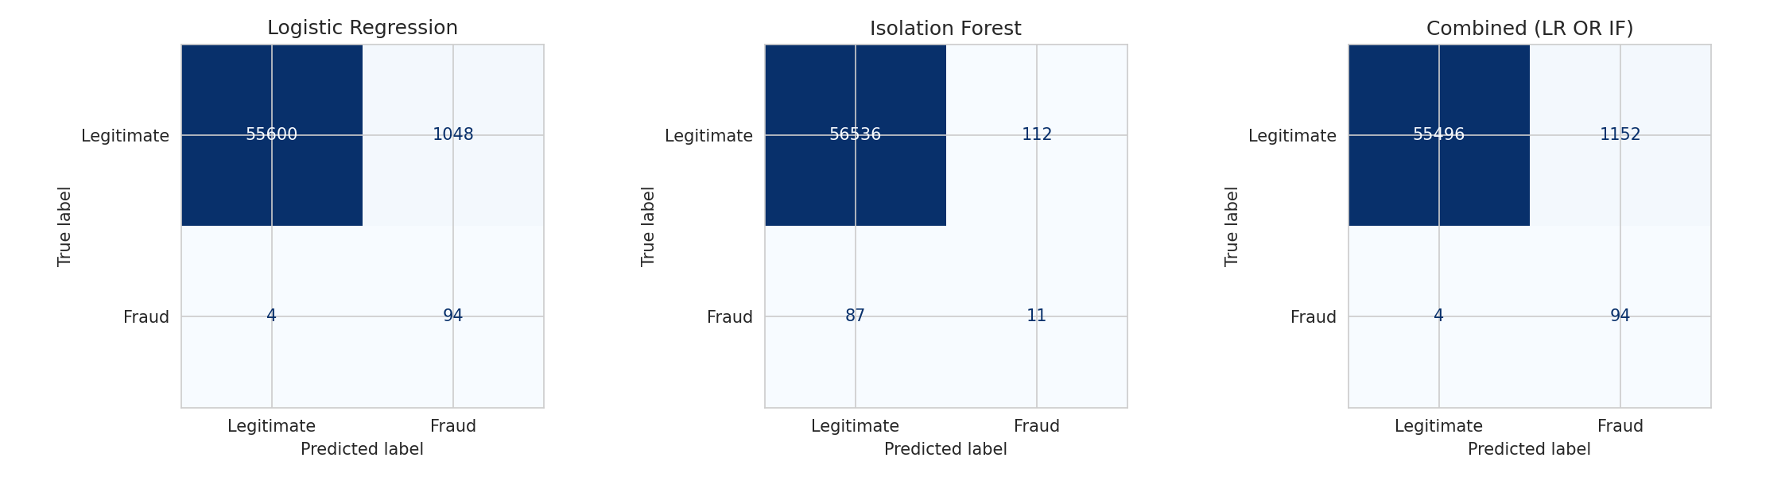
Figure 7: Confusion matrices of the three approaches
Observation: Logistic Regression detects 94 of the 98 frauds with 1,048 false alarms. Isolation Forest detects only 11 frauds with 112 false alarms. The combined rule still catches 94 frauds, because the frauds found by Isolation Forest were already found by Logistic Regression, and it adds 104 more false alarms.
Step 11 (continued): ROC and Precision–Recall curves
fig, ax = plt.subplots(1, 2, figsize=(12, 4.5))
for name, score, c in [("Logistic Regression", lr_prob, "#d1495b"),
("Isolation Forest", iso_score, "#2e86ab")]:
fpr, tpr, _ = roc_curve(y_test, score)
ax[0].plot(fpr, tpr, color=c, label=f"{name} (AUC = {roc_auc_score(y_test, score):.3f})")
p, r, _ = precision_recall_curve(y_test, score)
ax[1].plot(r, p, color=c, label=f"{name} (AP = {average_precision_score(y_test, score):.3f})")
ax[0].plot([0, 1], [0, 1], "k--", lw=1)
ax[0].set(xlabel="False Positive Rate", ylabel="True Positive Rate", title="ROC Curve")
ax[1].set(xlabel="Recall", ylabel="Precision", title="Precision-Recall Curve")
ax[0].legend(); ax[1].legend()
plt.tight_layout()
plt.savefig("figs/roc_pr_curves.png", dpi=150)
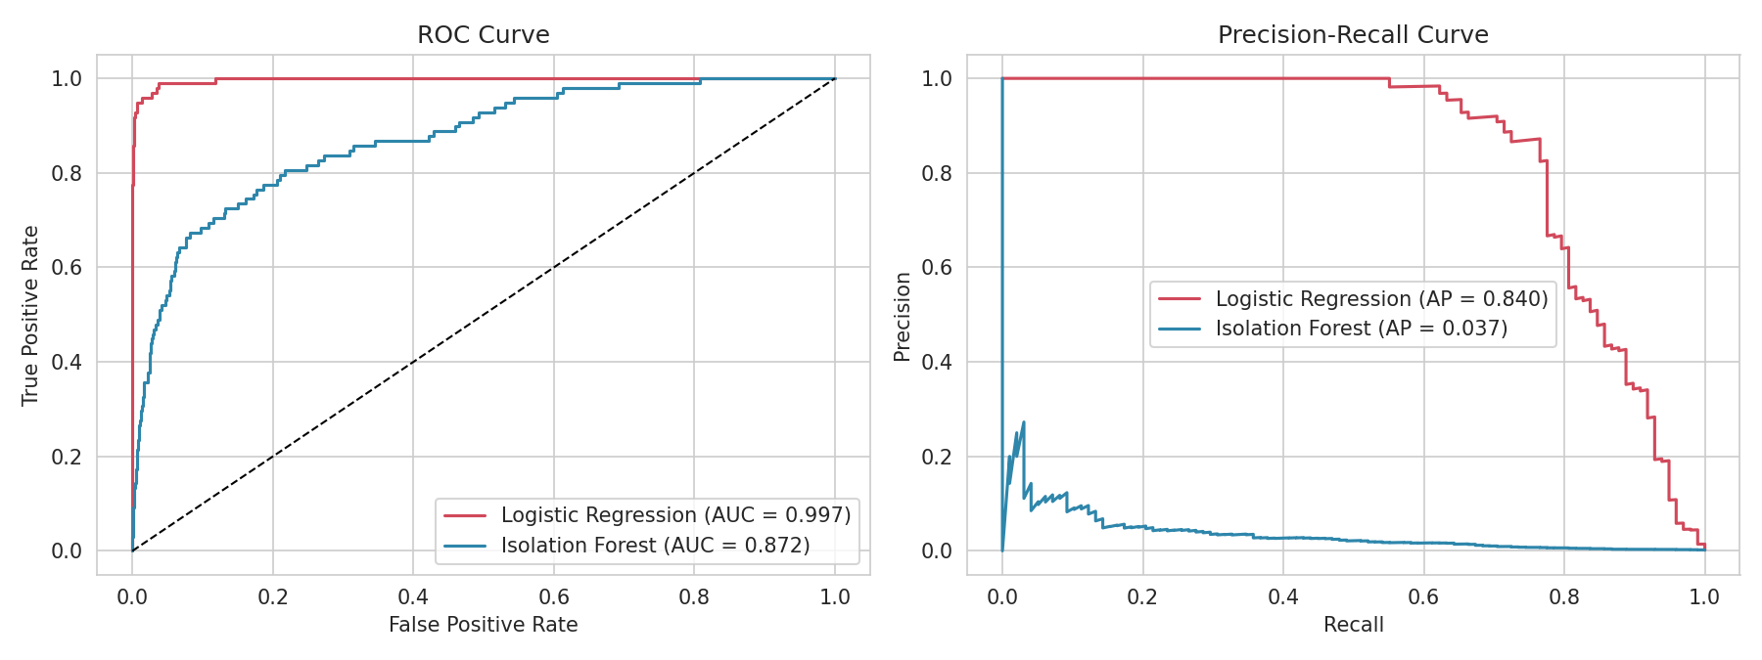
Figure 8: ROC curve and Precision-Recall curve (LR vs. Isolation Forest)
Observation: Logistic Regression’s ROC curve is close to the top-left corner (AUC ≈ 0.997) and its PR curve stays high for a wide range of recall (AP ≈ 0.84), showing it ranks frauds very well and that precision can be improved by raising the decision threshold. Isolation Forest has a lower AUC (≈ 0.87) and a very low average precision.
Step 12: Display the final fraud detection results
flagged = X_test.copy()
flagged["Actual"] = y_test.values
flagged["Fraud_Probability"] = lr_prob.round(4)
flagged["Anomaly_Score"] = iso_score.round(4)
flagged["Final_Label"] = result["Final_Label"].values
flagged["Risk_Level"] = result["Risk_Level"].values

print("Top 10 highest-risk transactions in the test set:")
top10 = flagged[flagged.Risk_Level == "High"].sort_values("Fraud_Probability", ascending=False).head(10)
print(top10[["Actual", "Fraud_Probability", "Anomaly_Score", "Final_Label", "Risk_Level"]].to_string())

print("\nFinal summary")
print("Total test transactions :", len(y_test))
print("Actual frauds in test set :", y_test.sum())
print("Flagged Fraudulent/Suspicious:", combined_pred.sum())
print("Frauds correctly caught :", ((combined_pred == 1) & (y_test.values == 1)).sum())
Output:
Top 10 highest-risk transactions in the test set:
Actual Fraud_Probability Anomaly_Score Final_Label Risk_Level
140565 1 1.0 0.0003 Fraudulent/Suspicious High
184905 1 1.0 0.0083 Fraudulent/Suspicious High
160801 1 1.0 0.0006 Fraudulent/Suspicious High
127846 1 1.0 0.0212 Fraudulent/Suspicious High
105357 1 1.0 0.0044 Fraudulent/Suspicious High
87823 1 1.0 0.0224 Fraudulent/Suspicious High
46954 1 1.0 0.0060 Fraudulent/Suspicious High
126924 1 1.0 0.0071 Fraudulent/Suspicious High
123547 1 1.0 0.0050 Fraudulent/Suspicious High
236718 1 1.0 0.0204 Fraudulent/Suspicious High

Final summary
Total test transactions : 56746
Actual frauds in test set : 98
Flagged Fraudulent/Suspicious: 1246
Frauds correctly caught : 94
Observation: The final output assigns each test transaction a fraud probability, an anomaly score, a final label and a risk level. Of the 98 actual frauds in the test set, 94 were caught by the system and 1,246 transactions were flagged for review in total.
Comparison of the Approaches and Fraud-Risk Strategy
Model | Accuracy | Precision | Recall | F1-Score | ROC-AUC | PR-AUC
Logistic Regression | 0.9815 | 0.0823 | 0.9592 | 0.1516 | 0.9972 | 0.8401
Isolation Forest | 0.9965 | 0.0894 | 0.1122 | 0.0995 | 0.8725 | 0.0373
Combined (LR OR IF) | 0.9796 | 0.0754 | 0.9592 | 0.1399 | – | –

- Logistic Regression (supervised): best at finding known fraud – it caught 94 of 98 frauds and has the highest ROC-AUC and PR-AUC. Its weakness is low precision at the default threshold, which can be improved by tuning the threshold.
- Isolation Forest (unsupervised): works without labels and its ROC-AUC (≈ 0.87) shows that fraud is partly “unusual”, but it detects far fewer frauds here. It is more useful as a secondary signal for new, unseen fraud types than as the main detector.
- Combined OR rule: guarantees that a transaction is reviewed if either model raises an alert, which maximises recall, but it adds extra false alarms (1,152 vs. 1,048).
Suggested fraud-risk strategy: instead of one flat “suspicious” label, use risk levels. A transaction flagged by both models is High risk and can be blocked or verified immediately; a transaction flagged by only one model is Medium risk and goes to a review queue or triggers an SMS/OTP verification; a transaction flagged by neither is Low risk and is approved. The Logistic Regression threshold can be tuned using the Precision-Recall curve to balance missed frauds against false alarms.
Conclusion
A credit-card fraud detection system was developed using Logistic Regression and Isolation Forest. EDA showed severe class imbalance (≈ 0.17% fraud), skewed Amount values and 1,081 duplicate records, which were handled during preprocessing. Logistic Regression with balanced class weights was the strongest individual model, while Isolation Forest provided a complementary anomaly signal. Combining both models into risk levels gives a practical strategy: High-risk transactions are acted on immediately, Medium-risk transactions are reviewed, and Low-risk transactions pass through. Accuracy alone was shown to be misleading, so Precision, Recall, F1-Score, ROC-AUC, PR-AUC and the Confusion Matrix were used for a fair evaluation.

