TASK-1

\*BASIC OPERATIONS OF POWERBI\*

STEP-1 : Open the POWERBI and then click on BLANK REPORT.

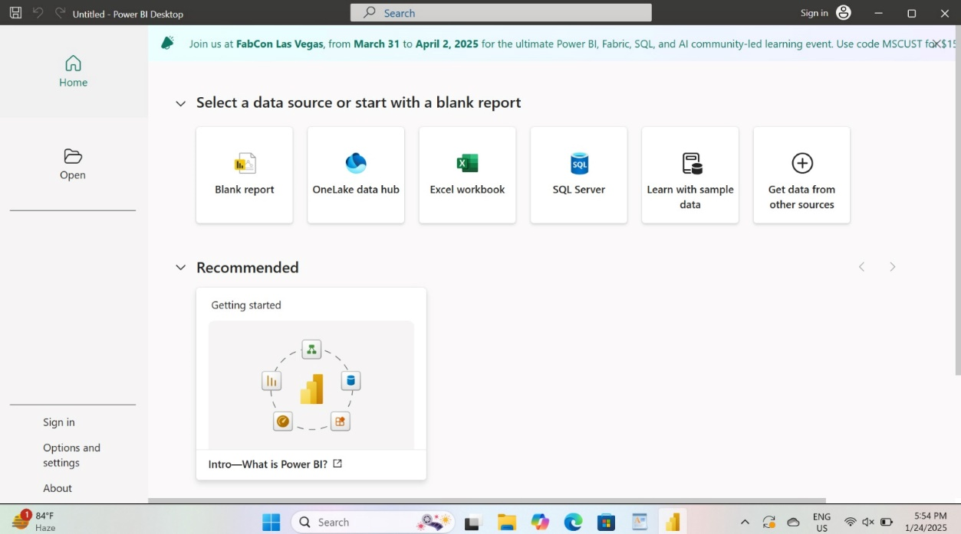



STEP-2 : Then Retrieve the Data from the Local storage by using the GETDATA button on the Tool Bar.

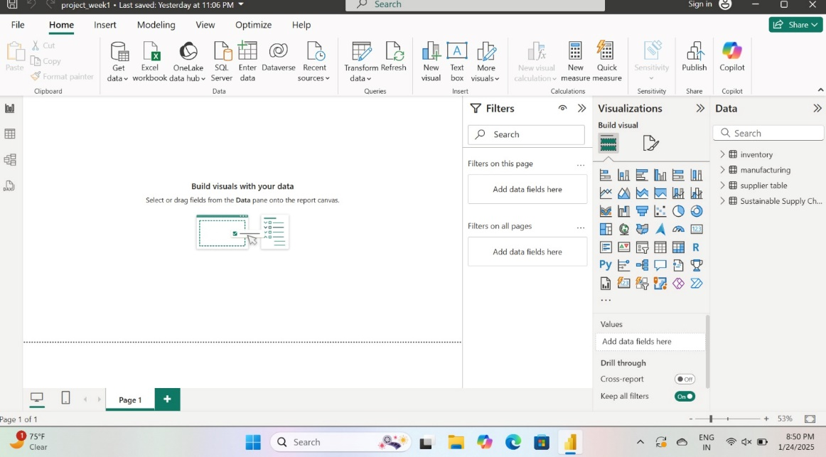



STEP-3 : After Selecting the GETDATA option select the TEXT/CSV format type from the given data sources option yretrieve the CSV file from local storage.

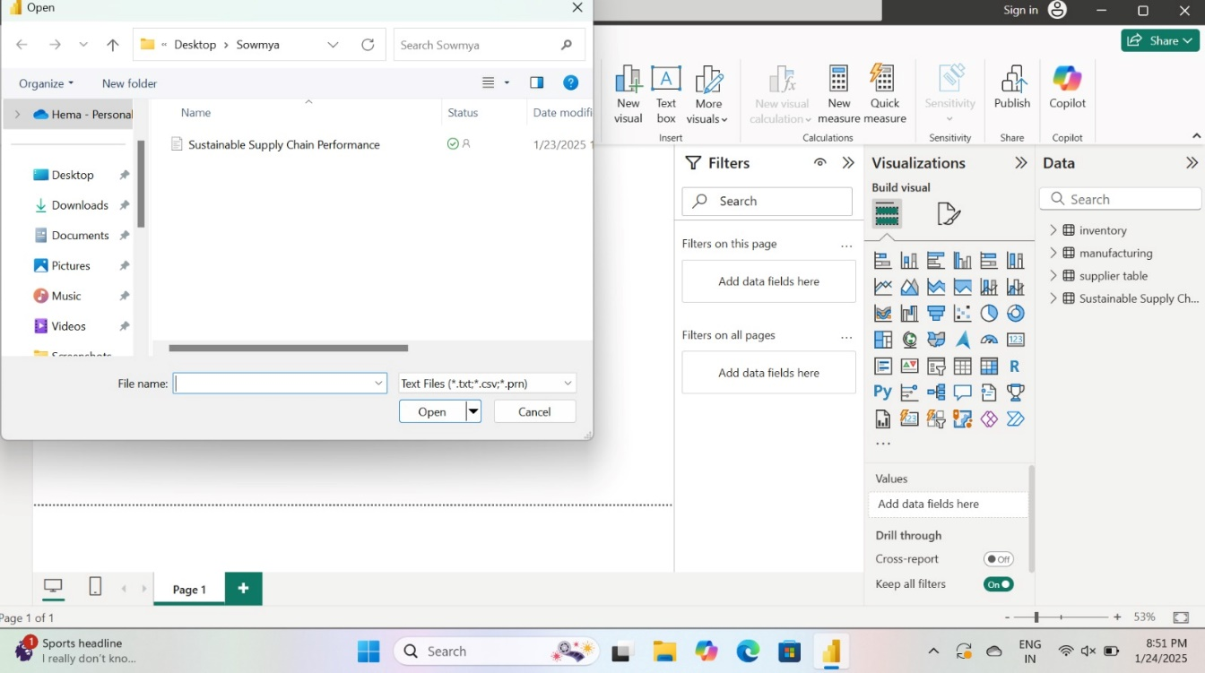

STEP-4 : Then select the FILE from the Local PC storage and Open it.

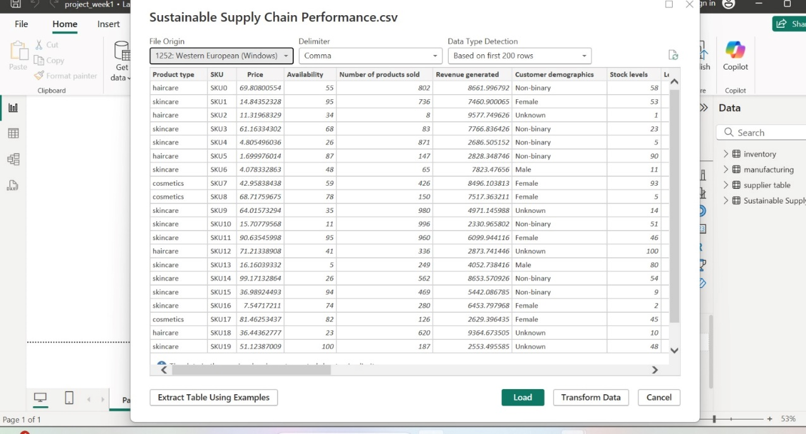

STEP-5 : After opening the CSV FILE, we will be clicking on the TRANSFORN DATA to Clean the data by removing various data ERRORS such as Missing values and Duplicate values or can Delete Unnecessary rows and columns to LOAD the dataset.

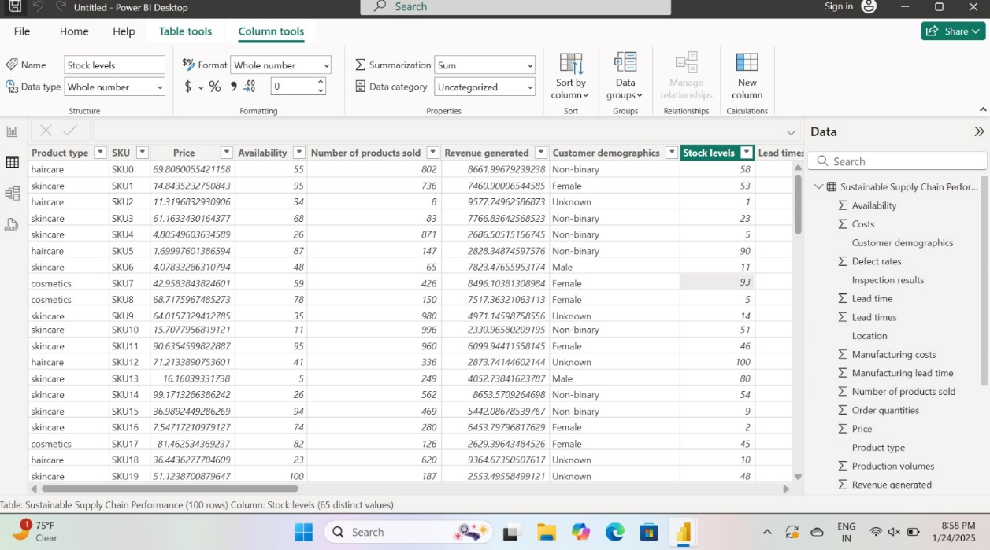

STEP-6 : We can remove the blank rows or unnecessary data by Remove option.

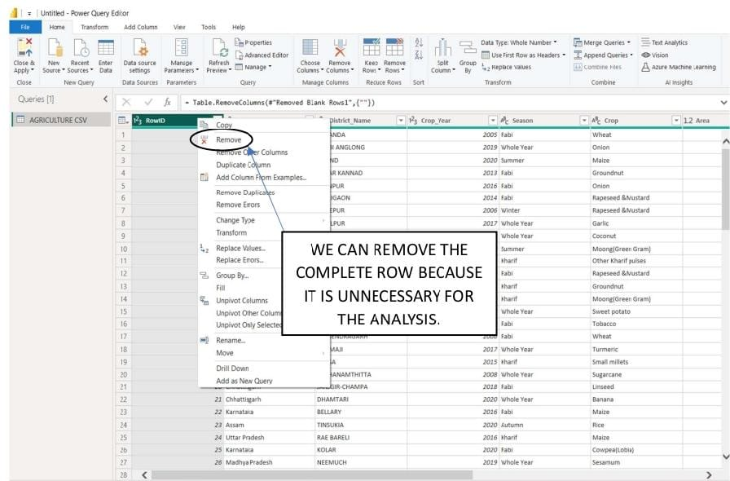

STEP-7 : Once the data Transformation Task is done Then click on the CLOSE AND APPLY Button to load the data for further processing.

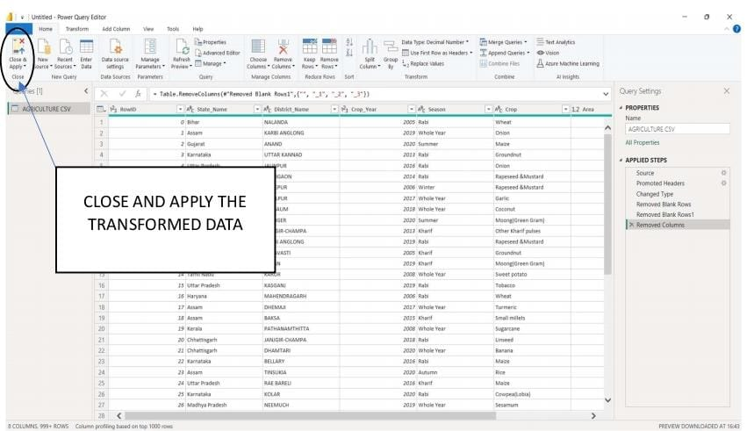

STEP-8 : We After loading the data go to the Report view and Visualize

The DATASET into Desired Format.

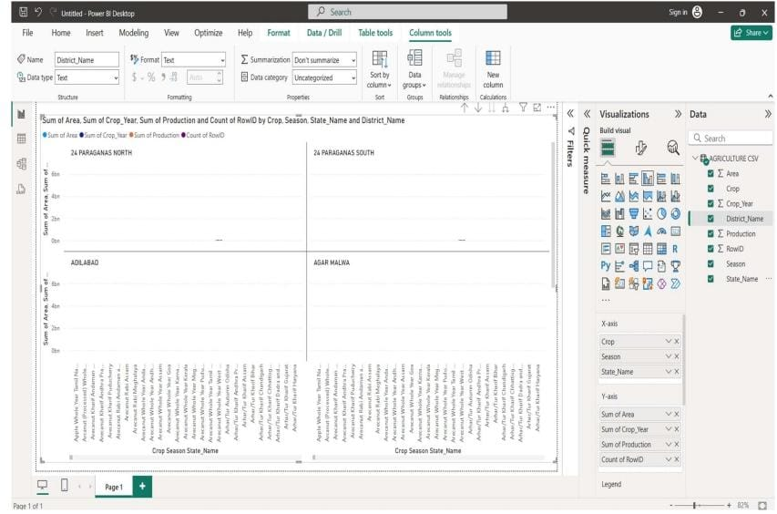

HENCE, OUR BASIC OPERATION OF POWERBI IS COMPLETE.