**TASK-3**

**USING DIFFERENT GRAPHS TO IMPLEMENT**

**DASHBOARDS.**

**STEP-1:** Open previous task-2 graph and customize the graph up to your mark As I selected the **area graph** it tells the area coverd.

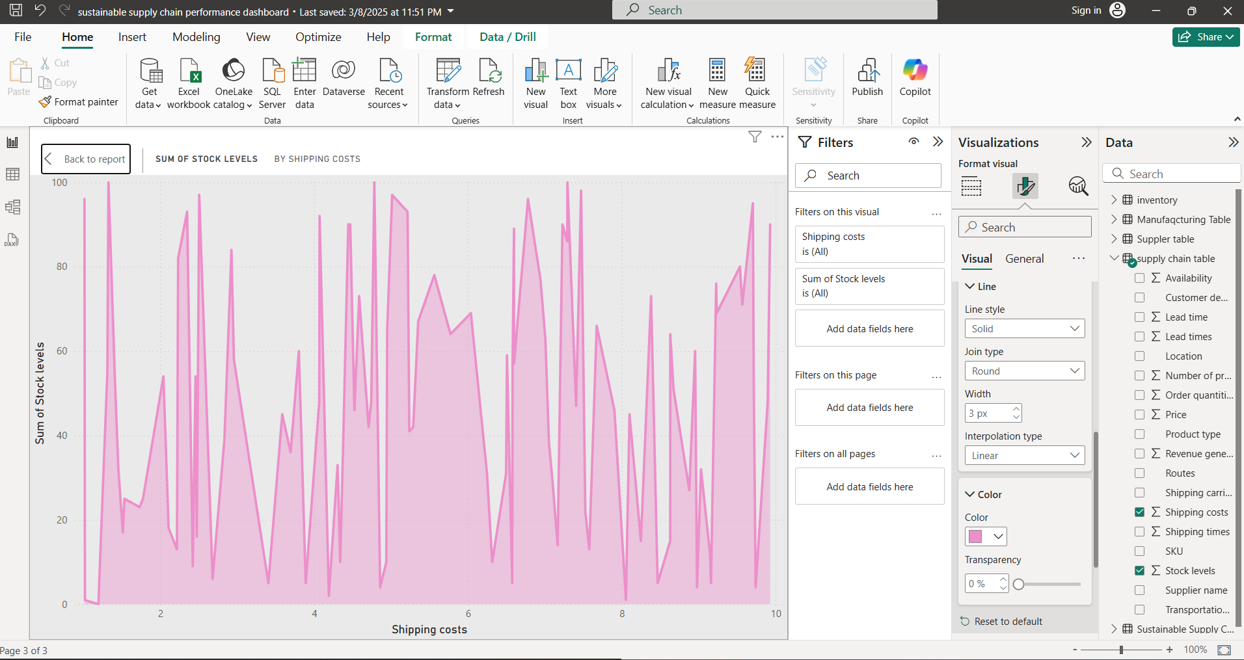

**Step-2:** Go to the visualizations select the **matrix** to perform the **total of the table values given.**

Using rows and columns and values by chosen Inventory table options as shown in below picture.

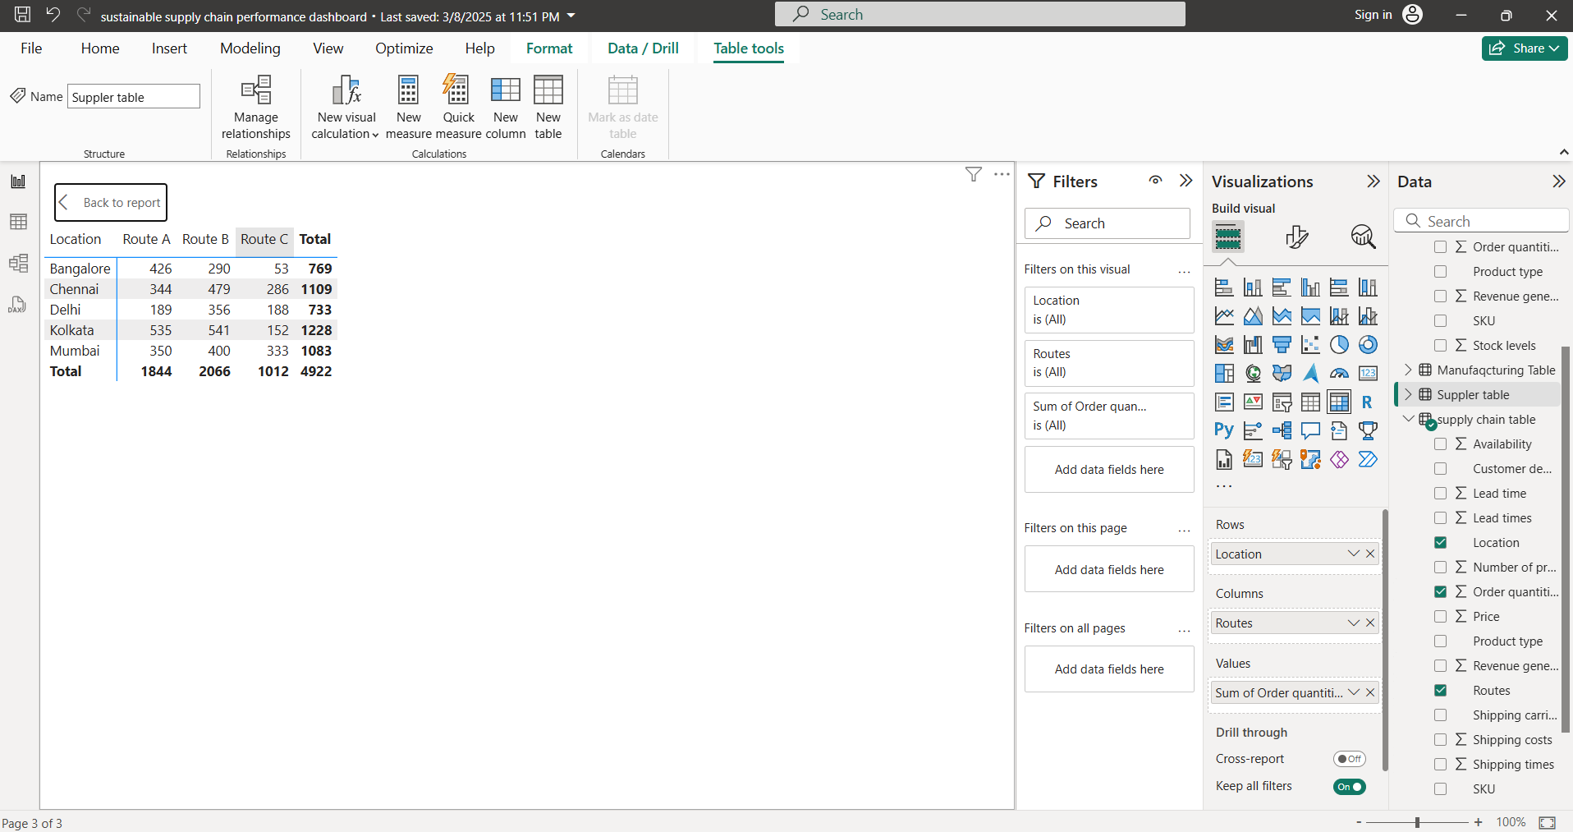

**Step-3:** Go to the visualizations select the **Tree map** to perform the **sum of shipping costs by shipping carries** as shown in the **given picture.**

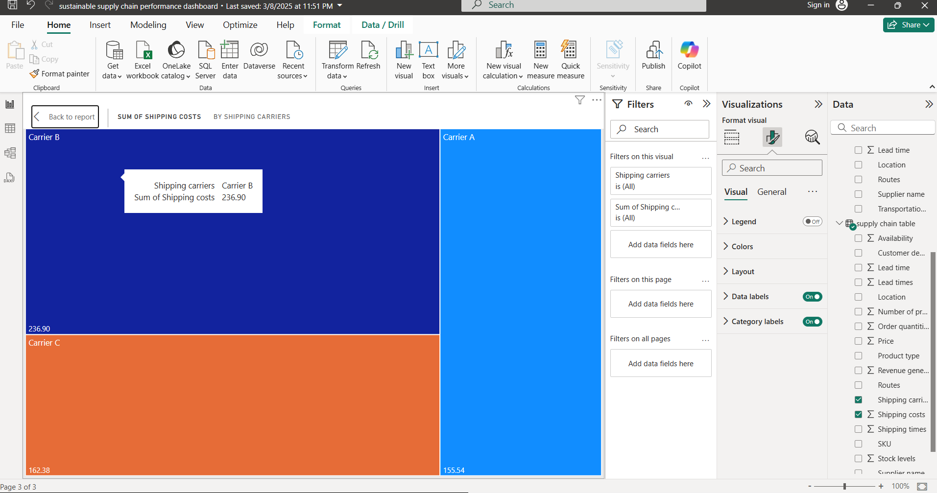

**Step-4:** Go to the visualizations select the **KPI** to perform the by selecting the options **values, Trend axis** as shown in picture**.**

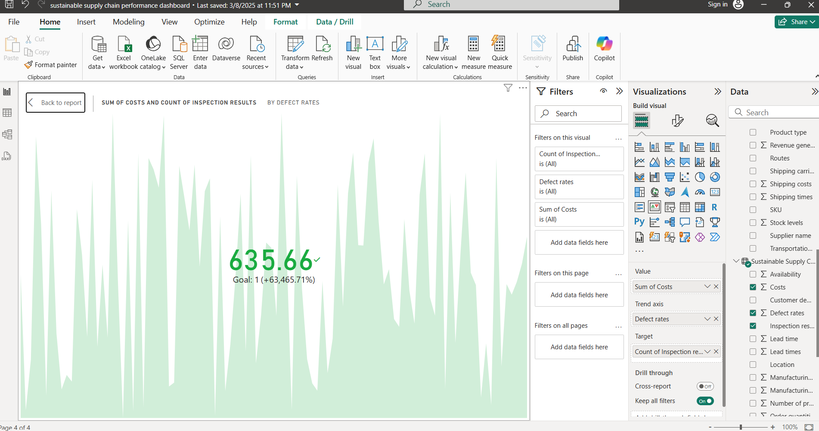

**Step-5:** Go to the visualizations select the **table** to perform the by selecting the options **columns in supply chain table** as shown in picture**.**

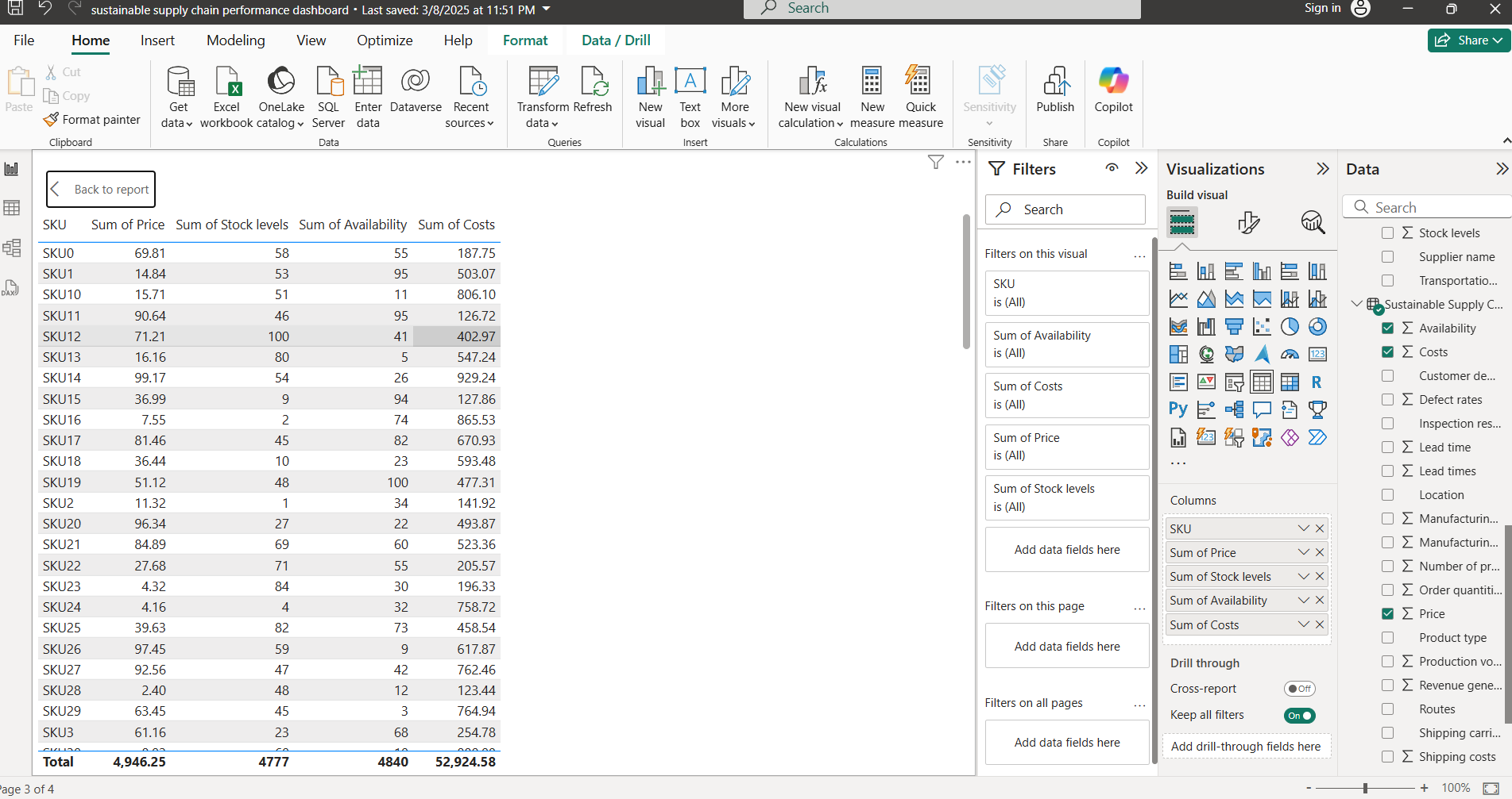

**Step-6:** Go to the visualizations select the **Water-Fall Chart** to perform the by selecting the options **category, Break-Down** as shown in picture**.**

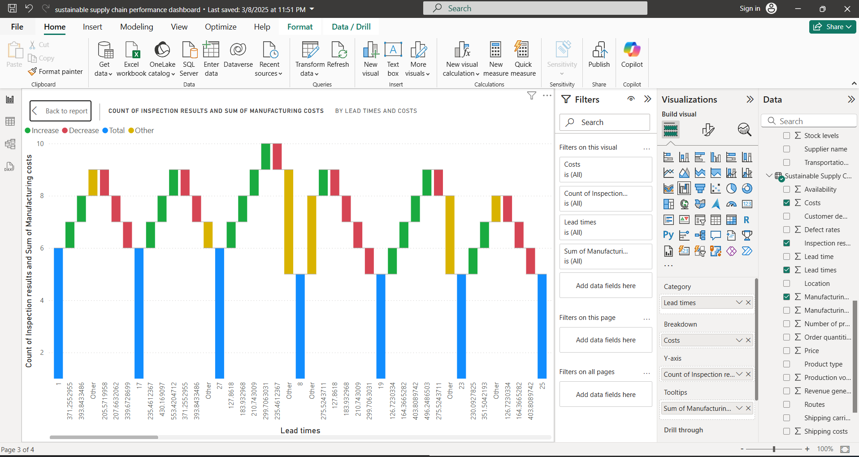

**Step-7:** Go to the visualizations select the **Multi-Row Cart** to perform the by selecting the options **Fields** as shown in picture**.**

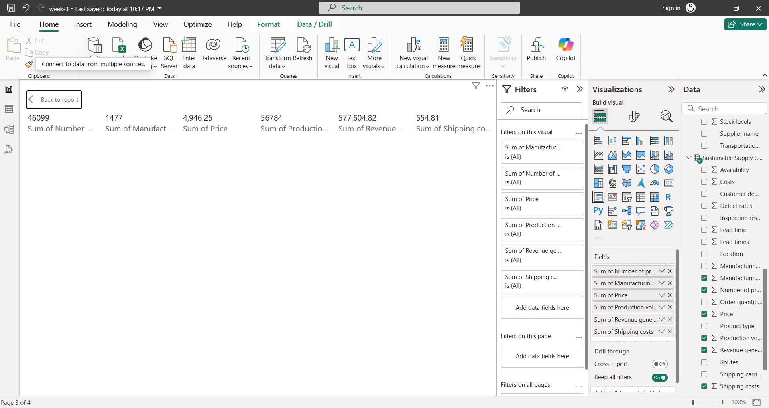

**Step-8:** Go to the visualizations select the **Key- Influencers** to perform the by selecting the options **Analyze, Explain by** as shown in picture**.**

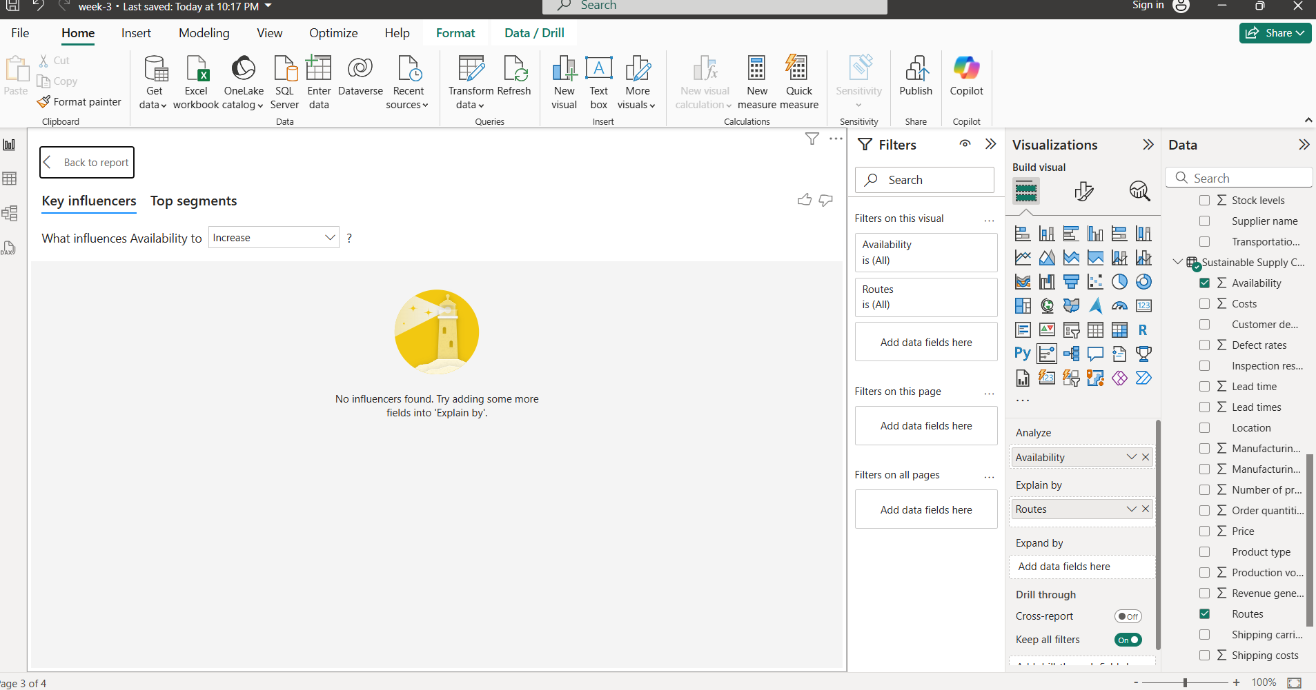

This **task-3** was completed by this **step-8** with proper pictures.