**TASK-2**

**USING DIFFERENT GRAPHS TO IMPLEMENT**

**DASHBOARDS.**

**STEP-1:** Open previous task-1 graph and customize the graph up to your mark.

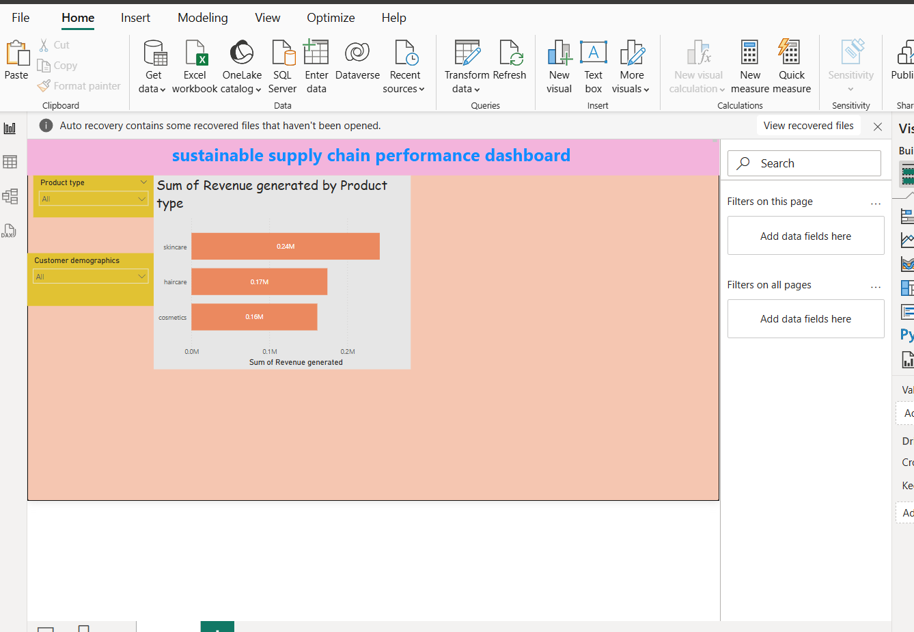

STEP-2: Go to the visualizations select the **cluster** **bar chart** to perform the **Average graph.**

Using y-axis and x-axis by choosen supply chain table options as shown in below picture.



**Step-3:** Go to the visualizations select the **pie** **chart** to perform the **Sum of the graph.**

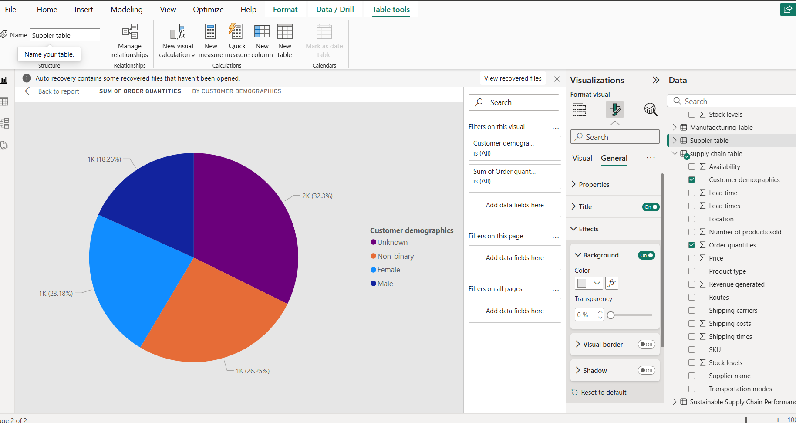

**STEP-4:** Go to the visualizations select the **Donut** to perform the **Sum of the graph.**

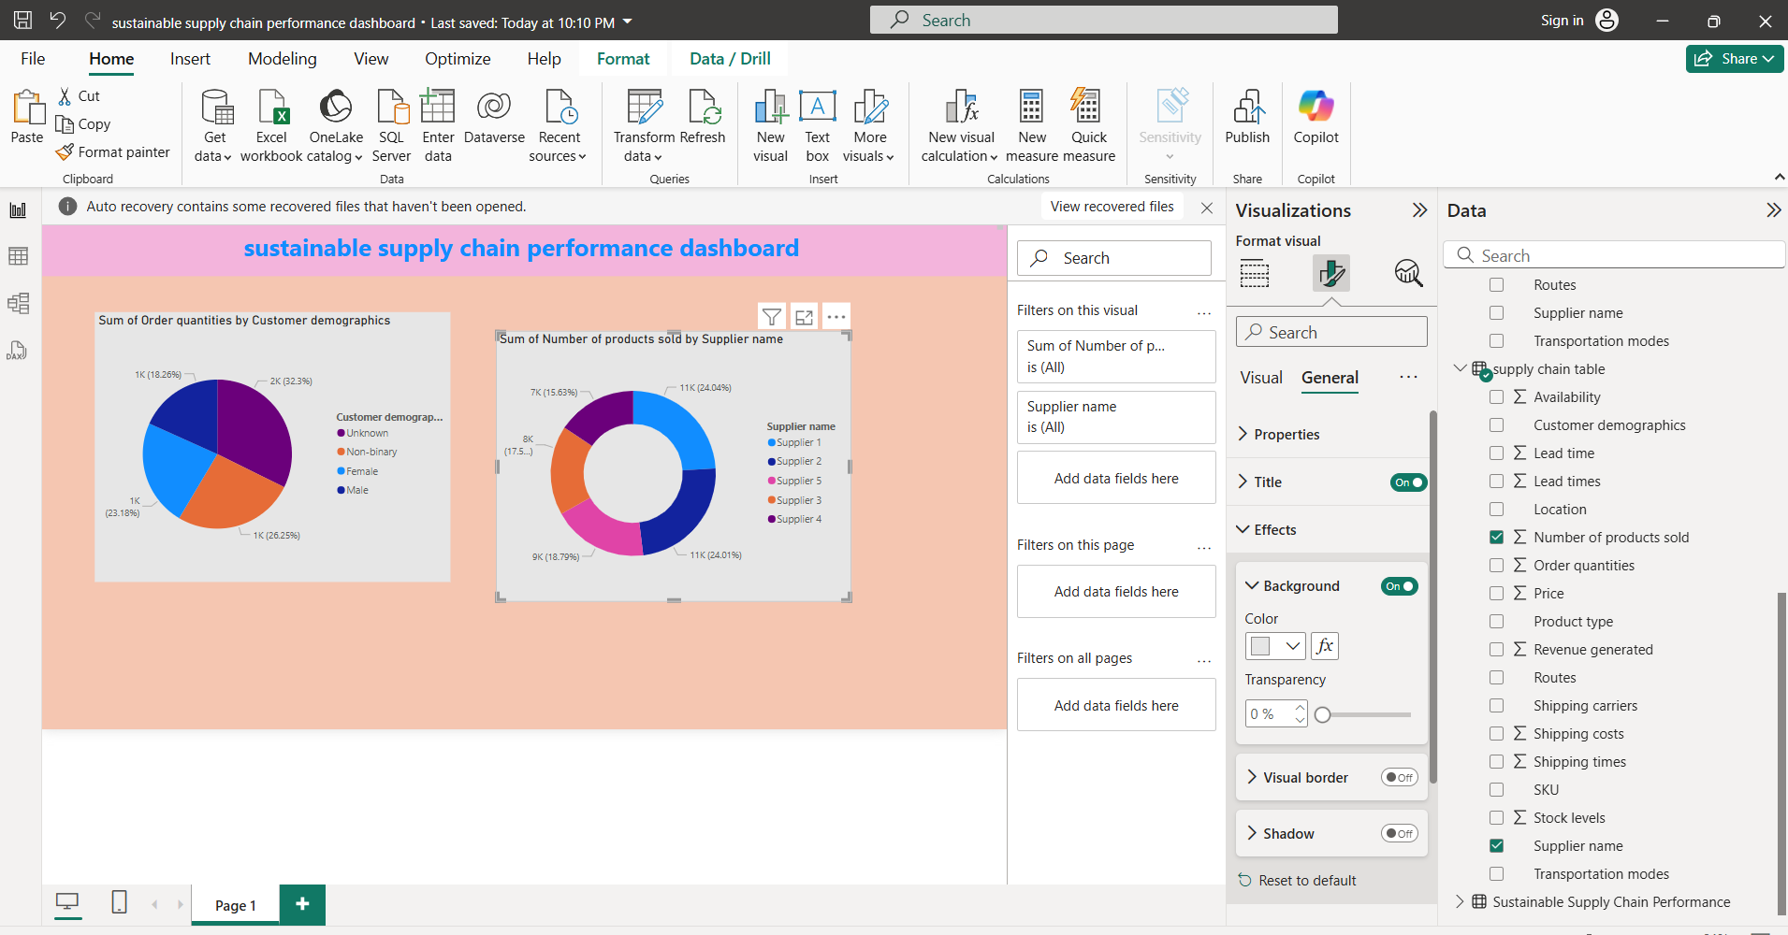

**STEP-5:** Go to the visualizations select the **funnel chart** to perform the **Average of the graph** withthe suppler table**.**

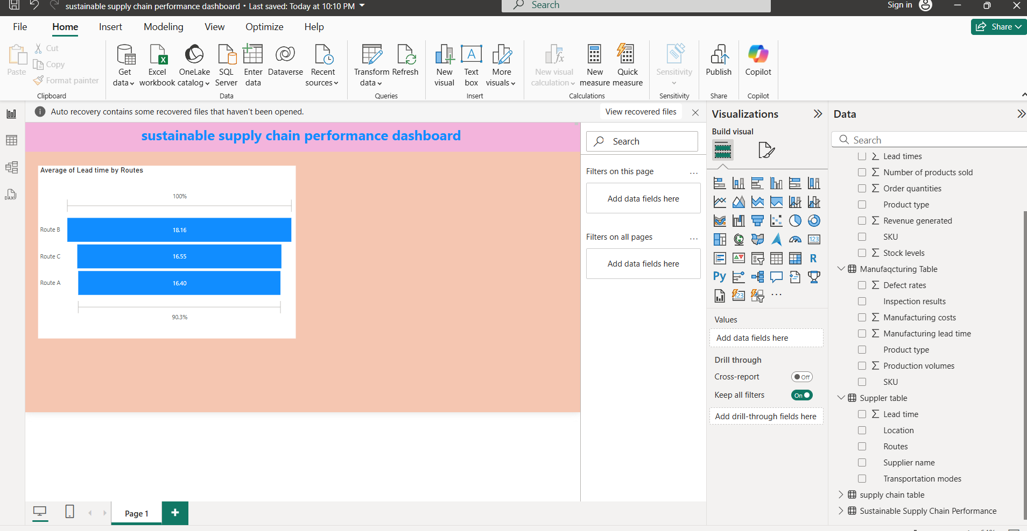

**STEP-6:** Go to the visualizations select the **Tree chart** to perform the **Sum of the graph** withthe supply chain table**.**

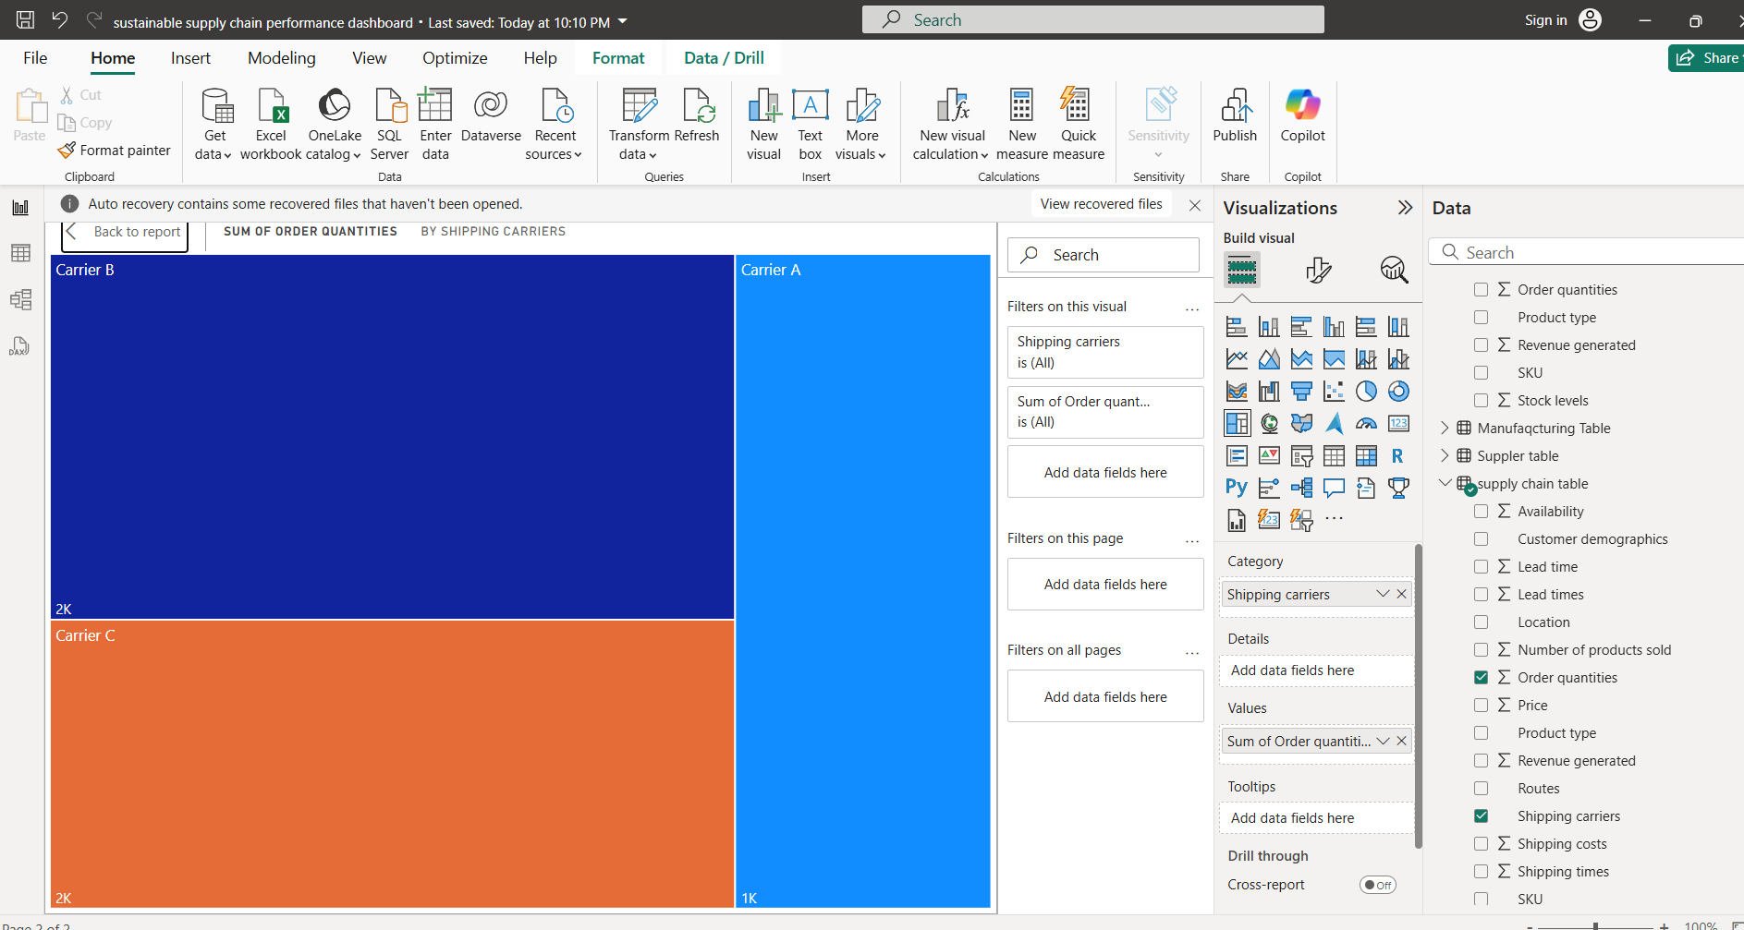

**STEP-7:** Now take the carts from visualizations to perform the **Count of the graph** withthe supply chain table.

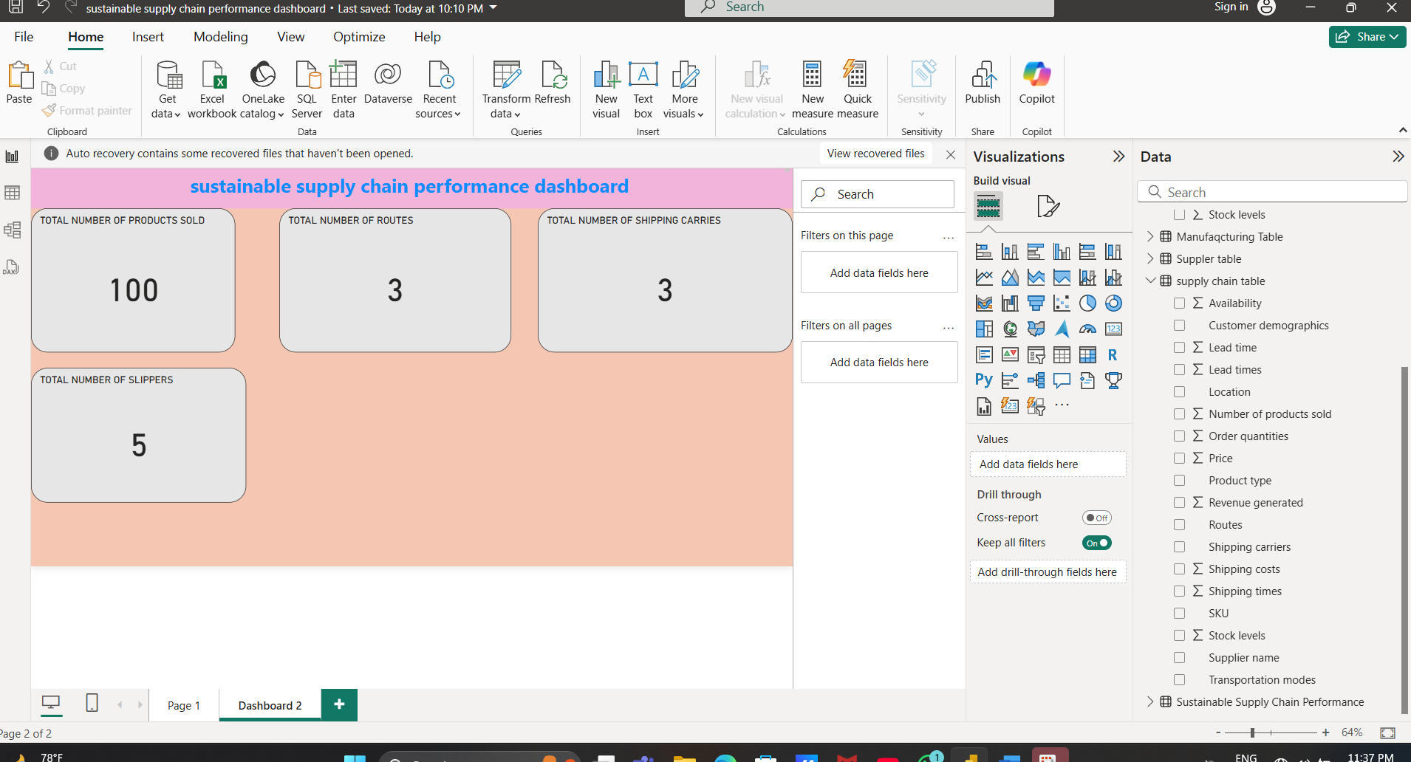

**STEP-8: Finally**, take the **stacked column carts** from visualizations to perform the **sum of the graph** withthe supply chain table.

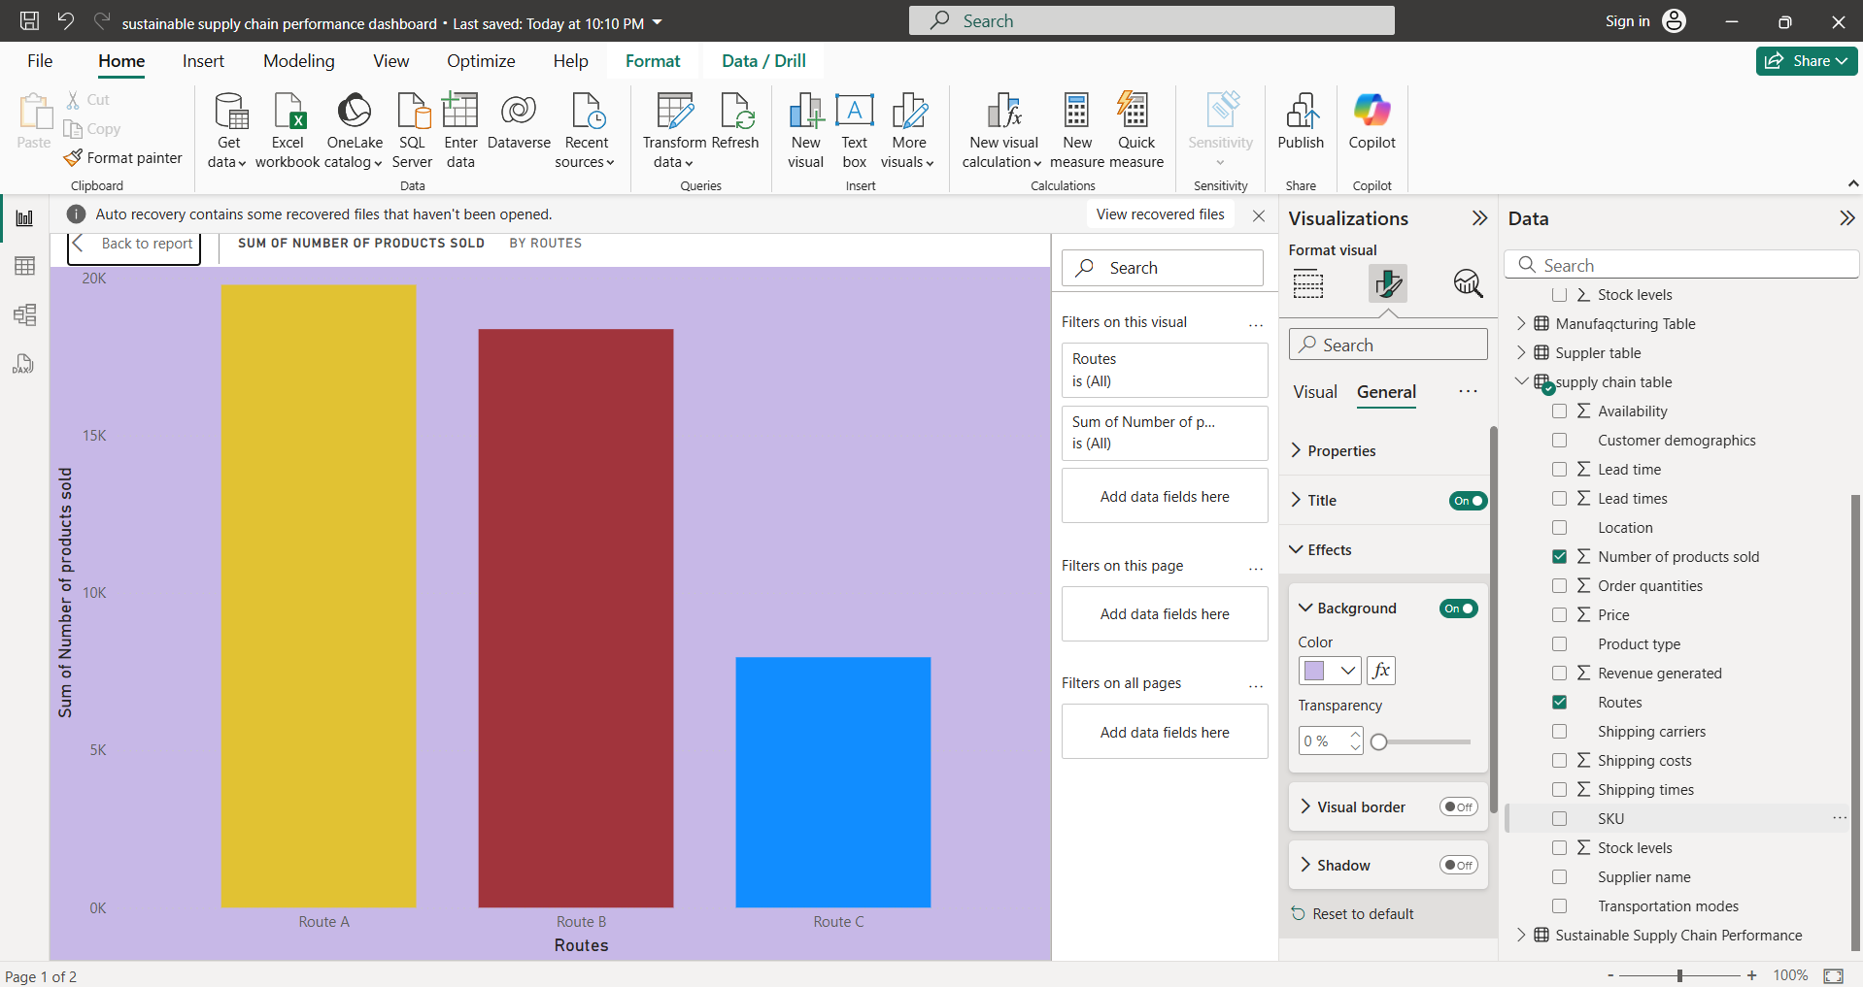

This task-2 was completed by this **step-8** with proper pictures.