DATE: EXPT NO:04
DATA VISUALIZATION
AIM:
To visualize the Earthquake dataset using Python and create different charts to understand earthquake patterns, magnitude distributions, and identify important geographic features.
PROCEDURE:
1. Start the program.
2. Import Pandas, Matplotlib, and Seaborn libraries.
3. Load the Earthquake CSV dataset.
4. Display the first few records using head().
5. Create a bar chart to compare seismic events based on magnitude.
6. Create a box plot to show the distribution of earthquake magnitudes.
7. Create a line chart to analyze seismic trends across recorded events.
8. Add suitable titles, axis labels, and legends.
9. Display all the visualizations.
10. Analyze the graphs and identify important patterns.
11. Stop the program.
CODE:
import pandas as pd
import matplotlib.pyplot as plt
import seaborn as sns
# Load dataset
df = pd.read_csv("earthquake_data.csv")
# Select numerical columns
num_cols = df.select_dtypes(include="number").columns
print("Numerical columns:", num_cols.tolist())
# BAR CHART
plt.figure(figsize=(8, 5))
df[num_cols[0]].value_counts().head(10).plot(kind="bar")
plt.title("Bar Chart")
plt.xlabel(num_cols[0])
plt.ylabel("Count")
plt.show()
# BOX PLOT
plt.figure(figsize=(8, 5))
sns.boxplot(x=df[num_cols[0]])
plt.title("Box Plot")
plt.xlabel(num_cols[0])
plt.show()
# LINE CHART
plt.figure(figsize=(8, 5))
plt.plot(df[num_cols[0]].head(20), marker="o")
plt.title("Line Chart")
plt.xlabel("Earthquake Event")
plt.ylabel(num_cols[0])
plt.grid()
plt.show()
OUTPUT:
Columns:
['title', 'magnitude', 'date_time', 'cdi', 'mmi', 'alert', 'tsunami', 'sig', 'net', 'nst', 'dmin', 'gap', 'magType', 'depth', 'latitude', 'longitude', 'location', 'continent', 'country']
Numerical columns: ['magnitude', 'cdi', 'mmi', 'tsunami', 'sig', 'nst', 'dmin', 'gap', 'depth', 'latitude', 'longitude']
First 5 Records:
title magnitude date_time cdi mmi alert tsunami sig net nst dmin gap magType depth latitude longitude location continent country
0 M 7.0 - 18 km SW of Malango, Solomon Islands 7.0 22-11-2022 02:03 8 7 green 1 768 us 117 0.509 17.0 mww 14.000 -9.7963 159.596 Malango, Solomon Islands Oceania Solomon Islands
1 M 6.9 - 204 km SW of Bengkulu, Indonesia 6.9 18-11-2022 13:37 4 4 green 0 735 us 99 2.229 34.0 mww 25.000 -4.9559 100.738 Bengkulu, Indonesia NaN NaN
2 M 7.0 - 7.0 12-11-2022 07:09 3 3 green 1 755 us 147 3.125 18.0 mww 579.000 -20.0508 -178.346 NaN Oceania Fiji
3 M 7.3 - 205 km ESE of Neiafu, Tonga 7.3 11-11-2022 10:48 5 5 green 1 833 us 149 1.865 21.0 mww 37.000 -19.2918 -172.129 Neiafu, Tonga NaN NaN
4 M 6.6 - 6.6 09-11-2022 10:14 0 2 green 1 670 us 131 4.998 27.0 mww 624.464 -25.5948 178.278 NaN NaN NaN
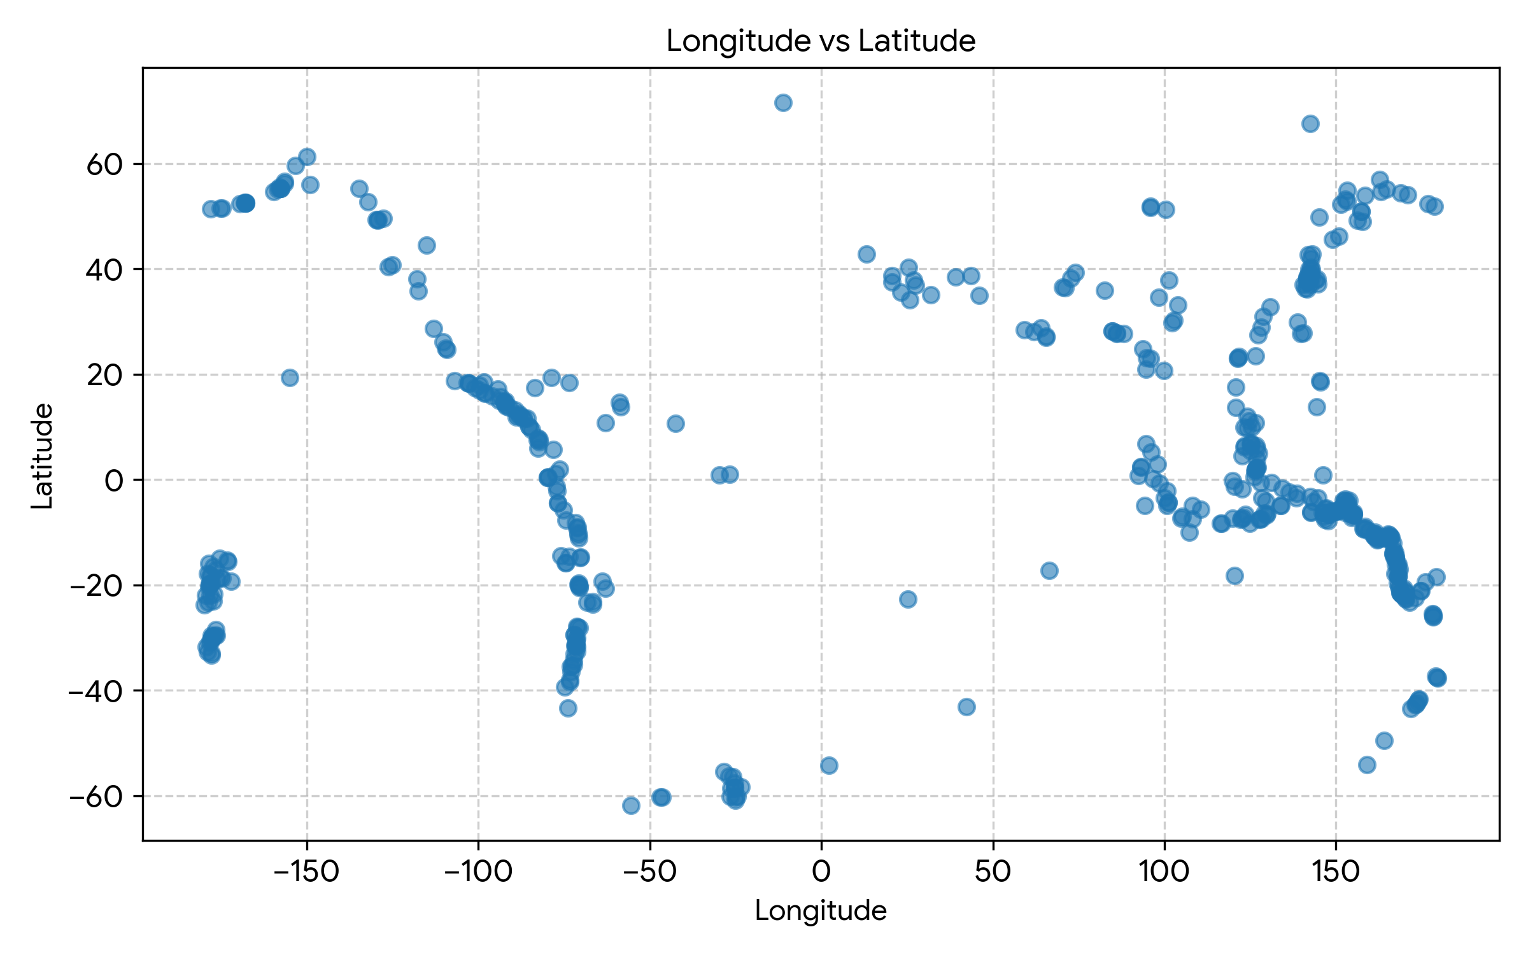
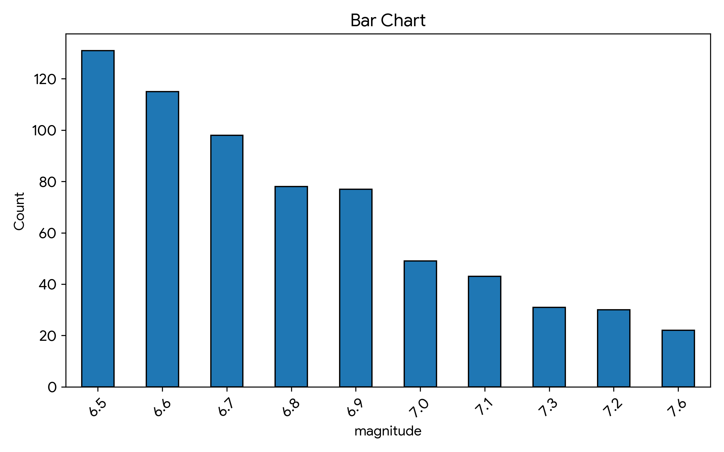
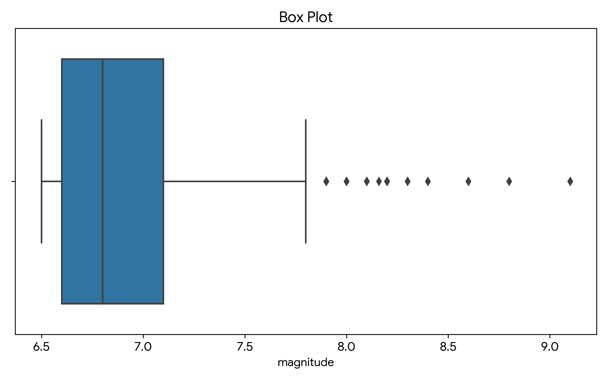
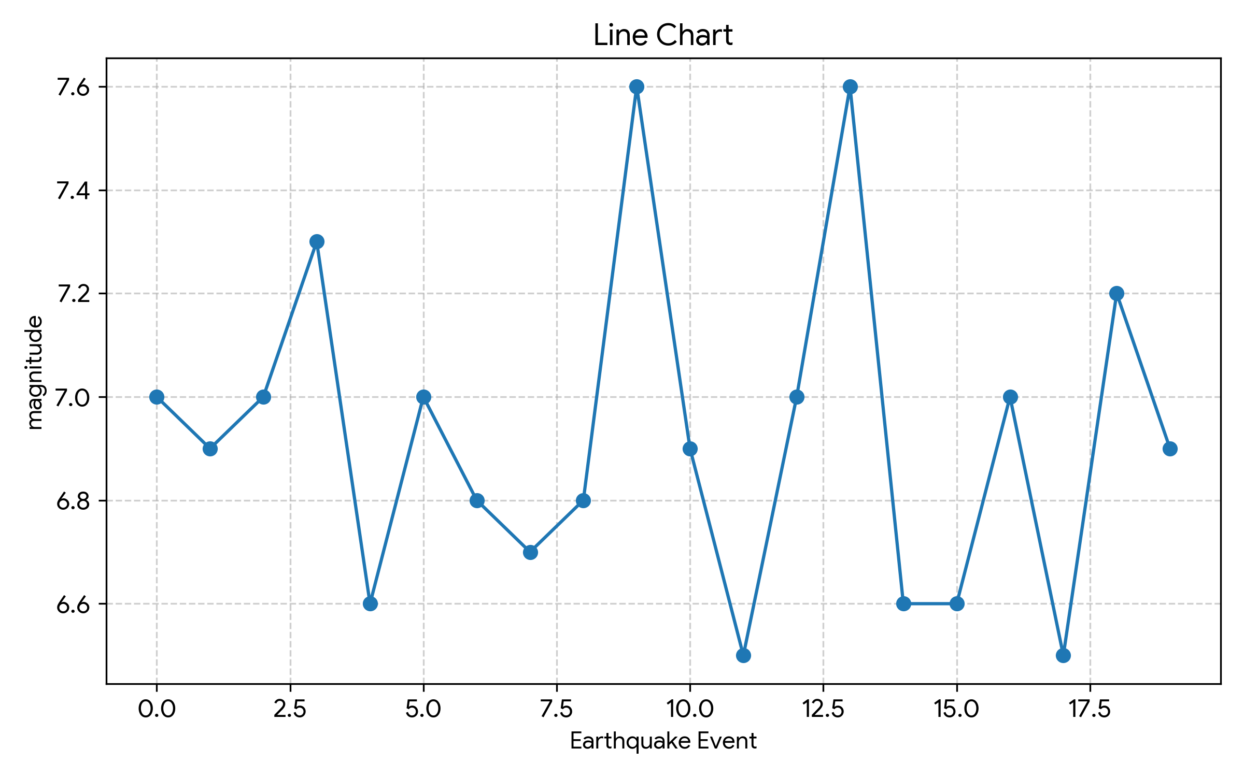
RESULT:
The Earthquake dataset was successfully imported, analyzed, and visualized using various charts including bar charts, box plots, scatter plots, and line charts. Important patterns regarding seismic magnitudes, geographical distribution, and depth characteristics were identified through data visualization.

