DATE: | EXPT NO: 02
EDA - DATA CLEANING
AIM:
To perform Exploratory Data Analysis (EDA) and data cleaning on the Earthquake dataset to identify patterns, handle missing values, remove duplicates, and prepare the data for Machine Learning.
PROCEDURE:
1. Import the required Python libraries such as Pandas, NumPy, Matplotlib, and Seaborn.
2. Load the Earthquake dataset using Pandas.
3. Display the first few records and check the dataset shape.
4. Examine the data types and dataset information.
5. Check for missing or null values.
6. Handle missing values using suitable methods.
7. Identify and remove duplicate records.
8. Check for incorrect or inconsistent data.
9. Perform statistical analysis using describe().
10. Visualize important features using graphs and charts.
11. Analyze correlations between numerical features using a heatmap.
12. Save the cleaned dataset for further analysis and Machine Learning.
CODE:
import pandas as pd
# Import Excel file
df = pd.read_excel(r"C:\Users\babyn\Downloads\archive\earthquake_data.xlsx")
# Display first 5 records
print("First 5 Records")
print(df.head())
# Dataset Information
print("\nDataset Information")
df.info()
# Statistical Summary
print("\nStatistical Summary")
print(df.describe(include='all'))
OUTPUT:
First 5 Records
title magnitude date_time cdi mmi alert tsunami sig net nst dmin gap magType depth latitude longitude location continent country
0 M 7.0 - 18 km SW of Malango, Solomon Islands 7.0 22-11-2022 02:03 8 7 green 1 768 us 117 0.509 17.0 mww 14.000 -9.7963 159.596 Malango, Solomon Islands Oceania Solomon Islands
1 M 6.9 - 204 km SW of Bengkulu, Indonesia 6.9 18-11-2022 13:37 4 4 green 0 735 us 99 2.229 34.0 mww 25.000 -4.9559 100.738 Bengkulu, Indonesia NaN NaN
2 M 7.0 - 7.0 12-11-2022 07:09 3 3 green 1 755 us 147 3.125 18.0 mww 579.000 -20.0508 -178.346 NaN Oceania Fiji
3 M 7.3 - 205 km ESE of Neiafu, Tonga 7.3 11-11-2022 10:48 5 5 green 1 833 us 149 1.865 21.0 mww 37.000 -19.2918 -172.129 Neiafu, Tonga NaN NaN
4 M 6.6 - 6.6 09-11-2022 10:14 0 2 green 1 670 us 131 4.998 27.0 mww 624.464 -25.5948 178.278 NaN NaN NaN
Dataset Information
<class 'pandas.core.frame.DataFrame'>
RangeIndex: 782 entries, 0 to 781
Data columns (total 19 columns):
# Column Non-Null Count Dtype
--- ------ -------------- -----
0 title 782 non-null object
1 magnitude 782 non-null float64
2 date_time 782 non-null object
3 cdi 782 non-null int64
4 mmi 782 non-null int64
5 alert 415 non-null object
6 tsunami 782 non-null int64
7 sig 782 non-null int64
8 net 782 non-null object
9 nst 782 non-null int64
10 dmin 782 non-null float64
11 gap 782 non-null float64
12 magType 782 non-null object
13 depth 782 non-null float64
14 latitude 782 non-null float64
15 longitude 782 non-null float64
16 location 777 non-null object
17 continent 206 non-null object
18 country 484 non-null object
dtypes: float64(6), int64(5), object(8)
memory usage: 116.2+ KB
Statistical Summary
magnitude cdi mmi tsunami sig nst dmin gap depth latitude longitude
count 782.000000 782.000000 782.000000 782.000000 782.000000 782.000000 782.000000 782.000000 782.000000 782.000000 782.000000
mean 6.940153 4.333760 5.964194 0.388747 776.008951 275.396419 2.231937 25.807864 75.883168 2.386000 39.734707
std 0.445213 2.658939 1.983592 0.487778 185.083392 218.192074 2.839655 17.652131 137.279603 30.344421 108.016952
min 6.500000 0.000000 1.000000 0.000000 650.000000 0.000000 0.005000 9.000000 9.000000 -61.848000 -179.962000
50% 6.800000 4.000000 6.000000 0.000000 708.500000 213.000000 1.300000 21.000000 26.000000 -3.580000 103.982000
75% 7.100000 7.000000 7.000000 1.000000 819.750000 385.000000 2.880000 29.000000 55.000000 26.126500 139.710250
max 9.100000 9.000000 9.000000 1.000000 2910.000000 934.000000 17.654000 239.000000 670.810000 71.631200 179.662000
[11 rows x 19 columns]

import pandas as pd
df = pd.read_csv(r"C:\Users\babyn\Downloads\archive\earthquake_data.csv")
print(df.head())
OUTPUT:
title magnitude date_time cdi mmi alert tsunami sig net nst dmin gap magType depth latitude longitude location continent country
0 M 7.0 - 18 km SW of Malango, Solomon Islands 7.0 22-11-2022 02:03 8 7 green 1 768 us 117 0.509 17.0 mww 14.000 -9.7963 159.596 Malango, Solomon Islands Oceania Solomon Islands
1 M 6.9 - 204 km SW of Bengkulu, Indonesia 6.9 18-11-2022 13:37 4 4 green 0 735 us 99 2.229 34.0 mww 25.000 -4.9559 100.738 Bengkulu, Indonesia NaN NaN
2 M 7.0 - 7.0 12-11-2022 07:09 3 3 green 1 755 us 147 3.125 18.0 mww 579.000 -20.0508 -178.346 NaN Oceania Fiji
3 M 7.3 - 205 km ESE of Neiafu, Tonga 7.3 11-11-2022 10:48 5 5 green 1 833 us 149 1.865 21.0 mww 37.000 -19.2918 -172.129 Neiafu, Tonga NaN NaN
4 M 6.6 - 6.6 09-11-2022 10:14 0 2 green 1 670 us 131 4.998 27.0 mww 624.464 -25.5948 178.278 NaN NaN NaN
[5 rows x 19 columns]

import pandas as pd
import sqlite3
# Read Excel file
df = pd.read_excel(r"C:\Users\babyn\Downloads\archive\earthquake_data.xlsx")
# Connect to SQLite database
conn = sqlite3.connect("earthquake_data.db")
# Export data to SQLite table
df.to_sql("earthquake_data", conn, if_exists="replace", index=False)
print("Data exported to SQLite successfully!")
conn.close()

import matplotlib.pyplot as plt
mag_type = df["magType"].value_counts()
plt.bar(mag_type.index, mag_type.values)
plt.title("Magnitude Type-wise Event Count")
plt.xlabel("Magnitude Type (magType)")
plt.ylabel("Number of Earthquakes")
plt.show()
OUTPUT:
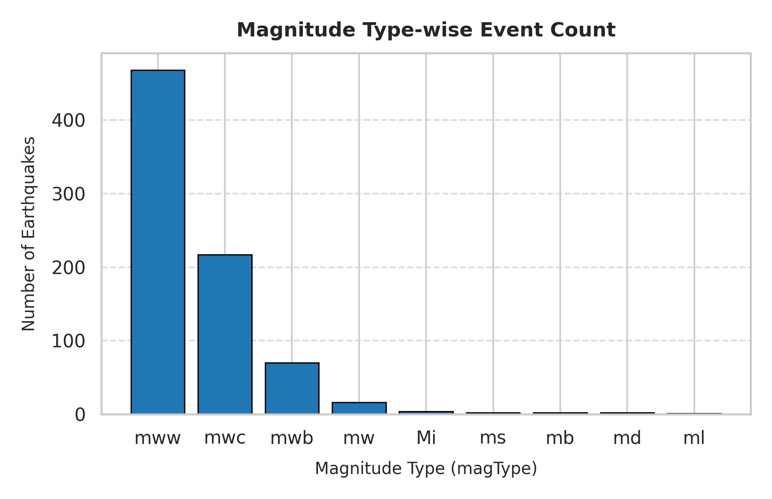
RESULT:
The Earthquake dataset was successfully cleaned and analyzed using EDA. Missing values and duplicate records were handled, important patterns were identified through visualizations, and the cleaned dataset was prepared for further Machine Learning analysis.

