DATE: EXPT NO:03
EDA-Data Inspection and Analysis
AIM:
To inspect and analyze the Earthquake dataset using Exploratory Data Analysis (EDA) to understand the data structure, identify patterns, detect missing values, and discover relationships between different earthquake attributes.
PROCEDURE:
1. Import Pandas, NumPy, Matplotlib, and Seaborn libraries.
2. Load the Earthquake dataset using Pandas.
3. Display the first and last records using head() and tail().
4. Check the number of rows and columns using shape.
5. Display column names and data types using info().
6. Check missing values using isnull().sum().
7. Generate statistical summaries using describe().
8. Check and identify duplicate records.
9. Analyze important earthquake-related attributes.
10. Create suitable graphs such as histograms, bar charts, and scatter plots.
11. Generate a correlation heatmap to identify relationships between numerical variables.
12. Interpret the findings and identify important patterns in the Earthquake dataset.
CODE:
import pandas as pd
import numpy as np
import matplotlib.pyplot as plt
import seaborn as sns
file_path = r"C:\Users\babyn\Downloads\archive\earthquake_data.xlsx"
df = pd.read_excel(file_path)
print("Dataset Preview:")
print(df.head())
# 1. Identifying Missing Values
print("\nMissing Values in Each Column:")
print(df.isnull())
# 2. Count Missing Values
print("\nTotal Missing Values:")
print(df.isnull().sum())
# Import required libraries
import pandas as pd
import numpy as np
import matplotlib.pyplot as plt
import seaborn as sns
from sklearn.preprocessing import MinMaxScaler
# Load Dataset
file_path = r"C:\Users\babyn\Downloads\archive\earthquake_data.xlsx"
df = pd.read_excel(file_path)
print("Original Dataset:")
print(df.head())
print("\nDataset Information:")
print(df.info())
# 1. Identify Missing Values
print("\nMissing Values in Dataset:")
print(df.isnull())
# 2. Count Missing Values
print("\nTotal Missing Values in Each Column:")
print(df.isnull().sum())
# 3. Replace Missing Values
# Numerical columns - replace missing values with mean
numeric_columns = df.select_dtypes(include=np.number).columns
for col in numeric_columns:
df[col] = df[col].fillna(df[col].mean())
# Categorical columns - replace missing values with mode
categorical_columns = df.select_dtypes(include="object").columns
for col in categorical_columns:
df[col] = df[col].fillna(df[col].mode()[0])
print("\nMissing Values After Replacement:")
print(df.isnull().sum())
# 4. Detect Duplicate Records
print("\nNumber of Duplicate Rows:")
print(df.duplicated().sum())
# Remove duplicate records
df = df.drop_duplicates()
print("\nDuplicate Rows After Removing:")
print(df.duplicated().sum())
# 5. Detect Outliers using IQR Method
print("\nOutlier Detection:")
outlier_result = {}
for col in numeric_columns:
Q1 = df[col].quantile(0.25)
Q3 = df[col].quantile(0.75)
IQR = Q3 - Q1
lower_bound = Q1 - (1.5 * IQR)
upper_bound = Q3 + (1.5 * IQR)
outliers = df[(df[col] < lower_bound) | (df[col] > upper_bound)]
outlier_result[col] = len(outliers)
print(outlier_result)
# 6. Outlier Visualization
for col in numeric_columns:
plt.figure(figsize=(6, 4))
sns.boxplot(x=df[col])
plt.title("Outlier Detection: " + col)
plt.show()
# 7. Data Cleaning
# Remove spaces from column names
df.columns = df.columns.str.strip()
# Convert column names into lowercase
df.columns = df.columns.str.lower()
print("\nCleaned Column Names:")
print(df.columns)
# 8. Data Transformation
# Normalization using MinMaxScaler
scaler = MinMaxScaler()
df[numeric_columns] = scaler.fit_transform(df[numeric_columns])
print("\nTransformed Dataset:")
print(df.head())
# 9. Save Cleaned Dataset
output_file = "cleaned_earthquake_data.xlsx"
df.to_excel(output_file, index=False)
print("\nCleaned Dataset Saved Successfully!")
print("File Name:", output_file)
OUTPUT:
Original Dataset:
title magnitude date_time cdi mmi alert tsunami sig net nst dmin gap magType depth latitude longitude location continent country
0 M 7.0 - 18 km SW of Malango, Solomon Islands 7.0 22-11-2022 02:03 8 7 green 1 768 us 117 0.509 17.0 mww 14.000 -9.7963 159.596 Malango, Solomon Islands Oceania Solomon Islands
1 M 6.9 - 204 km SW of Bengkulu, Indonesia 6.9 18-11-2022 13:37 4 4 green 0 735 us 99 2.229 34.0 mww 25.000 -4.9559 100.738 Bengkulu, Indonesia NaN NaN
2 M 7.0 - 7.0 12-11-2022 07:09 3 3 green 1 755 us 147 3.125 18.0 mww 579.000 -20.0508 -178.346 NaN Oceania Fiji
3 M 7.3 - 205 km ESE of Neiafu, Tonga 7.3 11-11-2022 10:48 5 5 green 1 833 us 149 1.865 21.0 mww 37.000 -19.2918 -172.129 Neiafu, Tonga NaN NaN
4 M 6.6 - 6.6 09-11-2022 10:14 0 2 green 1 670 us 131 4.998 27.0 mww 624.464 -25.5948 178.278 NaN NaN NaN
Missing Values in Dataset:
Total Missing Values in Each Column:
title 0
magnitude 0
date_time 0
cdi 0
mmi 0
alert 367
tsunami 0
sig 0
net 0
nst 0
dmin 0
gap 0
magType 0
depth 0
latitude 0
longitude 0
location 5
continent 576
country 298
dtype: int64
Outlier Detection:
{'magnitude': 38, 'cdi': 0, 'mmi': 0, 'tsunami': 0, 'sig': 42, 'nst': 34, 'dmin': 48, 'gap': 25, 'depth': 86, 'latitude': 0, 'longitude': 0}
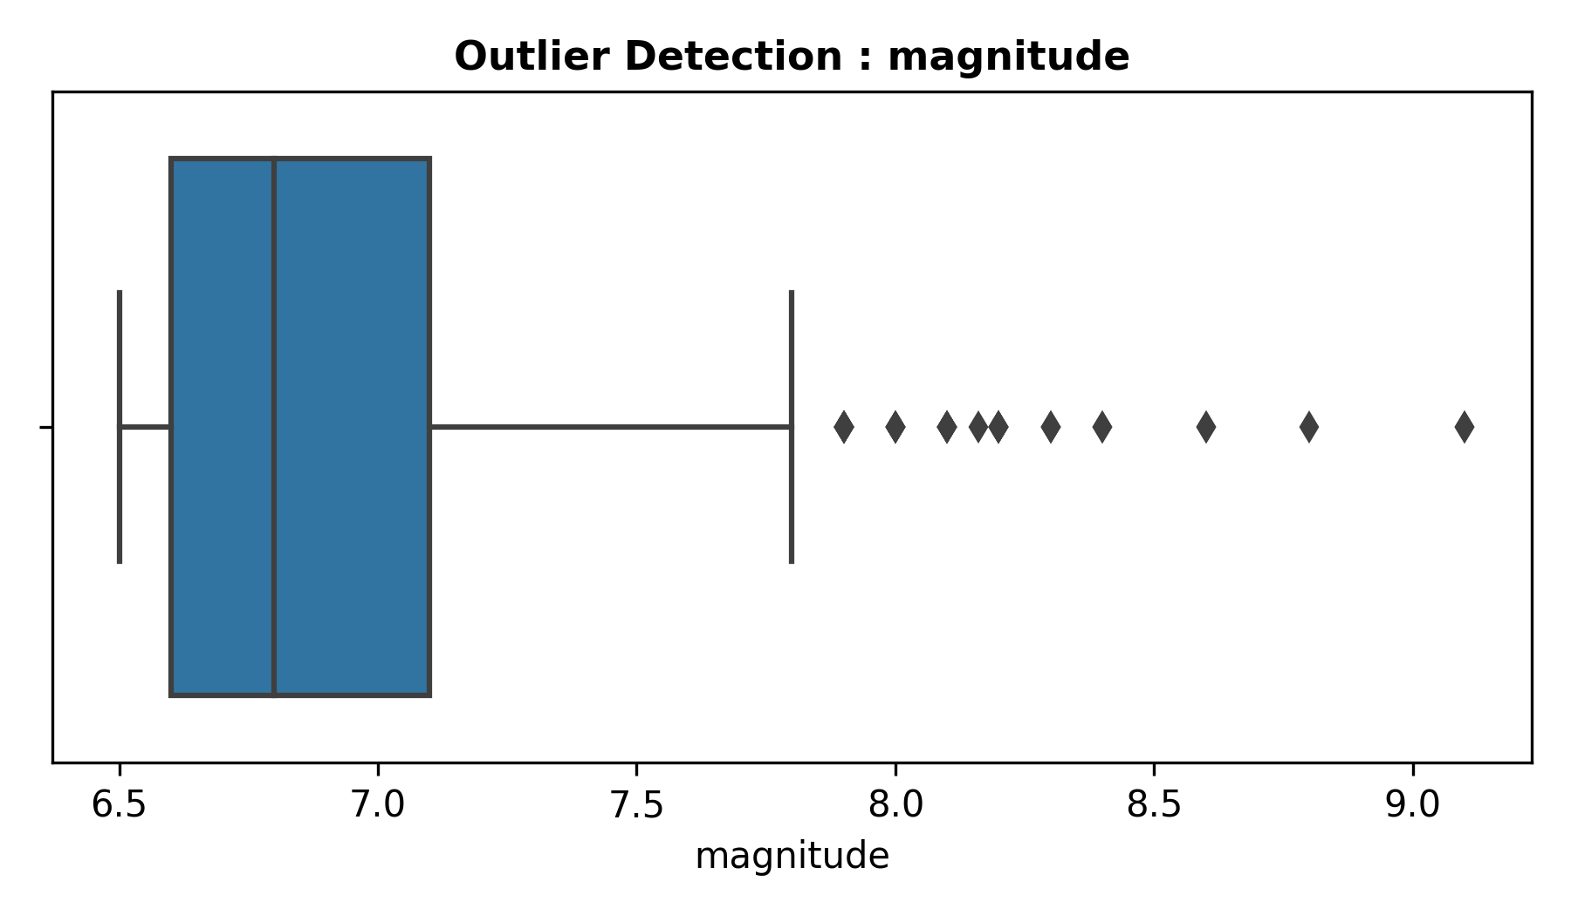
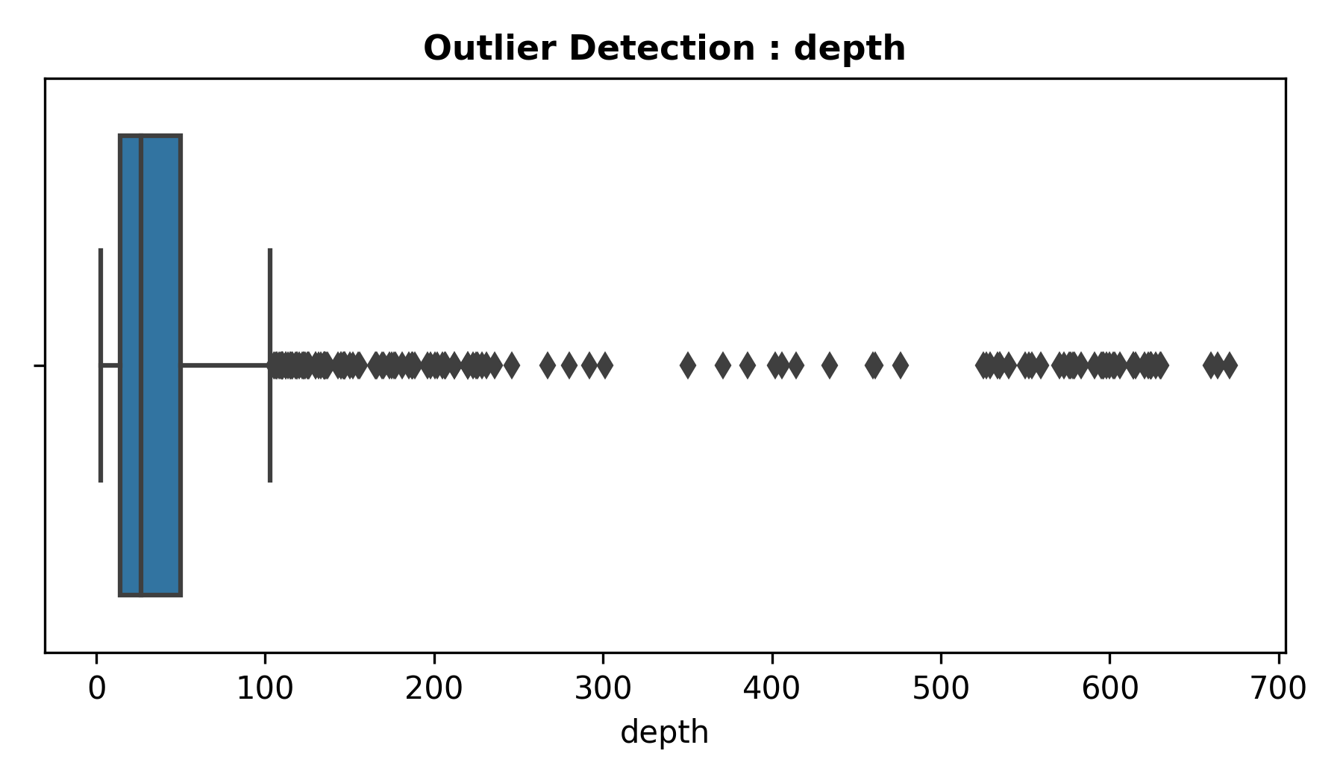
RESULT:
The Earthquake dataset was successfully inspected and analyzed using EDA. The dataset structure, missing values, duplicates, statistical details, and important relationships were identified through data analysis and visualization.

