🚀 Exploratory Data Analysis Report on Amazon Prime Content History 📺

Introduction

This report presents an exploratory data analysis (EDA) of Amazon Prime's content history from 2008 to 2021. The dataset, comprising a vast catalog of movies, TV shows, and original content, provides insights into the evolution of the platform's offerings. The analysis delves into the oldest content dating back to 1925 and the newest releases from 2021.

Summary and Key Findings

- Content Trends Over Time:\*\*   
 📈 The content additions to Amazon Prime have varied over the years. The year 2018 saw the highest number of additions, marking a peak in the platform's growth.

-Content by Genre/Category:\*\*   
 🎬 The platform's top five content genres/categories are International Movies, Dramas, Comedies, Action & Adventure, and Independent Movies.

- Ratings Distribution:\*\*   
 📢 The most common content rating is 'TV-MA,' indicating its prominence among the platform's offerings.

Visualizations and Detailed Insights

Content Trends Over Time

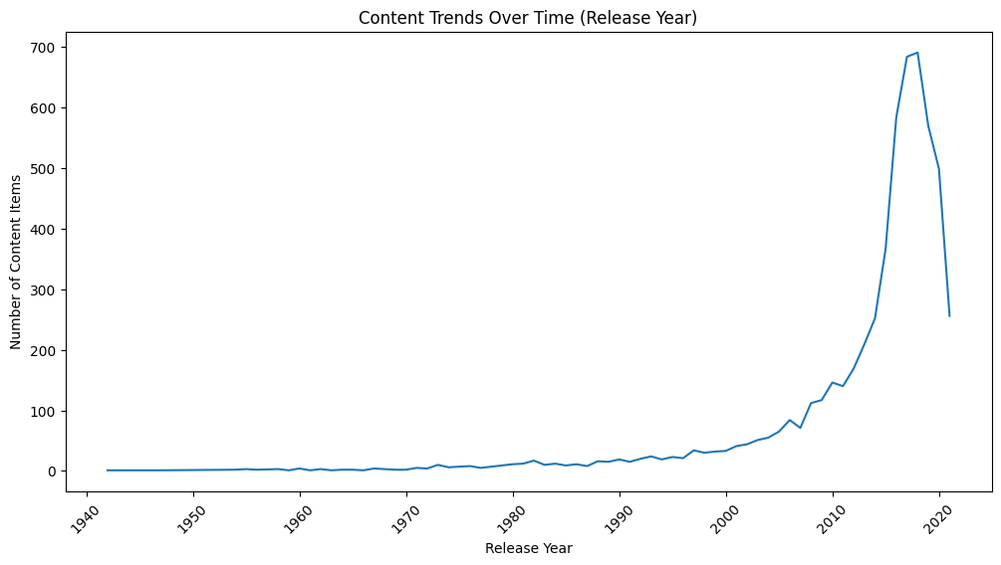

- In 2018, the platform experienced a significant surge in content additions, marking a milestone in its expansion. 🌱

- In contrast, 1942 had the lowest number of content additions, suggesting a significant variation in content acquisition strategies over the years. 🛑

Content by Genre/Category

- The dominance of International Movies, Dramas, Comedies, Action & Adventure, and Independent Movies highlights strong viewer interest in these genres. 🌟

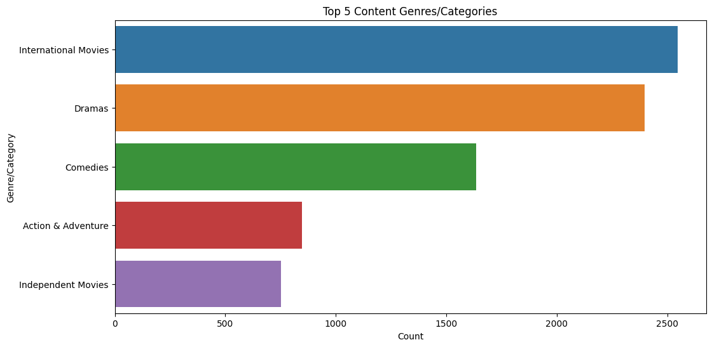

Ratings Distribution

- The preeminence of 'TV-MA' among content ratings signifies a strong alignment with audience preferences. 👍

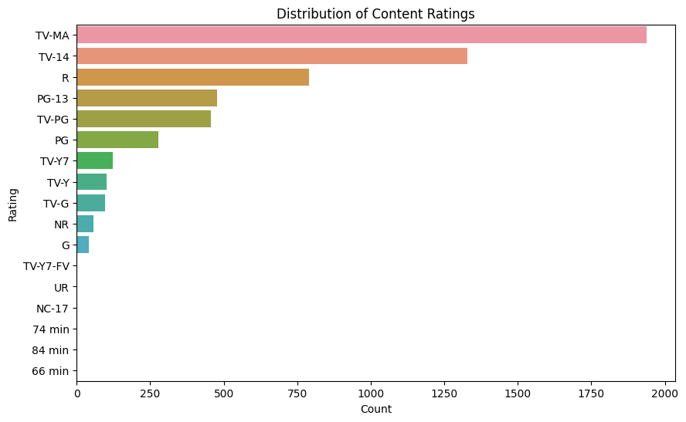

Distribution of Release Years

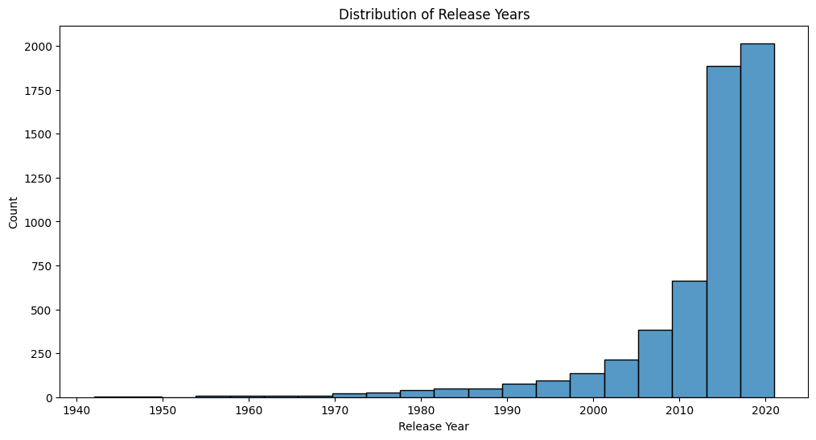

-The year 2018 had the highest number of content additions with 691 additions.

- The year 1942 had the lowest number of content additions with 1 addition.

- The average number of content additions per year is approximately 79.17.

Conclusion

In conclusion, the analysis of Amazon Prime's content history reveals intriguing insights into the platform's evolving content library. The findings shed light on content trends, genre preferences, and the distribution of content ratings. These insights can inform content acquisition strategies, user engagement, and platform development. 🌐

References

(<https://github.com/suryamr2002/kovai_task1>)

---