Video Game Sales Analysis 🌎

🚀 Key Insights:

🎯 Successful Games: Our analysis focuses on identifying successful games. We define success as games falling within the top 10% of global sales.

🌍 Regional Preferences: We explore how regional gaming preferences differ in terms of genre and sales.

📈 Trends Over Time: We analyze how global game sales have evolved over the years.

🎮 Attributes of Success: We investigate the impact of genres, platforms, and publishers on game success.

📝 Correlation with Ratings: We examine the correlation between game review scores and global sales.

Visualizations and Detailed Insights:

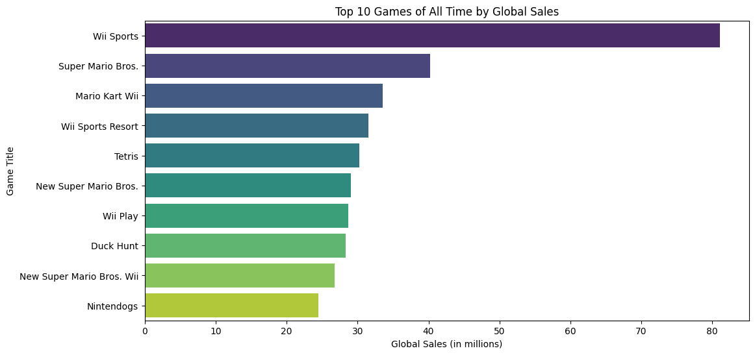

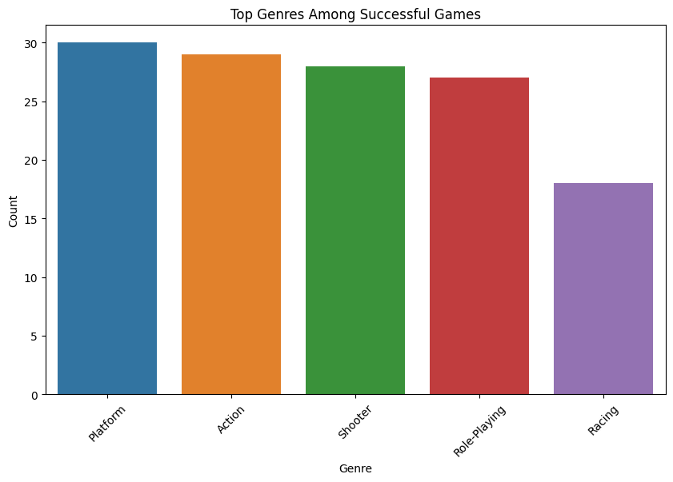

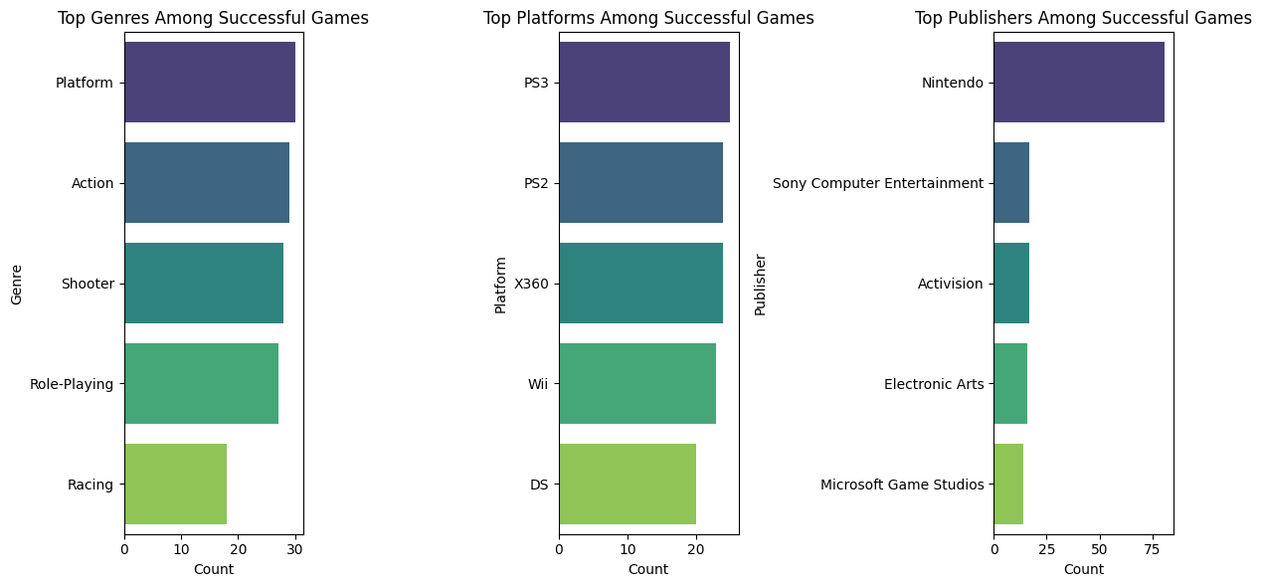

Key Insights - Detailed

**Insight 1:** The average global sales of games is approximately 2.49 million, with a standard deviation of 3.56 million.

**Insight 2:** The highest global sales for a game is approximately 81.12 million.

**Insight 3:** The most common genre among games in the dataset is 'Sports' with 308 games.

**Insight 4:** The most common gaming platform in the dataset is 'PS2' with 372 games.

**Insight 5:** Games that fall within the top 10% of global sales are considered successful.

**Insight 6:** Games' global sales have seen significant variations over the years, reflecting evolving trends in the gaming industry.

**Insight 7:**There is a correlation of approximately 0.18 between game review scores and global sales.

**Insight 8:** Different regions have distinct preferences in game genres. For example, in North America, 'Action' games are highly popular.

**Insight 9:** The most prolific publisher in the dataset is 'Electronic Arts' with 341 games.

Conclusion

In conclusion, our analysis of video game sales data unveils the intricacies of the gaming industry. We identify what defines a successful game and explore regional variations in gaming preferences. The data also reflects the ever-changing landscape of the gaming market and provides insights into the significance of genres, platforms, and publishers. Additionally, we find clues about the connection between review scores and game sales, which can guide game developers and publishers in their future endeavors.

References

(<https://github.com/suryamr2002/kovai_task2> )

—-----------