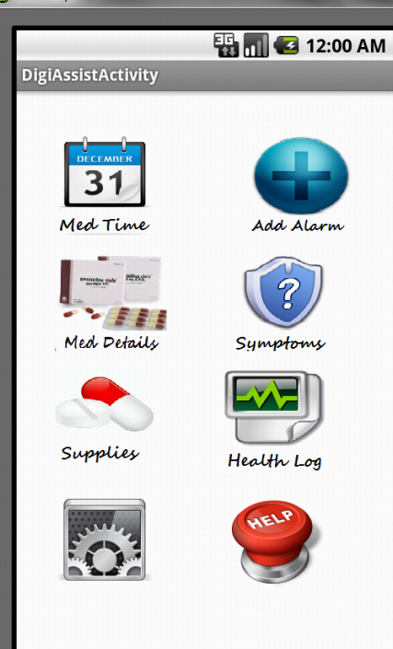

DigiAssist Home - There are 8 icons on the DIGIASSIST HOME SCREEN
- Med Time
- Add Alarm
- Medication Details
- Symptoms
- Supplies
- Health Log
- Settings
- Help

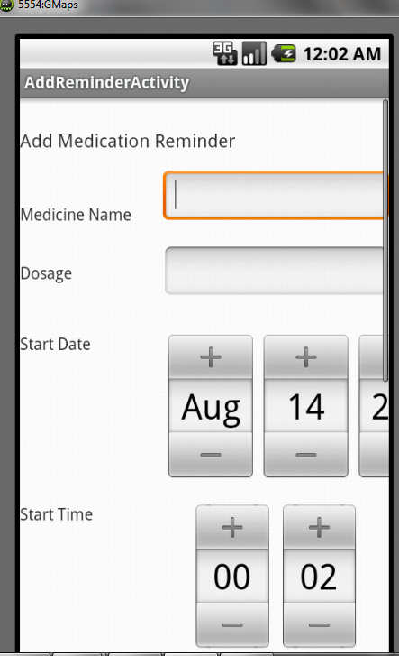
- First,
- Click on the Add icon i.e., Add Alarm icon and add all the medications that you’d like to be reminded about.
- Enter the drug name against MEDICATION NAMe.
  - Example - Ibuprofen
- Enter the dosage amount against DOSAGE
  - Example - 1
- Enter the day when reminders for this drug should start against START DATE
  - Example - August 17 2012
- Enter the time when reminders for this drug should start against START TIME
  - Example - 13:00 (Note : Time is in 24 Hr Format)
- Enter the day when reminders for this drug should end against END DATE
  - Example - August 20 2012
- Enter the time when reminders for this drug should end against END TIME
  - Example - 03:00 (Note : Time is in 24 Hr Format)
- Enter how often you’d like to receive a reminder for this drug i.e., how often it has been prescribed that you take this drug.
  - Example - 2 per Day
  - 1 every 3 hours
- Click on SAVE to save a reminder for this drug.
- Click on CANCEL to discard the values entered and go back to the DIGIASSIST Home screen.
- Repeat this process for all medications you want to be reminded about.

- Click on the calendar icon i.e., Med Time icon to view the current day’s medication plan.
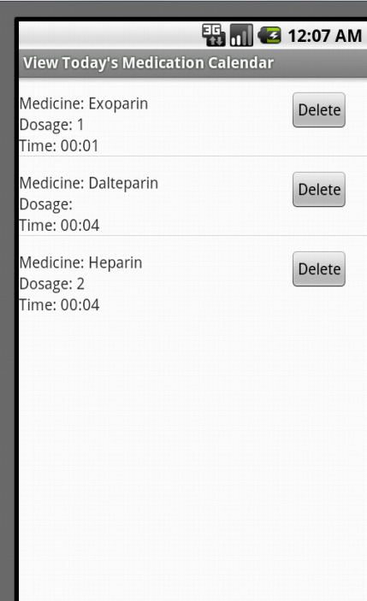
This option lists all the pills that are due that day.
The user can see at a glance what pills are due that day and ensure that those pills are readily accessible.

- Click on the Medication Details tab to view details of all the medicines that you have added.
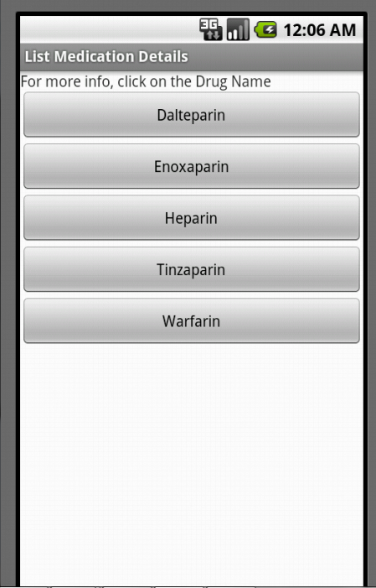
Note: To use this feature, the phone/device needs to be able to connect to the internet.

- Click on the drug name that you are interested in.
- A website that contains details of that specific drug is opened.
- Use the back button to go back to the DIGIASSIST application.

- 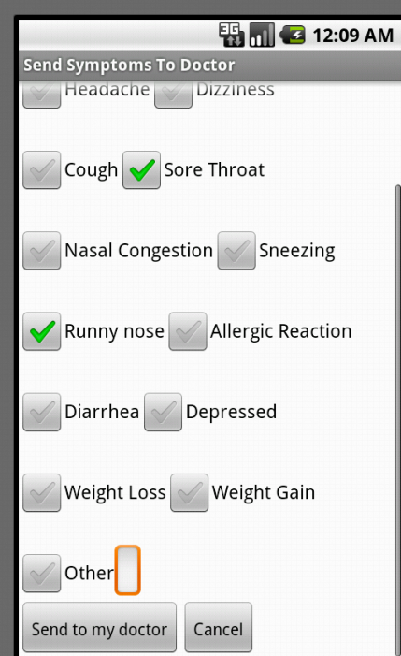
Click on the Symptoms button if you would like to
  - communicate with your health care provider about side effects of certain medication that you are taking.
  - communicate with your health care provider about common ailments that may not warrant visiting a physician.
  - Provide statistics to scientists to help them design better drugs.

- A list of common side effects/ conditions are listed in this menu.
- This list includes nausea, fever, headache, dizziness, depression, weight loss, weight gain etc.
- Select all the conditions that apply.
- To send this information to your health care provider, click on Send to my Doctor.

- An email is sent out to your doctor from your email account listing your current medication as well as your ailments.
- Note: To use this feature, your device must be capable of sending email and your email settings must be configured.
- Click on CANCEL to discard the values entered and go back to the DIGIASSIST Home screen.
- Click on the supplies tab to keep track of your medication supplies. (WORK IN PROGRESS)
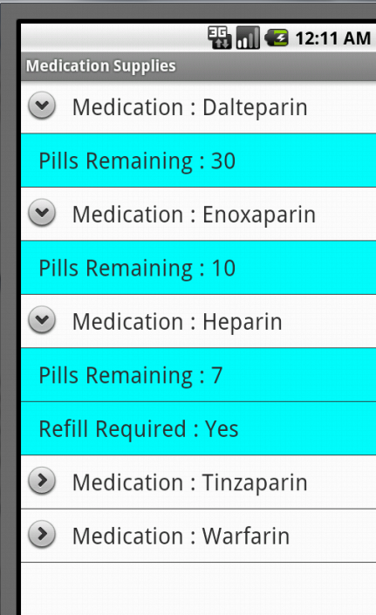
- This feature lists all the medications in the database as well as how many days supply is remaining.
- The user is alerted if he has less than 7 days supply of medication.
- The user has the option of calling his preferred pharmacy to refill his prescription

- Click on the health log icon to maintain a record of your vital statistics and to track the effects of your medication.
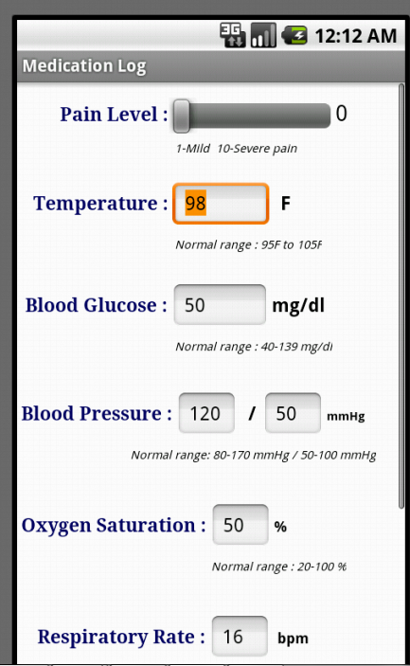
Note: To use this feature, certain medical apparatus is essential

  - Thermometer - to measure body temperature
  - Blood Pressure Monitor - to measure systolic and diastolic blood pressure
  - Blood Glucose Meter - to measure blood glucose level
  - Oximeter - to measure oxygen saturation
  - Clock/Watch - to measure respiratory rate and pulse rate
- Use the slider to enter your current pain level (if any) against PAIN LEVEL.
- Use the thermometer to measure the body temperature and enter this value against TEMPERATURE.
- Use the Blood Pressure monitor to measure the systolic and diastolic blood pressure and enter this value against BLOOD PRESSURE.
- Use the Blood Glucose meter to measure the blood glucose value and enter this value against BLOOD GLUCOSE.
- Use the oximeter to measure the oxygen saturation and enter this value against OXYGEN SATURATION.
- Use a clock to measure the number of breaths per minute and enter this value against RESPIRATORY RATE
- Use a clock to measure the number of heartbeats per minute and enter this value against PULSE RATE.
- Click on SAVE to save this record in the log.
- Click on CANCEL to discard the values entered and go back to the DIGIASSIST Home screen.

- Click on the Settings icon to view and edit your information.
This includes your name, date of birth, address, phone number, email, insurance details, preferred pharmacy details, health care provider details, donor status etc

- Click on the HELP icon to view information about how to use the DIGIASSIST application
