DEPARTMENT OF COMPUTER SCIENCE AND ENGINEERING

LAB MANUAL

DATA MINING LAB



Sai Spurthi Institute of Technology
B.Ganagaram, Sathupally,Khammam – 507 303 (A. P.)

B.GANGARAM
SATHUPALLY-507303,Khammam Dist
C E R T I F I C A T E
This is certify that it is a bonafide record of practical
Work of Mr / Miss……………………………………………
Roll No…………of……………. B.Tech ……..………….sem.
In the Department of…………………….Engineering,
In………………………………….Laboratory during the
academic year………………………………………….

No.ofExperiments Conducted---------- No. of Experiments Attended………

Signature of the Staff Member Signature of Head of the Dept
Signature of the External Examinar

1 | Weka Intorduction | 1-8
2a | Preprocessing Intorduction | 9
2b | Clustering | 10
2c | Identification of missing values | 11
3 | Study the arff file format using Student.arff file | 12-13
4 | Explore the available datasets in weka | 14-16
5 | Load a data set (ex. Weather data set, Iris data set, etc) | 17-18
6 | Load Cpu.arff dataset and observe the following:  - List the attribute names and they types:  - Number of records in each dataset  Determine the no of records for each class  - Identify the class attribute (if any):  - Plot Histogram:  - Visualize the data in various dimensions: | 18-21
7 | Demonstration of Association rule process on dataset wheather.nominal.arff using apriori algorithm  - Demonstration of clustering rule process on dataset glass.arff using simple k-means  b. Demonstration of clustering rule process on dataset glass.arff using simple EM | 22-25
8 | Design a Knowledge Flow Layout for classifying a dataset of glass.arff | 26-27
9 | Simple CLI Commands  - Classify the dataset using j48 algorithm  - Classify the dataset using id3 algorithm.  - Cluster the following given dataset using dB scan algorithm.  - Cluster the following given dataset using simple k-means algorithm

WEKA MANUAL

1: Weka Introduction

WEKA stands for Waikato Environment for Knowledge Learning. It was developed by the University of Waikato, New Zealand. WEKA supports many data mining tasks such as data re-processing, classification, clustering, regression and feature selection to name a few. The workflow of WEKA would be as follows:
Data -> Pre-processing -> Data Mining -> Knowledge
Getting started with WEKA
Choose “WEKA 3.7.x” from Programs. The first interface that appears looks like the one given below.
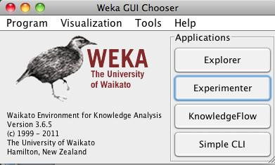

- Explorer: An environment for exploring data. It supports data preprocessing, attribute selection, learning and visualization

- Experimenter: An environment for performing experiments and conducting statistical tests between machine learning algorithm

- Knowledge Flow: It is similar to Explorer but has a drag-and-drop interface. It gives a visual design of the KDD process.

- Simple CLI: Provides a simple command-line interface for executing WEKA commands.

WEKA Tools

- Preprocessing Filters: The data file needs to be loaded first. Given below is an example.
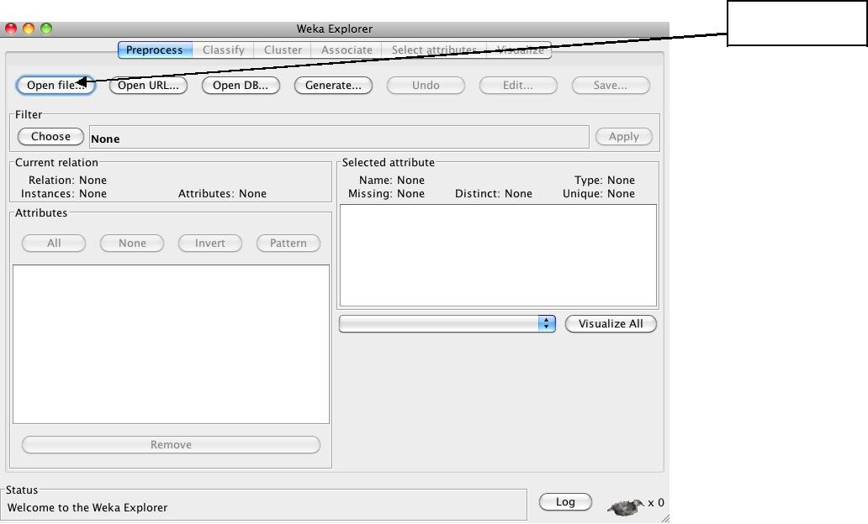
To load a file

The supported data formats are ARFF, CSV, C4.5 and binary. Alternatively you could also import from URL or an SQL database. After loading the data, preprocessing filters could be used for adding/removing attributes, discretization, Sampling, randomizing etc.

- Select attributes: WEKA has a very flexible combination of search and evaluation methods for the dataset’s attributes. Search methods

include Best-first, Ranker, Genetic-search, etc. Evaluation measures include InformationGain, GainRatio, ReliefF, etc.

- Classification: The predicted target must be categorical. WEKA includes methods such as Decision Trees, Naïve Bayes and Neural Networks to name a few. Evaluation methods also include test data set and cross validation.

- Clustering: The learning process occurs from data clusters. Methods include k-means, Cobweb and FarthestFirst.

- Regression: The predicted target is continuous. Methods such as linear regression, Neural networks and Regression trees are included in the library.

Exercise (Using built-in dataset)

- Click Explorer on the first interface screen and load a dataset from the library. Given here is an illustration for the dataset ‘weather.arff’.
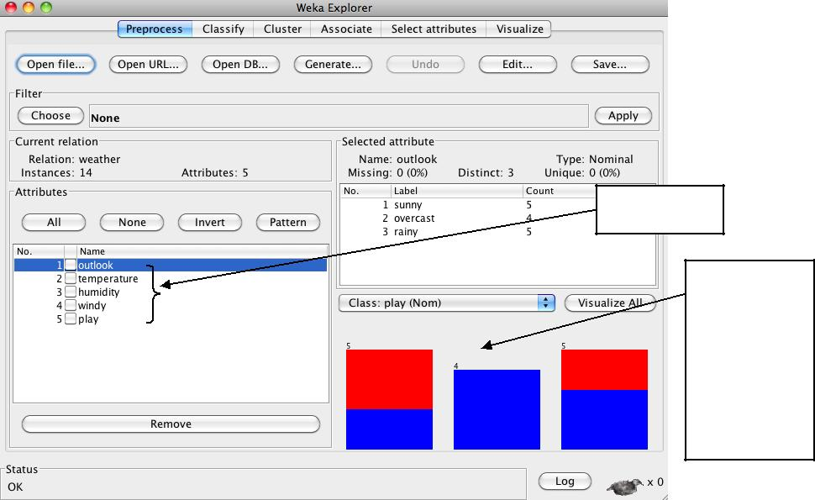

Attributes

Distribution of the samples for the highlighted feature
- Click over each attribute to visualize the distribution of the samples for each of them. You can also visualize all of them at the same time by clicking the ‘Visualize all’ on the right pane.

- Under the Classify tab, click ‘Choose’ and select a classifier from the drop-down menu. E.g.: ‘Decision Stump’
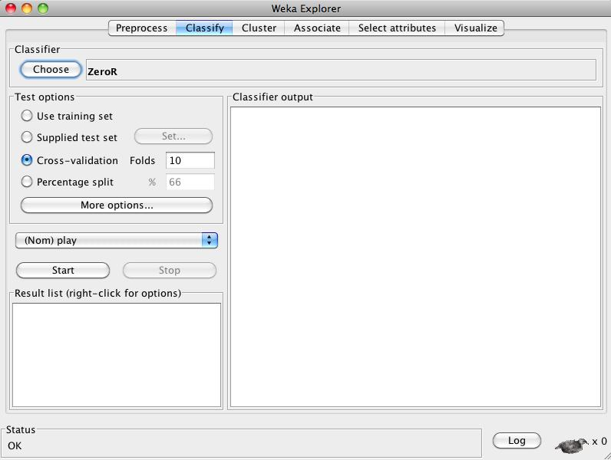

- Once, a classifier is chosen, select percentage split and leave it with its default values. The default ratio is 66% for training and 34% for testing.
- Click ‘Start’ to train and test the classifier. The interface will now like this:
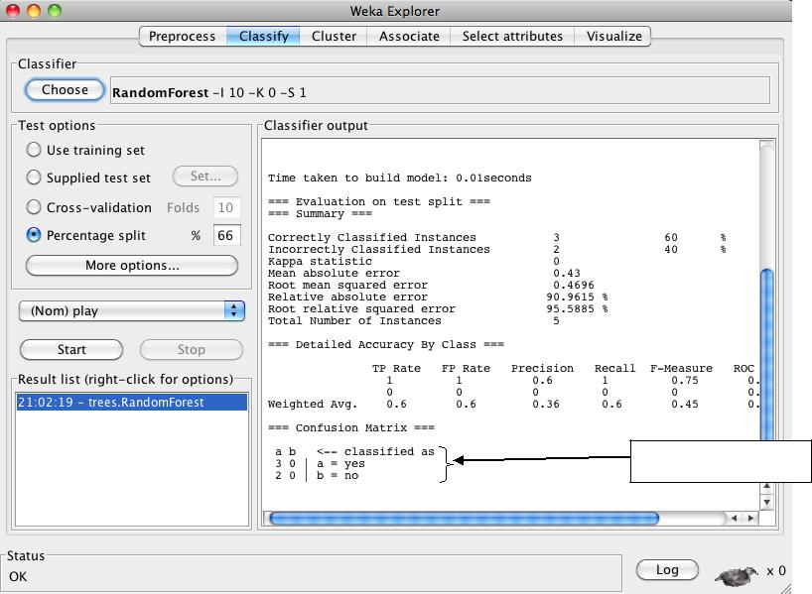

Confusion matrix

- You could also try using ‘Crossvalidation’ method to train and test the data.

- The right pane shows the results for training and testing. It also indicates the number of correctly classified and misclassified samples.

- You could right click on the model generated and do various operations. You could also save the model if you wanted. Another performance measure is the ROC curve that can be viewed as shown in the next picture. Select ‘no’ in the option to view the curve.
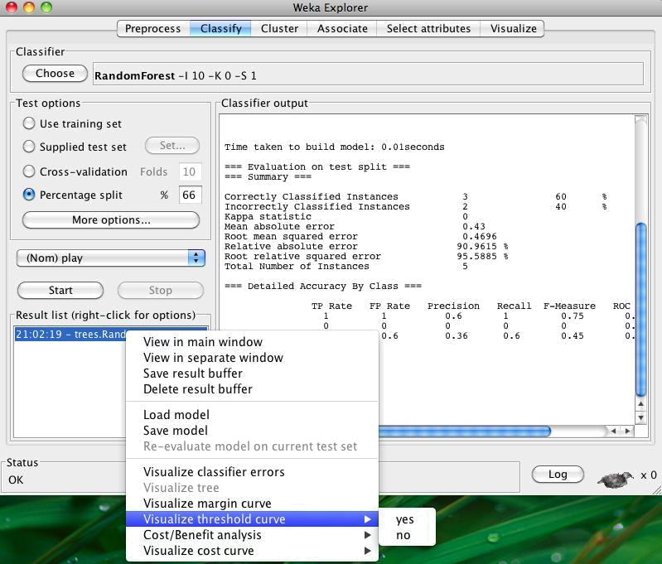

- Click on the ‘Select Attributes’ tab and to analyze the attributes. A number of ‘Attribute Evaluator’ and ‘Search methods’ can be combined to gain insight about the attributes. Given below is an example.
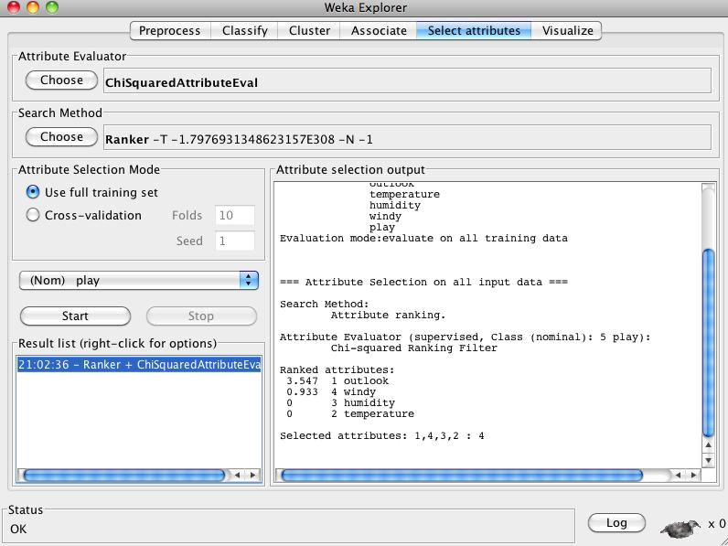

10. Click on the Visualize tab to see the pair wise relationship of the attributes.

Performance Analysis

Once the model has been trained and tested, we need to measure the performance of the model. For this purpose we used three measures namely: precision, recall and accuracy.

Precision (P) = tp/(tp+fp)

Recall (R) = tp/(tp+fn)

Accuracy (A) = (tp+tn)/Total # samples

1Where tp, fp, tn and fn are true positive, false positive, true negative and false negative respectively.
Deliverables:

Use any preexisting dataset from the WEKA library. Choose any classifier and perform all the steps mentioned above. In your HW, please summarize the following:

- Classifier used

- Test Options used

- Confusion Matrix in the form of a table

- Figure of the ROC curve

- The top 2 ranked attributes when you choose the Attribute Evaluator as ‘ChiSquaredAttributeEval’ and Search Method as ‘Ranker’.

- P, R and A measures

Acknowledgement: This handout is a guide for WEKA for EECS 730 students at KU only. Some information above is taken from a few related internet sources.

2): Preprocessing:

Step1: Open WEKA by passing command as java –jar weka.jar.
Step2: Click on Preprocessing Tab and select corresponding dataset.
Step3: Click on the Open file tab and choose the dataset.
Step4: Identify Statistical information about selected dataset.

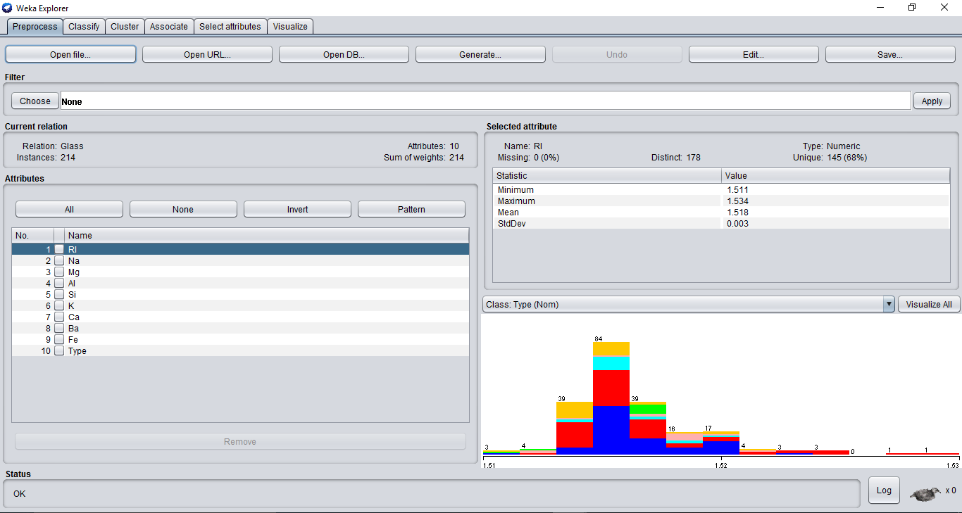

Classification:

Step1: Open WEKA by passing command as java –jar weka.jar.
Step1: We begin the experiment by loading the data into weka.
Step2: Next we select the “classify” tab and click “choose” button to select the classifier.

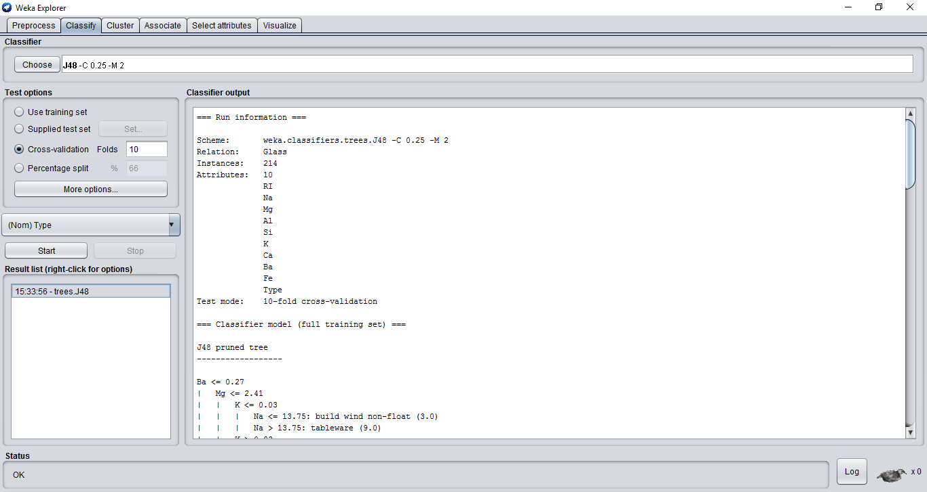

Clustering:

Step1: Open WEKA by passing command as java –jar weka.jar.
Step 2: Inorder to perform clustering select the ‘cluster’ tab in
the explorer and click on the choose button.
This step results in a dropdown list of available
clustering algorithms.
Step 3: In this case we select ‘simple k-means’.

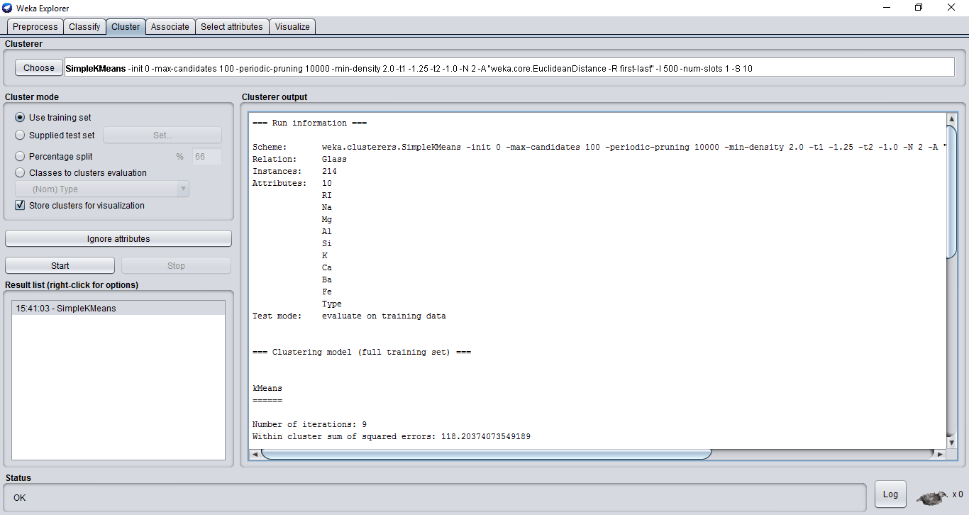

IDENTIFICATION OF MISSING VALUES:

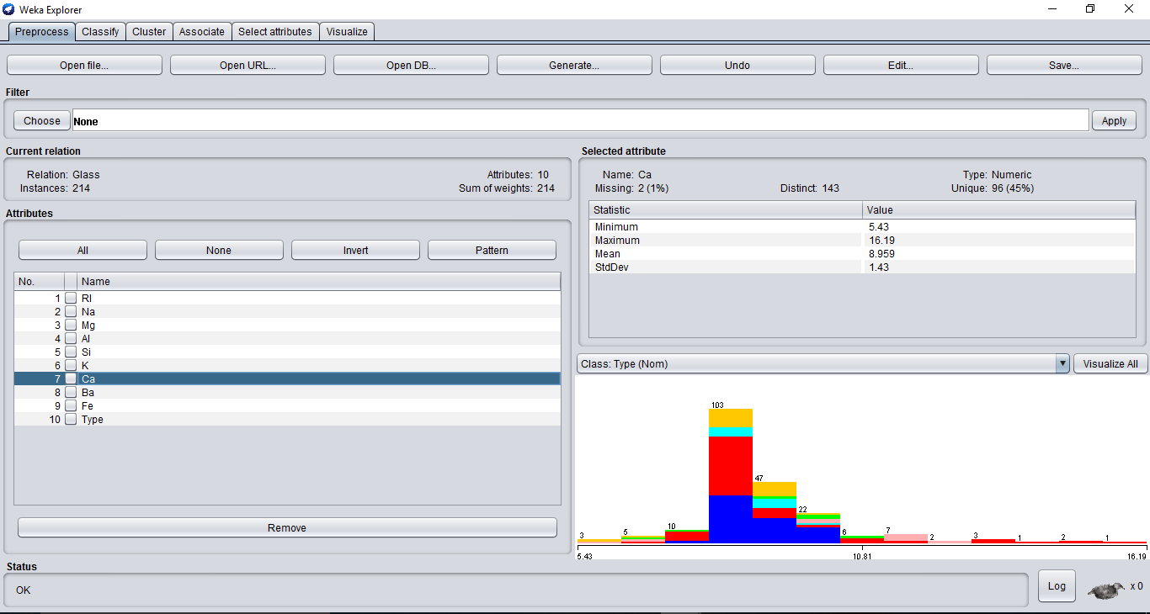

3) Study the arff file format
Student.arff file:
Creation:
Step1: open WEKA by passing command as java –jar weka.jar.
Step2: click on preprocessing tab and select corresponding data set.
Step3: click on open file tab and choose data set student.arff.
Step4: identify statistical information about selected dataset
student.arff.
Step5: identify type of attributes on dataset student.arff.
Step6: click on visualize all tab and identify (or) observe graphical info-
-rmation selected dataset student.arff.
Step7: select particular class of attribute on visualization tab observe the
Graph.
Step8: select the choose tab on processing window apply any one of
the filters on attributes (or) instance.
Step9: identify the errors by clicking on log tab.

List Of Attributes:

Attributes | Type
Roll Number | Numeric
Name | Nominal
Gender | Nominal
Percentage | Numeric

Selected Attribute: Roll Number
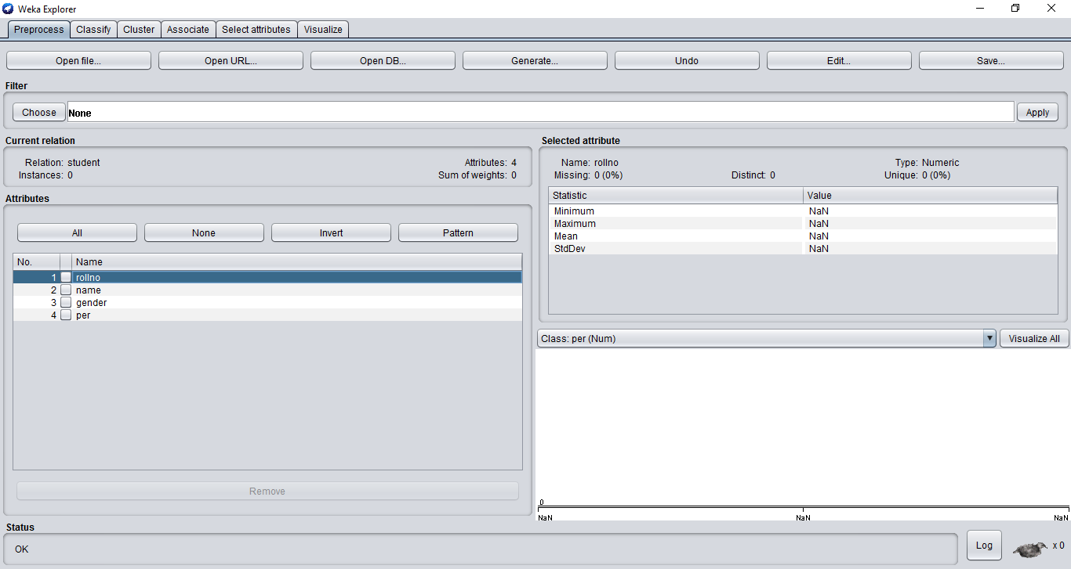

VISUALIZE ALL:
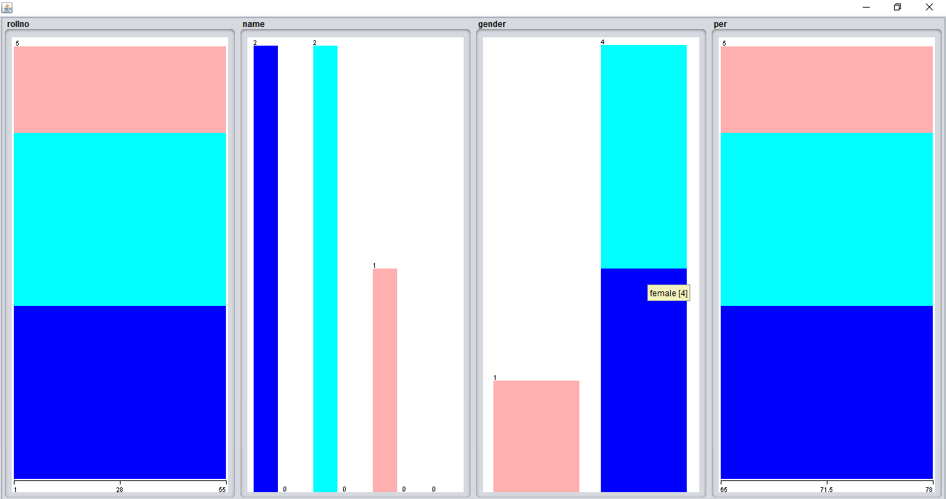

4) Explore the available datasets in WEKA:
Labour.arff:
Step1: open WEKA by passing command as java –jar weka.jar.
Step2: click on preprocessing tab and select corresponding data set.
Step3: click on open file tab and choose data set Labor.arff.
Step4: identify statistical information about selected dataset
Labor.arff.
Step5: identify type of attributes on dataset Labor.arff.
Step6: click on visualize all tab and identify (or) observe graphical information selected dataset Labor.arff.
Step7: select particular class of attribute on visualization tab observe the Graph.
Step8: select the choose tab on processing window apply any one of
the filters on attributes (or) instance.
Step9: identify the errors by clicking on log tab.

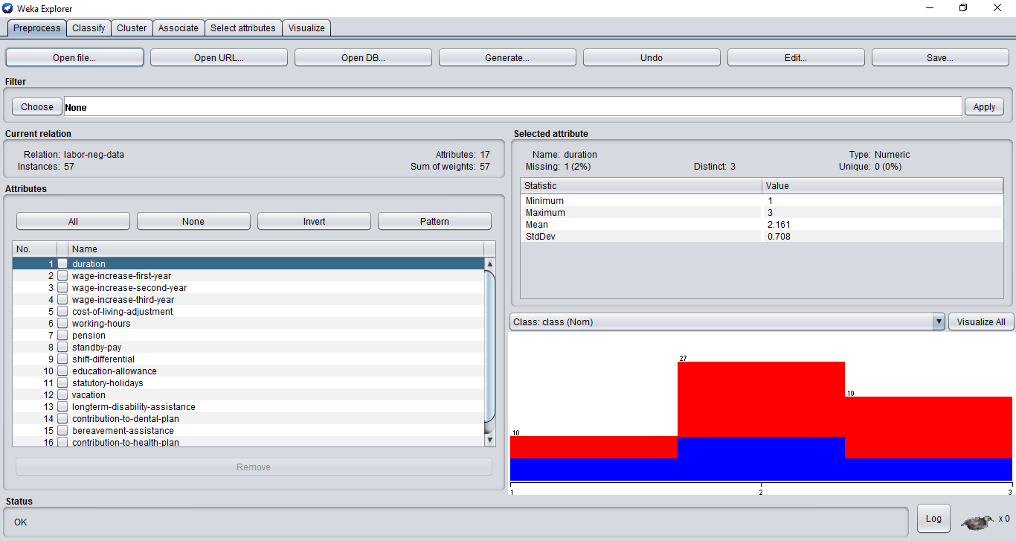

Contact-lenses.arff:
Step1: open WEKA by passing command as java –jar weka.jar.
Step2: click on preprocessing tab and select corresponding data set.
Step3: click on open file tab and choose data set Contact-lenses.arff.
Step4: identify statistical information about selected dataset
Contact-lenses.arff.
Step5: identify type of attributes on dataset Contact-lenses.arff.
Step6: click on visualize all tab and identify (or) observe graphical information selected dataset Contact-lenses.arff.
Step7: select particular class of attribute on visualization tab observe the
Graph.
Step8: select the choose tab on processing window apply any one of
the filters on attributes (or) instance.
Step9: identify the errors by clicking on log tab.

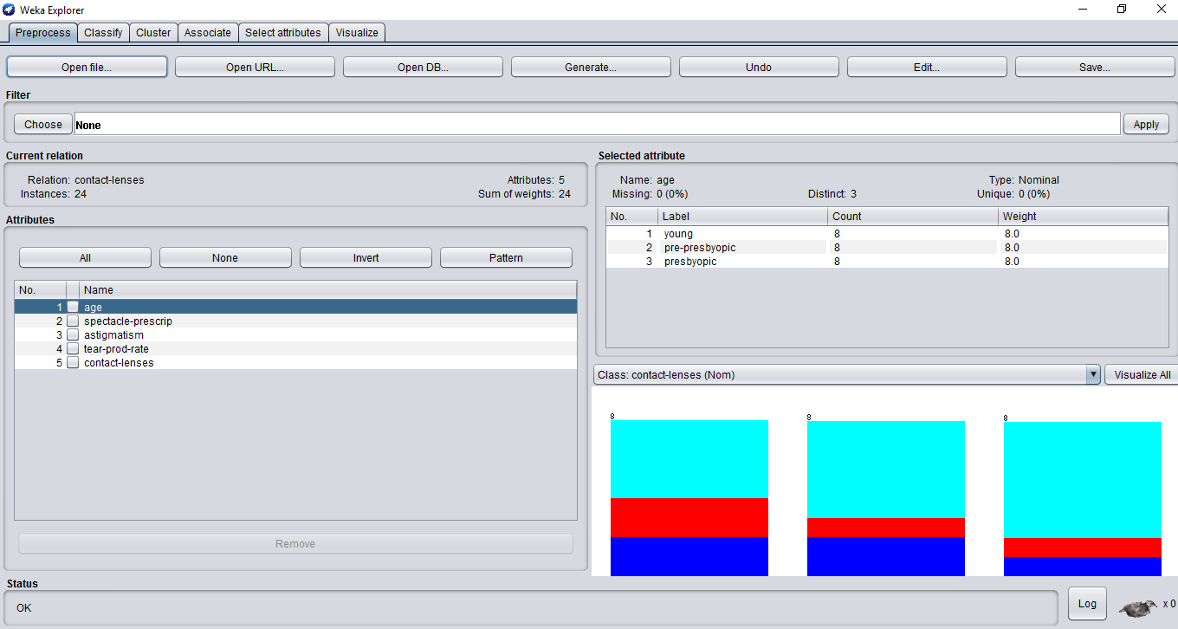

Glass.arff:
Step1: open WEKA by passing command as java –jar weka.jar.
Step2: click on preprocessing tab and select corresponding data set.
Step3: click on open file tab and choose data set Glass.arff.
Step4: identify statistical information about selected dataset
Glass.arff.
Step5: identify type of attributes on dataset Glass.arff.
Step6: click on visualize all tab and identify (or) observe graphical info-
-rmation selected dataset Glass.arff.
Step7: select particular class of attribute on visualization tab observe the
Graph.
Step8: select the choose tab on processing window apply any one of
the filters on attributes (or) instance.
Step9: identify the errors by clicking on log tab.

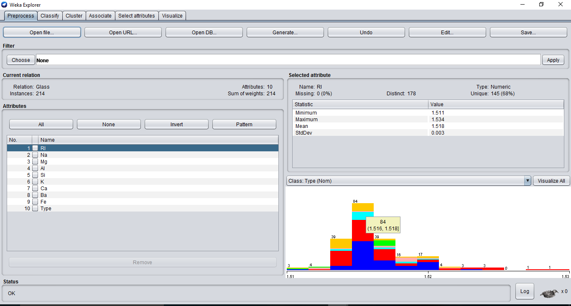

5) Load a data set (ex. Weather data set, Iris data set, etc):
Step1: open WEKA by passing command as java –jar weka.jar.
Step2: click on preprocessing tab and select corresponding data set.
Step3: click on open file tab and choose data set Weather.arff
or Iris.arff.
Step4: identify statistical information about selected dataset
Weather.arff or Iris.arff.
Step5: identify type of attributes on dataset Weather.arff or Iris.arff.
Step6: click on visualize all tab and identify (or) observe graphical info-
-rmation selected dataset Weather.arff or Iris.arff.
Step7: select particular class of attribute on visualization tab observe the
Graph.
Step8: select the choose tab on processing window apply any one of
the filters on attributes (or) instance.
Step9: identify the errors by clicking on log tab.
List of Attributes in Iris.arff:
Attributes | Type
Sepal length | Numeric
Sepal width | Numeric
Petal length | Numeric
Petal width | Numeric
class | Nominal

List of Attributes in Weather.symbolic:
Attributes | Type
Out look | Nominal
Temperature | Nominal
Humidity | Nominal
Windy | Nominal
Play | Nominal

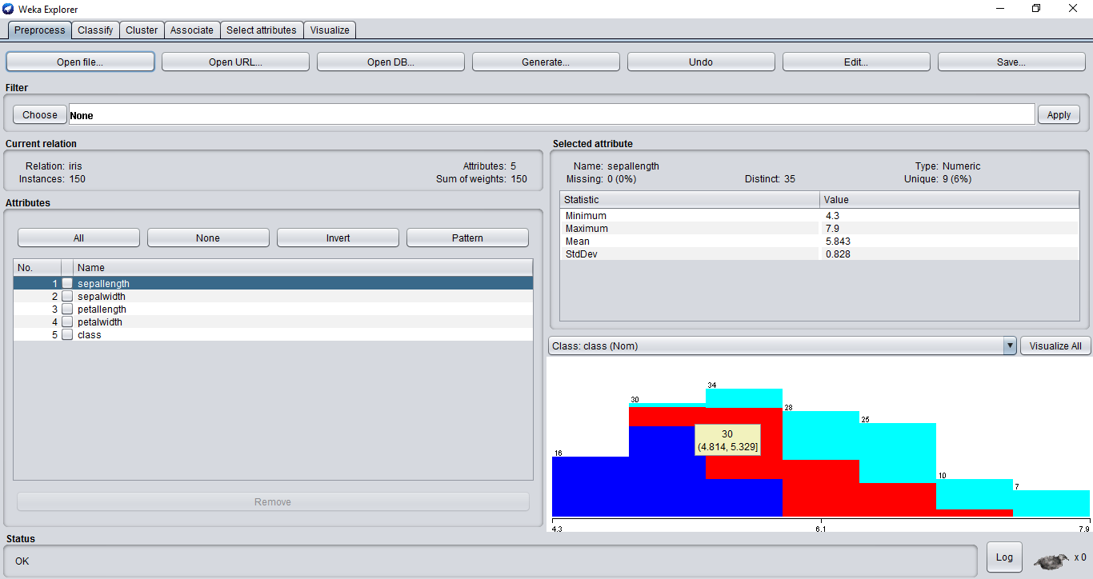

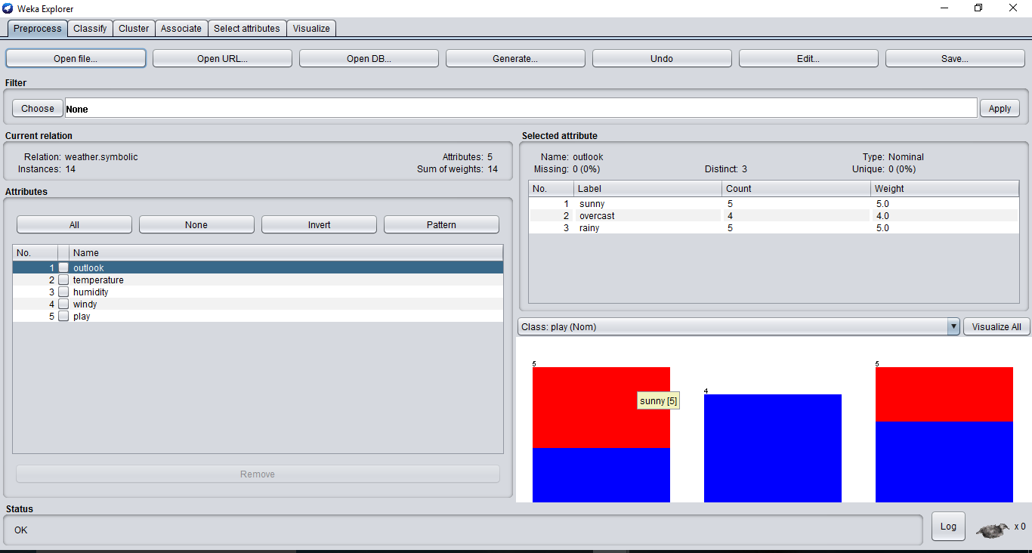

6 Load Cpu.arff dataset and observe the following:
i). List the attribute names and they types:
Attributes | Type
MYCT | Numeric
MMIN | Numeric
MMAX | Numeric
CACH | Numeric
CHMIN | Numeric
CHMAX | Numeric
CLASS | Nominal

ii). Number of records in each dataset:
v). Determine the no of records for each class:
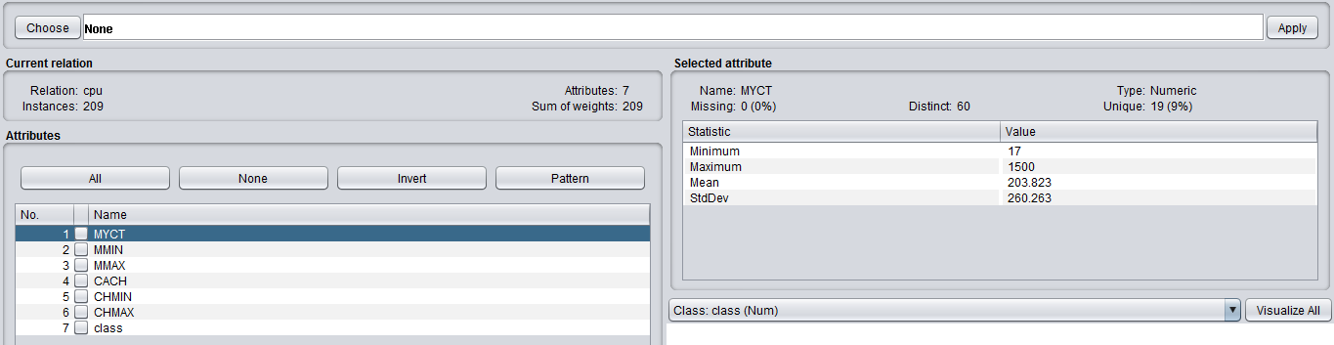
iii). Identify the class attribute (if any):
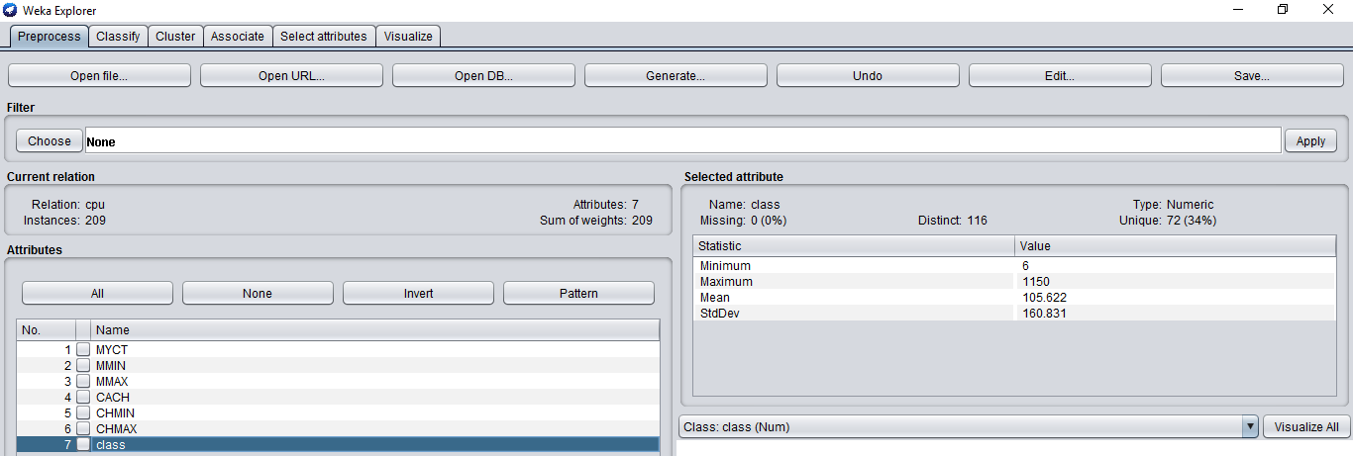
iv). Plot Histogram:
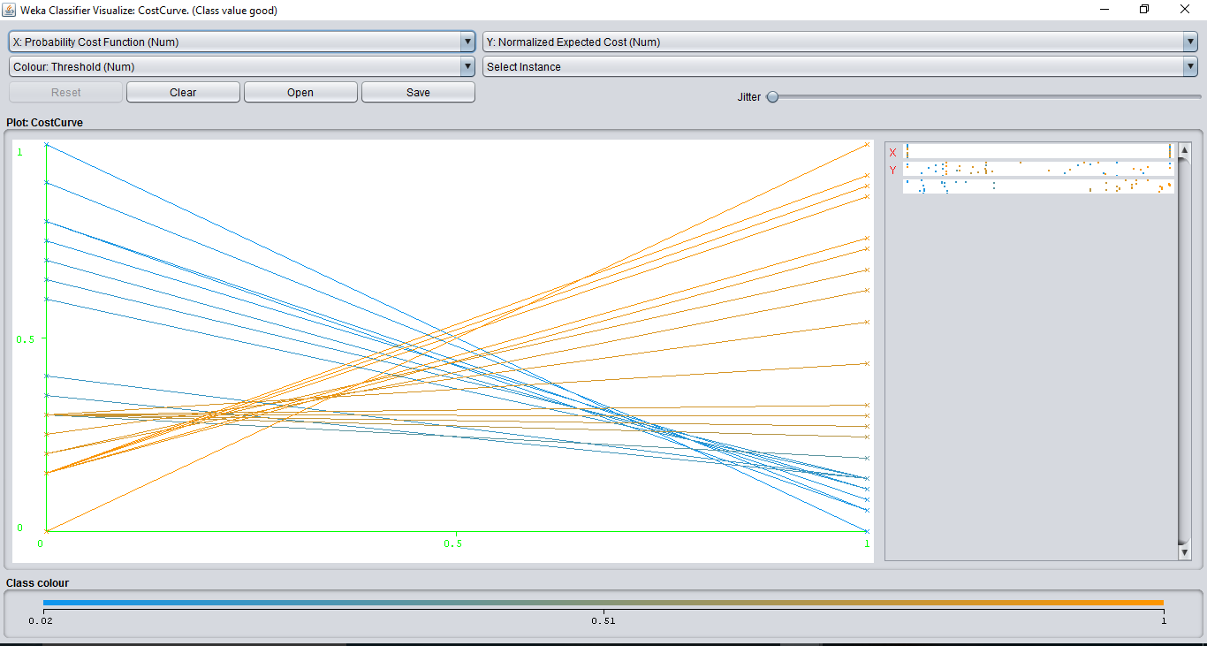
vi). Visualize the data in various dimensions:
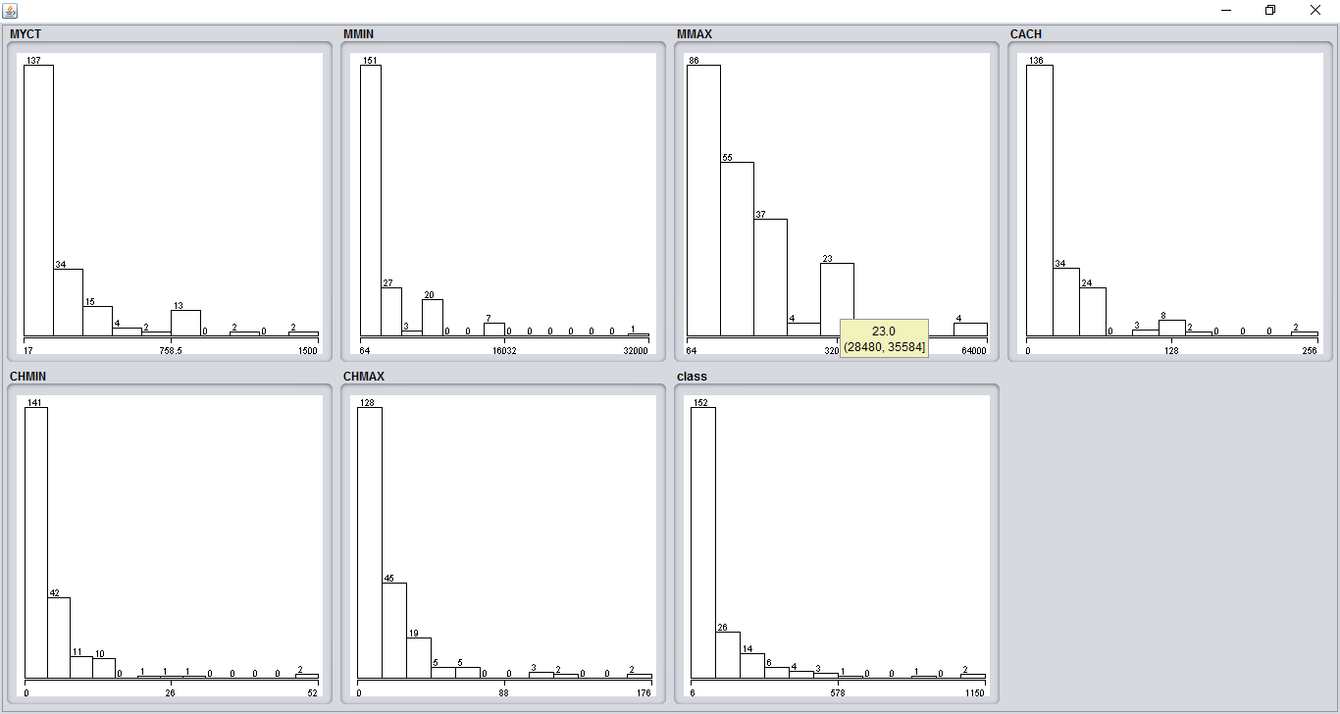

7. Demonstration of Association rule process on dataset wheather.nominal.arff using apriori algorithm
Procedure:-

Step:1 Open weka by passing command as java –jar weka. Jar
Step2: Click on Preprocessing tab and select corresponding data set
Step3: Click on Openfile tab and choose the dataset wheather.nominal.arff
Step4: Clicking on the associate tab will bring up the interface for association rule algorithm.
Step5: We will use apriori algorithm.
Step6: Click on Start button to run the Apriori algorithm
OUTPUT:-
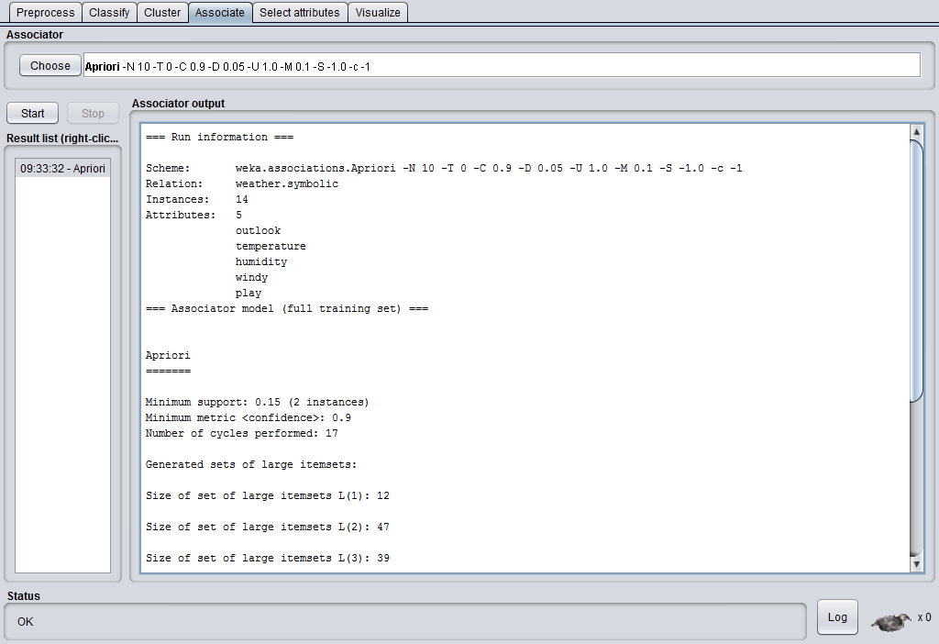
4a) Demonstration of clustering rule process on dataset glass.arff using simple k-means

Procedure:-
Step:1 Open weka by passing command as java –jar weka. Jar
Step2: Click on Preprocessing tab and select corresponding data set
Step3: Click on Openfile tab and choose the dataset glass.arff
Step4: Clicking on the cluster tab will bring up the interface for cluster rule algorithm.
Step5: We will use K-means algorithm.
Step6: Click on Start button to run the K-means algorithm
OUTPUT:-
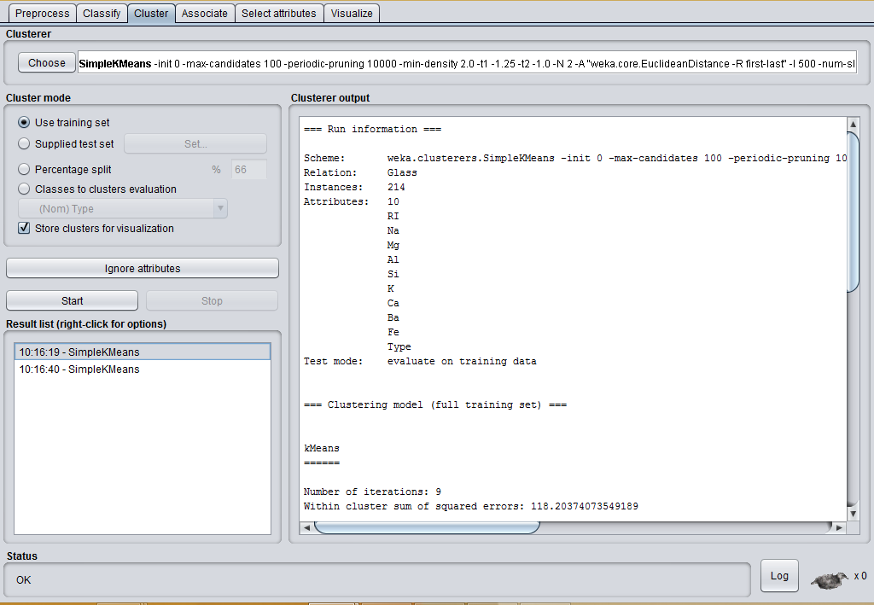

4b) Demonstration of clustering rule process on dataset glass.arff using simple EM

Procedure:-
Step:1 Open weka by passing command as java –jar weka. Jar
Step2: Click on Preprocessing tab and select corresponding data set
Step3: Click on Openfile tab and choose the dataset glass.arff
Step4: Clicking on the cluster tab will bring up the interface for cluster rule algorithm.
Step5: We will use EM algorithm.
Step6: Click on Start button to run the EM algorithm
OUTPUT:-
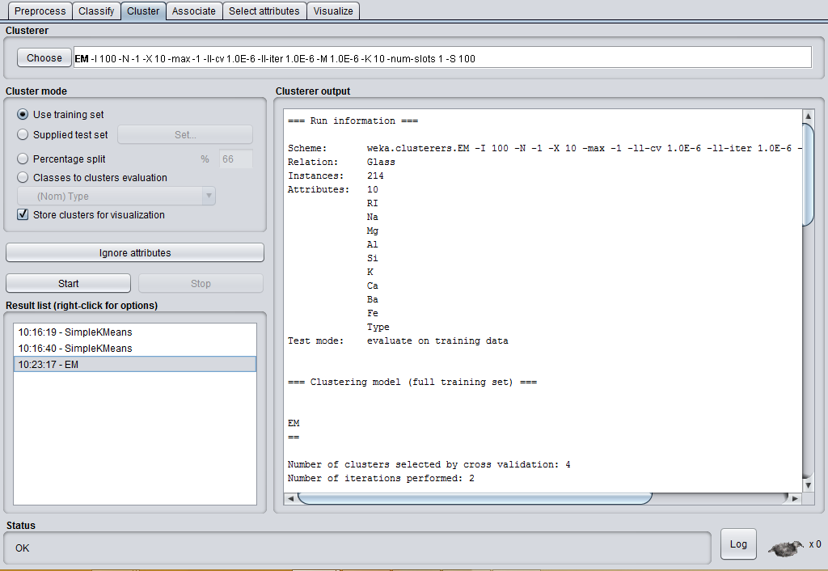

8.Design a Knowledge Flow Layout for classifying a dataset of glass.arff
PROCEDURE:-
Step1:- Click on datasource tab and choose arff loader from the tool b bar.
Step2: Right click on arff loader a pop menu will be appear from these selected configure option for selection of datasource.
Step3: Click on evaluation tab and choose the class assigner components from the toolbar and place on the layout.
Step:4 Right click on the arff loader and select dataset under connections for connection between source and classassigner.
Step5: Right click on class assigner component and choose configure from the menu on popup window will be appear under class attribute select any one of the class evaluation.
Step 6: Click on evaluation tab select Cross validation fold maker component placed on layout.
Step7: Right click on Class Assigner from the edit menu .Select dataset for connection between Class Assigner and Cross validation fold maker .
Step 8: Select Classifier tab under tree algorithm select any one of the algorithm for classification and placed on the layout.
Step9: Right click on Cross validation fold maker and select training set for connection and select textset for testing.
Step10: Click on evaluation evaluation tab and place a classifier performance evaluator component.
Step 11:- Right click on j48 under the edit select batch classifier for connection between algorithm nad evaluator.
Step12:- Select visualization tool and place Text viewer component on the layout.
Step13: Select Evaluator compmonent under edit select text for connection between evaluator & visualization.
Step14:- Start the flow Evaluation by selecting start loading from the arff loader.

OUTPUT:-
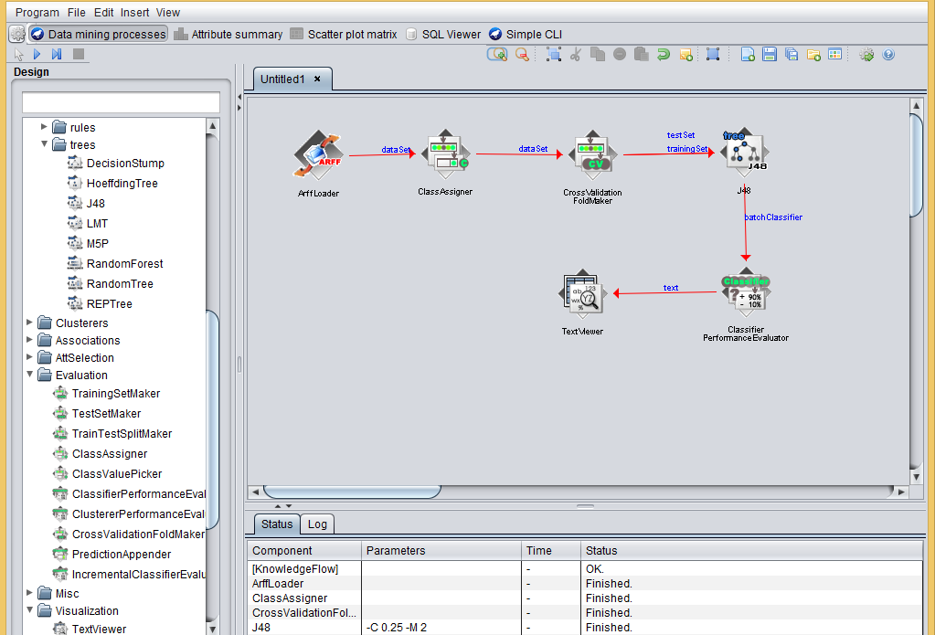

9. SIMPLE CLI EXPERIMENTS

EXPERIMENT-1:
Classify the dataset using j48 algorithm

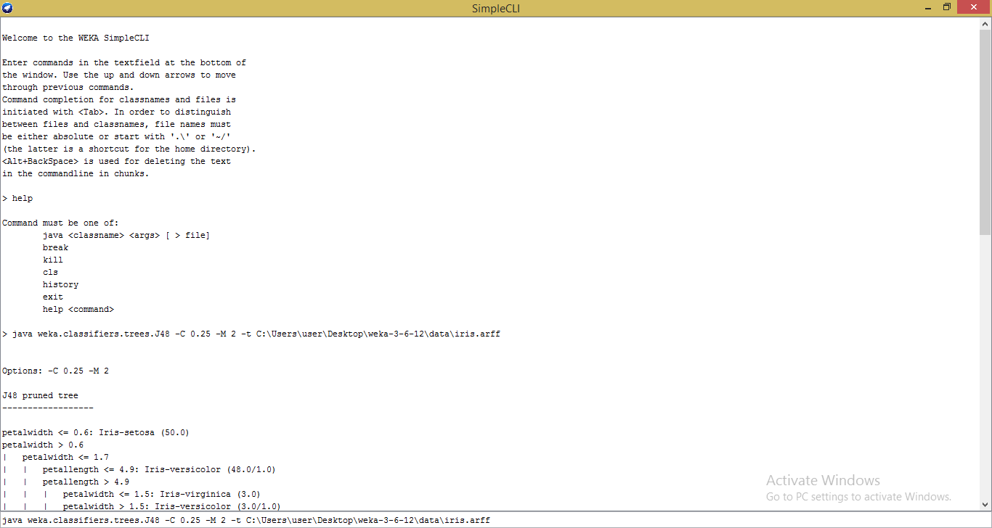

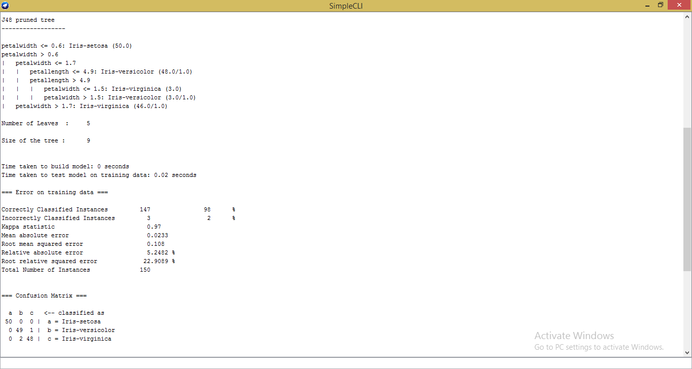

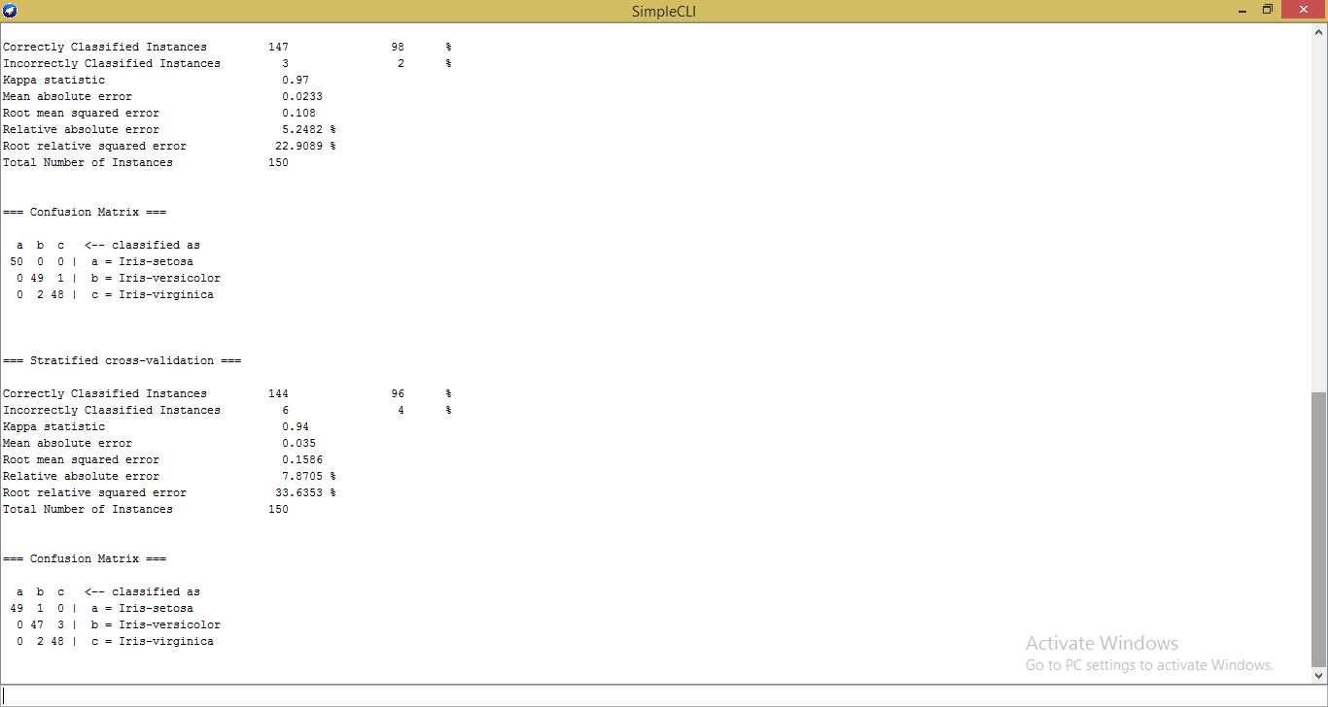

Experiment-2:
Classify the dataset using id3 algorithm.
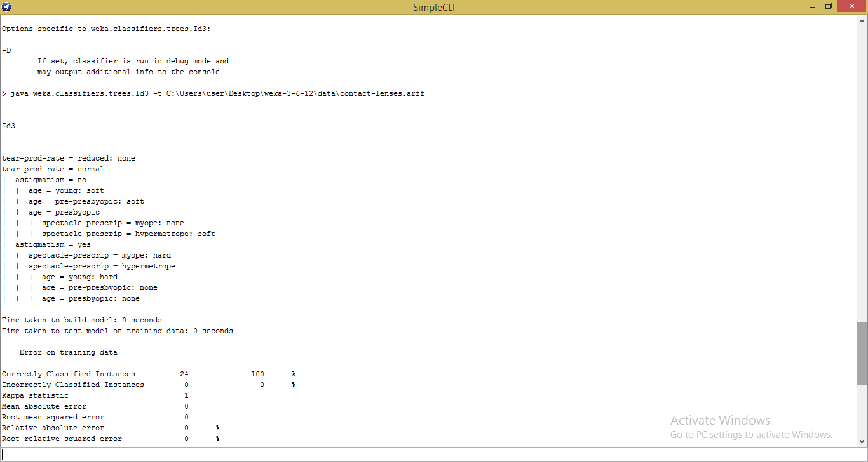
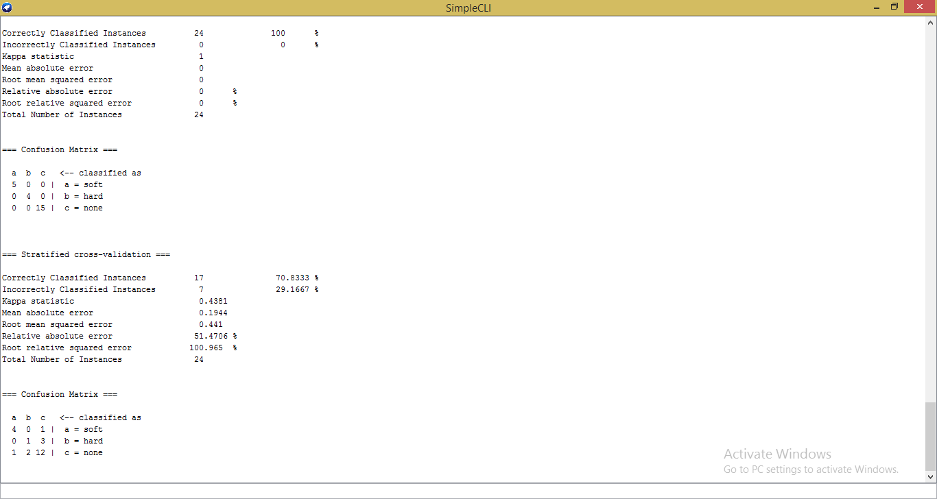

Experiment-3:
Cluster the following given dataset using dB scan algorithm.
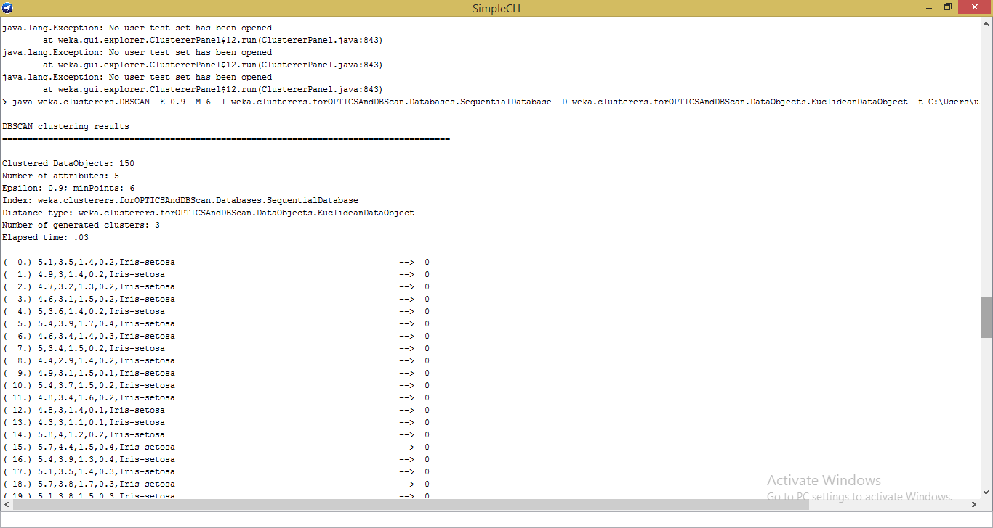
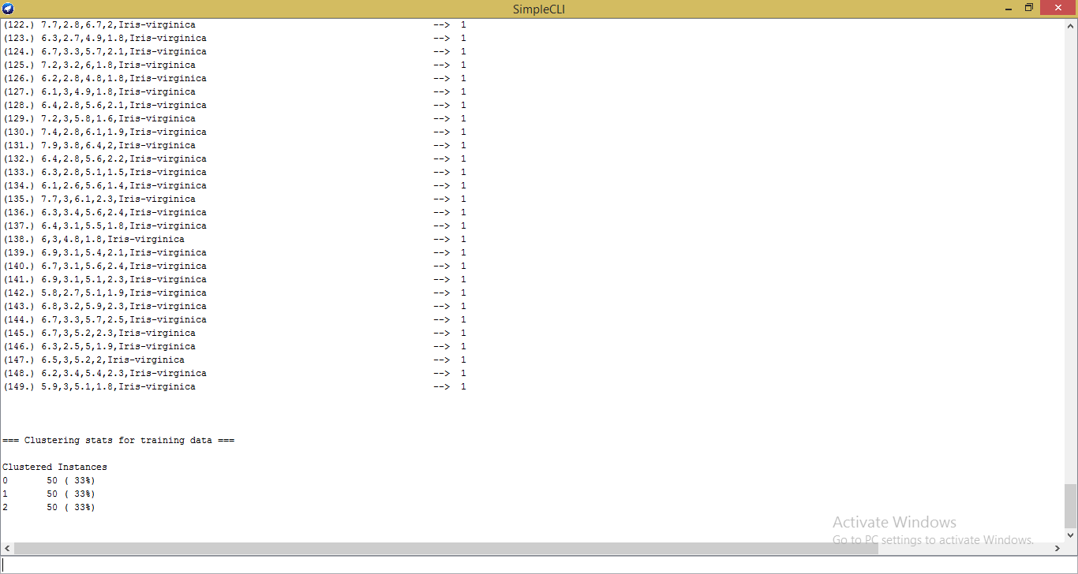

Experiment:-4
Cluster the following given dataset using simple k-means algorithm

