# Answers for 2.3P Code Analysis 1

Student Name: Nagireddy Surya Rao

Student ID: 216283458

**Question 1**: What is the output of **Code 1**?

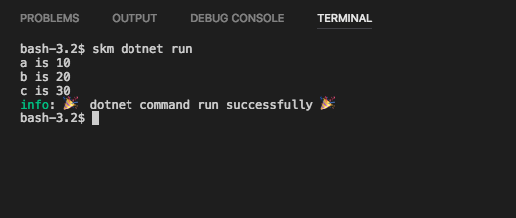

**Question 2**: What is output by **Code 2**?

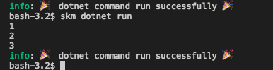

**Question 3:** What is output by **Code 3**?

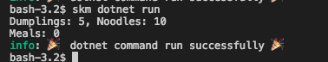

**Question 4:** What is output by **Code 4**?



**Question 5**: How does *Code 3* illustrate the concept of **sequence**?

In this Code it illustrates that instructions carry out in a sequence manner from top to bottom. The value of the instruction doesn’t change even if the value of the variables changes after the calculation.

**Question 6:** What are the value and type of the following expressions (given the associated variable values)?

|  |  |  |  |
| --- | --- | --- | --- |
| Variable Values | Expression | Value | Type |
|  | 5 |  |  |
|  | 5.1 |  |  |
|  | “Hello” | Hello |  |
|  | 1 + 2 * 3 | 7 |  |
| a = 1; b = 2; | a + b | 3 |  |
| a = 3; | 2 * a | 6 |  |
| a = 1.5; b = 2; | 2 * a + b | 5 |  |
| a = 1.5; b = 2; | a + 2 * b | 5.5 |  |
| a = 1; b = 1; c = 5; | (a + b) * c | 10 |  |
|  | “Fred” + “ “ + “Smith” | Fred Smith |  |
| a = “Wilma” | a + “ Smith” | WilmaSmith |  |

**Question 7:** What is the most appropriate type to store the following?

|  |  |  |  |
| --- | --- | --- | --- |
| Data | Type | Example/s | |
| A person's name |  | Fred | Wilma |
| Number of students in a class | Int | 87 | 715 |
| Average age of a group of people | double | 23.4 | 17.6 |
| A temperature in Celsius |  | -18.1 | 40.2 |
| The name of a subject |  | OOP | Physics |
| Runs scored in a cricket match | Int | 102 | 10 |
| A student’s ID number |  | 1827162 | 9371293X |
| A person’s phone number |  | 04123723 | +6137198262 |
| The cost of an item |  | $12.50 | $99.00 |